# UNIT TESTING SPECIFICATION

|  |  |
| --- | --- |
| Author | Daryll Moya |
| Creation Date | November 13, 2020 |
| Last Updated | November 13, 2020 |
| Version | 0.1 |

# Document Control

|  |  |  |  |
| --- | --- | --- | --- |
| Date | Author | Version | Change Reference |
| 13-NOV-2020 | Daryll Moya | 0.1 | Initial Version |
|  |  |  |  |
|  |  |  |  |

# Introduction

## Purpose

The purpose of the Testing Specification Document is to provide a consolidated/indexed view of various information related to testing efforts for the coding exam. This includes the following:

* Defining plans for unit testing
* Summary of test results

## Scope

* **In-scope** – Unit testing for the following scenarios related to the following:
* Palindrome Checker
* Longest Palindrome Substring
* **Out-of-scope** - The following testing will not be considered for this document:
* Other challenges/problems not specified in the instructions for this coding exam

# Test Method

Running the program in Eclipse IDE.

# Unit Test Results

## Test Case # 1 – User inputs “1” as the function to be executed; The input only contains number and it is not a palindrome

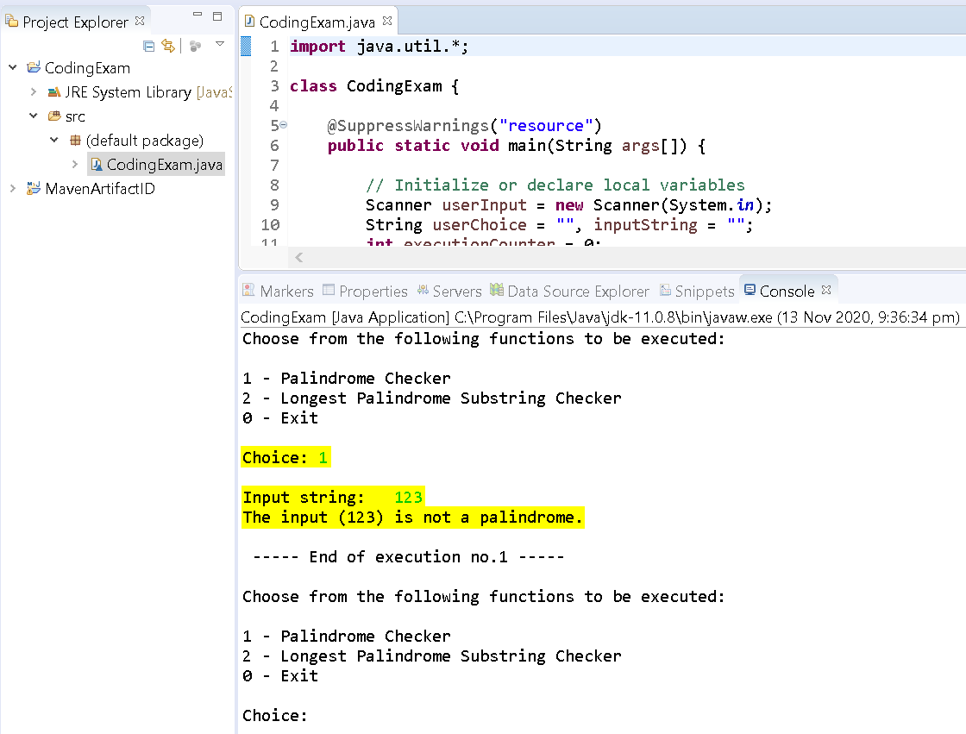

## Test Case # 2 – User inputs “1” as the function to be executed; The input only contains lower case letters and it is not a palindrome

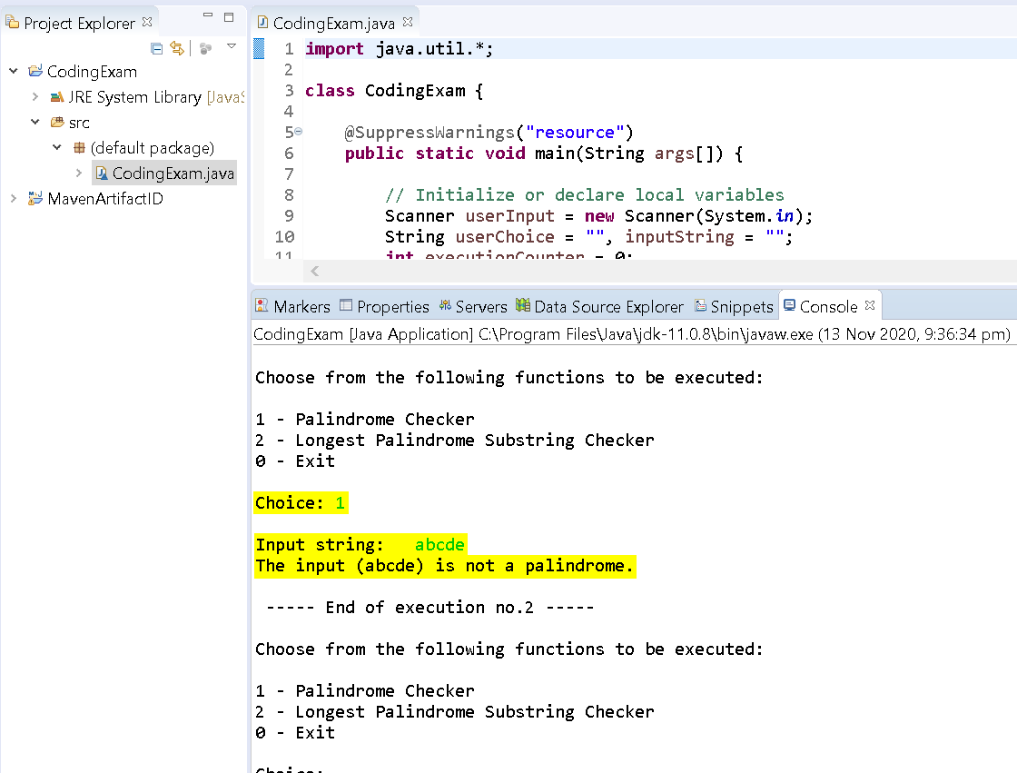

## Test Case # 3 – User inputs “1” as the function to be executed; The input only contains upper case letters and it is not a palindrome

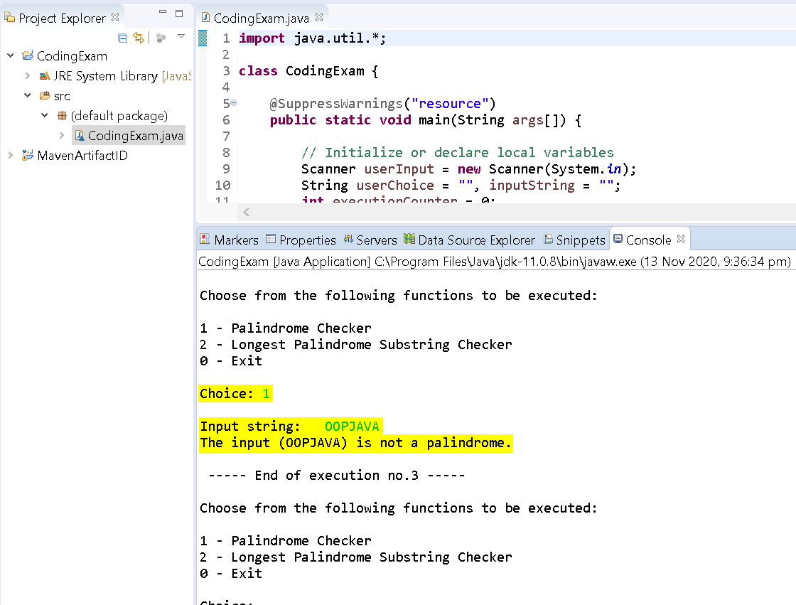

## Test Case # 4 – User inputs “1” as the function to be executed; The input contains a combination of alpha-numeric characters and special characters and it is not a palindrome

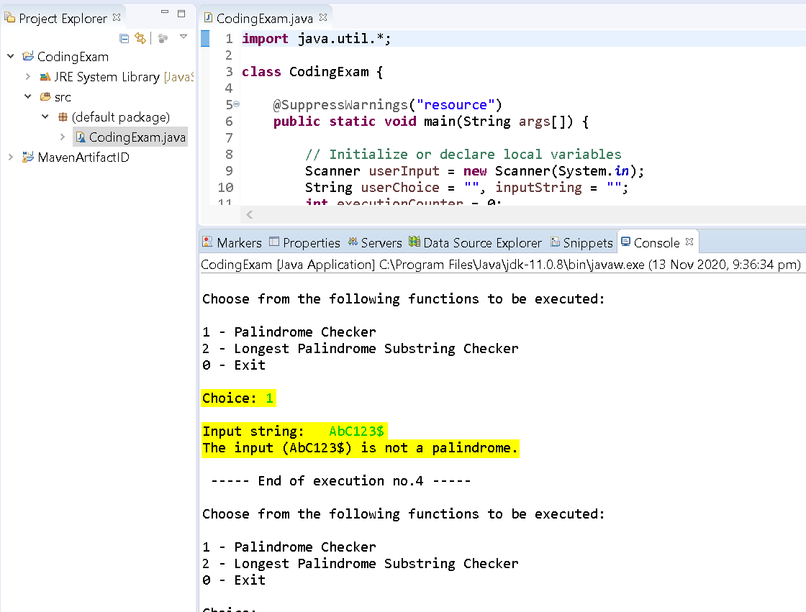

## Test Case # 5 – User inputs “1” as the function to be executed; The input only contains number and it is a palindrome

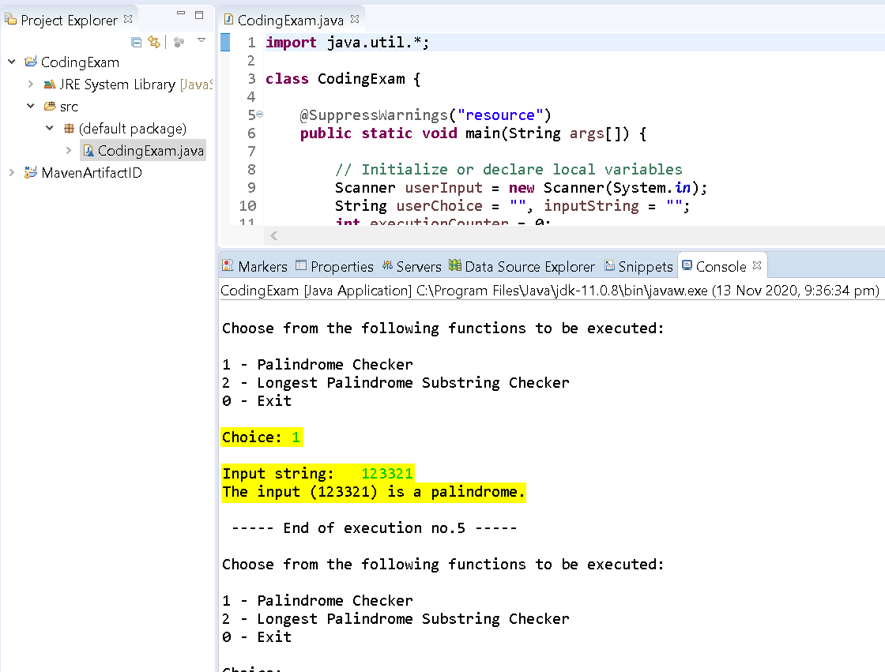

## Test Case # 6 – User inputs “1” as the function to be executed; The input only contains lower case letters and it is a palindrome

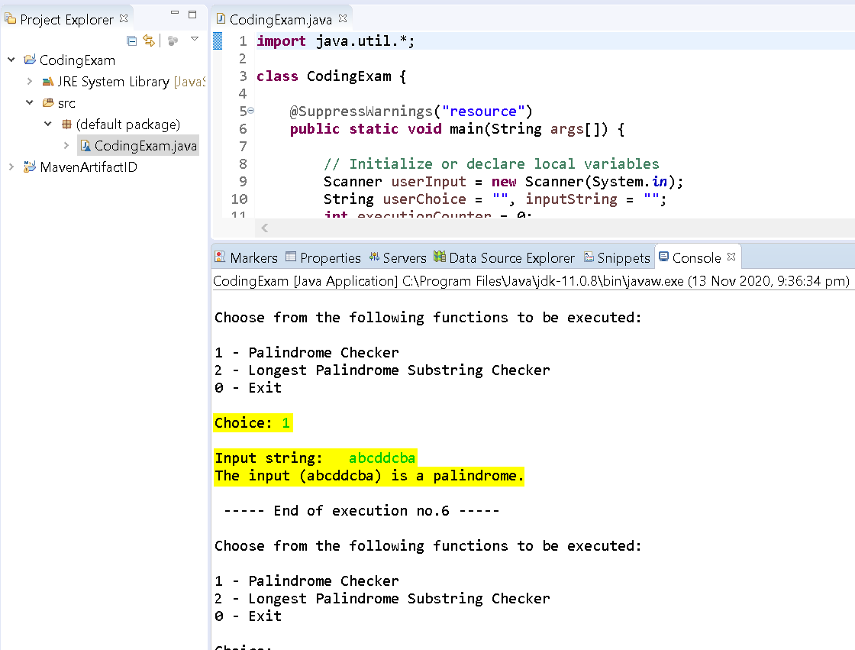

## Test Case # 7 – User inputs “1” as the function to be executed; The input only contains upper case letters and it is a palindrome

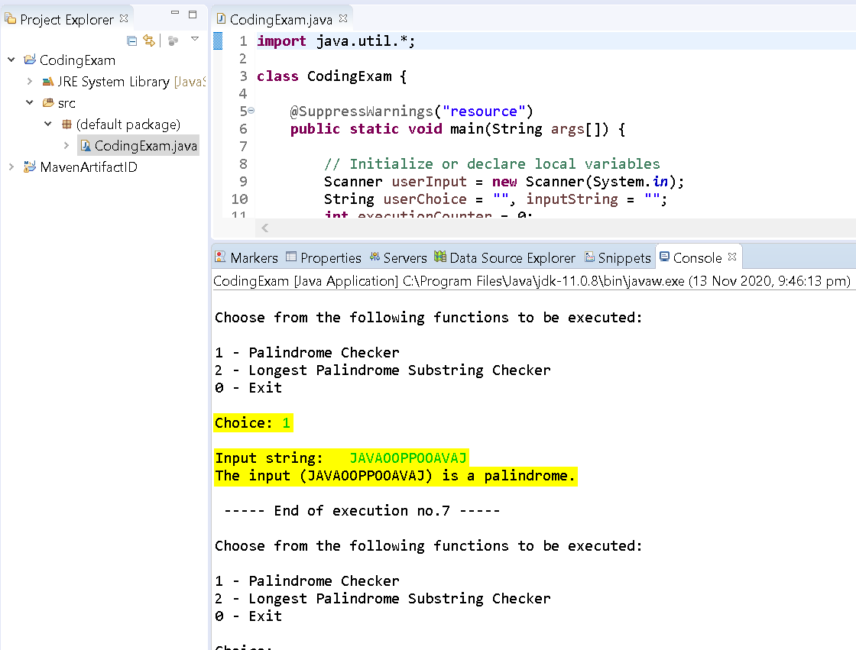

## Test Case # 8 – User inputs “1” as the function to be executed; The input contains a combination of alpha-numeric characters and special characters and it is a palindrome

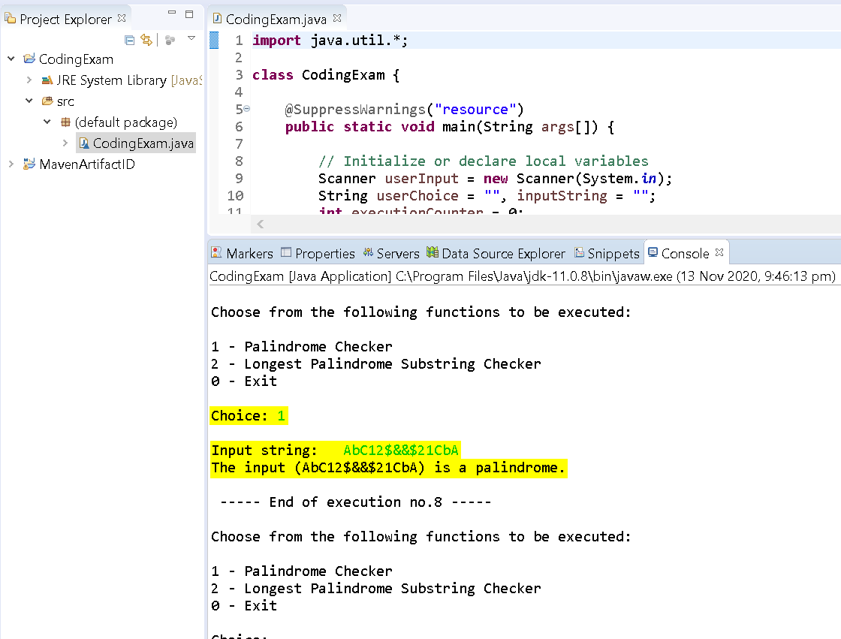

## Test Case # 9 – User inputs “1” as the function to be executed; The input contains a combination of alpha-numeric characters and has spaces and it is a palindrome

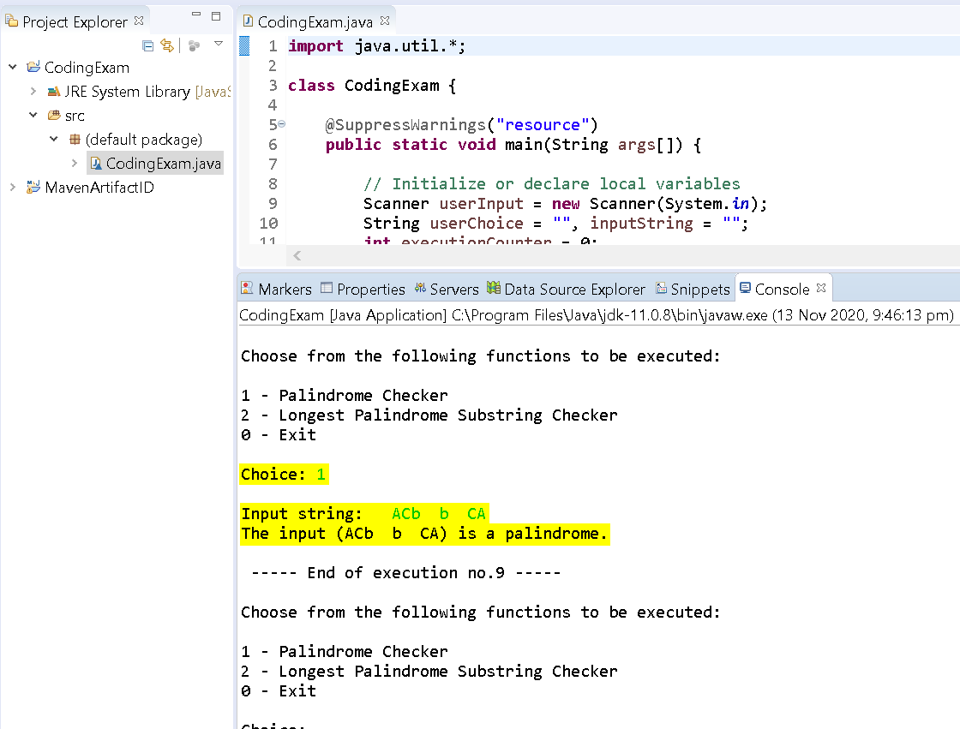

## Test Case # 10 – User inputs “2” as the function to be executed; The input does not contain any palindrome substring

Since there exist no palindrome substrings that has a length of more than one, it only retrieves the first character.

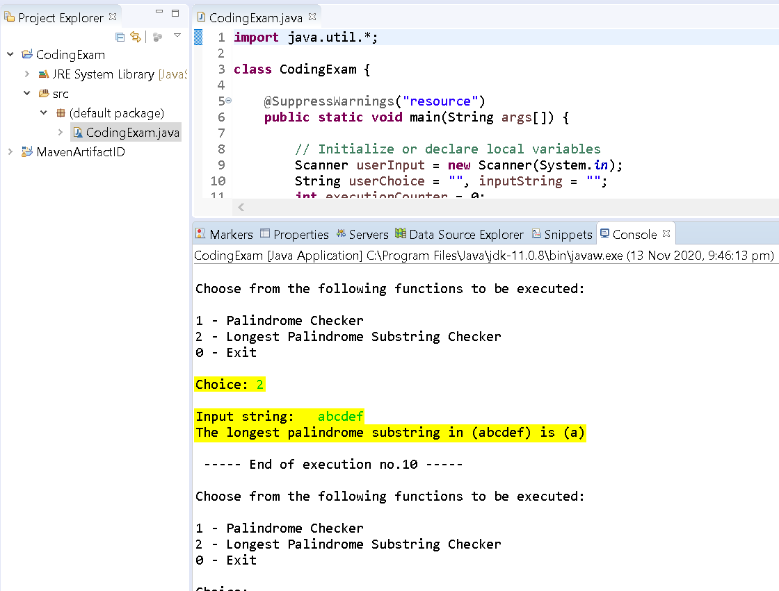

## Test Case # 11 – User inputs “2” as the function to be executed; The input does not contains a palindrome substring

