

WORKPLACE HEALTH, SAFETY & ENVIRONMENT
MANAGEMENT PLAN
WR1773121 MILC Millchester Substation Civil Works
251 Bluff Rd, Millchester QLD 4820 Australia

Company | Austen Landscaping & Earthmoving
ABN | 30 643 517 350
QBSA Licensee | John Austen 1208758 John Leggett 31323
Principal Contractor | Ergon Energy / Energy Queensland
Prepared By | John Austen
Date Prepared | 15/05/2026
Revision | 1.0

Austen Landscaping & Earthmoving is committed to delivering civil construction, earthworks and landscaping services safely, professionally and in compliance with applicable WHS, environmental and client requirements.

Contact: 0407 763 435 | kathieshome@westnet.com.au
This document is uncontrolled when printed. Current revision must be verified before use.

Document Control
Revision | Date | Description | Approved By
1.0 | 15/05/2026 | Initial issue | John Austen

Project Details
Company | Austen Landscaping & Earthmoving | Phone | 0407 763 435
ABN | 30 643 517 350 | Email | kathieshome@westnet.com.au
Industry | Civil Construction, Earthworks & Landscaping | QBSA Licensee | 1208758
Principal Contractor | Ergon Energy / Energy Queensland | Project | WR1773121 MILC Millchester Substation Civil Works
Project Address | 251 Bluff Rd, Millchester QLD 4820 Australia | Site Supervisor | John Austen
First Aid Officer | John Austen | Emergency | 000

Contents
1. Purpose
2. Emergency Assembly Site Plan
3. Workplace Health & Safety Policy
4. Company Profile
5. Safety Commitment
6. Life Saving Rules
7. Scope of Works
8. Responsibilities
9. Site Safety Rules
10. Personal Protective Equipment
11. Hazard & Risk Management
12. High Risk Construction Work
13. Mobile Plant & Earthwork Safety
14. Traffic Management
15. Excavation & Underground Services
16. Manual Handling
17. Silica Dust Controls
18. Environmental Controls
19. Fatigue, Heat & Fitness for Work
20. Emergency Procedures
21. First Aid
22. Incident Reporting
23. Training & Competency
24. Plant & Equipment Maintenance
25. Consultation & Communication
26. Monitoring, Auditing & Review
27. Project Specific SWMS Register
28. Approval
Appendices

1. Purpose
This Workplace Health, Safety & Environment Management Plan (WHS&E Plan) outlines the systems, processes and controls implemented by Austen Landscaping & Earthmoving to manage workplace health, safety, environmental and operational risks associated with the delivery of works for Energy Queensland / Ergon Energy.
The Plan establishes a consistent and systematic approach to risk management throughout all stages of project delivery. It defines the standards, responsibilities and procedures required to ensure work activities are performed safely, efficiently and in compliance with legislative, client and project requirements.
This Plan applies to all employees, subcontractors, visitors, suppliers and any other persons engaged by or working on behalf of Austen Landscaping & Earthmoving.
This Plan is supported by Safe Work Method Statements (SWMS), forms, checklists, inspections, registers and site records used to manage daily work activities and project risks.

2. Emergency Assembly Site Plan
The emergency assembly point must be identified during site induction and confirmed during the daily pre-start briefing. The emergency assembly point map shall be attached as Appendix C and displayed or made available onsite.
- All workers must know the emergency assembly point before commencing work.
- Emergency access routes must remain clear at all times.
- Workers must not re-enter the work area until authorised by the supervisor or emergency services.

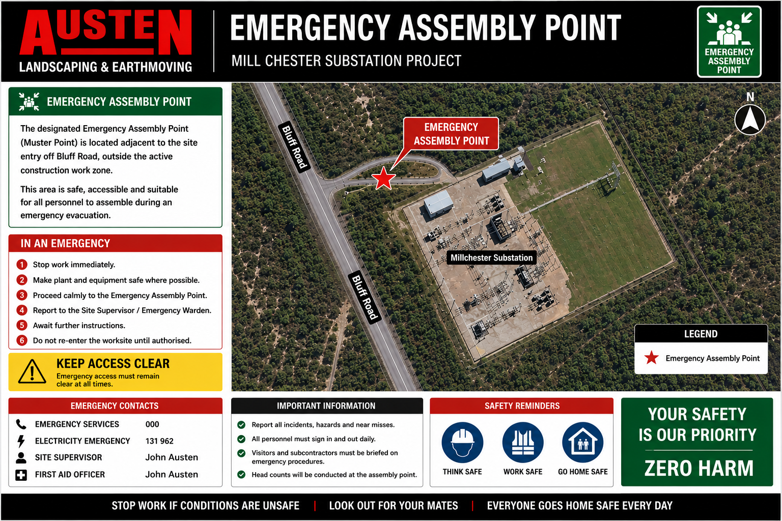

3. Workplace Health & Safety Policy
Austen Landscaping & Earthmoving is committed to providing a safe and healthy working environment for all employees, contractors, visitors, clients and stakeholders.

We are committed to:
- Working safely at all times
- Preventing injuries and environmental harm
- Following WHS laws, electrical safety requirements and site requirements
- Identifying hazards before work begins
- Consulting with workers on safety matters
- Providing training, supervision and PPE
- Maintaining plant and equipment in safe condition
- Continually improving safety performance

We believe:
- All incidents are preventable
- No job is so urgent that it cannot be done safely
- Safety is everyone's responsibility
- All workers have the authority to stop unsafe work

4. Company Profile
Austen Landscaping & Earthmoving delivers civil construction, excavation, earthmoving and landscaping services across Queensland. The business is committed to delivering projects safely, professionally and in compliance with WHS, environmental and client requirements.
- Civil construction works
- Earthmoving and excavation
- Drainage installation
- Concrete and retaining structures
- Trenching and service installation
- Landscaping and revegetation
- Mobile plant operations
- Road and infrastructure support works

5. Safety Commitment
- Safety comes before production
- Look out for yourself and your workmates
- Hazards can be managed through planning and controls
- Good housekeeping and planning prevent injuries
- Zero harm and zero environmental incidents are the goal
- Unsafe behaviour will not be tolerated

6. Life Saving Rules
1. Always wear required PPE
2. Never work under suspended loads
3. Maintain exclusion zones around plant
4. Never enter excavations without controls in place
5. Never work near live services without approval
6. Always isolate plant before maintenance
7. Never operate plant without authorisation
8. Stop work immediately if conditions are unsafe
9. No drugs or alcohol onsite
10. Always use seatbelts in vehicles and plant
Breaches of Life Saving Rules may result in removal from site.

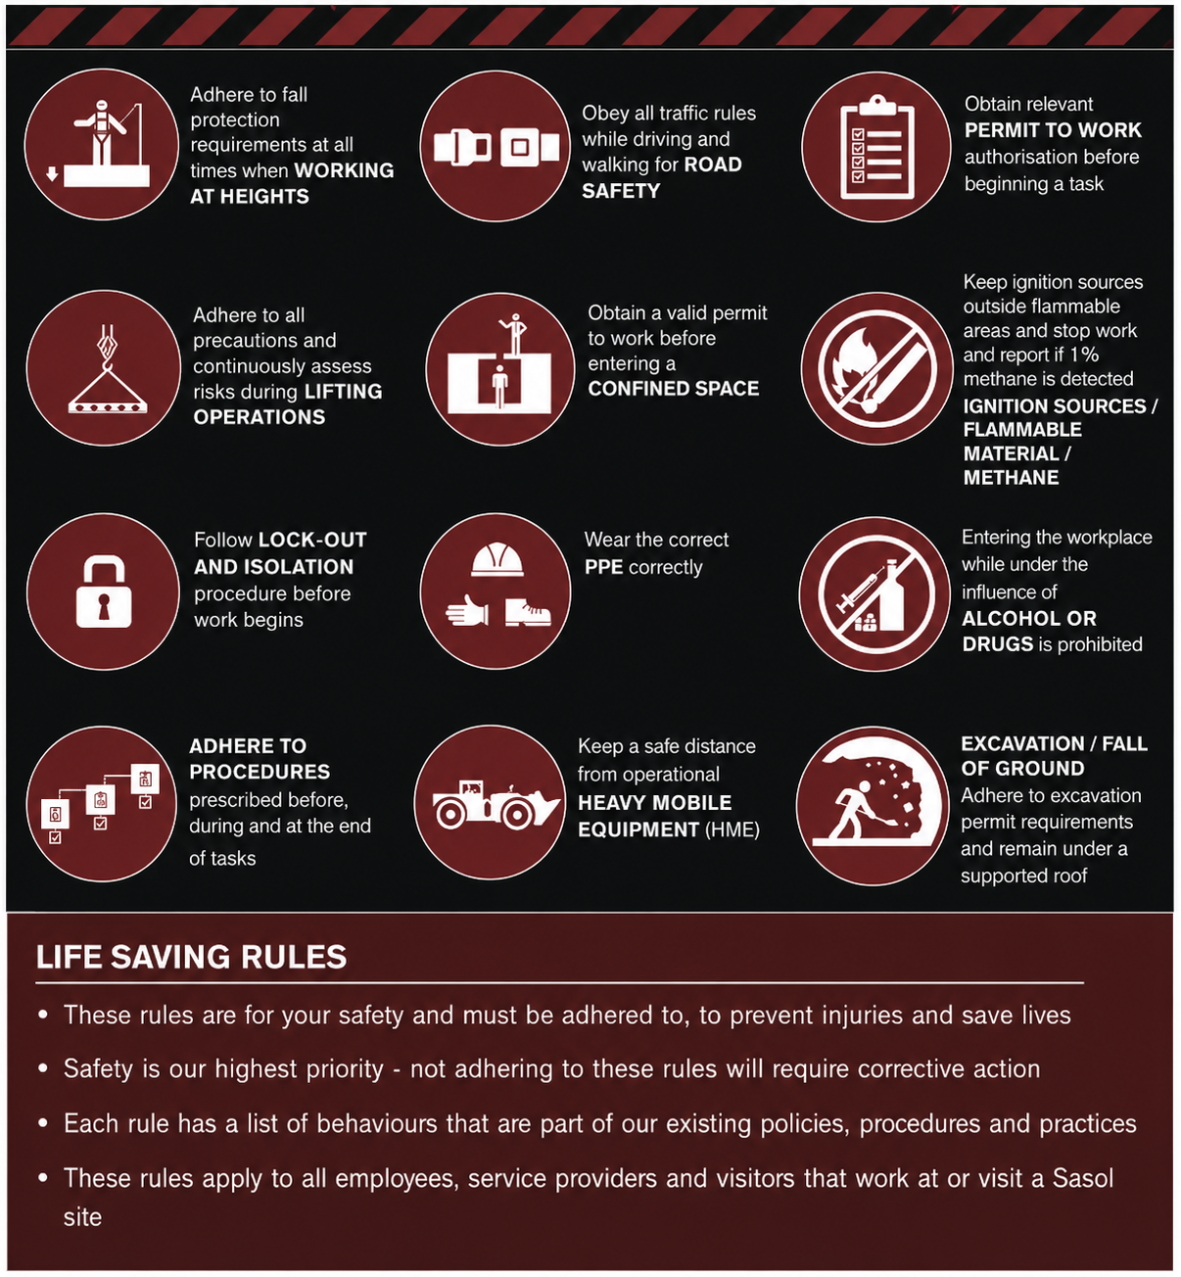

7. Scope of Works
Typical work activities may include:
- Earthmoving
- Excavation
- Landscaping works
- Site preparation
- Retaining wall construction
- Operation of powered mobile plant
- Material delivery and removal
- Concrete and paving works
- Work near live electrical services and substations
- Vacuum excavation and potholing

8. Responsibilities
Role | Responsibilities
Management | Provide safe systems of work, training, supervision, PPE, SWMS, incident investigation and maintained plant/equipment.
Supervisors | Monitor work areas, conduct pre-starts/toolbox talks, ensure SWMS are followed, stop unsafe work and report hazards/incidents.
Workers | Work safely, follow instructions and SWMS, wear PPE, report hazards/incidents, use equipment correctly and stop unsafe work.
Subcontractors | Comply with this Plan, site rules, SWMS, inductions, permits and supervisor directions.
Visitors | Sign in where required, follow site instructions, remain in authorised areas and wear required PPE.

9. Site Safety Rules
- Sign in and out where required
- Wear mandatory PPE
- Follow site speed limits
- Obey supervisor directions
- Maintain good housekeeping
- Never operate plant without authorisation
- Never work under the influence of drugs or alcohol
- Report hazards immediately
- Follow exclusion zone requirements
- Maintain positive communication around mobile plant

10. Personal Protective Equipment (PPE)
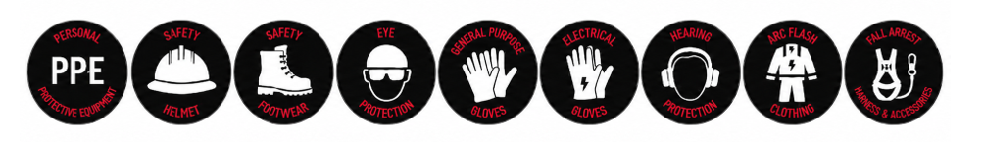
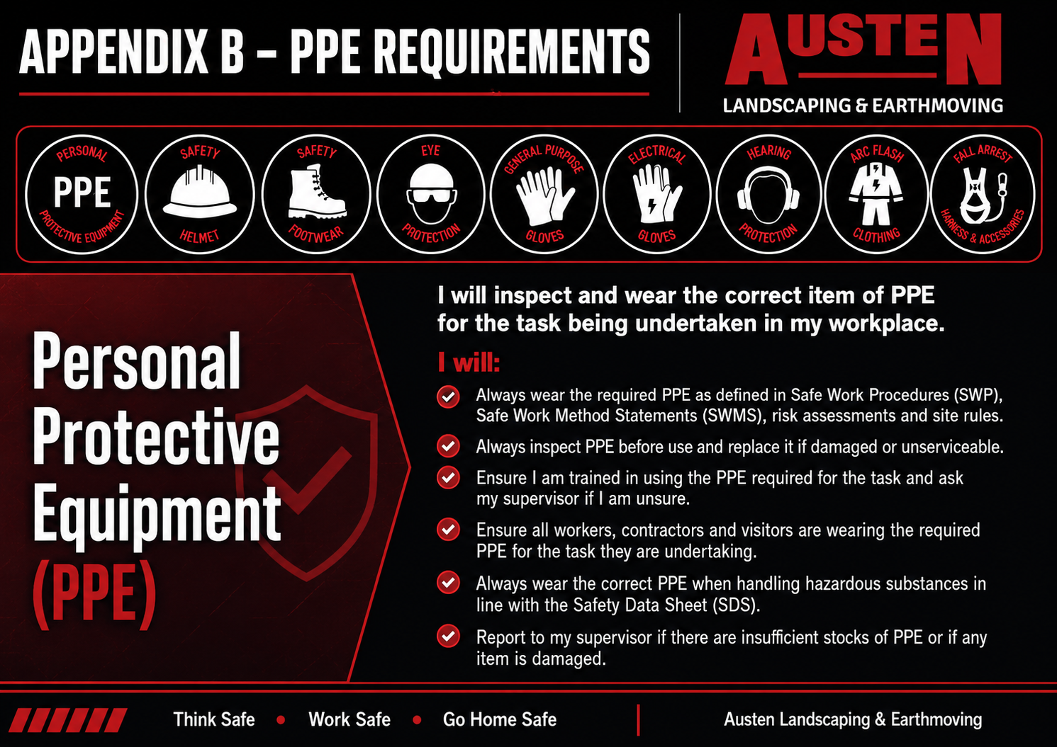
PPE | Requirement
Hard Hat | Mandatory where required
Hi-Visibility Clothing | Mandatory
Steel Cap Boots | Mandatory
Safety Glasses | As required by task
Hearing Protection | As required by noise risk
Gloves | Task specific
Respiratory Protection | Dust/silica generating works
Sunscreen / UV Protection | Outdoor works
Arc Flash / Electrical PPE | Where required by electrical risk assessment
All PPE must be suitable for the task, maintained in good condition and comply with relevant Australian Standards where applicable.

11. Hazard & Risk Management
Hazards are identified through site inspections, SWMS, Take 5 / JHA processes, toolbox talks, pre-start meetings, worker consultation and incident investigations.
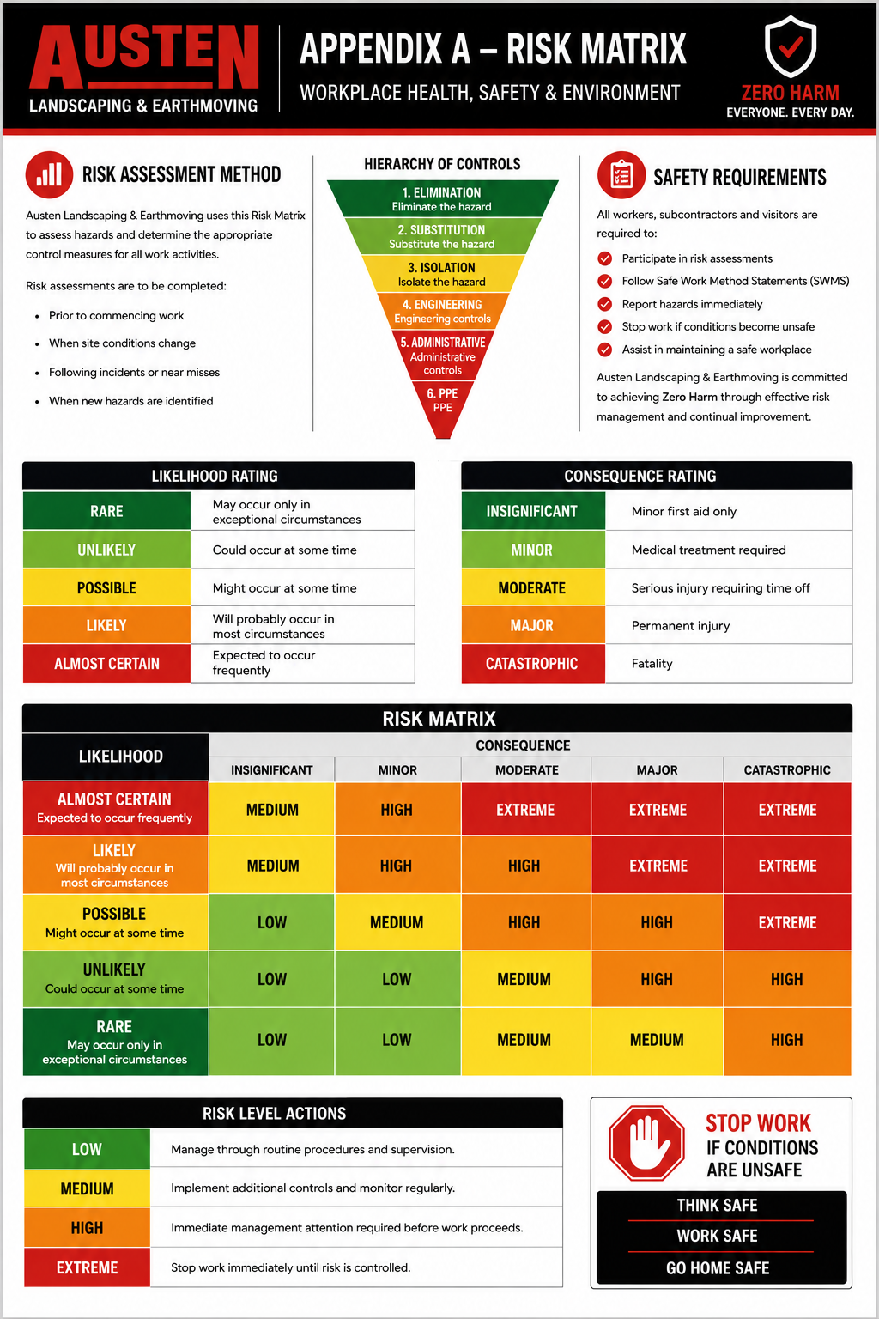

Typical hazards include:
- Mobile plant
- Excavations
- Underground services
- Live electrical services
- Dust and silica
- Manual handling
- Traffic movement
- Slips, trips and falls
- Heat stress and fatigue
- Environmental harm

Control measures may include:
- Elimination or substitution where practicable
- Exclusion zones
- Spotters and positive communication
- Barricades and signage
- PPE
- Training and supervision
- SWMS and permits
- Traffic management
- Environmental controls
All workers have authority to stop work if conditions become unsafe.

12. High Risk Construction Work
Safe Work Method Statements must be available, reviewed and followed for applicable high risk construction work.
- Excavation work
- Work near underground services
- Work near overhead or live electrical services
- Mobile plant operation
- Traffic management
- Use of powered tools
- Silica generating activities
- Work within live substations

13. Mobile Plant & Earthwork Safety
- Operators must hold relevant competencies/licences and complete pre-start inspections.
- Exclusion zones must be maintained around operating plant.
- Spotters must be used where visibility is restricted or workers/services are nearby.
- Reversing alarms, flashing beacons and positive communication are required.
- Ground conditions must be assessed before operation.
- Excavations greater than 1.5 metres must be benched, battered, shored or engineered.
- Underground services must be identified prior to excavation.

14. Traffic Management
- Signage, barricades, cones and spotters must be used as required.
- Traffic controllers or approved traffic management plans must be implemented where required.
- Pedestrian and vehicle movements must be separated where practicable.
- Delivery areas and vehicle routes must be controlled.
- Emergency access must be maintained.

15. Excavation & Underground Services
- Underground services must be identified before excavation.
- DBYD / Before You Dig information must be obtained where required.
- Services must be marked and potholing completed where required.
- Excavation collapse risks must be controlled.
- Workers must maintain safe distances from overhead and underground electrical services.
- Work near live substations must comply with applicable SWMS and Energy Queensland requirements.

16. Manual Handling
- Use mechanical lifting aids where possible.
- Avoid repetitive heavy lifting.
- Use team lifting for heavy or awkward items.
- Maintain correct lifting posture and avoid twisting.
- Plan lifting tasks before commencing.
- Store heavy or frequent-use items between waist and chest height where practicable.

17. Silica Dust Controls
- Wet cutting methods must be used where practicable.
- Dust suppression and/or extraction must be implemented.
- P2/P3 respirators must be worn where required.
- Airborne dust must be minimised and workers kept out of dust plumes.
- Dry sweeping and compressed air must not be used for silica dust clean-up.
- HEPA vacuum or wet clean-up methods must be used where required.

18. Environmental Controls
Austen Landscaping & Earthmoving is committed to minimising environmental impacts on all projects.
- Dust suppression
- Erosion and sediment control
- Spill management
- Waste segregation and recycling
- Noise control
- Protection of waterways and drains
- Safe fuel and chemical storage
- Weed hygiene and biosecurity controls
Environmental incidents must be reported immediately.

19. Fatigue, Heat & Fitness for Work
Workers must present fit for work at all times. Workers affected by fatigue, heat stress, drugs, alcohol, illness or medication must not operate plant or undertake high-risk work.
- Hydration and rest breaks
- Heat stress monitoring and heat index review
- Fatigue management
- Sun protection
- Drug and alcohol controls
- Suitable working hours and task rotation
- Buddy checks in hot or remote conditions

20. Emergency Procedures

Emergency Contacts
Service | Contact
Emergency Services | 000
Electricity Emergency | 131 962
Site Supervisor | John Austen
First Aid Officer | John Austen
Medical Centre | Charters Towers Medical Centre - 50 Gill St, Charters Towers City QLD 4820
Nearest Hospital | Charters Towers Hospital - 137-139 Gill Street, Charters Towers QLD 4820

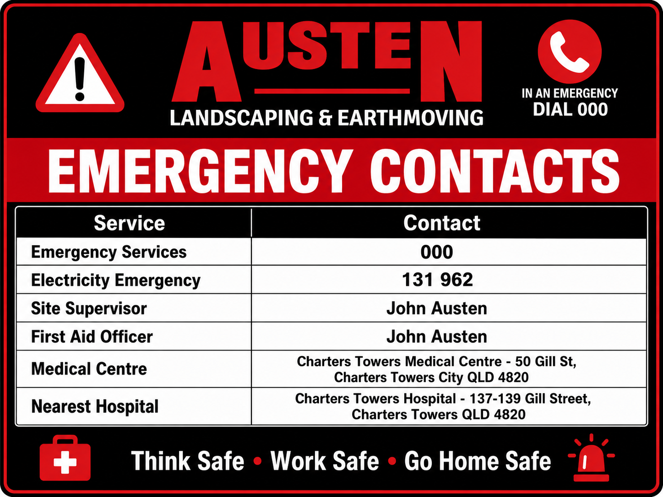

Emergency Response
- Stop work immediately.
- Raise the alarm.
- Make the area safe if safe to do so.
- Contact emergency services if required.
- Notify John Austen / Site Supervisor.
- Evacuate to the nominated assembly point.
- Do not re-enter the work area until authorised.
- Report all incidents, injuries and near misses immediately.

21. First Aid
- Adequate first aid kits shall be available onsite.
- Trained first aid personnel shall be identified.
- All injuries must be reported immediately.
- Incident and first aid records shall be maintained.

22. Incident Reporting
All incidents, injuries, hazards, near misses, property damage and environmental incidents must be reported immediately to management and the principal contractor as required.
Austen Landscaping & Earthmoving must report notifiable incidents to the relevant authority where required by legislation, including WHSQ / Electrical Safety Office / QBCC as applicable.

Notifiable incidents include:
- Death of a person
- Serious injury or illness
- Dangerous incident
- Serious electrical incident
- Dangerous electrical event
Incident investigations shall identify causes, determine corrective actions, prevent recurrence and be documented appropriately.

23. Training & Competency
- General Construction Induction Card (White Card)
- Plant operator competencies and licences
- Verification of Competency (VOC) where applicable
- Traffic control tickets where applicable
- First aid training where required
- Energy Queensland / site-specific inductions
- SWMS, toolbox and pre-start training
Records of training and competencies shall be maintained.

24. Plant & Equipment Maintenance
- Plant and equipment must be fit for purpose.
- Pre-start inspections must be completed before use.
- Maintenance must be completed as per manufacturer recommendations.
- Defects must be reported immediately.
- Unsafe plant or equipment must be removed from service until repaired.

25. Consultation & Communication
- Toolbox talks
- Daily pre-start briefings
- Site meetings
- Safety alerts
- Worker feedback
- SWMS reviews
- Incident and hazard consultation
Workers are encouraged to raise safety concerns at any time.

26. Monitoring, Auditing & Review
This WHS&E Management Plan will be reviewed annually, following incidents or near misses, when work activities change, when new hazards are identified and following legislative or client requirement updates.
Regular inspections, audits, toolbox talks and pre-start briefings will be conducted to monitor compliance and improve safety performance.

27. Project Specific SWMS Register
SWMS No. | SWMS Title | Revision | Prepared By
MLCH-01 | Manual Handling & Housekeeping | Rev A | John Austen
MLCH-02 | Working Near Underground Services | Rev A | John Austen
MLCH-03 | Working On or Near Exposed Live Parts | Rev A | John Austen
MLCH-04 | Moving Powered Plant at the Workplace | Rev A | John Austen
MLCH-05 | Excavations in a Live Substation | Rev A | John Austen
MLCH-06 | Vacuum Excavation | Rev A | John Austen
MLCH-07 | Traffic Management / Working Near Roads | Rev A | John Austen
MLCH-08 | Silica & Dust Exposure | Rev A | John Austen
MLCH-09 | Use of Power Tools | Rev A | John Austen
MLCH-10 | Delivery, Loading & Unloading Operations | Rev A | John Austen
MLCH-11 | Environmental Controls & Spill Response | Rev A | John Austen
MLCH-12 | Heat Stress, Remote Conditions & Fitness for Work | Rev A | John Austen

28. Approval
Approved By | Position | Signature | Date
John Austen | Director / Site Supervisor |  | 15/05/2026
Appendices
Appendix | Document / Record
Appendix A | Risk Matrix
Appendix B | PPE Requirements
Appendix C | Emergency Assembly Point Plan
Appendix D | Daily Pre-Start - SMEAC Briefing Form
Appendix E | Toolbox Talk / Safety Meeting Record
Appendix F | Incident / Injury / Near Miss Report Form
Appendix G | Worker Sign Off Register
Appendix H | Machine / Plant Pre-Start Checklist
Appendix I | SWMS Register
Appendix J | Project SWMS Pack MLCH-01 to MLCH-12

