This SWMS must be reviewed with all workers before work commences. Work must stop immediately if controls cannot be maintained or conditions change.
Activity / Task | Manual Handling and Housekeeping | Location | MILC - Millchester Substation / Project Specific
Scope | Applies to all Austen workers undertaking manual handling, material movement, clean-up and housekeeping tasks. | SWMS No. | MLCH-01
Training & Experience | Experienced, trained, competent and site inducted workers. | Prepared By | John Austen
Site Risk Assessment By | Site Supervisor: John Austen | Creation / Review Date | 15/05/2026
Revision | A | Principal Contractor | Energy Queensland / Ergon Energy (Project Specific)

PURPOSE
This SWMS sets out the hazards, risks and controls for manual handling and housekeeping activities undertaken by Austen Landscaping & Earthmoving. It is designed to be practical, easy to follow and suitable for civil, earthworks, utility and substation work environments.

CRITICAL RISKS AND MANDATORY CONTROLS
Critical Risk | Possible Outcome | Mandatory Controls
Heavy or awkward lifting | Back, shoulder, knee or hand injuries | Plan the lift; use mechanical aids where possible; team lift heavy or awkward items; keep loads close to the body.
Repetitive manual tasks | Muscle strain and overuse injuries | Rotate tasks; take breaks; avoid repeated twisting, shovelling or lifting above shoulder height.
Poor housekeeping | Slips, trips, falls, cuts and falling into excavations | Keep access ways clear; remove rubbish; maintain barricades; store materials securely.
Climbing in/out of plant or trucks | Falls, sprains or strains | Use three points of contact; check steps and handholds; do not jump from plant.
Unsecured materials | Falling objects, trip hazards or weather damage | Tie down, brace and secure loose materials; store tools and equipment correctly.
Changing site conditions | Unexpected hazards or unsafe work | Stop work; reassess; report hazards; update SWMS or controls before recommencing.

HAZARD IDENTIFICATION
Hazard Group | Hazards Identified
Gravity | People falling; lifting; carrying
Muscular | Twisting or reaching; lifting or pushing; awkward postures
Electrical | Electrocution risk where work is conducted in or near substations or live assets
Radiation | UV exposure from outdoor work
Temperature | Heat illness and dehydration
Mechanical | Pinch points, cuts, abrasions and contact with tools or materials
Environmental | Rubbish, loose materials, dust, mud, wet surfaces and poor access
Work Area | Slips, trips, falls, falling into excavations and blocked access ways
ACTIVITIES INVOLVING HIGH RISK WORK
Manual handling and housekeeping are generally routine tasks; however, they may occur in high risk areas such as live substations, near powered mobile plant, near electrical installations/services or near excavations. If these conditions apply, the relevant task-specific SWMS must also be reviewed and followed.
PPE REQUIREMENTS
PPE Item | Requirement
Medium impact eye protection | Required as applicable to the task and site conditions.
Safety helmet | Required as applicable to the task and site conditions.
Safety footwear | Required as applicable to the task and site conditions.
Task specific gloves, durable nitrile or rigger gloves | Required as applicable to the task and site conditions.
Hi-vis long sleeve cotton clothing | Required as applicable to the task and site conditions.
UV protection and 30+ sunscreen | Required as applicable to the task and site conditions.
Hearing protection as per task risk assessment | Required as applicable to the task and site conditions.
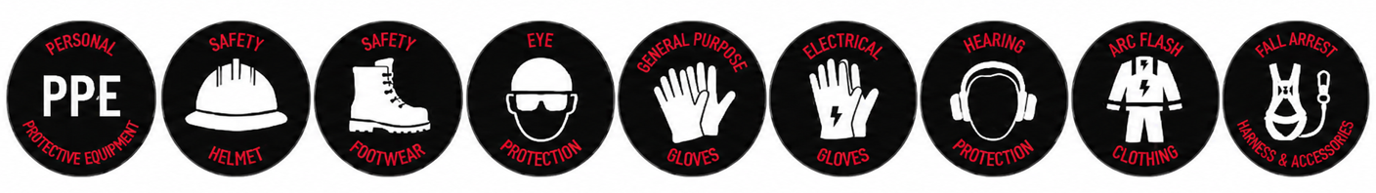

RISK RATING GUIDE
Extreme | Do not proceed. Alternative method required.
High | Senior management / supervisor approval required before work proceeds.
Medium | Management responsibility must be specified and controls monitored.
Low | Work may proceed with normal supervision and routine controls.
Stop Work | All workers have authority to stop work if controls cannot be maintained.

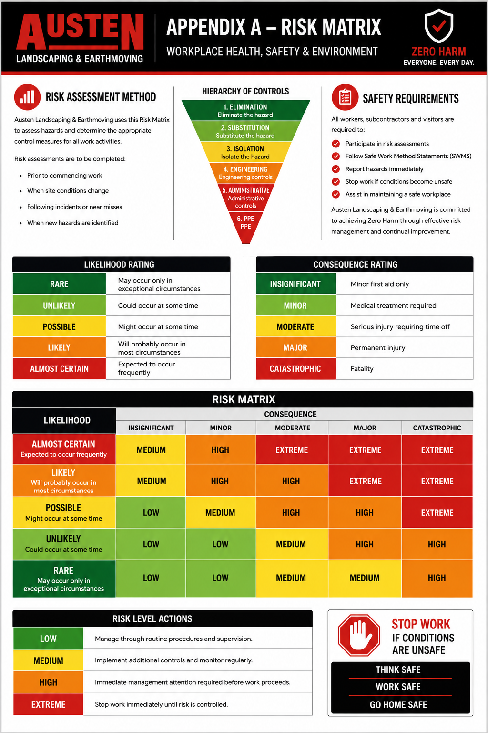
SEQUENCE OF WORK AND CONTROL MEASURES
Sequence of Work | Hazards / Risk | Initial Risk | Work Methods & Control Measures | Residual Risk | Responsible Person
Planning, preparation and verification of competency | Legislation breach; workers not inducted or trained | Medium | - All workers must hold a current construction induction card and complete the site induction.  - Workers must read, understand and sign onto this SWMS before starting work.  - Supervisor to confirm relevant training, competency and site requirements.  - Workers must wear site PPE and task specific PPE as required.  - Relevant SWMS must be reviewed where manual handling occurs around plant, excavations or live electrical assets. | Low | Supervisor
Pre-start and consultation | Untrained workers; poor communication; unclear work method | Medium | - Attend Austen daily pre-start meeting before commencing work.  - Discuss manual handling tasks, loads, access ways, plant movement and housekeeping expectations.  - Identify additional hazards and implement controls before work starts.  - Supervisor to monitor workers and inspect work areas during the task.  - Workers must report hazards and stop work if unsafe conditions arise. | Low | Supervisor / All Workers
Assess the manual handling task | Muscle strain; incorrect lifting method; lack of mechanical assistance | Medium | - Assess the load before lifting - weight, size, shape, stability, distance and access route.  - Check work area layout, posture, frequency, duration and environmental conditions.  - Store heavy or frequently used items between waist and chest height where practicable.  - Use mechanical assistance such as trolley, forklift, crane or plant where possible.  - Use team lifting for heavy, long or awkward items. | Low | All Workers
Lifting and carrying | Back strain; shoulder, knee or hand injury; dropped loads | Medium | 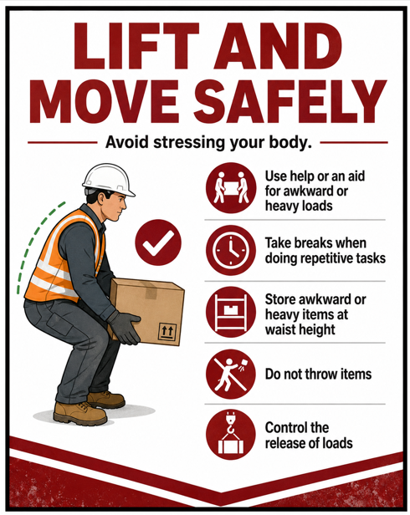  - Plan the lift and route before lifting.  - Keep feet stable, bend knees and hips, keep back and neck straight.  - Hold the load close to the body and avoid twisting while lifting or carrying.  - Do not lift above shoulder height unless unavoidable and controlled.  - Use smooth movements and avoid sudden jerking or overreaching. | Low | All Workers
Repetitive tasks and awkward postures | Overuse injuries; muscle fatigue; strain from shovelling or twisting | Medium | - Rotate workers through repetitive tasks where practicable.  - Take regular rest breaks and stretch before or during extended manual tasks.  - Avoid prolonged awkward postures where possible.  - Use long handled tools where suitable to reduce bending.  - Report discomfort early so the task can be reviewed. | Low | All Workers
Climbing in and out of trucks or plant | Slips, trips, falls, strains and sprains | Medium | - Use three points of contact when accessing or exiting plant and trucks.  - Check steps, footholds and grab rails are secure and free from mud, grease or water.  - Do not jump from plant, trays or equipment.  - Avoid twisting while climbing or reaching for the seat.  - Report damaged steps, handrails or access points. | Low | All Workers
Housekeeping during works | Slips, trips, falls; cuts; blocked access; falling into excavations | Medium | - Keep work areas, walkways and access routes clear.  - Remove rubbish, offcuts and unused materials progressively.  - Maintain barricades, signs and exclusion zones where required.  - Do not leave tools, hoses, leads or materials across walkways.  - Place waste in correct bins or designated disposal areas. | Low | Supervisor / All Workers
Completion and clean up | Poor housekeeping; unsecured materials; environmental harm; incomplete permits | Medium | - Correctly pack and store tools and equipment.  - Secure loose materials against wind, weather or unauthorised movement.  - Switch off generators and isolate power where applicable.  - Ensure tie-downs, braces, barriers and covers are secure.  - Complete, close out and return permits where required. | Low | Supervisor / All Workers
Task observation and monitoring | Unidentified hazards; changed conditions; work outside SWMS scope | Medium | - Supervisor to monitor work activities and inspect work areas regularly.  - All workers to monitor for additional hazards.  - If a hazard is identified, stop work, make safe and notify supervisor.  - Review and update controls if work conditions change.  - Do not recommence work until hazards are controlled. | Low | Supervisor / All Workers
ENVIRONMENTAL AND SITE CONTROLS
- Maintain access to spill kits where plant, fuel, oil or chemicals are present.
- Maintain erosion and sediment controls where required by the project.
- Use dust suppression where dust is generated during clean up or material movement.
- Dispose of waste in the correct bins or approved disposal area.
- Maintain weed hygiene controls where required by the site or client.
- Report environmental incidents immediately.
PROJECT INFORMATION AND REQUIREMENTS
Principal Contractor | Energy Queensland / Ergon Energy (Project Specific)
Workers | 2+ or as required by the task
Competency | General Safety Induction Card (White/Blue Card), site induction and task instruction
Training | Austen Site Specific Induction, toolbox talks, daily pre-starts and Energy Queensland / site inductions as required
Supervision & Monitoring | John Austen / project supervisor to monitor work, inspect work areas and review controls
Plant & Equipment | Trolleys, forklifts, cranes, trucks, excavators, bobcats, hand tools and other mechanical aids as applicable
Chemicals | Diesel, petrol, oil or other substances only where associated with plant or site works
PPE | Refer to PPE section and site requirements
SWMS Review | Reviewed by John Austen during works and updated when conditions change
Environmental Considerations | Spill kits, erosion controls, dust suppression, waste control and weed hygiene as required
Legislation & Codes of Practice | WHS Act 2011; WHS Regulation 2011; Hazardous Manual Tasks Code of Practice 2021; How to Manage WHS Risks 2021; Managing Noise and Preventing Hearing Loss at Work 2021; WHS Consultation, Cooperation and Coordination 2021; Environmental Protection Act 1994; Biosecurity Act 2014
EMERGENCY AND INCIDENT RESPONSE
- Stop work immediately.
- Make the area safe if it is safe to do so.
- Notify John Austen / Site Supervisor.
- Provide first aid or contact emergency services if required.
- Report all incidents, hazards, injuries and near misses immediately.
- Do not restart work until the hazard is controlled and the SWMS has been reviewed if required.
WORKER SIGN ON
We, the undersigned, confirm this Safe Work Method Statement has been explained, its contents are clearly understood and we will comply with the stated requirements. We also confirm that we have the required qualifications to undertake these activities.
Name | Signature | Date
SUPERVISOR DECLARATION
I confirm I have trained all above workers in this SWMS and I hereby confirm that the documented precautions, controls and work methods will be complied with.
Name | Position | Date | Signature
John Austen | Site Supervisor
THINK SAFE - WORK SAFE - GO HOME SAFE

