This SWMS must be reviewed with all workers before work commences. Work must stop immediately if controls cannot be maintained or conditions change.
Activity / Task | Working Near Underground Services | Location |  | MILC - Millchester Substation / Project Specific
Scope | Applies to all Austen workers undertaking service locating, potholing, excavation, plant operation or work near underground services. | SWMS No. |  | MLCH-02
Training & Experience | Experienced, trained, competent and site inducted workers. ESO required where working near live electrical services. | Prepared By |  | John Austen
Site Risk Assessment By | Site Supervisor: John Austen | Creation / Review Date |  | 15/05/2026
Revision | A | Principal Contractor |  | Energy Queensland / Ergon Energy (Project Specific)
PURPOSE
This SWMS sets out the hazards, risks and controls for identifying, locating, exposing, protecting and working near underground services. It is designed for civil, earthworks, utility and substation work environments where underground electrical, communications, gas, water, sewer, stormwater, earthing grids or other assets may be present.
CRITICAL RISKS AND MANDATORY CONTROLS
Critical Risk | Possible Outcome | Mandatory Controls
Underground service strike | Electric shock, explosion, fire, service outage or serious injury | DBYD / service plans; site inspection; locating; potholing; no mechanical excavation until services are positively identified.
Live underground electrical services | Electrocution, arc flash, burns or fatality | ESO where required; exclusion zones; insulated gloves and non-conductive tools; maintain required approach distances.
Unidentified or inaccurate service information | Unexpected contact with services | Treat all services as live; verify with drawings, locating, potholing and consultation with asset owner / principal contractor.
Mechanical excavation near services | Service damage, electrocution or asset failure | Spotter, positive communication, clearance distances, controlled excavation method and stop work if marker tape, conduits or cables are found.
Exposed service damage | Electric shock, outage, contamination or public risk | Support and protect exposed services; prevent undermining; no excavation below exposed services unless approved controls are in place.
Gas or pressurised services | Explosion, fire, release of pressure or injury | Confirm location, expose by hand/vacuum where required, do not mechanically excavate under exposed services, notify relevant utility if damaged.
Earthing grid damage | Step/touch potential, electric shock or substation fault risk | Identify and mark grid where known; expose carefully; do not cut; report damage immediately; repairs by competent electrical personnel.
Plant and worker interaction | Crush injury or struck-by injury | Exclusion zones, spotters, positive communication, pre-start inspections and separation of workers from plant.
HAZARD IDENTIFICATION
Hazard Group | Hazards Identified
Gravity | People falling, objects falling, falling into excavations, lifting and carrying.
Muscular | Twisting, reaching, lifting, pushing, shovelling and awkward postures.
Electrical | Live LV/HV services, electrocution, arc flash, induced voltage, step and touch potential.
Mechanical | Caught between plant, struck by plant, pinch points, contact with tools and materials.
Kinetic | Projectiles, broken services, pressurised releases and uncontrolled material movement.
Environmental | Spills to ground, contaminated soil, sediment runoff, dust, flora/fauna impact and waste.
Work Area | Poor access, blocked egress, open trenches, public interface and unauthorised access.
HIGH RISK WORK INTERFACE
Working near underground services may involve high risk construction work, including excavation, powered mobile plant, work near electrical installations/services, work within substations, traffic interfaces and potential exposure to hazardous substances or contaminated ground. Where these conditions apply, the relevant task-specific SWMS must also be reviewed and followed.
PPE REQUIREMENTS
PPE Item | Requirement
Medium impact eye protection | Required for locating, excavation, potholing, cutting, digging and work near plant.
Safety helmet | Required onsite and when working near plant, excavations or overhead hazards.
Safety footwear | Required at all times onsite.
Hi-vis long sleeve cotton clothing | Required for visibility and UV protection.
Task specific gloves | Durable gloves for general works; 1000V insulated gloves where required near live electrical services.
Hearing protection | Required where plant, vacuum excavation or power tool noise is present.
Respiratory protection | Required where dust, silica, fumes or contaminated ground risk is present.
UV protection and 30+ sunscreen | Required for outdoor works.
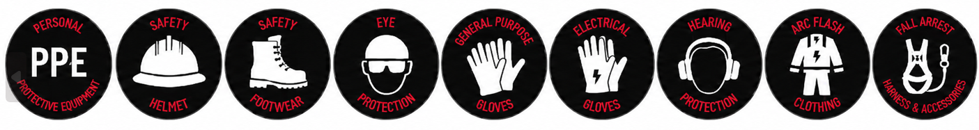

RISK RATING GUIDE
Risk Rating | Required Action
Extreme | Do not proceed. Alternative method required.
High | Senior management / supervisor approval required before work proceeds.
Medium | Management responsibility must be specified and controls monitored.
Low | Work may proceed with normal supervision and routine controls.
Stop Work | All workers have authority to stop work if controls cannot be maintained.

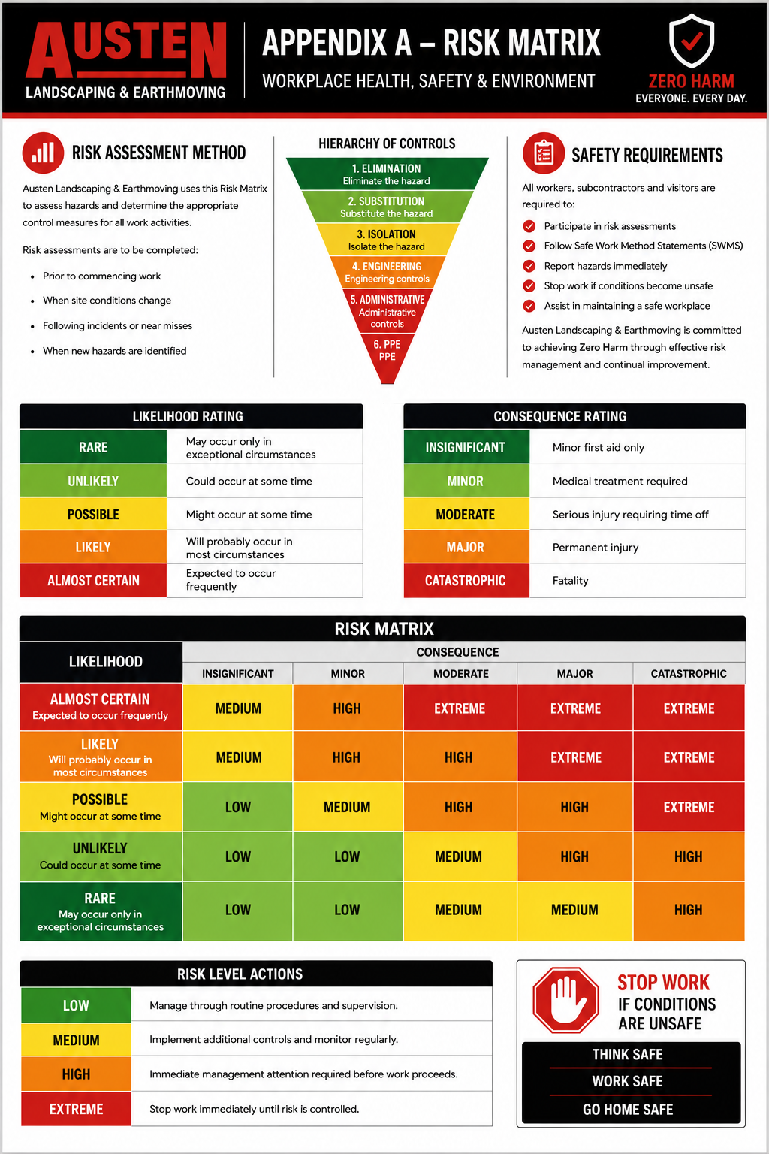
SEQUENCE OF WORK AND CONTROL MEASURES
Sequence of Work | Hazards / Risk | Initial Risk | Work Methods & Control Measures | Residual Risk | Responsible Person
Planning, preparation and competency | Legislation breach; untrained workers; incorrect method | High | • All workers must hold current construction induction and complete the site induction.  • Supervisor to confirm worker competency, plant VOCs, permits and site requirements.  • Review all relevant SWMS including excavation, powered plant and working near live electrical assets.  • Confirm whether an Electrical Safety Observer (ESO) is required.  • Confirm emergency procedures, communication methods, first aid and rescue arrangements before work starts. | Low | Supervisor
Pre-start and consultation | Poor communication; changed conditions; unclear work method | Medium | • Attend Austen daily pre-start meeting before commencing work.  • Discuss known services, permit conditions, exclusion zones, plant movements and emergency response.  • Confirm who is supervising, spotting and operating plant.  • Identify additional hazards and implement controls before work starts.  • Stop work if the job changes or controls cannot be maintained. | Low | Supervisor / All Workers
Review underground service information | Inaccurate or incomplete service information | High | • Obtain and review DBYD / Before You Dig information and principal contractor service drawings.  • Review available as-built drawings, site plans, cable schedules and service records.  • Consult with the principal contractor, client or asset owner where service location is uncertain.  • Treat all services as live until positively identified and confirmed otherwise.  • Do not rely on plans alone; verify service locations onsite. | Low | Supervisor
Site walkover and mark-up | Unidentified pits, conduits, trenches, marker tape or service routes | High | • Walk the work area before excavation or ground disturbance.  • Inspect pits, cable trenches, foundations, marker posts, valves, conduits and surface signs of underground services.  • Mark known and suspected service locations using paint, pegs, flags or other approved marking methods.  • Take photos or measurements where required so marks can be reinstated if lost.  • Maintain service markings for the duration of the work. | Low | Supervisor / All Workers
Service locating | Failure to locate underground assets | High | • Cable locating equipment shall be used by a competent person where required.  • Scan the proposed work area and mark detected services.  • Identify limitations of locating equipment and do not assume absence of a signal means absence of a service.  • Where services are suspected or records are uncertain, potholing or vacuum excavation must be used to confirm the service. | Low | Competent Locator / Supervisor
Potholing and positive identification | Electric shock; service strike; conduit damage | High | • Services within the work area must be positively located before mechanical excavation proceeds.  • Services within 1000mm of the excavation edge must be potholed to confirm exact location and depth.  • Potholing to be completed by hand or vacuum excavation as required.  • Use insulated gloves and non-conductive tools where live electrical services are identified or suspected.  • Do not use crowbars, picks or jackhammers near suspected live services unless specifically controlled and approved. | Low | Supervisor / ESO / All Workers
Hand excavation near services | Contact with live cables; hand injury; manual handling strain | High | • All hand excavation within 1000mm of known or suspected live electrical services must be supervised by an ESO where required.  • Use fibreglass or non-conductive shovels and insulated tools where live electrical services may be present.  • Wear 1000V insulated gloves where required and inspect gloves before use.  • Shovels must not be taken above shoulder height near exposed live parts.  • Rotate workers and take breaks to manage manual handling and fatigue. | Low | Supervisor / ESO / All Workers
Vacuum excavation near services | Service damage; high pressure water injury; contaminated material | High | • Vacuum excavation to be undertaken by competent operators.  • ESO required where live underground electrical services are identified or suspected and required by site controls.  • Pressure settings must comply with equipment and site requirements.  • Water jet must be directed towards the ground and trigger must not be bypassed.  • Contaminated soils, asbestos, PCB or acid sulphate soil risks must be assessed before vacuum excavation is used. | Low | Supervisor / ESO / Operator
Mechanical excavation near services | Underground service strike; electrocution; plant contact | High | • No mechanical excavation shall commence until services have been positively located.  • A spotter shall be used where plant operates near services, structures, workers or exclusion zones.  • Stop immediately if marker tape, bedding sand, conduits, unknown cables or unexpected ground conditions are encountered.  • Mechanical excavation must not occur below exposed services unless approved controls are in place.  • Maintain positive communication between operator, spotter and supervisor at all times. | Low | Supervisor / Operator / Spotter
Minimum approach controls for electrical services | Electric shock; arc flash; damage to HV/LV cables | High | • No mechanical excavation within 1000mm of a live direct buried cable unless under ESO supervision and approved controls.  • For direct buried HV cables: no mechanical excavation within 500mm either side or 500mm above the cable unless mechanical protection is confirmed.  • For cables in conduit: no mechanical excavation within 300mm either side or 300mm above the conduit.  • At no stage is mechanical excavation permitted below a direct buried cable or exposed conduit containing cables.  • Manual or vacuum excavation must be used inside restricted distances. | Low | Supervisor / ESO / Operator / Spotter
Working around non-electrical services | Gas leak, water main damage, sewer exposure, comms outage | High | • Positively locate gas, water, sewer, stormwater, communications and fibre services before excavation.  • Do not mechanically excavate under exposed gas, water, sewer, communication or fibre services.  • Obtain utility owner approval where required before working near or exposing critical services.  • Protect exposed services from impact, unsupported loading, vibration and movement.  • Notify the principal contractor and utility owner immediately if damage occurs. | Low | Supervisor / All Workers
Earthing grid and substation infrastructure | Step/touch potential; broken earth grid; electrical hazard | High | • Where the earthing grid location is known, mark it out before excavation.  • Expose earthing conductors carefully before mechanical excavation continues.  • Do not cut or damage existing earthing grid conductors.  • If an earthing conductor is damaged or hooked by plant, stop work and notify the supervisor immediately.  • Repairs must be completed by licensed and competent electrical personnel as directed by the principal contractor. | Low | Supervisor / ESO / Operator
Protecting exposed services | Service collapse, mechanical damage, unauthorised access | Medium | • Support and protect exposed services from damage, bending, sagging or undermining.  • Install barricades, covers, signage or exclusion zones around exposed services.  • Do not place spoil, plant, tools or materials on exposed services.  • Prevent public or unauthorised access.  • Maintain service protection until backfill or reinstatement is complete. | Low | Supervisor / All Workers
Unexpected service or service damage | Electric shock, explosion, outage, flooding or environmental harm | High | • Stop work immediately if an unidentified service is found or a service is contacted.  • Move workers and plant away from the area where safe to do so.  • Do not touch exposed or damaged electrical services.  • Notify John Austen / Site Supervisor and principal contractor immediately.  • Contact emergency services or utility emergency contacts where required.  • Preserve the scene and do not recommence until authorised and controls are reviewed. | Low | Supervisor / All Workers
Backfill and reinstatement | Damage to exposed services; poor compaction; future service risk | Medium | • Backfill only after exposed services have been inspected and protection requirements confirmed.  • Use approved bedding, warning tape, marker tape or covers where required.  • Do not compact directly over exposed or unsupported services unless approved.  • Reinstate markings, barriers and surface controls as required.  • Ensure all permits and inspections are closed out. | Low | Supervisor / All Workers
Task observation and monitoring | Changed conditions; work outside SWMS scope; uncontrolled hazards | Medium | • Supervisor to monitor work activities and controls regularly.  • All workers to monitor for additional hazards.  • Review SWMS if conditions change or additional services are identified.  • Stop work if controls cannot be maintained.  • Do not recommence until hazards are controlled and workers have been briefed. | Low | Supervisor / All Workers
Completion and clean up | Poor housekeeping; remaining hazards; unsecured excavation | Medium | • Remove tools, rubbish, materials and trip hazards from the work area.  • Maintain barricades and signage until the area is safe for access.  • Secure loose materials from wind or weather.  • Return permits, service plans and inspection records where required.  • Conduct final inspection before leaving site. | Low | Supervisor / All Workers

ENVIRONMENTAL AND SITE CONTROLS
- Spill kits must be available where plant, fuel, oil or chemicals are present.
- Dust suppression must be used where locating, excavation or plant movement generates dust.
- Erosion and sediment controls must be maintained where ground disturbance occurs.
- Waste and spoil must be managed in accordance with site environmental requirements.
- Contaminated soils, asbestos, PCB or acid sulphate soils must be reported and managed under specific controls.
- Weed hygiene controls must be maintained where required by the site or client.
- Environmental incidents must be reported immediately.
PROJECT INFORMATION AND REQUIREMENTS
Principal Contractor | Energy Queensland / Ergon Energy (Project Specific)
Workers | 2+ or as required by task
Competency | General Safety Induction Card, site induction, task instruction, operator competency / VOC, service locating competency and ESO where required
Training | Austen Site Specific Induction, toolbox talks, daily pre-starts and Energy Queensland / site inductions as required
Supervision & Monitoring | John Austen / project supervisor to monitor work, inspect work areas and review controls
Plant & Equipment | Excavator, bobcat, vacuum excavation truck, truck, compactor, locator and other project specific equipment
Tools and Equipment | Service plans, cable locator, non-conductive shovels, insulated tools, barricades, signage, radios, spill kits and first aid equipment
Chemicals | Diesel, petrol, oil, hydraulic fluid or other substances associated with plant use
PPE | Refer to PPE section and site requirements
SWMS Review | Reviewed by John Austen during works and updated when conditions change
Legislation & Codes of Practice | WHS Act 2011; WHS Regulation 2011; Electrical Safety Act 2002; Electrical Safety Regulation 2013; Excavation Work Code of Practice 2021; Managing Risks of Plant in the Workplace 2021; Managing Electrical Risks in the Workplace 2021; How to Manage WHS Risks 2021; Environmental Protection Act 1994; Biosecurity Act 2014
EMERGENCY AND INCIDENT RESPONSE
- Stop work immediately.
- Make the area safe if it is safe to do so.
- Keep all workers and plant clear of damaged or exposed services.
- Do not touch any exposed or damaged electrical cable or conduit.
- Notify John Austen / Site Supervisor and the principal contractor immediately.
- Contact Emergency Services on 000 where required.
- Contact electricity emergency on 131 962 where electrical assets may be involved.
- Preserve the incident scene where required.
- Do not restart work until the hazard is controlled and the SWMS has been reviewed if required.
WORKER SIGN ON
We, the undersigned, confirm this Safe Work Method Statement has been explained, its contents are clearly understood and we will comply with the stated requirements. We also confirm that we have the required qualifications to undertake these activities.
Name | Signature | Date
SUPERVISOR DECLARATION
I confirm I have trained all above workers in this SWMS and I hereby confirm that the documented precautions, controls and work methods will be complied with.
Name | Position | Date | Signature
John Austen | Site Supervisor

THINK SAFE - WORK SAFE - GO HOME SAFE
Austen Landscaping & Earthmoving | ABN 30 643 517 350 | Phone: 0407 763 435 | Email: kathieshome@westnet.com.au | MLCH-02 | Uncontrolled when printed

