This SWMS must be reviewed with all workers before work commences. Work must stop immediately if controls cannot be maintained or conditions change.
Activity / Task | Working On or Near Exposed Live Parts | Location | MILC - Millchester Substation / Project Specific
Scope | Applies to all Austen workers working on, near, adjacent to, or in proximity to exposed live electrical parts, live substations, underground electrical services, switchboards, panels, conduits, pillars, overhead or underground assets. | SWMS No. | MLCH-03
Training & Experience | Competent and authorised workers only. Electrical Safety Observer (ESO) and Energy Queensland / site authorisations required where applicable. | Prepared By | John Austen
Site Risk Assessment By | Site Supervisor: John Austen | Creation / Review Date | 15/05/2026
Revision | A | Principal Contractor | Energy Queensland / Ergon Energy (Project Specific)

PURPOSE
This SWMS sets out the hazards, risks and controls for work on or near exposed live parts. It is designed for civil, earthworks, utility and substation environments where workers, plant, tools or materials may come within proximity of energised electrical equipment, underground or overhead electrical services, exposed conductors, switchboards, pillars, panels, substations or associated assets.

SCOPE
- Work near live LV and HV electrical assets.
- Work in or near substations, switchyards, pillars, panels and service installations.
- Work near exposed live parts, underground electrical services, conduits and earthing systems.
- Use of mobile plant, hand tools, barriers, mats or covers near live assets.
- Job setup, work execution, monitoring, pack up and completion activities.

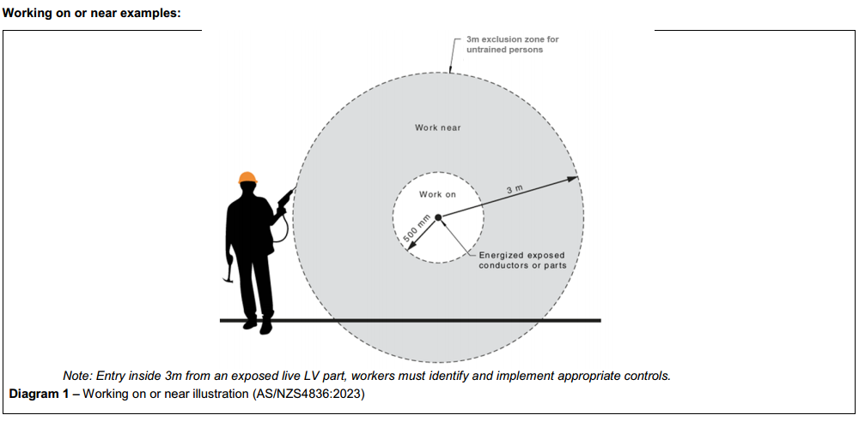
FATAL HAZARDS AND CRITICAL CONTROLS
Critical Risk | Possible Outcome | Mandatory Controls
Electric shock / electrocution | Fatality, serious injury or burns | Identify all exposed live parts. Maintain exclusion zones and minimum approach distances. Do not touch exposed or damaged conductors.
Arc flash | Burns, eye injury, fatality | Use arc flash PPE where required. Confirm fault level / risk where applicable. Keep workers outside arc flash boundary unless authorised and protected.
Live electrical work without justification | Uncontrolled live work exposure | Live work must only proceed where criteria are met, authorised, and safer than de-energising or where de-energising is not reasonably practicable.
Failure to isolate or prove de-energised | Unexpected energisation | Confirm isolation, access permits, switching status and test before touch where required. Treat equipment as live until proven otherwise.
Plant or tools entering exclusion zone | Contact with live assets or flashover | Maintain no-go zones, use spotters or ESO, use limiters where required, maintain clear communication and stop work if distances cannot be maintained.
Underground or overhead electrical assets | Service strike, shock or outage | Review plans, locate services, pothole, use barriers/covers and implement MLCH-02 / MLCH-05 controls where excavation is involved.
Poor communication | Uncontrolled plant or worker movement | Agree communication methods, use radios/hand signals, stop if communication is lost and keep all workers briefed.
Emergency rescue not available | Delayed rescue or secondary injury | Rescue equipment, trained persons, first aid and emergency access must be available before work starts.
KEY TOOLS, EQUIPMENT AND SAFETY EQUIPMENT
- Insulating mats and barriers.
- Approved insulated tools.
- Approved and rated test instruments.
- Rescue kit suitable for the task.
- Barricades, signage and exclusion-zone controls.
- Radios or approved communication devices.
- First aid kit and emergency contact details.
- Plant pre-start checklist and equipment inspection records where plant is used.
PPE REQUIREMENTS
PPE Item | Requirement
Safety helmet | Required onsite and when working near live assets, plant or overhead hazards.
Safety footwear | Required at all times onsite.
Eye protection | Medium impact eye protection as minimum. Arc flash face shield where required by risk assessment.
General purpose gloves | Required for general handling tasks.
Electrical / insulated gloves | 1000V rated or task-specific insulated gloves where required. Inspect before use and confirm test date where applicable.
Arc flash clothing | Required where arc flash risk or client requirement applies.
Hearing protection | Required where noise exposure is present.
Hi-vis long sleeve cotton clothing | Required for visibility and reduced synthetic clothing risk.
Fall arrest equipment | Required where work at height risk exists.

HIGH RISK WORK INTERFACE
This SWMS may interface with high risk construction work, including work near electrical installations or services, work near powered mobile plant, excavation work, work in substations, work near roads, work at height, and work involving energised electrical assets. The relevant task-specific SWMS must also be reviewed and followed.

RISK RATING GUIDE
Extreme | Do not proceed. Alternative method required.
High | Senior management / supervisor approval required before work proceeds.
Medium | Management responsibility must be specified and controls monitored.
Low | Work may proceed with normal supervision and routine controls.
Stop Work | All workers have authority to stop work if controls cannot be maintained.

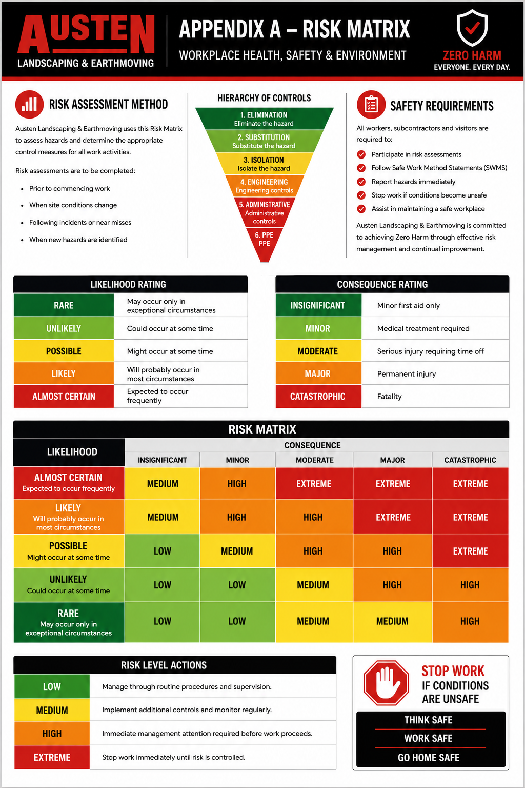
SEQUENCE OF WORK AND CONTROL MEASURES
Sequence of Work | Hazards / Risk | Initial Risk | Work Methods & Control Measures | Residual Risk | Responsible Person
Planning, preparation and authorisation | Unauthorised work; incorrect method; workers not competent | High | - Review scope, drawings, site instructions, work permits, switching status and access requirements.  - Confirm the task is permitted and authorised by the principal contractor / asset owner.  - Verify worker competency, inductions and ESO requirements.  - Confirm emergency response, rescue kit, first aid and communication arrangements before work starts.  - Review MLCH-02, MLCH-04 and MLCH-05 where underground services, plant or excavation is involved. | Low | Supervisor
Determine whether live work is justified | Live work where de-energising is practicable | High | - Confirm whether work can be completed de-energised.  - Live work must only proceed where approved criteria are met, documented and authorised.  - If controls cannot be applied or are not suitable, stop work and seek direction.  - Apply the highest level of control required by the asset owner, Energy Queensland or site procedure. | Low | Supervisor / PC
Pre-start and consultation | Poor communication; changed conditions; unclear roles | Medium | - Conduct Austen daily pre-start before work commences.  - Discuss exposed live parts, exclusion zones, access paths, rescue arrangements, communication methods and stop-work triggers.  - Confirm who is the supervisor, ESO, spotter, operator and work party members.  - All workers must understand the work method and sign onto this SWMS. | Low | Supervisor / All Workers
Identify exposed live parts and proximity hazards | Contact with exposed live parts; arc flash; step and touch potential | High | - Identify all exposed live parts and potential secondary points of contact.  - Mark, barricade or cover exposed parts where permitted and safe.  - Confirm minimum approach distances and exclusion zones before workers or plant enter the work area.  - Never assume equipment is de-energised unless verified by an authorised process. | Low | Supervisor / ESO
Establish exclusion zones and no-go zones | Workers or plant entering unsafe distance | High | - Establish exclusion zones for workers, plant, vehicles and the public.  - Use barricades, signage, spotters, barriers or insulating mats where required.  - Keep unauthorised workers out of the work area.  - Maintain clear access and emergency egress.  - Stop work immediately if any person, plant or tool breaches the exclusion zone. | Low | Supervisor / ESO / Spotter
Inspect tools, PPE and equipment | Defective tools; failed PPE; unsuitable test instruments | High | - Inspect PPE, insulated gloves, mats, barriers, rescue kit, test instruments and tools before use.  - Confirm test dates where applicable.  - Remove defective, damaged or out-of-date equipment from service.  - Use only approved and rated tools and instruments for the task. | Low | Supervisor / All Workers
Safety Observer / ESO controls | Delayed warning; uncontrolled approach to live assets | High | - Appoint an ESO or Safety Observer where required by the task, asset owner, exclusion zone or site procedure.  - ESO must understand the work method, exclusion distances and rescue requirements.  - ESO must maintain clear view and communication with workers / operator.  - If communication is lost or conditions change, work must stop immediately. | Low | ESO / Supervisor
Use of mobile plant near live parts | Plant contact; flashover; induced voltage | High | - Plant operators must be competent and authorised.  - Establish plant exclusion zones and minimum approach distances before plant operates.  - Use a spotter or ESO where plant can encroach on exclusion distances.  - Maintain positive communication between operator, spotter and ESO.  - Consider plant selection, boom limiters, trailing earths or grounding where required by the asset owner. | Low | Operator / ESO / Spotter
Work near underground electrical services | Cable strike; electrocution; arc flash | High | - Review service drawings, DBYD / Before You Dig and site records.  - Locate and positively identify services before excavation or ground disturbance.  - Pothole within required distances and apply MLCH-02 and MLCH-05 controls.  - Use insulated gloves, non-conductive tools and ESO where required.  - Stop work if unidentified services, marker tape, conduits or unexpected ground conditions are found. | Low | Supervisor / ESO / All Workers
Work near panels, pillars, switchboards or exposed equipment | Exposed live parts; faulty equipment; arc flash | High | - Inspect panels, covers, doors, hinges, locks and conductors for condition before work.  - Do not remove covers or barriers unless authorised and controlled.  - Use insulating barriers, mats and covers where required.  - Keep tools, body parts and materials clear of exposed live parts.  - Do not wear jewellery, watches or other conductive items. | Low | Supervisor / ESO / All Workers
Communication devices and site communications | Distraction; poor communication; uncontrolled movement | Medium | - Agree communication method before work starts.  - Radios must be charged and tested where used.  - Non-work mobile phone use is not permitted while performing live work, spotting, guiding vehicles or moving through traffic.  - Stop work if communication becomes unclear. | Low | Supervisor / All Workers
Performing the work | Electric shock; arc flash; contact with live assets; unsafe position | High | - Work on one potential at a time where applicable.  - Cover or control secondary points of contact where required.  - Maintain body position outside exclusion zones and line-of-fire areas.  - Never work alone where live electrical risk requires rescue or observation.  - Do not rush the task. Stop and reassess if conditions change. | Low | All Workers
Declared non-live or prohibited live tasks | Unauthorised live work | High | - Workers must not perform declared non-live tasks live.  - If a task is listed by the asset owner as not permitted live, work must be de-energised or alternative approved method used.  - Any uncertainty must be escalated to the supervisor / principal contractor before work proceeds. | Low | Supervisor / All Workers
Emergency response and rescue readiness | Delayed rescue; secondary electrocution | High | - Rescue kit and first aid arrangements must be available before work starts where required.  - Confirm emergency contacts and access routes.  - Do not approach or touch a person in contact with energised equipment until the area is made safe.  - Call 000 for serious injury or electrical incident.  - Preserve the incident scene where required. | Low | Supervisor / ESO / All Workers
Task monitoring and changed conditions | Work outside SWMS scope; new hazards | Medium | - Supervisor to monitor work activities and controls.  - All workers to monitor for new hazards.  - Review SWMS if conditions change, additional live parts are identified or work method changes.  - Stop work if controls cannot be maintained. | Low | Supervisor / All Workers
Pack up and completion | Unsafe equipment left exposed; poor housekeeping; incomplete records | Medium | - Ensure covers, panels, doors, barriers and guards are reinstated and secured.  - Confirm work area is electrically and physically safe.  - Remove tools, waste, barriers and signage only when safe to do so.  - Close permits, sign off records and advise principal contractor of completion.  - Review task and identify improvement opportunities. | Low | Supervisor / All Workers
KEY DEFINITIONS
Term | Definition
Exposed live part | A part that is bare, not effectively insulated, or not effectively guarded and may be energised.
Work on or near | Work where a person, tool, plant or material may come within proximity of exposed live parts or conductive parts.
De-energised | Separated from all sources of electricity and confirmed not energised by an approved test method.
Effectively guarded | Barriers, covers or shields in place to prevent contact or unsafe approach, installed and maintained for the activity.
Electrical Safety Observer / ESO | A competent person appointed to observe and warn workers or operators where electrical risk or exclusion zones apply.
Minimum approach distance | The closest distance a worker, plant, tool or material may approach an electrical asset under specified controls.
DECLARED NON-LIVE / PROHIBITED LIVE TASK CONTROLS
Workers must not perform tasks live where the principal contractor, asset owner, Energy Queensland procedure, site instruction or permit system requires the task to be de-energised. If there is any doubt, stop work and seek written direction before proceeding.
- Do not bypass barriers, covers or guards without approval and controls.
- Do not cut, open or disturb conduits, cables, panels or pillars unless the status is confirmed and the method is authorised.
- Do not perform live work using uninsulated tools unless specifically permitted by procedure and risk assessment.
- Do not work alone where a rescue or Safety Observer requirement applies.
- Do not allow plant, ladders, tools or materials to enter exclusion zones without control and approval.
ENVIRONMENTAL AND SITE CONTROLS
- Maintain good housekeeping and clear emergency access paths.
- Use spill kits where plant, fuel, oil or chemicals are present.
- Control dust, waste and loose materials during works and pack up.
- Maintain erosion and sediment controls where ground disturbance is involved.
- Report environmental incidents immediately to John Austen / Site Supervisor.
PROJECT INFORMATION AND REQUIREMENTS
Principal Contractor | Energy Queensland / Ergon Energy (Project Specific)
Workers | 2+ or as required by task
Competency | General Safety Induction Card, site induction, task instruction, Energy Queensland / site authorisations, ESO competency where required, operator VOC where plant is used
Training | Austen Site Specific Induction, toolbox talks, daily pre-starts and Energy Queensland / site inductions as required
Supervision & Monitoring | John Austen / project supervisor to monitor work, inspect controls and review SWMS
Plant & Equipment | Project-specific mobile plant, insulated tools, barriers, mats, rescue kit, rated test instruments, radios and first aid equipment
Chemicals | Diesel, petrol, oil, grease, hydraulic fluid or other substances associated with plant or site works
SWMS Review | Reviewed by John Austen during works and updated when conditions change
Legislation & Codes of Practice | WHS Act 2011; WHS Regulation 2011; Electrical Safety Act 2002; Electrical Safety Regulation 2013; Managing Electrical Risks in the Workplace 2021; Electrical Safety Code of Practice - Working Near Overhead and Underground Electric Lines; Excavation Work Code of Practice 2021; Managing Risks of Plant in the Workplace 2021; How to Manage WHS Risks 2021; Environmental Protection Act 1994; Biosecurity Act 2014
EMERGENCY AND INCIDENT RESPONSE
- Stop work immediately.
- Do not approach or touch energised equipment or a person in contact with energised equipment until the area is confirmed safe.
- Call Emergency Services on 000 for serious injury, electric shock, fire or rescue response.
- Contact electricity emergency on 131 962 where electrical assets may be involved.
- Notify John Austen / Site Supervisor and the principal contractor immediately.
- Keep all workers, plant and public clear of the area.
- Provide first aid only when safe to do so.
- Preserve the incident scene where required.
- Do not restart work until the hazard is controlled and the SWMS has been reviewed if required.
WORKER SIGN ON
We, the undersigned, confirm this Safe Work Method Statement has been explained, its contents are clearly understood and we will comply with the stated requirements. We also confirm that we have the required qualifications to undertake these activities.
Name | Signature | Date
SUPERVISOR DECLARATION
I confirm I have trained all above workers in this SWMS and I hereby confirm that the documented precautions, controls and work methods will be complied with.
Name | Position | Date | Signature
John Austen | Site Supervisor
THINK SAFE - WORK SAFE - GO HOME SAFE

