 | SAFE WORK METHOD STATEMENT (SWMS)  MLCH-11 - ENVIRONMENTAL CONTROLS & SPILL RESPONSE

This SWMS must be reviewed with all workers before work commences. Work must stop immediately if controls cannot be maintained or conditions change.
Activity / Task | Environmental Controls and Spill Response | Location | MILC - Millchester Substation / Project Specific
Scope | Applies to Austen workers, subcontractors, operators and visitors involved in works that may impact soil, water, drains, vegetation, waste, dust, sediment or environmental controls. | SWMS No. | MLCH-11
Training & Experience | Competent, trained and site inducted workers. Workers must understand spill response, waste controls and project environmental requirements. | Prepared By | John Austen
Site Risk Assessment By | Site Supervisor: John Austen | Creation / Review Date | 15/05/2026
Revision | A | Principal Contractor | Energy Queensland / Ergon Energy (Project Specific)
PURPOSE
This SWMS sets out the hazards, risks and controls for environmental management and spill response during civil, earthworks, utility and substation works. The intent is to prevent pollution, sediment release, dust migration, waste mismanagement, vegetation damage, weed spread and environmental harm.
SCOPE
- Fuel, oil, hydraulic fluid, chemical and contaminated water spill prevention and response.
- Operation and storage of plant, fuel, oils, chemicals, waste and materials.
- Dust, sediment, erosion, stormwater and runoff controls.
- Waste segregation, spoil management and disposal controls.
- Protection of drains, waterways, soil, vegetation, fauna and sensitive areas.
- Contaminated ground, asbestos, acid sulphate soil or unknown material response.
- Weed hygiene, site clean-up, monitoring and environmental incident reporting.
CRITICAL RISKS AND MANDATORY CONTROLS
Critical Risk | Possible Outcome | Mandatory Controls
Fuel, oil or hydraulic spill | Soil, stormwater or waterway contamination | Spill kits available, plant inspected, leaks reported, spills contained immediately and contaminated waste disposed correctly.
Spill entering drain or waterway | Environmental harm, regulatory notification or prosecution | Protect drains, use bunds, socks or mats, stop source, contain spill and notify supervisor immediately.
Sediment runoff | Sediment entering drains, waterways or sensitive areas | Install and maintain sediment controls, protect drains, manage stockpiles and stop work if controls fail.
Dust leaving work area | Worker exposure, public nuisance or environmental impact | Use dust suppression, reduce vehicle speed, cover stockpiles and stop work if dust cannot be controlled.
Poor waste management | Pollution, fire risk, trip hazards or non-compliance | Use correct bins, segregate waste, remove rubbish, secure lightweight waste and dispose at approved location.
Contaminated soil or unknown material | Exposure, contamination or incorrect disposal | Stop work, isolate area, notify supervisor/principal contractor and manage under specific controls.
Asbestos or suspected ACM | Worker exposure or contamination | Do not disturb. Stop work, isolate area, notify supervisor and use licensed/specialist controls where required.
Chemical storage failure | Spill, fire, exposure or incompatible storage | Store in labelled containers, use SDS, secure lids, bund where required and keep away from drains/ignition sources.
Vegetation or fauna impact | Damage to protected areas or habitat | Stay within approved work areas, avoid unnecessary clearing, report fauna and follow site environmental requirements.
Weed spread | Biosecurity breach or site contamination | Clean down plant where required, follow weed hygiene controls and avoid moving contaminated soil/material.
HAZARD IDENTIFICATION
Hazard Group | Hazards Identified
Environmental | Fuel/oil spills, chemical spills, sediment runoff, dust, waste, contaminated soil and vegetation impact.
Hazardous Substances | Diesel, petrol, oils, hydraulic fluid, chemicals, concrete slurry, contaminated water and unknown substances.
Water / Stormwater | Drains, watercourses, overland flow, sediment migration and contaminated runoff.
Waste | General waste, packaging, scrap materials, contaminated waste, oily rags, slurry and spoil.
Plant and Equipment | Leaking plant, refuelling, hydraulic hose failure, maintenance fluids and washdown water.
Ground Conditions | Contaminated soil, asbestos conduit, acid sulphate soils, unstable stockpiles and erosion risk.
Weather | Rain, wind, heat, storms, dust movement and runoff changes.
Biosecurity | Weeds, seeds, contaminated soil on plant, pest movement and restricted areas.
People Interface | Exposure during spill response, slips on spills/slurry and poor communication during incident response.
HIGH RISK WORK INTERFACE
Environmental controls and spill response may interface with excavation, vacuum excavation, powered mobile plant, traffic management, delivery/loading operations, silica/dust works, work near underground services and work within live substations. Relevant SWMS must also be reviewed where these risks apply.
PPE REQUIREMENTS
PPE Item | Requirement
Safety helmet | Required onsite and when working near plant, excavations or overhead hazards.
Safety footwear | Required at all times onsite.
Hi-vis long sleeve clothing | Required for visibility and UV protection.
Medium impact eye protection | Required during spill response, chemical handling, washdown or dusty works.
Task specific gloves | Nitrile, chemical resistant or rigger gloves depending on substance/task.
Respiratory protection | Required where fumes, vapours, dust, silica or contaminated material may be present.
Hearing protection | Required where plant or equipment creates noise exposure.
Waterproof / disposable PPE | Required where spill, slurry, contaminated water or unknown substance exposure may occur.
UV protection and 30+ sunscreen | Required for outdoor works.
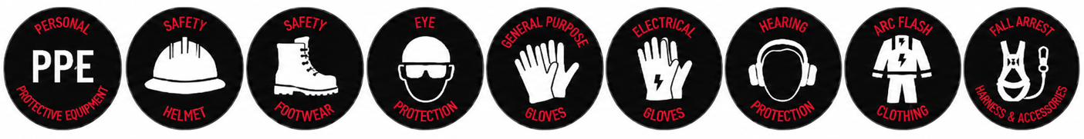

RISK RATING GUIDE
Risk Rating | Required Action
Extreme | Do not proceed. Alternative method required.
High | Senior management / supervisor approval required before work proceeds.
Medium | Management responsibility must be specified and controls monitored.
Low | Work may proceed with normal supervision and routine controls.
Stop Work | All workers have authority to stop work if controls cannot be maintained.
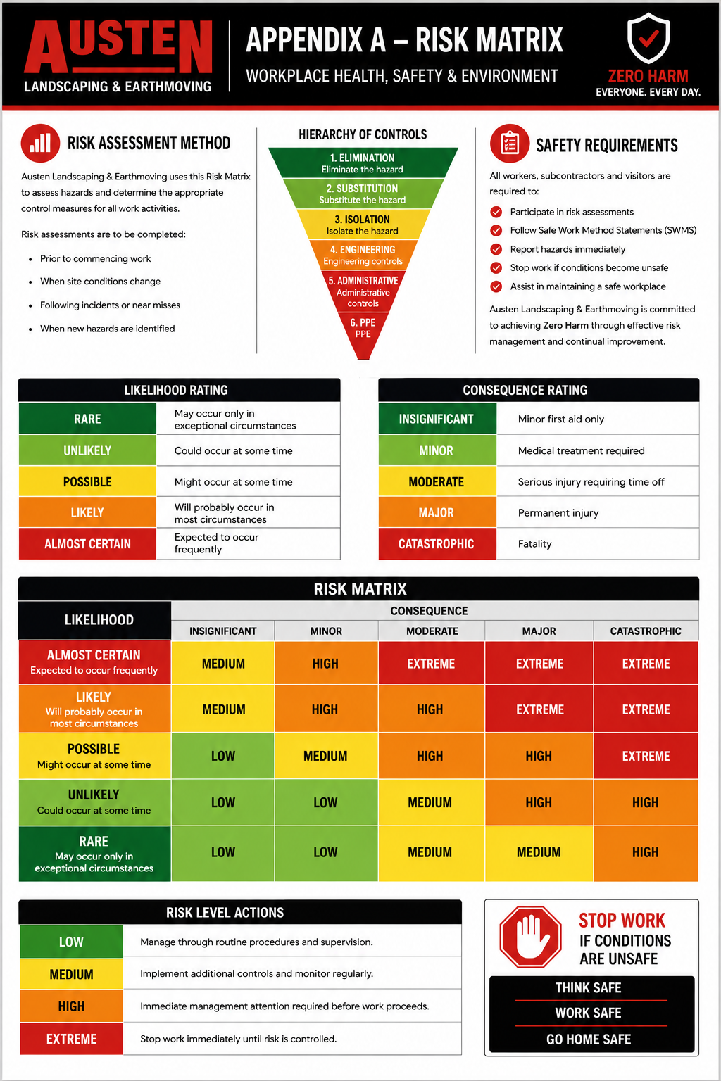
SEQUENCE OF WORK AND CONTROL MEASURES
Sequence of Work | Hazards / Risk | Initial Risk | Work Methods & Control Measures | Residual Risk | Responsible Person
Planning, preparation and competency | Workers unaware of environmental requirements; no controls in place | High | • All workers must hold current construction induction and complete site induction.  • Review project environmental requirements, sensitive areas, drains, waterways, vegetation, waste areas and spill response arrangements.  • Confirm spill kits, sediment controls, dust controls, waste bins and emergency contacts are available.  • Review relevant SWMS for plant, excavation, vacuum excavation, silica/dust, traffic or delivery activities.  • Confirm workers understand reporting requirements for environmental incidents. | Low | Supervisor
Pre-start and consultation | Poor communication; changed site or weather conditions | Medium | • Attend Austen daily pre-start meeting before commencing work.  • Discuss environmental controls, spill kit locations, drain protection, stockpile controls, dust suppression and waste management.  • Review weather forecast, wind, rain and runoff risks.  • Identify additional hazards and implement controls before work starts.  • Stop work if controls cannot be maintained. | Low | Supervisor / All Workers
Inspect work area and sensitive receptors | Unidentified drains, waterways, vegetation or protected areas | High | • Inspect work area before commencing.  • Identify drains, pits, waterways, overland flow paths, vegetation, fauna habitat, access tracks and stockpile areas.  • Establish exclusion zones or no-go areas where required.  • Protect drains and sensitive areas before works commence.  • Keep plant and materials within approved work areas. | Low | Supervisor / All Workers
Spill kit readiness | Unable to contain spill quickly | High | • Suitable spill kit must be available for the size and type of plant, fuel and chemicals onsite.  • Workers must know spill kit location and basic response process.  • Spill kits must be checked regularly and restocked after use.  • Keep spill kits accessible and not buried under materials or locked away from work area.  • Additional spill controls required near drains, waterways or refuelling areas. | Low | Supervisor
Plant inspection and leak prevention | Fuel, oil or hydraulic fluid leak | High | • Plant and vehicles must be inspected before use.  • Check for oil, fuel, coolant or hydraulic leaks.  • Report leaks immediately and remove defective plant from service where required.  • Drip trays or mats to be used where required.  • Do not park leaking plant near drains, waterways or sensitive ground. | Low | Operator / Supervisor
Fuel, oil and chemical storage | Spill, fire, exposure or incorrect storage | High | • Store fuels, oils and chemicals in labelled containers with lids secured.  • Store away from drains, waterways, ignition sources and traffic impact areas.  • Use bunding or secondary containment where required.  • Keep SDS available where chemicals are used or stored.  • Do not decant into unlabelled drink bottles or unsuitable containers. | Low | Supervisor / All Workers
Refuelling and transfer of liquids | Spill, fire, skin/eye contact | High | • Refuelling must be completed by a competent person in a controlled area.  • Turn plant off and allow hot surfaces to cool where required.  • Spill kit and fire extinguisher must be nearby.  • Do not overfill tanks.  • Use funnels, nozzles or pumps suitable for the task.  • Clean and report spills immediately. | Low | Operator / Supervisor
Spill response - minor spill | Spill spreading to soil, drain or waterway | High | • Stop work and stop the source if safe to do so.  • Prevent spill entering drains, waterways or soil using pads, socks, bunds or mats.  • Notify John Austen / Site Supervisor.  • Use spill kit to absorb or contain spill.  • Place contaminated materials in suitable bags / containers for correct disposal.  • Restock spill kit after use. | Low | All Workers / Supervisor
Spill response - major spill or uncontrolled release | Environmental harm, fire, exposure or regulatory incident | Extreme | • Stop work immediately and raise alarm.  • Evacuate workers from unsafe area and isolate ignition sources if safe.  • Do not enter contaminated area unless safe and wearing suitable PPE.  • Contact Emergency Services on 000 if required.  • Notify John Austen / Site Supervisor and principal contractor immediately.  • Protect drains/waterways if safe to do so.  • Do not recommence until authorised and controls are reviewed. | Low | Supervisor / All Workers
Drain and stormwater protection | Contamination entering drains or waterways | High | • Identify drains, pits, culverts and flow paths before work starts.  • Install drain covers, sediment socks, bunds, sandbags or other controls where required.  • Do not wash tools, plant, concrete slurry or sediment into stormwater drains.  • Maintain controls during rainfall and inspect after rain.  • Remove accumulated sediment and dispose correctly. | Low | Supervisor / All Workers
Erosion and sediment controls | Sediment runoff, erosion, blocked drains | High | • Install sediment fencing, socks, bunds or diversion controls where required.  • Stabilise access tracks, stockpiles and exposed soil where practicable.  • Keep stockpiles away from drains and flow paths.  • Inspect controls daily and after rain.  • Repair failed controls immediately and report issues. | Low | Supervisor / All Workers
Dust controls | Dust migration, worker exposure, public nuisance | Medium | • Use water cart, hose, misting or other dust suppression where dust is generated.  • Reduce vehicle speeds on dry access roads.  • Cover or dampen dusty stockpiles where required.  • Coordinate with MLCH-08 for silica/dust exposure controls.  • Stop or modify work if dust leaves the controlled work area. | Low | Supervisor / All Workers
Waste segregation and disposal | Incorrect disposal, pollution, fire risk or poor housekeeping | Medium | • Place waste in correct bins or approved disposal areas.  • Segregate general waste, scrap metal, contaminated waste, oily rags and regulated waste where required.  • Secure lightweight waste from wind.  • Do not burn or bury waste onsite.  • Remove rubbish progressively and keep work areas tidy. | Low | All Workers / Supervisor
Spoil, slurry and washdown | Contaminated runoff, blocked drains, sediment release | High | • Spoil and slurry must be contained and managed in accordance with site requirements.  • Prevent slurry or washdown water entering drains, waterways or sensitive areas.  • Washdown only in approved areas where runoff is controlled.  • Concrete slurry, cutting slurry and vacuum excavation slurry must be disposed correctly.  • Contaminated material must not be mixed with clean spoil unless approved. | Low | Supervisor / Operator
Contaminated soil or unknown material | Worker exposure, incorrect disposal or environmental harm | High | • Stop work if unusual odour, staining, buried waste, asbestos, oily material or unknown material is found.  • Isolate area and prevent disturbance.  • Notify John Austen / Site Supervisor and principal contractor.  • Do not remove or dispose of suspect material until approved method is confirmed.  • Specialist assessment or licensed contractor may be required. | Low | Supervisor / All Workers
Asbestos or suspected ACM | Exposure and contamination | High | • Stop work immediately if suspected asbestos containing material is identified.  • Do not break, cut, drill, crush, sweep or disturb suspected ACM.  • Isolate the area and prevent access.  • Notify John Austen / Site Supervisor and principal contractor.  • Use licensed/specialist controls where required before work recommences. | Low | Supervisor / All Workers
Vegetation, fauna and site protection | Damage to vegetation, habitat or fauna | Medium | • Stay within approved access tracks and work areas.  • Do not clear, trim or damage vegetation unless authorised.  • Report fauna, nests, burrows or protected areas to supervisor.  • Avoid unnecessary ground disturbance.  • Reinstate disturbed areas as required by project direction. | Low | All Workers / Supervisor
Weed hygiene and biosecurity | Spread of weeds, seeds or contaminated soil | Medium | • Follow site weed hygiene requirements.  • Inspect and clean down plant, tyres, tracks and attachments where required.  • Avoid moving contaminated soil or vegetation between areas.  • Dispose of weed contaminated material as directed by the site requirements.  • Report suspected declared weeds or biosecurity risks. | Low | Supervisor / Operator
Monitoring and inspection | Controls fail; changing weather or site conditions | Medium | • Supervisor to inspect environmental controls regularly.  • Inspect sediment controls, drains, spill kit, waste areas, stockpiles and access tracks.  • Reassess controls after rain, wind, delivery activities or ground disturbance.  • Workers must report environmental hazards, near misses or damaged controls immediately.  • Stop work if controls are ineffective. | Low | Supervisor / All Workers
Completion and clean up | Waste left onsite, uncontrolled drains, remaining contamination | Medium | • Remove rubbish, waste, unused materials and trip hazards.  • Ensure drains, pits, roads and access ways are clean and clear.  • Remove or maintain sediment controls as directed.  • Confirm spill kits are restocked and waste is correctly disposed.  • Close out environmental inspections, incidents or permits where required. | Low | Supervisor / All Workers
ENVIRONMENTAL AND SITE CONTROLS
- Spill kits must be available where plant, fuel, oil or chemicals are present.
- Drains, waterways and stormwater paths must be protected from spills, sediment and slurry.
- Dust suppression must be used where dust is generated.
- Sediment and erosion controls must be installed and maintained where ground disturbance occurs.
- Waste must be segregated, secured and disposed of correctly.
- Contaminated soil, asbestos, acid sulphate soil or unknown material must be reported and managed under specific controls.
- Weed hygiene controls must be maintained where required by the site or client.
- Environmental incidents must be reported immediately to John Austen / Site Supervisor.
PROJECT INFORMATION AND REQUIREMENTS
Principal Contractor | Energy Queensland / Ergon Energy (Project Specific)
Workers | 2+ or as required by task
Competency | General Safety Induction Card, site induction, task instruction, environmental awareness, spill response instruction and operator competency / VOC where plant is used
Training | Austen Site Specific Induction, toolbox talks, daily pre-starts and Energy Queensland / site environmental inductions as required
Supervision & Monitoring | John Austen / project supervisor to monitor environmental controls, spill readiness, waste areas and incident response
Plant & Equipment | Excavators, bobcats, trucks, rollers, vacuum excavation truck, generators, water cart and other project specific equipment
Tools and Equipment | Spill kits, drain covers, sediment socks, bunds, sandbags, shovels, bags, bins, barricades, signage, radios, fire extinguisher and first aid equipment
Chemicals | Diesel, petrol, oil, grease, hydraulic fluid, coolant, concrete slurry, cleaning products or other site substances
PPE | Refer to PPE section and SDS / site requirements
SWMS Review | Reviewed by John Austen during works and updated when conditions change
Legislation & Codes of Practice | WHS Act 2011; WHS Regulation 2011; Environmental Protection Act 1994; Environmental Protection Regulation 2019; Biosecurity Act 2014; Biosecurity Regulation 2016; Waste Reduction and Recycling Act 2011; How to Manage WHS Risks 2021; Managing Risks of Hazardous Chemicals in the Workplace 2021; Managing Risks of Plant in the Workplace 2021
EMERGENCY AND INCIDENT RESPONSE
- Stop work immediately.
- Make the area safe if it is safe to do so.
- Stop the source of the spill or release if safe to do so.
- Contain the spill and protect drains, waterways and soil using spill kit materials.
- Notify John Austen / Site Supervisor and the principal contractor immediately.
- Contact Emergency Services on 000 for major spill, fire, injury or immediate danger.
- Keep workers and public clear of the affected area.
- Use suitable PPE before responding to spills or unknown substances.
- Preserve incident scene where required and safe to do so.
- Collect contaminated spill materials for correct disposal.
- Do not restart work until the hazard is controlled and the SWMS / environmental controls have been reviewed.
WORKER SIGN ON
We, the undersigned, confirm this Safe Work Method Statement has been explained, its contents are clearly understood and we will comply with the stated requirements. We also confirm that we have the required qualifications to undertake these activities.
Name | Signature | Date
SUPERVISOR DECLARATION
I confirm I have trained all above workers in this SWMS and I hereby confirm that the documented precautions, controls and work methods will be complied with.
Name | Position | Date | Signature
John Austen | Site Supervisor

THINK SAFE - WORK SAFE - GO HOME SAFE

