 | SAFE WORK METHOD STATEMENT (SWMS)  MLCH-12 - HEAT STRESS, REMOTE CONDITIONS & FITNESS FOR WORK
This SWMS must be reviewed with all workers before work commences. Work must stop immediately if controls cannot be maintained or conditions change.
Activity / Task | Heat Stress, Remote Conditions and Fitness for Work | Location | MILC - Millchester Substation / Project Specific
Scope | Applies to Austen workers, subcontractors, operators and visitors exposed to heat, humidity, sun, fatigue, remote work, isolated work or fitness-for-work risks. | SWMS No. | MLCH-12
Training & Experience | Competent, trained and site inducted workers. Workers must understand heat illness signs, hydration controls, emergency response and stop-work triggers. | Prepared By | John Austen
Site Risk Assessment By | Site Supervisor: John Austen | Creation / Review Date | 15/05/2026
Revision | A | Principal Contractor | Energy Queensland / Ergon Energy (Project Specific)
HEAT INDEX / HUMIDITY RISK GUIDE
The heat index chart is to be used as a guide when assessing heat stress risk. Actual risk may increase due to PPE, hard physical work, radiant heat, poor airflow, fatigue, illness, medication, hydration status and individual worker fitness.
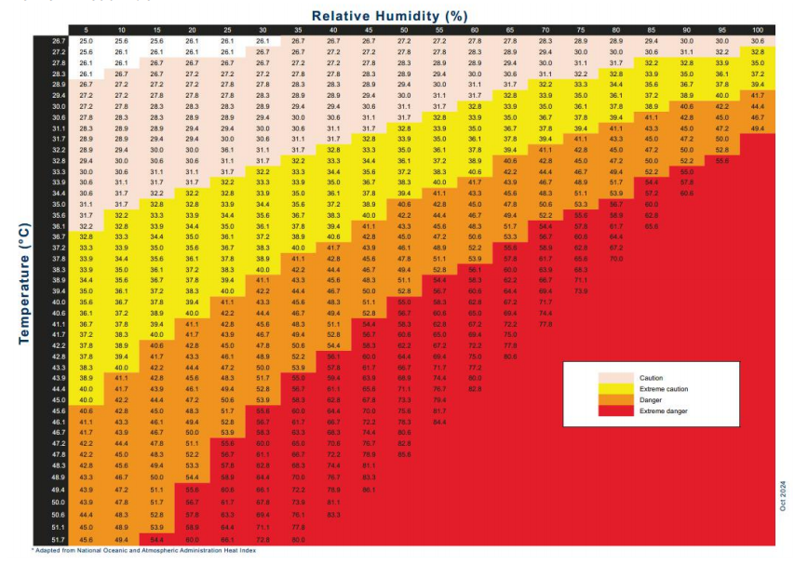

PURPOSE
This SWMS sets out the hazards, risks and controls for heat stress, humidity, UV exposure, fatigue, remote conditions and fitness-for-work risks during civil, earthworks, landscaping, utility and substation works. The intent is to prevent heat illness, dehydration, fatigue-related incidents, poor decision making and delayed emergency response.
SCOPE
- Outdoor work in hot, humid, sunny or high UV conditions.
- Physical work including excavation, manual handling, plant operation, traffic control, concrete works, tool use and clean-up.
- Work requiring PPE that may increase body heat, including long sleeves, gloves, helmets, respiratory protection or arc flash clothing.
- Remote, isolated or low-supervision work areas.
- Workers operating plant, driving, spotting, working near live services or performing safety-critical tasks.
- Heat illness prevention, fitness-for-work checks, hydration, rest breaks, emergency response and task monitoring.
CRITICAL RISKS AND MANDATORY CONTROLS
Critical Risk | Possible Outcome | Mandatory Controls
Heat stress / heat exhaustion | Collapse, confusion, illness or medical emergency | Monitor heat index, humidity, workload and PPE. Provide shade, water, rest breaks and task rotation.
Heat stroke | Life-threatening medical emergency | Stop work immediately. Call 000 for serious symptoms. Cool worker rapidly and provide first aid while waiting for help.
Dehydration | Dizziness, cramps, poor concentration or collapse | Workers must drink water regularly, replace electrolytes where needed and report symptoms early.
High humidity | Reduced cooling from sweating, faster heat build-up | Use heat index chart, increase rest breaks, reduce workload and monitor workers closely.
UV exposure | Sunburn, eye damage, heat load and long-term health risk | Use long sleeves, sunscreen, wide brim attachment, eye protection, shade and planned breaks.
Fatigue | Poor judgement, plant incident, service strike or injury | Monitor work hours, rest breaks, driving fatigue and worker alertness. Do not perform high-risk work if fatigued.
Fitness for work | Impaired worker performing safety-critical task | No worker to commence if affected by alcohol, drugs, illness, injury, medication, fatigue or heat stress.
Remote / isolated conditions | Delayed emergency response | Maintain communication, buddy checks, emergency access, first aid and clear location details.
Plant operation in heat | Operator fatigue, poor visibility or delayed reaction | Hydration, air-conditioning where available, breaks, job rotation and stop work if unfit.
Working near live assets while heat affected | Electrical incident, service strike or poor decision making | Stop work if worker concentration, communication or control measures are affected.
HAZARD IDENTIFICATION
Hazard Group | Hazards Identified
Thermal | Heat stress, heat illness, hot surfaces, sun exposure, high humidity and radiant heat.
Workload | Manual handling, shovelling, walking, repetitive work, PPE burden and high physical effort.
UV / Radiation | Sunburn, eye exposure, glare and UV exposure during outdoor works.
Fitness for Work | Fatigue, illness, medication, alcohol/drug impairment, dehydration and poor concentration.
Remote Conditions | Delayed emergency response, poor communication, limited shade, limited water and restricted access.
Plant / Vehicles | Operator fatigue, delayed reaction, poor decision making and driving fatigue.
Electrical / High Risk Work | Reduced focus around live assets, services, exclusion zones, excavation and plant operation.
Environmental | Hot wind, storm changes, poor air movement, dust, humidity and weather extremes.
Emergency | Heat stroke, collapse, breathing difficulty, delayed rescue and unclear site location.
HIGH RISK WORK INTERFACE
Heat stress and fitness-for-work risks may affect all high risk construction activities including excavation, powered mobile plant, traffic management, working near underground services, working on or near exposed live parts, vacuum excavation, power tools, silica/dust work and delivery/loading operations. Relevant SWMS must also be reviewed where these risks apply.
PPE REQUIREMENTS
PPE / Control Item | Requirement
Safety helmet | Required onsite. Use wide brim attachment where practicable for sun protection.
Safety footwear | Required at all times onsite.
Hi-vis long sleeve cotton clothing | Required for visibility and UV protection. Cotton clothing preferred for hot work.
Eye protection | Required. Tinted safety glasses may assist with glare where suitable.
Task specific gloves | Required for manual tasks, hot surfaces, tools and materials.
Hearing protection | Required where plant or equipment noise is present.
Respiratory protection | Required where dust/silica exposure exists. Monitor added heat burden from respirators.
Sunscreen 30+ or higher | Apply before work and reapply during the day as required.
Hydration / cooling controls | Water, electrolytes, shade, cooling towels, rest areas or air-conditioned vehicle access where available.
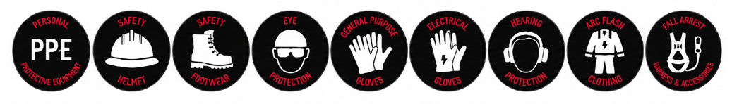
RISK RATING GUIDE
Risk Rating | Required Action
Extreme | Do not proceed. Alternative method required.
High | Senior management / supervisor approval required before work proceeds.
Medium | Management responsibility must be specified and controls monitored.
Low | Work may proceed with normal supervision and routine controls.
Stop Work | All workers have authority to stop work if heat, fatigue or fitness-for-work controls cannot be maintained.

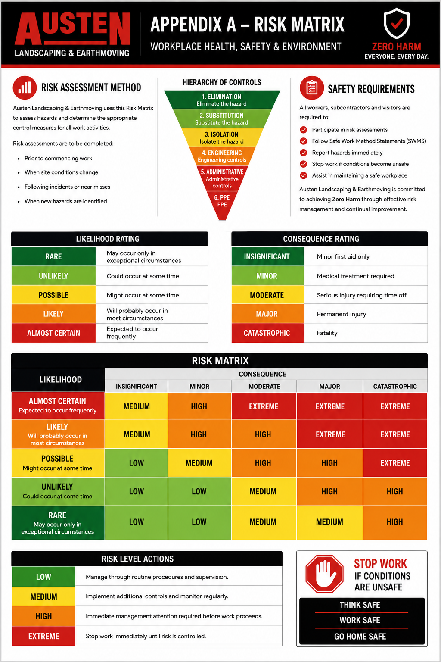
SEQUENCE OF WORK AND CONTROL MEASURES
Sequence of Work | Hazards / Risk | Initial Risk | Work Methods & Control Measures | Residual Risk | Responsible Person
Planning, preparation and competency | Heat risk not assessed; workers unaware of symptoms or controls | High | • All workers must hold current construction induction and complete site induction.  • Supervisor to check weather forecast, temperature, humidity, UV and expected workload before work starts.  • Review heat index / humidity chart and determine required controls.  • Plan high physical tasks for cooler parts of the day where practicable.  • Confirm water, shade, first aid, communication, emergency access and rest areas are available.  • Review relevant SWMS where heat impacts plant, excavation, live electrical work, traffic control or manual handling. | Low | Supervisor
Pre-start and fitness-for-work check | Worker starts unfit, dehydrated, fatigued or impaired | High | • Attend Austen daily pre-start meeting before commencing work.  • Workers must declare if affected by fatigue, illness, medication, dehydration, alcohol, drugs or injury.  • Supervisor to discuss heat risk, hydration, breaks, buddy checks, symptoms and emergency process.  • No worker is to perform safety-critical work if unfit.  • Workers have authority to stop work if they feel unwell or unsafe. | Low | Supervisor / All Workers
Heat index and weather monitoring | Heat controls not increased as conditions worsen | High | • Monitor temperature, humidity, UV, wind and storm conditions during the shift.  • Use heat index / humidity chart as a guide to determine caution, extreme caution, danger or extreme danger conditions.  • Increase rest breaks, hydration and task rotation as conditions worsen.  • Stop or modify work if conditions enter dangerous levels or controls cannot be maintained.  • Reassess after weather changes, rain, humidity increase or loss of shade. | Low | Supervisor
Hydration and electrolyte management | Dehydration, cramps, dizziness, confusion | High | • Potable drinking water must be available and accessible.  • Workers to drink small amounts regularly before feeling thirsty.  • Electrolytes to be used where heavy sweating, extended hot work or cramping risk exists.  • Avoid excessive caffeine / energy drinks in hot conditions.  • Workers must report headache, dizziness, nausea, cramps or unusual fatigue immediately. | Low | All Workers
Shade, cooling and rest breaks | Heat exhaustion, overexertion, poor recovery | High | • Provide shade, shelter, rest area or air-conditioned vehicle access where practicable.  • Schedule rest breaks based on heat, humidity, workload and PPE burden.  • Rotate workers through heavy tasks.  • Use cooling towels, misting, fans or other cooling methods where available.  • Do not pressure workers to continue when showing heat illness symptoms. | Low | Supervisor / All Workers
Work scheduling and task rotation | High body heat from heavy workload | High | • Schedule heavy work for early morning or cooler periods where practicable.  • Reduce work pace during high heat or humidity.  • Rotate workers between heavy and light duties.  • Use mechanical aids, plant or team lifting to reduce manual effort.  • Defer non-critical heavy tasks if conditions are unsafe. | Low | Supervisor
PPE and clothing management | Increased heat load from PPE or unsuitable clothing | Medium | • Wear required PPE at all times.  • Use long sleeve cotton hi-vis clothing for UV protection and breathability where practicable.  • Use wide brim helmet attachments and sunscreen.  • Consider added heat burden from respirators, arc flash clothing, gloves or chemical PPE.  • Increase rest breaks where PPE increases heat stress. | Low | Supervisor / All Workers
Manual handling and physical labour in heat | Heat exhaustion, muscle cramps, strains | High | • Assess physical effort before commencing manual tasks.  • Use mechanical aids, team lifting or plant where possible.  • Avoid repetitive heavy lifting, shovelling or carrying during peak heat where practicable.  • Take regular breaks and rotate workers.  • Follow MLCH-01 Manual Handling and Housekeeping controls. | Low | All Workers
Plant operation and driving in heat | Operator fatigue, delayed reaction, collision or plant incident | High | • Operators must be fit for work and alert.  • Use air-conditioning / ventilation where available.  • Take regular hydration and rest breaks.  • Do not operate plant if affected by heat, fatigue, illness or medication.  • Stop work if concentration, vision, communication or reaction time is affected.  • Follow MLCH-04 powered plant controls. | Low | Operator / Supervisor
Traffic control and public interface in heat | Fatigue, reduced alertness, vehicle strike | High | • Traffic control workers must have water, shade and relief breaks.  • Rotate workers in exposed positions where practicable.  • Monitor workers standing in direct sun or on hot road surfaces.  • Maintain communication and visibility controls.  • Follow MLCH-07 traffic management controls. | Low | Supervisor / All Workers
Work near live electrical assets in heat | Reduced concentration, communication failure, electrical incident | High | • Heat affected workers must not perform work near live electrical assets, spotting, ESO duties or safety-critical tasks.  • Monitor concentration, communication and decision making.  • Increase rest breaks where arc flash clothing or insulated gloves increase heat load.  • Stop work if workers show confusion, poor coordination or unsafe judgement.  • Follow MLCH-03 and MLCH-05 controls. | Low | Supervisor / ESO / All Workers
Remote or isolated work | Delayed rescue, poor communication, worker collapse not detected | High | • Confirm communication method before work starts.  • Workers must not work alone in high heat or remote areas without agreed check-ins.  • Maintain buddy system or regular contact.  • Confirm emergency access, GPS/location details, nearest hospital and assembly point.  • Keep first aid kit, water and emergency contacts available. | Low | Supervisor / All Workers
Fatigue management | Poor judgement, errors, microsleep, plant or driving incident | High | • Workers must present fit for work and rested.  • Monitor long work hours, early starts, travel distance, sleep quality and heat exposure.  • No worker affected by fatigue to operate plant, drive long distances or perform high-risk work.  • Use breaks, task rotation or stop work where fatigue risk is identified.  • Report fatigue early to supervisor. | Low | Supervisor / All Workers
Drug, alcohol, illness and medication controls | Impairment, poor judgement or medical emergency | High | • No drugs or alcohol permitted onsite.  • Workers must advise supervisor if medication, illness or medical condition may affect fitness for work.  • Workers with vomiting, diarrhoea, fever, heat illness symptoms or dehydration must not perform high-risk work.  • Supervisor may remove worker from task if fitness for work is in doubt.  • Seek medical advice where required. | Low | Supervisor / All Workers
Recognising heat illness symptoms | Heat illness not identified early | High | • Workers must watch for thirst, headache, cramps, dizziness, nausea, heavy sweating, weakness, confusion, poor coordination or collapse.  • Buddy checks to be used during hot work.  • Any worker showing symptoms must stop work, move to shade/cool area and notify supervisor.  • Do not leave a symptomatic worker alone.  • Escalate to first aid or emergency services where required. | Low | All Workers
Heat illness response | Worsening condition or heat stroke | Extreme | • Stop work immediately.  • Move worker to shade or cool area if safe.  • Remove excess PPE and cool worker using water, fans, wet towels or ice packs where available.  • Give water only if worker is conscious, alert and able to swallow.  • Call 000 immediately for confusion, collapse, seizure, loss of consciousness, hot/dry skin, or symptoms not improving.  • Notify John Austen / Site Supervisor and principal contractor. | Low | Supervisor / First Aid Officer / All Workers
Task monitoring and changed conditions | Controls fail, heat index increases, worker condition changes | Medium | • Supervisor to monitor weather, heat index, workload and worker condition throughout shift.  • Workers must monitor themselves and each other.  • Increase controls if heat, humidity, PPE burden or workload increases.  • Stop work if controls are not effective or workers are affected.  • Review and re-brief before recommencing. | Low | Supervisor / All Workers
Completion and travel home | Delayed fatigue effect, dehydration, driving risk | Medium | • Workers to rehydrate and cool down before leaving site.  • Report any heat illness symptoms before leaving.  • Workers affected by fatigue, heat illness or medication must not drive if unsafe.  • Supervisor to consider travel distance and worker condition after hot days.  • Record any heat-related incidents, symptoms or first aid treatment. | Low | Supervisor / All Workers

HEAT ILLNESS - WARNING SIGNS
Condition | Common Signs | Required Action
Heat cramps | Muscle cramps, heavy sweating, fatigue | Stop work, rest in shade, drink water/electrolytes, monitor.
Heat exhaustion | Headache, dizziness, nausea, weakness, heavy sweating, pale/clammy skin | Stop work, cool worker, provide first aid, do not leave alone, seek medical advice if not improving.
Heat stroke | Confusion, collapse, seizure, loss of consciousness, very high body temperature, hot skin | Medical emergency. Call 000 immediately. Cool worker rapidly while waiting for emergency services.
ENVIRONMENTAL AND SITE CONTROLS
- Provide adequate drinking water, shade and rest areas.
- Use the heat index / humidity chart as a guide and increase controls as risk increases.
- Plan heavy work for cooler parts of the day where practicable.
- Use dust suppression and manage hot, dry and windy conditions.
- Maintain emergency access and communications in remote or isolated work areas.
- Stop work during extreme heat, storms, lightning, poor visibility or unsafe weather conditions.
- Report heat-related symptoms, first aid treatment, near misses and incidents immediately.
PROJECT INFORMATION AND REQUIREMENTS
Principal Contractor | Energy Queensland / Ergon Energy (Project Specific)
Workers | 2+ or as required by task. Buddy system required for high heat or remote work.
Competency | General Safety Induction Card, site induction, task instruction, heat stress awareness, first aid availability and operator competency / VOC where plant is used.
Training | Austen Site Specific Induction, toolbox talks, daily pre-starts, heat stress awareness and Energy Queensland / site inductions as required.
Supervision & Monitoring | John Austen / project supervisor to monitor weather, worker condition, hydration, rest breaks and fitness for work.
Plant & Equipment | Project specific plant, vehicles, radios, shade, water, first aid kit, cooling aids and emergency communication equipment.
Tools and Equipment | Water containers, electrolytes, sunscreen, shade, cooling towels, thermometer / weather app, phones or radios, first aid equipment.
Chemicals | Diesel, petrol, oil, grease, hydraulic fluid or other substances associated with plant use.
PPE | Refer to PPE section and site requirements.
SWMS Review | Reviewed by John Austen during works and updated when conditions change.
Legislation & Codes of Practice | WHS Act 2011; WHS Regulation 2011; Managing the Work Environment and Facilities Code of Practice 2021; Managing the Risk of Psychosocial Hazards at Work Code of Practice 2022; Hazardous Manual Tasks Code of Practice 2021; Managing Risks of Plant in the Workplace 2021; How to Manage WHS Risks 2021; Electrical Safety Act 2002; Environmental Protection Act 1994.
EMERGENCY AND INCIDENT RESPONSE
- Stop work immediately.
- Move affected worker to shade or cooler area if safe.
- Remove excess PPE and cool the worker using water, wet towels, fans or ice packs where available.
- Give water only if the worker is conscious, alert and able to swallow.
- Do not leave the affected worker alone.
- Call Emergency Services on 000 for collapse, confusion, seizure, loss of consciousness, heat stroke signs or serious illness.
- Notify John Austen / Site Supervisor and the principal contractor immediately.
- Maintain emergency access and direct emergency services to the worker location.
- Do not restart work until conditions and controls have been reviewed and workers re-briefed.
- Record heat illness, first aid treatment, near misses and corrective actions.
WORKER SIGN ON
We, the undersigned, confirm this Safe Work Method Statement has been explained, its contents are clearly understood and we will comply with the stated requirements. We also confirm that we have the required qualifications to undertake these activities.
Name | Signature | Date
SUPERVISOR DECLARATION
I confirm I have trained all above workers in this SWMS and I hereby confirm that the documented precautions, controls and work methods will be complied with.
Name | Position | Date | Signature
John Austen | Site Supervisor
THINK SAFE - WORK SAFE - GO HOME SAFE
Austen Landscaping & Earthmoving | ABN 30 643 517 350 | Phone: 0407 763 435 | Email: kathieshome@westnet.com.au | MLCH-12 | Uncontrolled when printed

