

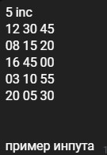

But:



So, I guess we can output:

3 10 55

8 15 20

12 30 45

16 45 0

20 5 30