



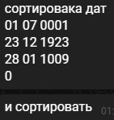

Input:

01 07 1923

12 12 1920

14 12 1924

0

Output:

12 12 1920

01 07 1923

14 12 1924