

I guess this:

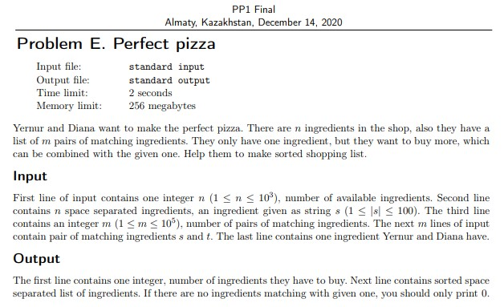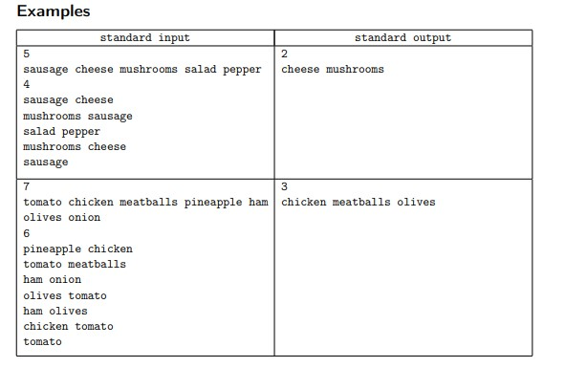

Input1:

5

sausage cheese mushrooms salad pepper

4

sausage cheese

mushrooms sausage

salad pepper

mushrooms cheese

sausage

Output1:

2

cheese mushrooms

Input2:

7

tomato chicken meatballs pineapple ham olives onion

6

pineapple chicken

tomato meatballs

ham onion

olives tomato

ham olives

chicken tomato

tomato

Output2:

3

chicken meatballs olives