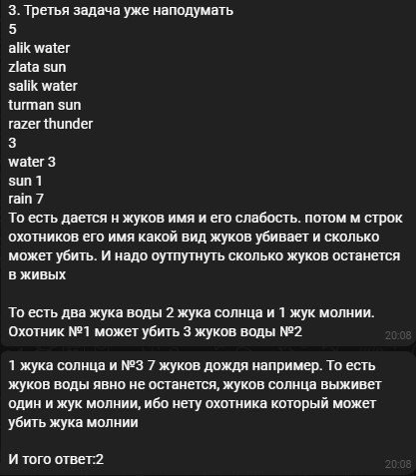

But input is another, there are forgotten names of hunters;



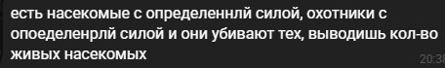

Крд :)

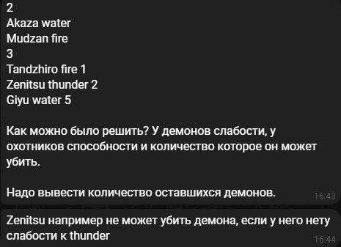

Input:

2

Akaza water

Mudzan fire

3

Tandzhiro fire 1

Zenitsu thunder 2

Giyu water 5

Ouput:

0

Input:

10

Az a

As a

Bs b

Bz b

Be b

Br b

Ce c

Cw c

Ct c

Cy c

3

On b 1

men a 9

sen b 1

Output:

6