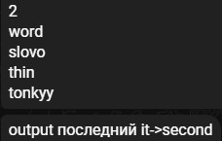



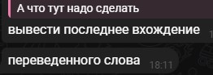

Honestly, I don’t understand enough, since even that person from screen got partial solution for this task. I guess we need to print not last “it->second”(because in map the order of first words/keys is sorted), but just map[last_name].