In the following assignment you are going to develop a Golang service that receives a **stream** of messages from **GRPC** and your service needs to store them into a database in batches.

Each message contains the following fields: ID -> string, Group ID -> string, Data -> bytes array.

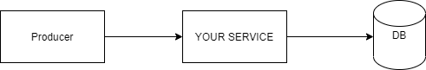

1. Create a Go module at version 1.13+.
2. Define a Protobuf with the messages and service.
3. Implement the GRPC server.
4. In order to store the messages into a database you are required to **batch** the results before sending them to a DB. Each batch shall include **at most** 3 messages OR wait from 1 second since the **last** message. Each batch is **grouped by the Group ID field**.  
   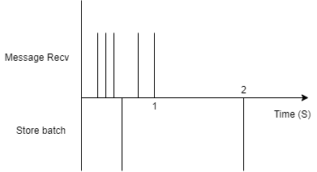
5. Choose a database that you think is best for your needs.
6. Store each batch into the database you choose. Limit the number of concurrent storing to 5 batches.
7. Dockerize your application.
8. Provide a docker-compose for the whole solution.

Notes:

1. You must use source control (GIT). Make sure your commits are readable and clear.
2. Write a README with instruction how to run your solution.
3. Pay attention to **performance**, **memory efficiency** and **simplicity**.
4. There can be **more than 1 producer**.
5. Your solution must have **more** than 1 goroutine.
6. Make sure you are using Golang best practices.