ImageLab Assessment 2
Short- and long-polling comparison
Daryn Forman | Report: 26 October 2026 | Experiments: 25 October 2026

1 Predictions recorded before testing
A — Quiet job: With a 30-second delay before real transformations, I expected short polling to send more requests because long polling avoids unnecessary checking.
B — Real progress: With real transformations only, I expected short polling to use fewer requests because the client stops when it detects completion.
C1 — Slow updates: With a 10-second simulated phase updating every 2 seconds, I expected long polling to use fewer requests because it waits for updates.
C2 — Fast updates: With a 10-second simulated phase updating every 200 ms, I expected short polling to use fewer requests because each check could reflect several intervening updates.
C3 — Fast updates with latency: Repeating C2 with added latency, I expected both modes’ detection delays to increase because responses take longer to arrive, with roughly the same request counts as C2.

2 Experimental method
Thirty runs used the real Firefox UI, Go API, PostgreSQL and one worker: five conditions × two modes × three repetitions. The recorder automated uploads and read the existing client log. Configurations recorded the same VALID-beach.png hash and transformation settings: 150 × 150 crop, preview within 800 × 600, and display within 1200 × 900. Final metadata recorded all three variants in every run.
The recorder checked for zero queued/processing jobs before each upload and used one controlled observer. Separate SQL check output was not retained. Each condition alternated mode-first order: short/long, long/short, short/long. Visibility samples stayed foreground; continuous visibility was not recorded.
Both modes began with a prompt snapshot, whose version became the baseline. Short polling waited 1,000 ms after each response/render, rather than between request starts; logs show no overlap. Long polling immediately renewed active responses, holding up to 20 seconds, with a 30-second client timeout. The window ran from first observation GET start to terminal JSON receipt, excluding upload and timing probes.
Detection delay = browser Date.now() at terminal JSON receipt − server wall-clock log immediately after terminal commit, matched by job ID and version on the same computer. This estimates availability-to-receipt delay; rendering timestamps record DOM updates, not screen paint. Processing duration = completed_at − started_at, including configured waits: 30 seconds in A and the 10-second simulated phase in C1–C3. Actual commits were logged; the UI labelled simulated progress; simulation_step stayed separate from real variants_completed and preceded transformations.
Only C3 used Firefox Network Monitor throttling: latency 200 ms, upload/download limits 1,000,000,000 bytes/s. Before each upload, five prompt health-GET timings with and without throttling gave median increases of 174–285 ms (baseline 6–51 ms; throttled 216–292 ms). This was approximate added latency, not exactly 200 ms. Other conditions had no configured added latency.

3 Measured results
Table 1. Median (minimum–maximum), three runs per cell. GETs count request starts, including the initial snapshot; uploads and health probes are excluded. Delay is measured in milliseconds (ms).
Condition | GETs  Short | GETs  Long | Delay (ms)  Short | Delay (ms)  Long
A | 32 (31–32) | 6 (6–6) | 693 (128–773) | 13 (3–21)
B | 2 (2–2) | 5 (5–6) | 111 (29–221) | 10 (7–12)
C1 | 12 (12–12) | 10 (10–11) | 427 (102–905) | 8 (7–39)
C2 | 12 (12–12) | 55 (55–56) | 346 (323–830) | 12 (4–14)
C3 | 10 (9–10) | 44 (42–45) | 542 (426–1221) | 425 (415–484)
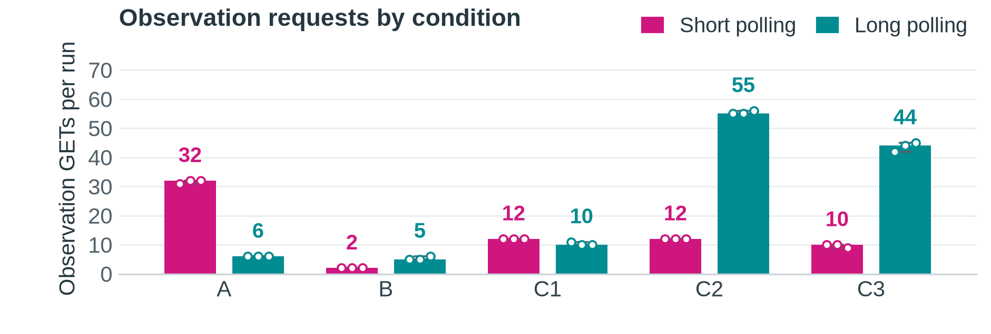
Figure 1. Bars and numeric labels show median GETs per run; dots show the three runs and lines show minimum–maximum. A: quiet; B: real; C1: slow updates; C2: fast updates; C3: fast updates with latency.
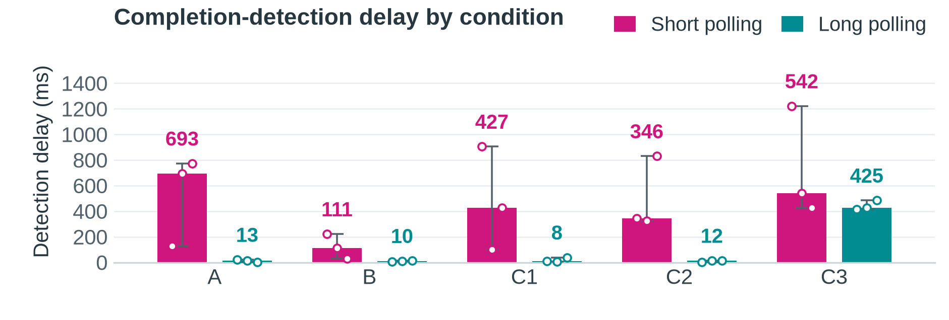
Figure 2. Bars and numeric labels show median detection delay (ms); dots show individual runs and lines show minimum–maximum. C3 prompt-GET median increases were 174–285 ms. Conditions match Figure 1.
All 30 measured runs reached completed with three variant records; no observation errors, cancellations or pending requests remained. The separate runs.csv contains every required per-run metric. Supporting client/server logs, snapshots and summaries retain received/committed versions, gaps and timing evidence. One incomplete recorder setup attempt is outside this measured series.

4 Interpretation and limitations
Long polling helped most during quiet work: A fell from 32 to 6 median GETs and from 693 to 13 ms median detection delay. Across the three A short runs, 86 of 95 GETs returned unchanged snapshots. C1 also used fewer long-poll GETs (10 versus 12). These results support my A and C1 request predictions.
Long polling did not minimise requests in B, C2 or C3. B finished quickly enough for short polling to use two GETs, while long polling observed more milestones. Both modes stop at completion, so that part of my B reasoning was not unique to short polling. C2 supported my request prediction (12 versus 55 median GETs), but each response is one current snapshot, not a list of events. C3 increased both median delays relative to C2; counts fell to 10 and 44, rather than staying roughly unchanged. Longer response cycles can span several commits. Although long polling had lower median delay in all conditions, C3 repetition 3 favoured short polling: 426 versus 484 ms.
These are observation results, not evidence that long polling accelerates image processing. The worker follows the same transformations independently. For example, B processing-duration medians were 217.594 ms (short) and 451.356 ms (long), with only three runs each. Configured waits dominate A and C1–C3; subtracting them would still leave database and scheduling time, not pure transformation time.
Fewer HTTP requests need not mean fewer SQL queries. In C1, median observation reads were 13 for short polling and 20 for long polling despite fewer long-poll GETs. This handler waits on notifications, not periodic SQL polling; reads occur on entry, wake-up and deadline recheck, with additional completed-result metadata reads. A server that repeatedly queried while waiting could hide further database work. These counters exclude worker queries; held-handler memory, CPU and connection reuse were not benchmarked.
The A-long-1 trace returned 204 after a 20.044-second request; the next GET started in the same receipt millisecond with after=2 unchanged. After an active 200, the browser must render, save the received version and immediately request again; after 204 it retains that version and renews. Terminal responses stop the loop. That run received versions 1, 2, 3, 4 and 6: missing version 5 did not lose the final result. If every event had to be retained, snapshots alone would be insufficient; durable event history and replay would be needed. A continuing response could instead carry separately framed updates that the browser reads incrementally, avoiding one new GET per update. This was not implemented.
Limitations include three repetitions, one image and one computer. Millisecond timestamps, JSON parsing, logging after commit and scheduling introduce uncertainty. Firefox monitoring was enabled only for C3, adding a possible tooling confound; latency was approximate. Foreground sampling and the unsaved queue-check output limit independent verification of those controls. Successful runs do not establish every failure/lifecycle acceptance check. No broad scaling or statistical-significance claim is justified.

5 Recommendation
Use long polling when prompt feedback matters and changes are occasional, as in A and C1. Keep short polling available when roughly one-second checks are acceptable and frequent updates would create many long-poll requests. The choice should follow feedback needs and measured server cost; neither mode is universally more efficient.
Evidence: runs.csv and matching *-client.json, *-server.log, *-snapshot.json, *-summary.json and *-prompt-get.json files in the accompanying evidence archive. Scope and definitions follow the teacher’s Assessment 2 brief and ImageLab Version 2 Requirements.

