Objectives
A digital thermometer with a multiplexed 7-segment display using the EasyPIC 7 demo board and the LM35 temperature sensor which measures temperature range between 0 and 100 °C and outputs voltage from 0 V to 1 V. A potentiometer is used to calibrate the temperature in range between 0 and 100 °C. The thermometer has the option of displaying the temperature in Celsius or Fahrenheit, toggled using the a push button. Temperature range are represented with LEDs:
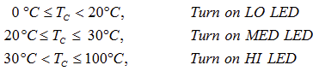

Program
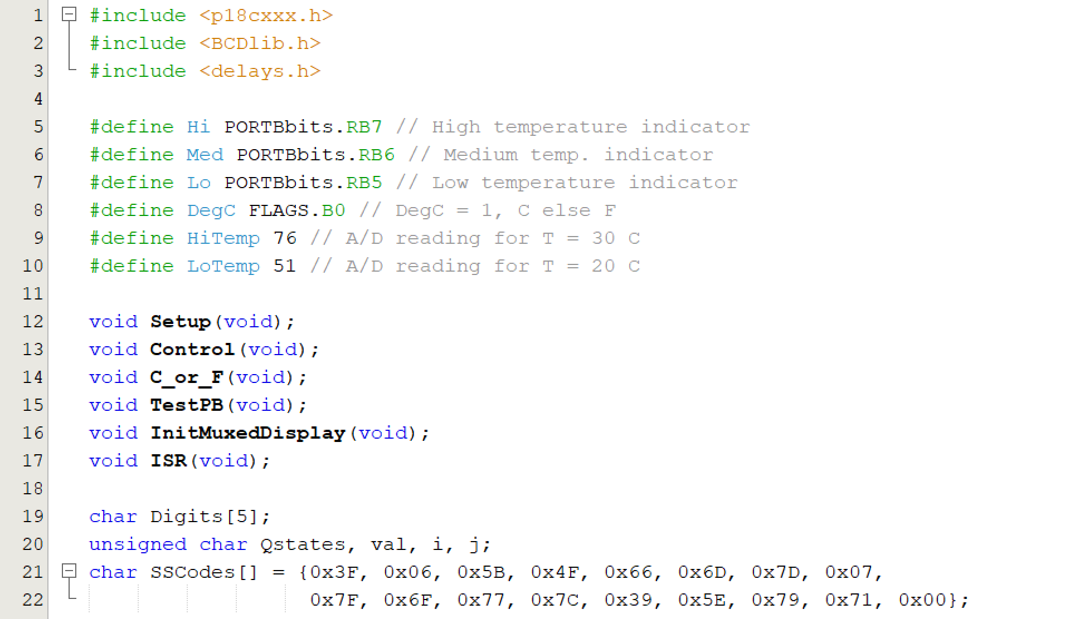Figure 1: Set up parameters

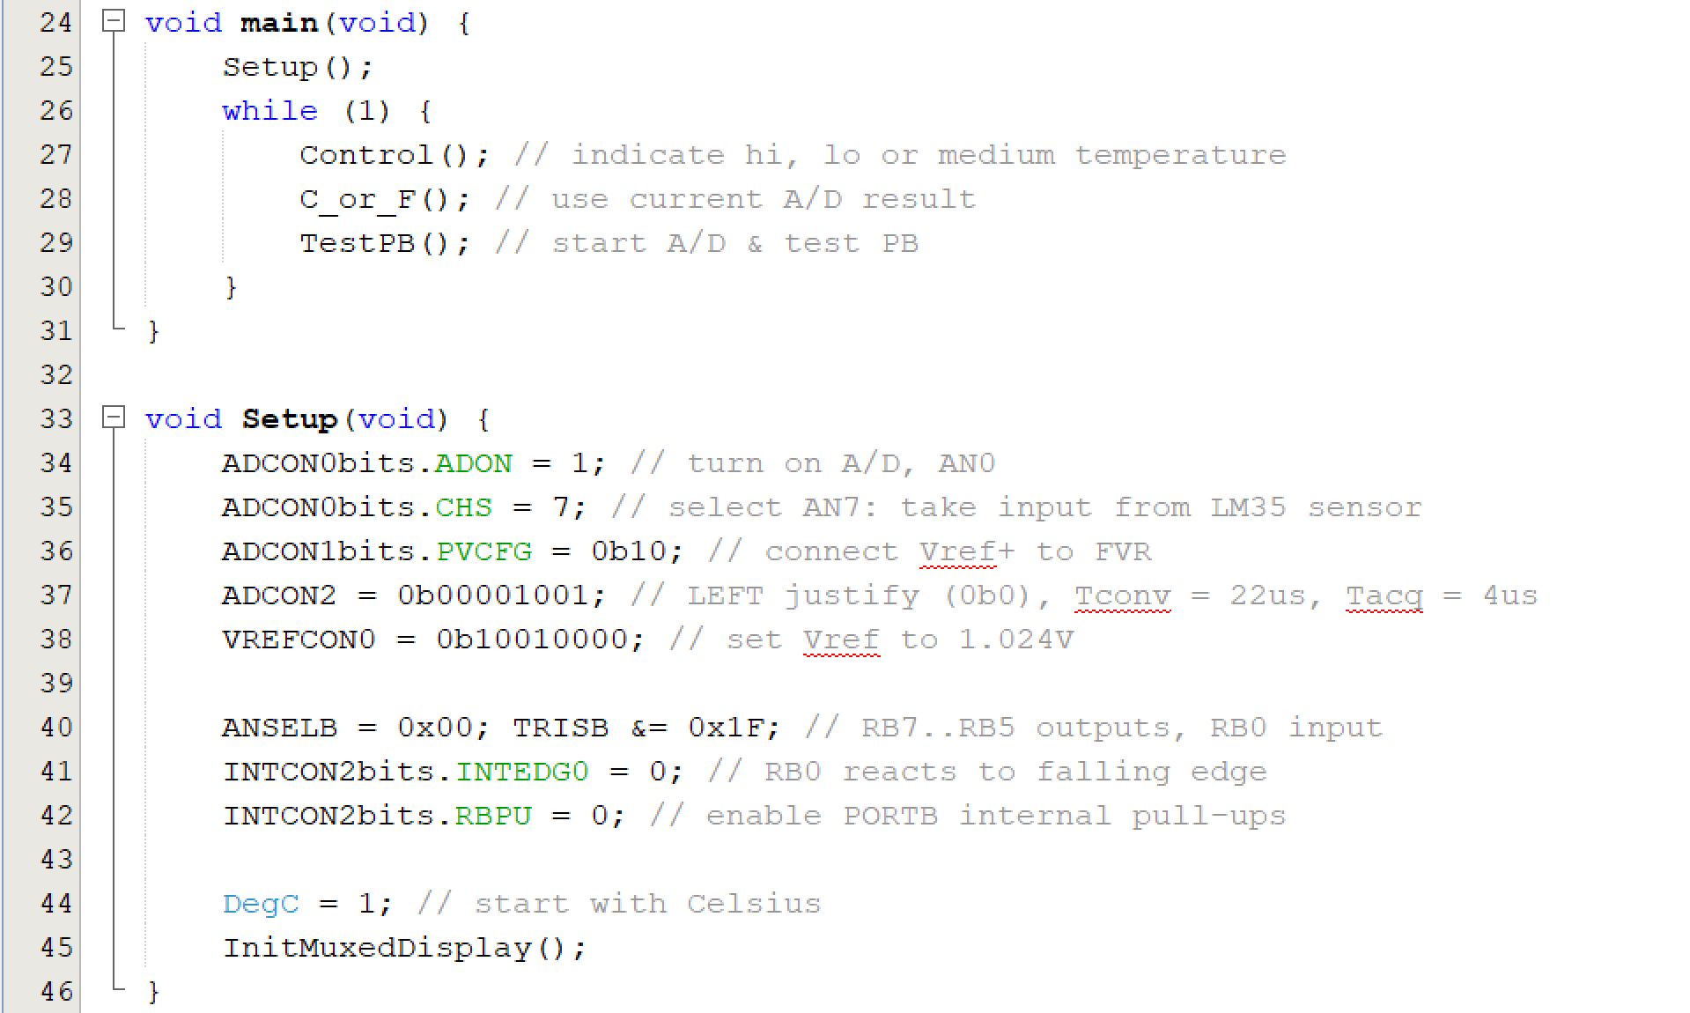
Figure 2: Main and Setup functions defined

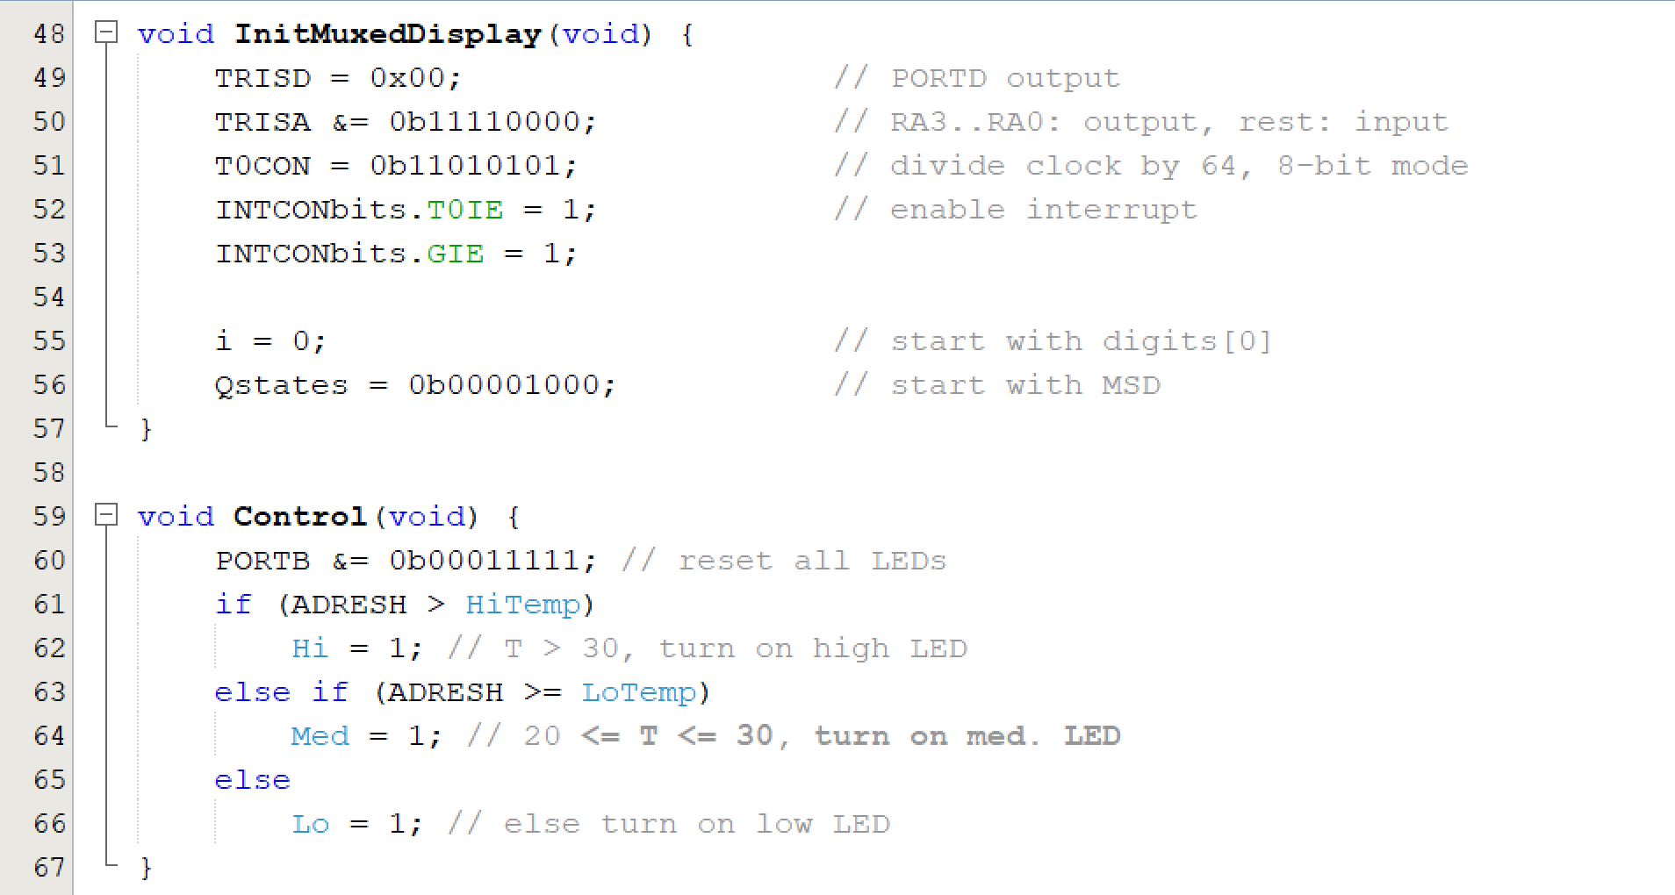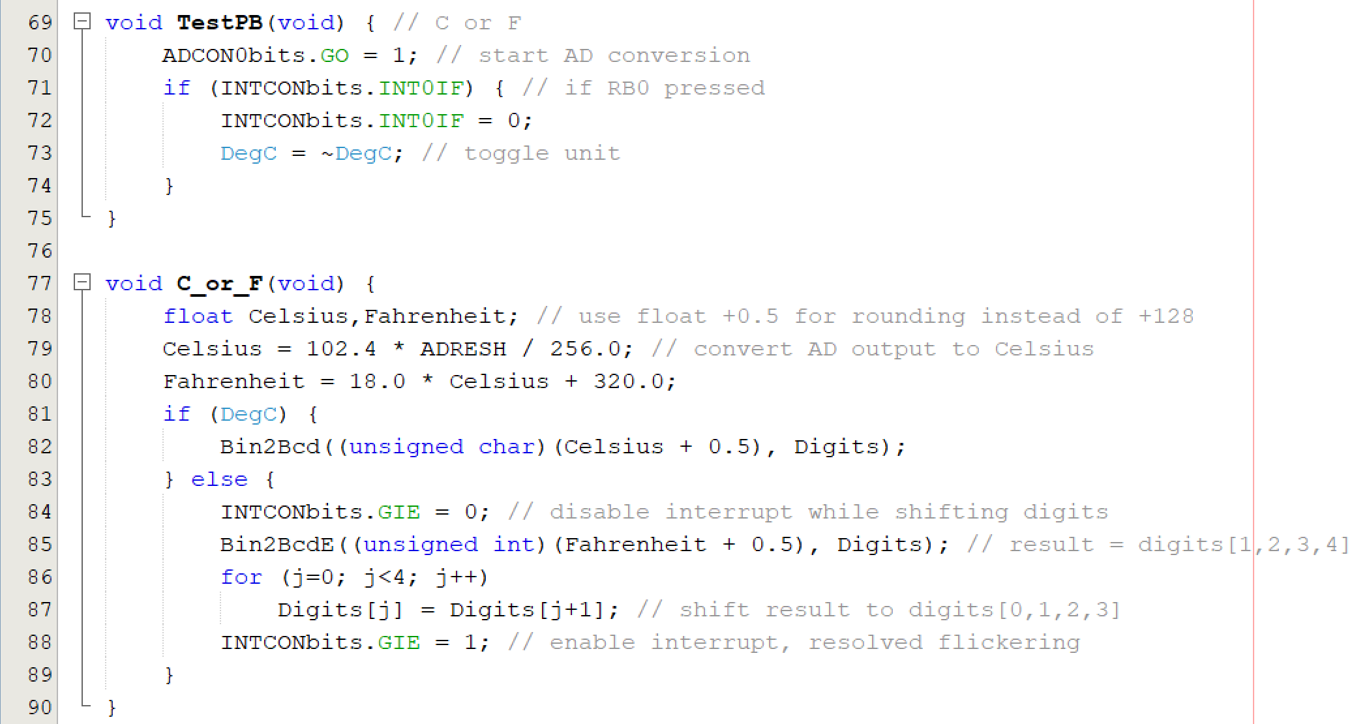
Figure 3: Digital Thermometer functionality and unit conversion defined
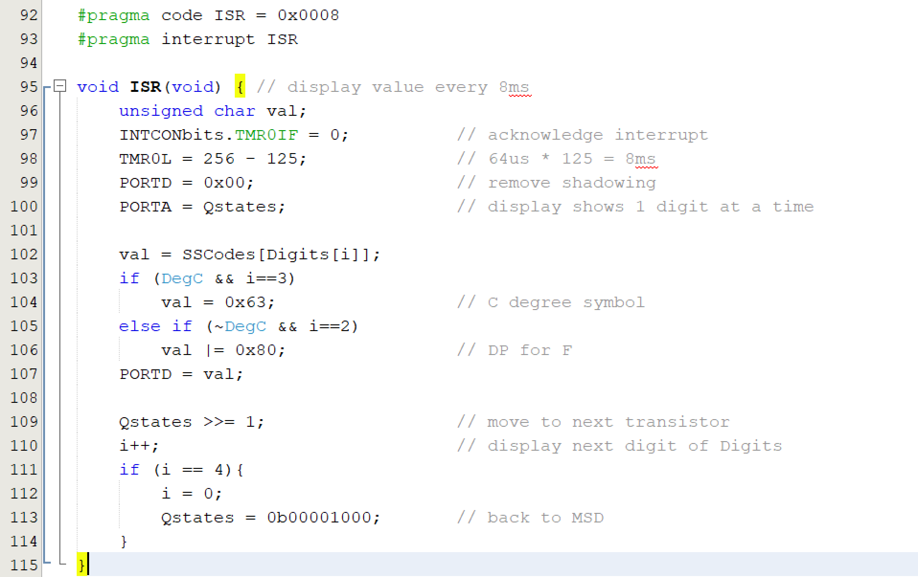
Figure 4: Interrupt setup to display value on multiplex 7-segment display
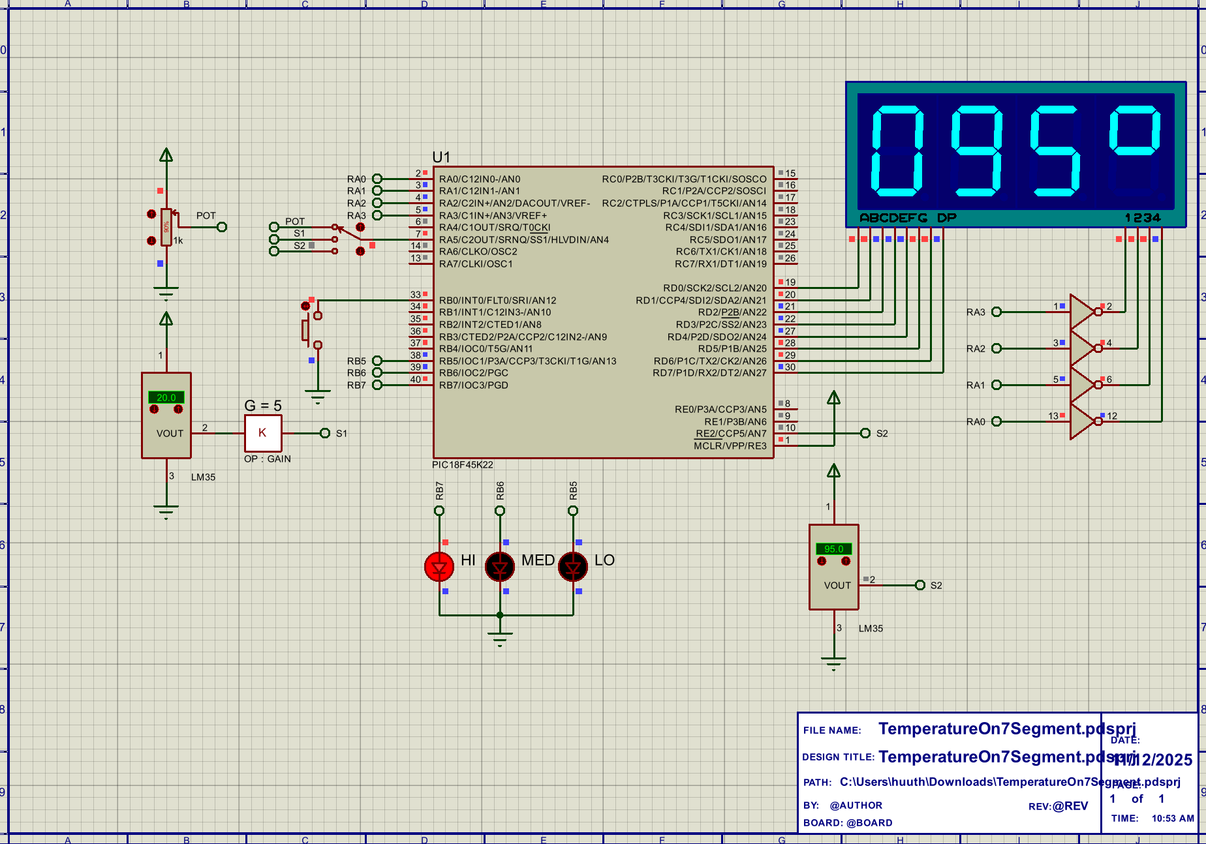
Figure 5: Proteus simulation

