

**LocalBlooms**

A Final Project Presented

to the College of Computing and Information Sciences

CARAGA STATE UNIVERSITY

Butuan City, Philippines

In Partial Fulfillment of the Requirements for the Subject

ITE 114 – Advanced Human Computer Interactions

**JKD Mikko Malcampo**

**Joshua Dexter Mah**

**Gil Vincent Padullon**

Bachelor of Science in Information Technology

December 2024

**TABLE OF CONTENTS**

Table of Contents

PART 1 PROJECT IDENTIFICATION 1

1.1 Description of the Project 1

1.2 Objectives of the Project 1

1.3 Scope of the Project 1

1.4 Rationale and Benefits of the Project 1

PART 2 PROJECT CONTEXT 3

2.1 Description of the User 3

2.2 Description of the Task / Goal 3

2.3 Description of the Equipment 3

2.4 Description of the Environment 4

PART 3 PROJECT DESIGN 5

3.1 Development Framework 5

3.2 User Interface Design 5

PART 4 PROJECT USABILITY EVALUATION 6

4.1 Usability Framework 6

4.2 Usability Testing 6

4.2.1 Performance Tasks 6

4.2.2 Task Success Rate 6

4.2.3 Error Rate 7

4.2.4 Task on Time 7

4.2.5 Time-Based Efficiency 8

4.2.6 Overall Relative Efficiency 8

4.2.7 Satisfaction Survey 8

PART 5 CONCLUSION AND RECOMMENDATIONS 9

5.1 Conclusion 9

5.2 Recommendations 9

REFERENCES 10

**LIST OF FIGURES**

**LIST OF TABLES**

Table 1 Performance Task 6

Table 2 Task Success Rate 6

Table 3 Error Rate 7

Table 4 Task on Time 8

Table 5 Time-Based Efficiency 8

Table 6 Overall Relative Efficiency 9

Table 7 Satisfaction Survey 9

# PART 1 PROJECT IDENTIFICATION

## 1.1 Description of the Project

***LocalBlooms*** *is a web-based platform designed to empower local flower retailers by expanding their reach and enhancing customer convenience. The platform will enable these businesses to sell their floral arrangements online, catering to various occasions such as weddings, birthdays, anniversaries, and funerals. By leveraging technology, LocalBlooms aims to bridge the gap between local florists and their potential customers.*

## 1.2 Objectives of the Project

1. ***Expand Market Reach:*** *Increase the visibility and accessibility of local flower retailers to a wider customer base beyond their physical store locations.*
2. ***Enhance Customer Experience:*** *Provide a user-friendly online platform that offers a seamless shopping experience, including easy browsing, secure payment options, and pickup services.*
3. ***Improve Operational Efficiency:*** *Streamline order processing, inventory management, and customer communication through automated systems and digital tools.*

## 1.3 Scope of the Project

*This project is to provide a e-commerce platform for local flower retailers to expand their reach. This project offers user to enable their businesses to sell flower online, catering to various occasion such as weddings, birthdays, anniversaries, and funeral, and features such as shopping cart, and secure checkout.*

## 1.4 Rationale and Benefits of the Project

*LocalBlooms will help local florists compete with larger internet stores by providing personalized service and locally produced products. This includes:*

***Improved Customer Satisfaction:*** *A user-friendly online platform and efficient customer service will enhance customer satisfaction and loyalty.*

***Operational Efficiency:*** *Automated systems and digital tools will streamline operations, reduce manual tasks, and improve overall efficiency.*

***Enhanced Brand Image:*** *A well-designed and professional online platform will elevate the brand image of local flower retailers.*

# PART 2 PROJECT CONTEXT

## 2.1 Description of the User

*Primary users of our website:*

* ***Seller****: A local shop responsible for creating and preparing flower arrangements.*
* ***Customers****: Individuals or businesses looking to purchase flowers for various occasions, such as birthdays, anniversaries. weddings, and funeral wreath.*
* ***Admin****: Manages the website, orders, and inventory.*

## 2.2 Description of the Task / Goal

*The primary goal of our website is to provide a convenient and efficient platform for local shops to sell their flowers and for customers to purchase flowers online. This includes:*

* ***Product Catalog****: Displaying a wide variety of flower arrangements.*
* ***Order Placement****: Allowing customers to select their desired flower, customize their orders.*
* ***Payment Processing****: Securely accepting online payments and cash on delivery.*
* ***Delivery Management****: Efficiently managing and tracking flower deliveries.*
* ***Inventory Management****: Maintaining accurate records of flower inventory.*

## 2.3 Description of the Equipment

* ***Computer or Laptops****: For website development, administration, and order processing.*
* ***Internet Connection****: For website hosting, online payments, and communications.*
* ***Delivery Tracking System****: A system for tracking flower deliveries.*
* ***Payment Gateway****: A system for processing online payments.*

## 2.4 Description of the Environment

*Our system is accessible and user-friendly on various devices, including:*

* ***PC****: For website administration, customer browsing, and order placement.*

# PART 3 PROJECT DESIGN

## 3.1Development Framework

* *The development of LocalBlooms utilizes a combination of frameworks and tools to ensure effective and efficient functionality for both users and administrators. These technologies are carefully selected to create a smooth and scalable platform:*

***Frontend Development****:*

* *The team uses ReactJS, a JavaScript library, to build the user interface (UI). ReactJS enables the creation of fast and interactive web applications, providing users with intuitive and engaging experience.*

***Backend Development****:*

* *For the backend, the team relies on plain JavaScript (Vanilla JS). This lightweight approach eliminates the need for additional frameworks, ensuring simplicity and complete control over backend logic. It handles essential tasks like user authentication, database interactions, and routing while maintaining a minimalistic and efficient codebase.*

***Development Tools****:*

* *The team utilizes Visual Studio Code (VS Code), a powerful and versatile code editor, to streamline coding tasks. For collaboration and version control, Git is employed, allowing the team to track changes, manage versions, and maintain seamless teamwork, ensuring all contributors work on the most up-to-date codebase without conflicts.*

## 3.2 User Interface Design

* *The LocalBlooms user interface is designed to offer engaging and user-friendly experience for both customers and sellers, facilitating seamless navigation and interaction with the flower shop platform.*

***Color Palette:***

* *The color palette of LocalBlooms primarily incorporates soft pastel tones and vibrant floral hues such as pinks, purples, and greens. These colors evoke feelings of elegance, joy, and warmth, reflecting the celebratory and emotional nature of occasions associated with flowers.*

***Typography:***

* *The fonts used are modern, stylish, and easy to read. A combination of a playful script font for headings and a clean sans-serif font for body text ensures a harmonious balance of elegance and readability.*

***Icons and Graphics:***

* *The interface features intuitive, floral-themed icons to represent key sections such as "Shops," "Shopping Cart," and "Accounts." Graphics include* *high-resolution flower images to enhance visual appeal and create a connection with the product.*

# PART 4 PROJECT USABILITY EVALUATION

## 4.1 Usability Framework

*Provide and discuss the diagram of Usability Framework*.

## 4.2 Usability Testing

## 4.2.1 Performance Tasks

 This figure shows the performance tasks of a system, designed to ensure smooth and efficient interactions with users.

## 4.2.2 Task Success Rate

*This chart illustrates the success rates of users completing various tasks. Each bar represents a task, categorized by complete success (blue), success with a minor problem (orange), success with a major problem (gray), and failure (yellow). Most tasks had high success rates, with either 100% complete success or 80% complete success combined with 20% and 60% minor issues. No major problems or failures were reported for any task.*

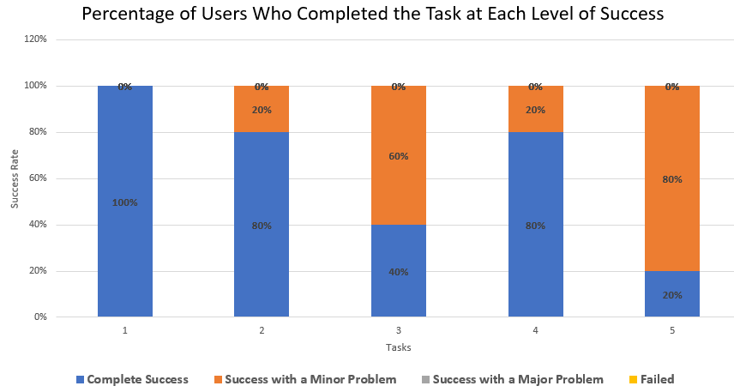

## 

## 4.2.3 Error Rate

*This figure shows the error rates of five tasks by comparing the total number of errors to the total number of attempts (each with 5 attempts), showing that tasks 1 have 0% error rate, 3 has 60% error rates, and 5 have 80% error rates, while tasks 2 and 4 have 20% error rates.*

## 4.2.4 Task on Time

*This figure illustrates the average time taken to complete five tasks, with task 5 having the longest average completion time of 70.8 seconds, indicating it was the most time-consuming, while tasks 2 and 4 were the quickest, with averages of 49 seconds and 52.4 seconds, respectively. task 3 required a moderate average time of 63.4 seconds, and task 1 fell in the mid-range at 56 seconds, highlighting variations in task complexity.*

## 4.2.5 Time-Based Efficiency

*This figure shows the summarizes of task performance for five users across five tasks. It shows the number of successful interactions or attempts (nij), the total time spent (tij), and the efficiency ratio (nij/tij) for each user*

## 4.2.6 Overall Relative Efficiency

*This figure shows the calculation of total performance (Total nij × tij), total task on time, and Overall Relative Efficiency (ORE) as percentages, highlighting varying performance across tasks.*

## 4.2.7 Satisfaction Survey

*This figure presents the results of a satisfaction survey evaluating user opinions. Responses are categorized as "Strongly Agree," "Agree," "Undecided," "Disagree," and "Strongly Disagree," with a total score and mean calculated for each task.*

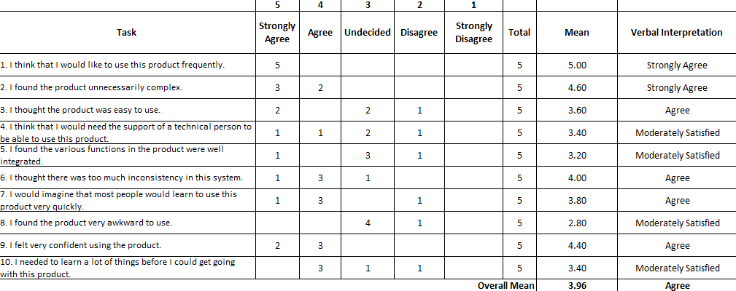

# PART 5 CONCLUSION AND RECOMMENDATIONS

## 5.1 Conclusion

* *The development and usability evaluation of LocalBlooms demonstrates its potential to address the challenges faced by local flower retailers in reaching customers and managing online orders effectively.*

*The platform simplifies the process of showcasing and purchasing floral arrangements, enhancing convenience and accessibility. User testing revealed that most tasks were performed successfully with minimal errors, highlighting the system’s ease of use and reliability. Efficiency metrics showed that while most interactions were quick and seamless, some areas could benefit from further optimization for faster task completion. Feedback from satisfaction surveys indicated that users found the platform intuitive and effective, with minor suggestions for improvement in functionality and design consistency.*

*In conclusion, LocalBlooms serves as a vital tool for empowering local florists, streamlining operations, and enhancing customer experiences, ultimately supporting the growth and sustainability of the local floral industry.*

## 5.2 Recommendations

* *To further enhance the usability and effectiveness of LocalBlooms, the following recommendations are proposed:*
* *1. Optimize Task Efficiency:*
* *Analyze and streamline processes for tasks that were identified as time-consuming during user testing. For example, improving the speed of product searches or simplifying the checkout process can enhance user satisfaction.*
* *2. Expand User Features:*
* *Incorporate additional features such as wish lists, personalized recommendations based on user preferences, and occasion-specific flower bundles to improve the overall user experience.*
* *3. Improve Seller Tools:*
* *Provide sellers with more advanced analytics and management tools, such as sales tracking, inventory alerts, and customer feedback summaries, to support their business growth.*
* *4. Regular User Feedback:*
* *Conduct periodic surveys and usability tests to gather insights from users and sellers, enabling continuous improvement based on real-world feedback.*

# REFERENCES