Testing EDKSsub

I test EDKS for

* Case 1: vertical finite strike slip fault (All the IDs are the same)

EDKS against OKADA finite fault displacements in which I subdivide the rectangle into many point sources: Plots show EDKS vs OKADA estimations. (E, N, U)

1. 2x2 point sources:

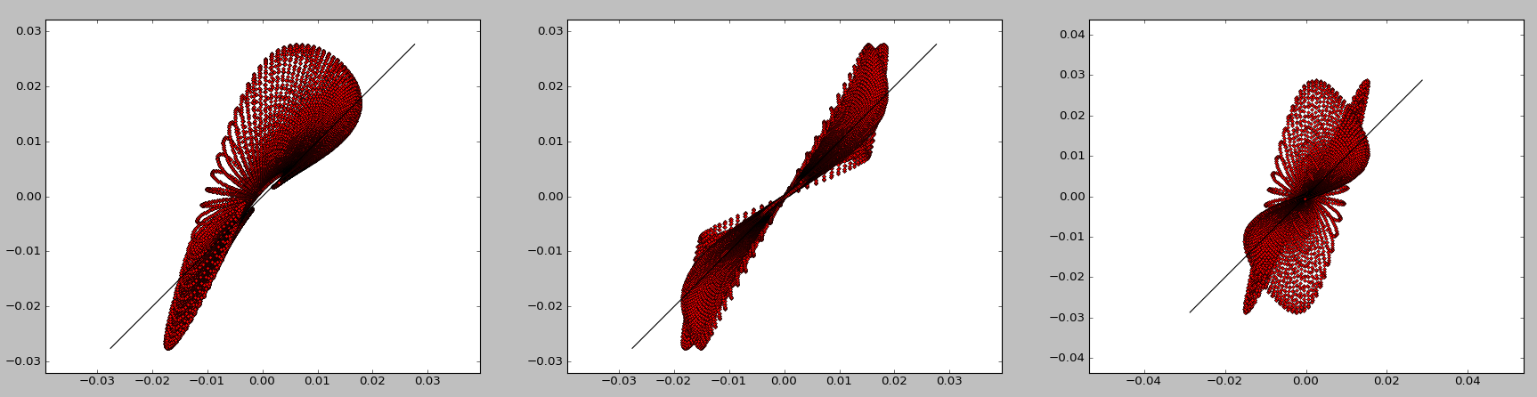

b) 4x4 point sources

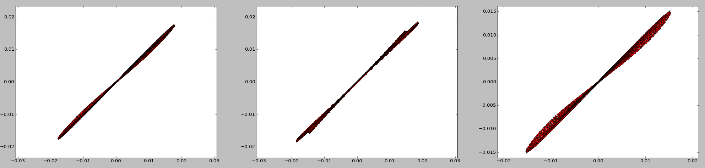

c) 8x8 point sources

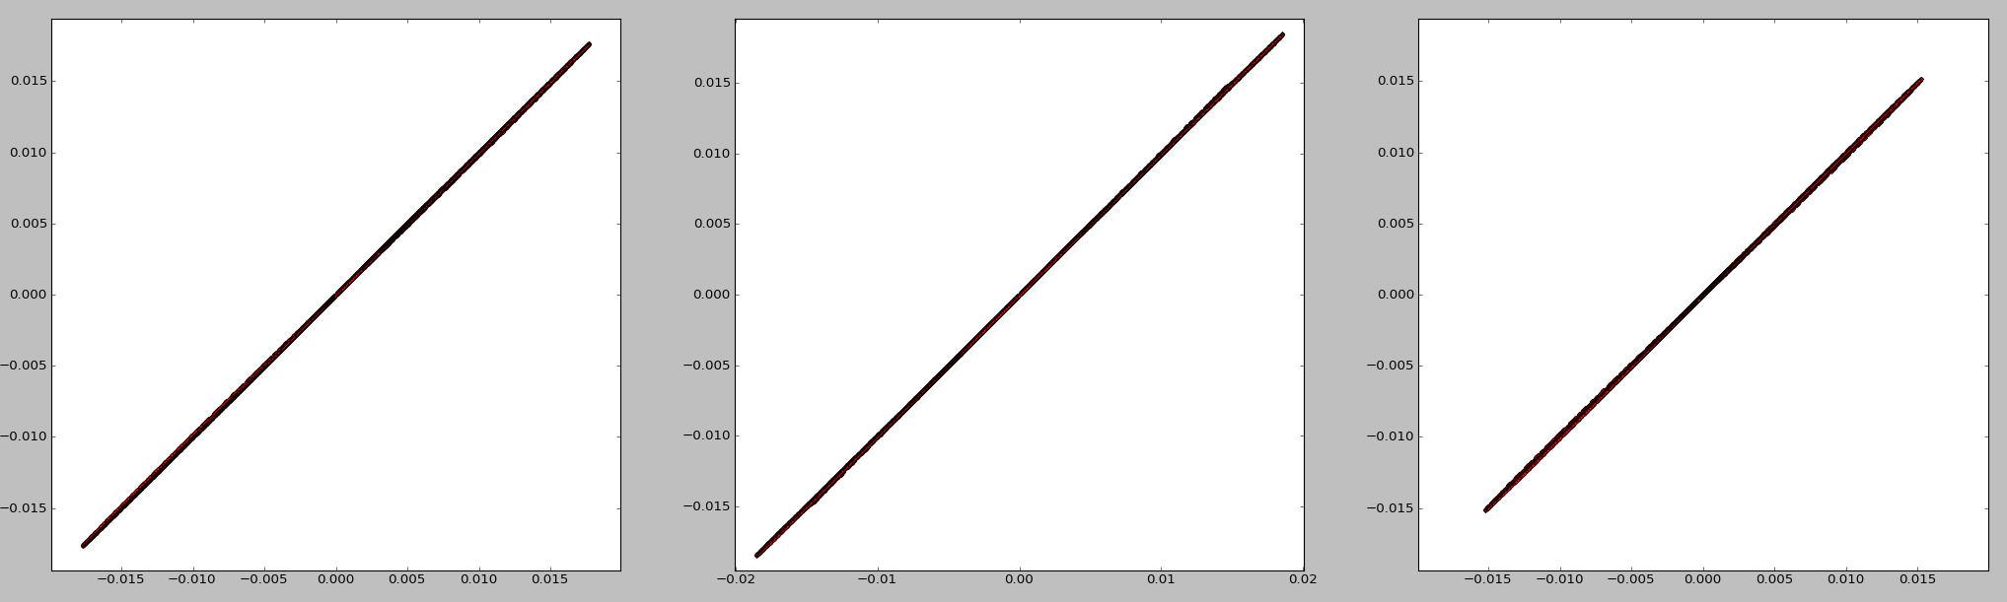

d) 50x50 point sources

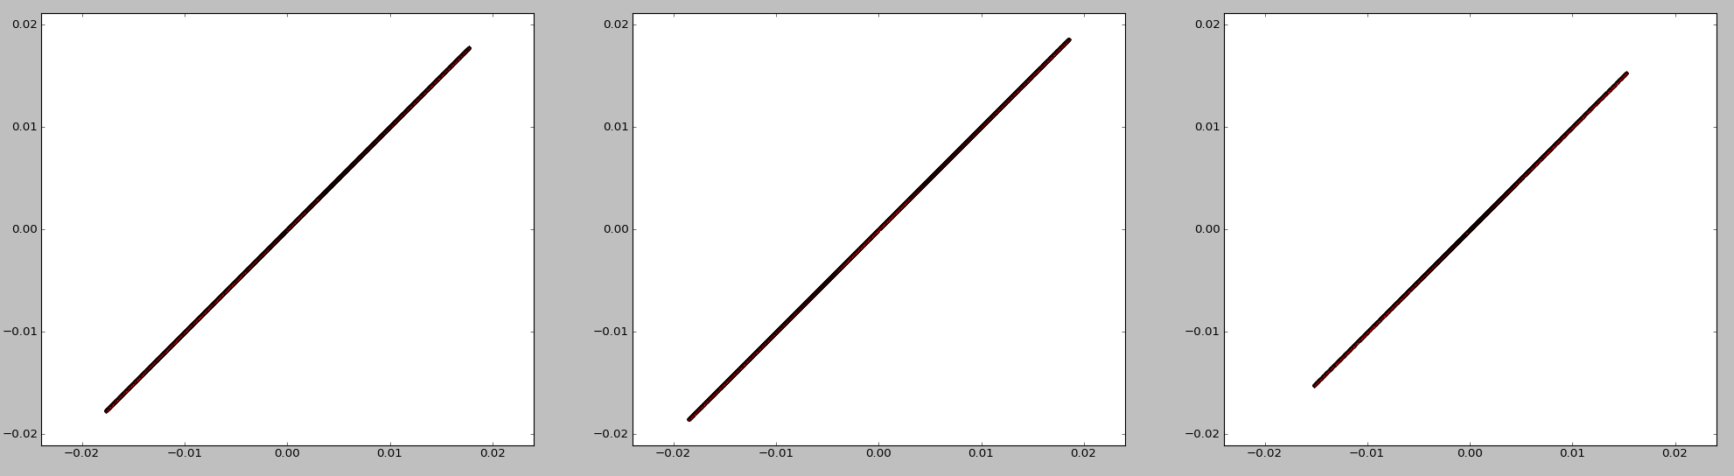

so it converges quite fast.

* Case 2: vertical finite strike slip fault (2 different IDs)

4x4

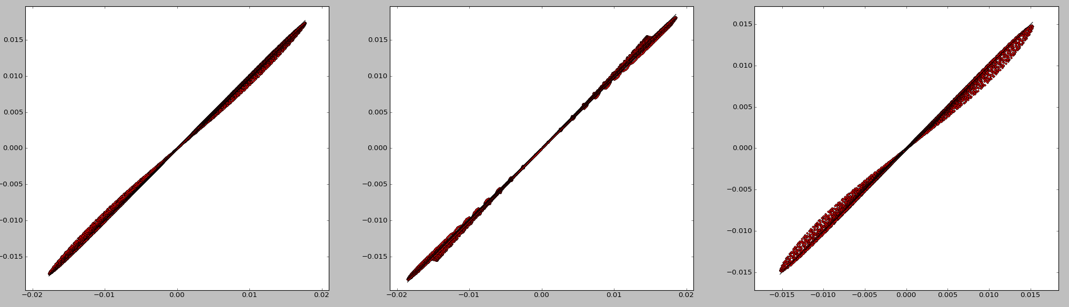

16x16

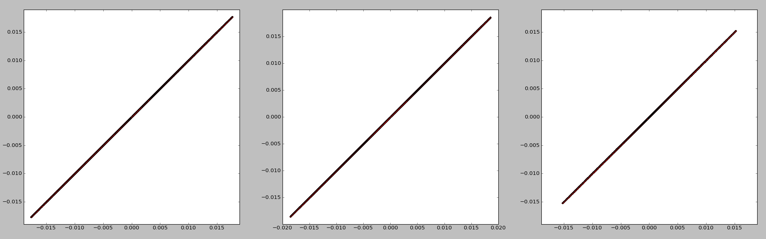

so it converges as before..

so there is not obvious bug in layered_disloc_sub.py nor in sum_layered_sub.f90