Project Report for Internship at Centre of Excellence for Quantum Computing, Institute of Engineering & Management, Kolkata.

Project Title: Comparative Analysis of Variational Quantum Circuit Ansatzes for Binary Classification

Repository: das-subho06/VQC-Trainability
Framework: PennyLane 0.45.0
Task: Binary Classification - Breast Cancer Wisconsin Dataset
Scope: Investigate trainability, and ansatz design in Variational Quantum Classifiers

Project Mentor: Prof. Dr. Amit Kumar Mandal

Duration: (15.05.2026 – 03.07.2026) Summer Internship, 2026

Submitted by:
Name: | Subhashree Das
Year: | 2nd
Department: | CSE(IOT CS BT)
Enrollment no.: | 12024052017066
Class Roll no.: | 64
Date of submission: | 01.07.2026

1. Abstract
Variational Quantum Classifiers (VQCs) are hybrid quantum-classical machine learning models that have gained significant attention as potential algorithms for near-term quantum devices. However, their performance is strongly influenced by the choice of circuit architecture, circuit depth, and number of qubits. This project presents a comparative study of two VQC ansatzes - a manually designed RY-CNOT circuit and PennyLane's built-in Strongly Entangling Layers - on the Breast Cancer Wisconsin dataset (having 569 samples) using the PennyLane framework.
The dataset was preprocessed using standardization followed by Principal Component Analysis (PCA), where the number of principal components was matched to the number of qubits. A total of 32 experiments were conducted by varying the qubit count (2, 4, 6, and 8) and circuit depth (2, 4, 6, and 8). The models were evaluated based on classification accuracy, training loss, gradient behaviour, and training time, while Logistic Regression, Support Vector Machine (SVM), and Random Forest served as classical baselines.
Experimental results indicate that the Strongly Entangling Layers ansatz consistently outperformed the manually designed circuit, achieving a maximum classification accuracy of 72.81%. Although the classical machine learning models achieved higher accuracies on this dataset, the study provides insights into the impact of ansatz design on VQC trainability and demonstrates the implementation and systematic benchmarking of variational quantum classifiers using PennyLane.

2. Introduction
Quantum Machine Learning (QML) combines principles of quantum computing with machine learning to explore new computational approaches for solving learning problems. Among the various QML algorithms, Variational Quantum Classifiers (VQCs) have emerged as one of the most promising methods for noisy intermediate-scale quantum (NISQ) devices. VQCs employ parameterized quantum circuits whose trainable parameters are optimized using classical optimization algorithms, forming a hybrid quantum-classical learning framework.
The performance of a VQC depends on several factors, including the choice of quantum circuit architecture (ansatz), the number of qubits, and the circuit depth. Increasing the complexity of a quantum circuit may improve its expressive power, but it can also increase computational cost and introduce optimization challenges such as vanishing gradients, commonly referred to as barren plateaus. Therefore, understanding how different circuit designs affect model performance is an important aspect of current quantum machine learning research.
This project investigates the effect of ansatz design and circuit complexity on the performance of Variational Quantum Classifiers using the Breast Cancer Wisconsin dataset. Two ansatz architecture - a manually designed RY-CNOT circuit and PennyLane's Strongly Entangling Layers - are implemented and evaluated across multiple qubit counts and circuit depths. The models are trained using the Adam optimizer and compared against classical machine learning algorithms including Logistic Regression, Support Vector Machine (SVM), and Random Forest.
The primary objectives of this project are:
- To implement and compare two different Variational Quantum Classifier architectures.
- To analyze the effect of circuit depth and qubit count on classification performance and training behaviour.
- To evaluate the trainability of the implemented quantum circuits through gradient analysis.
- To compare the performance of VQCs with established classical machine learning models on the same dataset.
The findings of this work provide an understanding of how ansatz selection influences the effectiveness of Variational Quantum Classifiers and highlight both the capabilities and current limitations of quantum machine learning models for binary classification tasks.

3. Methodology

3.1 Architecture & Code Structure
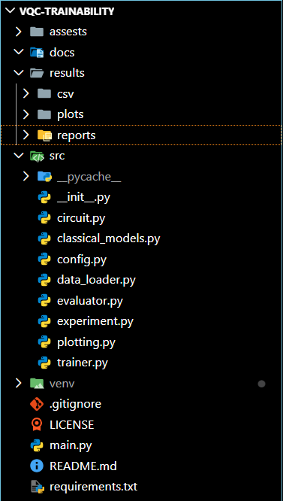
Dataset
↓
StandardScaler
↓
PCA
↓
AngleEmbedding
↓
VQC
↓
Training
↓
Evaluation
3.2 Key Configuration (src/config.py)
Parameter | Value
Dataset | Breast Cancer Wisconsin
Test Size | 20%
Epochs | 30
Optimizer | Adam (lr = 0.1)
Embedding | AngleEmbedding
Qubit Counts | [2, 4, 6, 8]
Circuit Depths | [2, 4, 6, 8]
Ansatzes | manual, strong
Random Seed | 42
3.3 Circuit Design
Manual Ansatz:
For each depth layer → RY rotations on all qubits + linear CNOT chain.
Weight shape: (depth, n_qubits)
Strongly Entangling Layers:
PennyLane's StronglyEntanglingLayers - arbitrary single-qubit rotations + all-to-all entanglement pattern.
Weight shape: (depth, n_qubits, 3)
Both circuits use AngleEmbedding for data encoding and qml.expval(qml.PauliZ(0)) as the measurement. Loss is MSE with targets ±1. The gradient norm ‖∇L‖ is tracked every epoch.
3.4 Dataset & Preprocessing
- Dataset: Scikit-learn Breast Cancer Wisconsin (569 samples, 30 features, binary labels)
- Preprocessing pipeline:
  - StandardScaler (zero mean, unit variance)
  - PCA to reduce to n_qubits components (2, 4, 6, or 8 features)
  - 80/20 train-test split → 455 train / 114 test samples
PCA ensures the data dimensionality matches the qubit count for AngleEmbedding.

4. Experimental Results
4.1 Summary by Ansatz
Ansatz | Mean VQC Accuracy | Mean Final Loss | Mean Training Time (s) | Mean Avg Gradient | Mean Final Gradient
manual | 61.84% | 0.8559 | 2,312.6 | 0.1046 | 0.0521
strong | 65.68% | 0.7939 | 4,336.3 | 0.0827 | 0.0457
The strong ansatz outperforms manual on average accuracy (+3.84%) and achieves lower final loss, at the cost of roughly 1.9× longer training time.
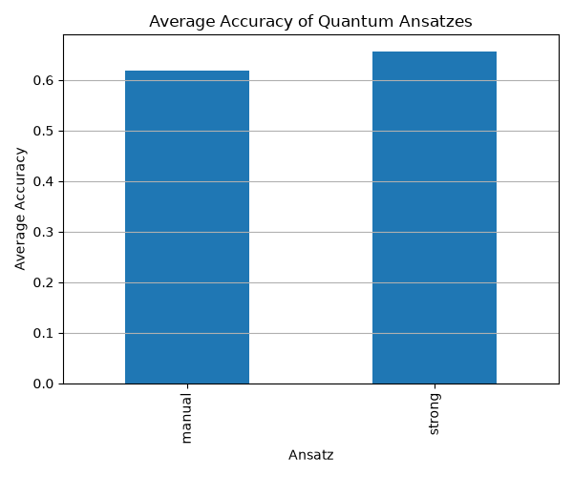
Figure 4.1: Comparison of average accuracy between the Manual and Strong ansatzes.

4.2 Full Results Table (All 32 Experiments)
Ansatz | Qubits | Depth | VQC Acc. | Final Loss | Avg Gradient | Final Gradient | Train Time (s) | LR Acc. | SVM Acc. | RF Acc.
manual | 2 | 2 | 62.28% | 0.9496 | 0.1003 | 0.0814 | 422.8 | 99.12% | 96.49% | 98.25%
manual | 2 | 4 | 61.40% | 0.8997 | 0.0769 | 0.0356 | 682.0 | 99.12% | 96.49% | 98.25%
manual | 2 | 6 | 64.04% | 0.8712 | 0.0676 | 0.0387 | 985.7 | 99.12% | 96.49% | 98.25%
manual | 2 | 8 | 62.28% | 0.8755 | 0.1573 | 0.0227 | 1228.9 | 99.12% | 96.49% | 98.25%
manual | 4 | 2 | 58.77% | 0.9789 | 0.2233 | 0.1322 | 887.8 | 97.37% | 96.49% | 95.61%
manual | 4 | 4 | 57.89% | 0.8566 | 0.1022 | 0.0240 | 2014.0 | 97.37% | 96.49% | 95.61%
manual | 4 | 6 | 65.79% | 0.7451 | 0.0868 | 0.0415 | 2427.3 | 97.37% | 96.49% | 95.61%
manual | 4 | 8 | 65.79% | 0.7445 | 0.1355 | 0.0500 | 2561.4 | 97.37% | 96.49% | 95.61%
manual | 6 | 2 | 64.04% | 0.9452 | 0.0246 | 0.0068 | 1213.7 | 98.25% | 97.37% | 95.61%
manual | 6 | 4 | 64.04% | 0.8771 | 0.0595 | 0.0577 | 2252.6 | 98.25% | 97.37% | 95.61%
manual | 6 | 6 | 64.04% | 0.8123 | 0.0620 | 0.0270 | 3558.0 | 98.25% | 97.37% | 95.61%
manual | 6 | 8 | 62.28% | 0.7136 | 0.0774 | 0.0353 | 4280.0 | 98.25% | 97.37% | 95.61%
manual | 8 | 2 | 53.51% | 1.0006 | 0.2335 | 0.1591 | 1547.0 | 99.12% | 96.49% | 94.74%
manual | 8 | 4 | 59.65% | 0.9217 | 0.0969 | 0.0386 | 2950.4 | 99.12% | 96.49% | 94.74%
manual | 8 | 6 | 63.16% | 0.7471 | 0.1015 | 0.0500 | 4276.9 | 99.12% | 96.49% | 94.74%
manual | 8 | 8 | 60.53% | 0.7560 | 0.0687 | 0.0328 | 5714.0 | 99.12% | 96.49% | 94.74%
strong | 2 | 2 | 70.18% | 0.9249 | 0.0965 | 0.0312 | 691.2 | 99.12% | 96.49% | 98.25%
strong | 2 | 4 | 65.79% | 0.8441 | 0.1229 | 0.0515 | 1260.0 | 99.12% | 96.49% | 98.25%
strong | 2 | 6 | 64.91% | 0.8427 | 0.1756 | 0.0743 | 1846.3 | 99.12% | 96.49% | 98.25%
strong | 2 | 8 | 64.91% | 0.8419 | 0.1543 | 0.0679 | 2388.8 | 99.12% | 96.49% | 98.25%
strong | 4 | 2 | 58.77% | 0.9508 | 0.0547 | 0.0405 | 1291.5 | 97.37% | 96.49% | 95.61%
strong | 4 | 4 | 72.81% | 0.6835 | 0.0793 | 0.0435 | 2440.8 | 97.37% | 96.49% | 95.61%
strong | 4 | 6 | 67.54% | 0.6709 | 0.0937 | 0.0457 | 5441.8 | 97.37% | 96.49% | 95.61%
strong | 4 | 8 | 71.93% | 0.6508 | 0.1142 | 0.0495 | 5460.7 | 97.37% | 96.49% | 95.61%
strong | 6 | 2 | 52.63% | 0.9277 | 0.0361 | 0.0176 | 1949.0 | 98.25% | 97.37% | 95.61%
strong | 6 | 4 | 62.28% | 0.7210 | 0.0576 | 0.0781 | 3721.0 | 98.25% | 97.37% | 95.61%
strong | 6 | 6 | 68.42% | 0.7177 | 0.0747 | 0.0487 | 5444.1 | 98.25% | 97.37% | 95.61%
strong | 6 | 8 | 71.05% | 0.6722 | 0.0747 | 0.0394 | 7471.5 | 98.25% | 97.37% | 95.61%
strong | 8 | 2 | 63.16% | 0.8957 | 0.0289 | 0.0145 | 2789.5 | 99.12% | 96.49% | 94.74%
strong | 8 | 4 | 63.16% | 0.7651 | 0.0522 | 0.0700 | 5195.8 | 99.12% | 96.49% | 94.74%
strong | 8 | 6 | 63.16% | 0.8085 | 0.0514 | 0.0306 | 9209.7 | 99.12% | 96.49% | 94.74%
strong | 8 | 8 | 70.18% | 0.7858 | 0.0563 | 0.0281 | 12779.5 | 99.12% | 96.49% | 94.74%
Best VQC configuration: strong, 4 qubits, depth 4 - 72.81% accuracy, F1 (weighted) 0.7203
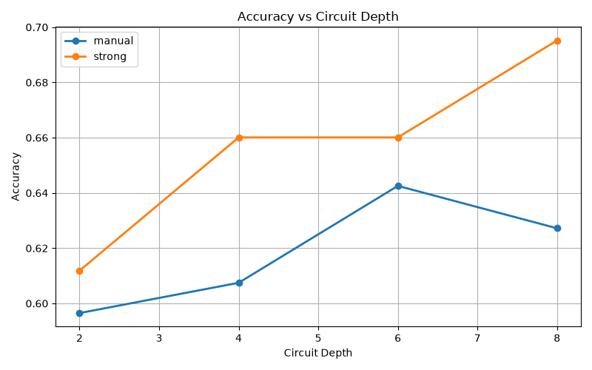
Figure 4.2: Accuracy vs. Circuit Depth.
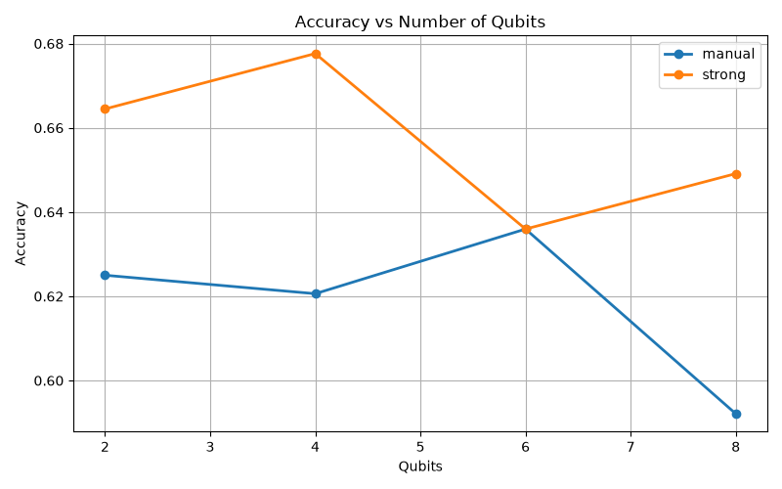
Figure 4.3: Accuracy vs. Number of Qubits.
4.3 Best VQC Classification Report - strong_q4_d4
precision recall f1-score support

0 0.6765 0.5349 0.5974 43
1 0.7500 0.8451 0.7947 71

accuracy 0.7281 114
macro avg 0.7132 0.6900 0.6961 114
weighted avg 0.7223 0.7281 0.7203 114
The model achieves high recall (84.5%) for class 1 (malignant), which is the clinically critical class. Precision on class 0 (benign) is lower, suggesting the model is biased toward predicting malignant - a pattern consistent with the class imbalance (71 malignant vs 43 benign in the test set).

4.4 Classical Baselines vs VQC
Model | 2-qubit or PCA | 4-qubit or PCA | 6-qubit or PCA | 8-qubit or PCA
Logistic Regression | 99.12% | 97.37% | 98.25% | 99.12%
SVM | 96.49% | 96.49% | 97.37% | 96.49%
Random Forest | 98.25% | 95.61% | 95.61% | 94.74%
Best VQC | 70.18% | 72.81% | 71.05% | 70.18%
Classical models consistently achieve 95–99% accuracy, while the best VQC reaches ~73%. The accuracy gap is approximately 25 percentage points on this task. This gap is expected given: (a) only 30 epochs of training on a simulator, (b) the inherent expressibility limits of shallow VQCs on classically well-separated data, and (c) the PCA compression reducing information.
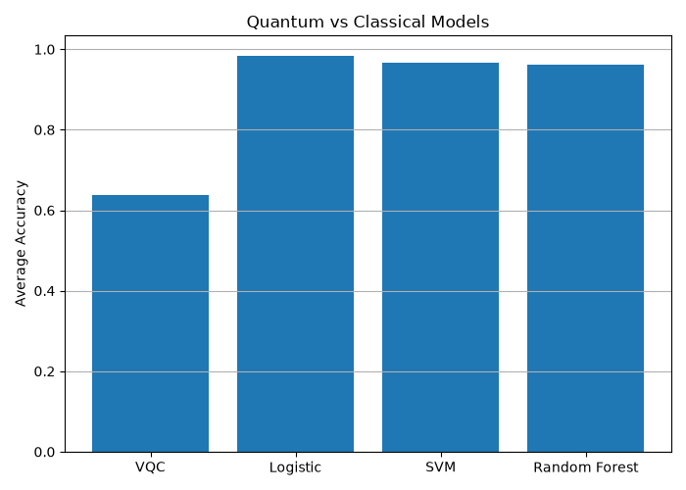
Figure 4.4: Comparison of the best VQC with classical machine learning models.

5. Gradient & Trainability Analysis
5.1 Gradient Behavior by Ansatz
Ansatz | Mean Avg Gradient | Mean Final Gradient
manual | 0.1046 | 0.0521
strong | 0.0827 | 0.0457
Both ansatzes maintain non-vanishing gradients across all configurations, suggesting barren plateaus are not a dominant issue at the scales tested (≤8 qubits, ≤8 layers, 30 epochs).
5.2 Training Time Scaling
Training time scales roughly linearly with circuit depth and quadratically with qubits due to the cost of PennyLane's parameter-shift gradient computation.
Qubits | Avg Train Time - manual (s) | Avg Train Time - strong (s)
2 | ~830 | ~1,547
4 | ~1,973 | ~3,659
6 | ~2,826 | ~4,646
8 | ~3,622 | ~7,494
The strongly entangling ansatz has ~3× more parameters per layer (depth × n_qubits × 3) vs manual (depth × n_qubits), explaining the higher wall-clock cost.
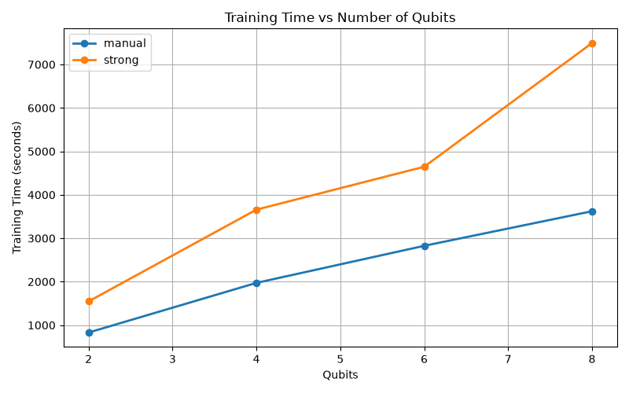
Figure 4.5: Training time of different VQC configurations.

6. Key Findings
- Strong ansatz outperforms manual. Mean accuracy 65.7% vs 61.8% (+3.9%). The richer entanglement structure of StronglyEntanglingLayers provides better expressibility.
- Sweet spot: 4 qubits, depth 4. The best VQC result (72.81%) occurs at moderate scale. Increasing to 6 or 8 qubits generally degrades performance, consistent with the curse of dimensionality in VQC training.
- Depth helps strong ansatz more than manual. For strong_q4, accuracy improves from 58.8% (d=2) to 72.8% (d=4). For manual_q4, the improvement plateaus after d=6.
- No catastrophic barren plateaus observed in the tested range, though gradient norms for strong_q8 are 3-4× smaller than for strong_q2, hinting at onset.
- Massive accuracy gap vs classical models. Classical baselines score 95-99%; the best VQC achieves 72.8%. For this classically easy dataset, quantum models are not yet competitive.
- Class 1 (malignant) recall is high (~84%) in the best configuration, which is medically desirable - missing a malignant case is worse than a false positive.

7. Conclusion
This project presented a comparative analysis of two Variational Quantum Classifier (VQC) ansatzes using the PennyLane framework on the Breast Cancer Wisconsin dataset. A total of 32 experiments were conducted by varying the number of qubits and circuit depths to evaluate their impact on classification accuracy, trainability, and computational cost.
The experimental results showed that the Strongly Entangling Layers ansatz consistently outperformed the manually designed RY-CNOT ansatz, achieving the best classification accuracy of 72.81% with 4 qubits and 4 circuit layers. The study also demonstrated that increasing circuit complexity does not necessarily improve performance, highlighting the importance of selecting an appropriate circuit architecture. Although the classical machine learning models significantly outperformed the VQCs on this dataset, the implemented framework successfully provides a systematic approach for benchmarking different VQC architectures and analyzing their training behaviour.
Overall, this project strengthened the understanding of hybrid quantum-classical machine learning workflows and demonstrated the practical implementation of Variational Quantum Classifiers using PennyLane. The developed framework can serve as a foundation for future investigations into more expressive quantum circuits, larger-scale datasets, and execution on real quantum hardware.

8. Limitations & Future Work
- Only 30 training epochs: classical models converge in milliseconds; VQCs may need more iterations to fully optimize.
- Single random seed per configuration: no variance estimation across initializations (the barren_plateau.py module exists for this but is not called in main.py).
- No data re-uploading: a known technique for improving VQC expressibility is not used.
- PCA information loss: reducing 30 features to 2–8 discards significant signal. The classical models use all 30 features.
- No noise modelling: all experiments run on the default.qubit statevector simulator; real hardware would degrade accuracy further.
- barren_plateau.py is not integrated: the module for multi-initialization gradient analysis is implemented but never invoked from the main pipeline.

9. Dependencies
Package | Version | Purpose
pennylane | 0.45.0 | Quantum circuit simulation
pennylane-lightning | 0.45.0 | Fast CPU backend
numpy | ≥2.0 | Numerical arrays
scipy | ≥1.16 | Scientific computing
scikit-learn | ≥1.7 | Dataset, preprocessing, classical models
pandas | ≥2.2 | Results tabulation
matplotlib | ≥3.10 | Plot generation

*****

