1. Front View

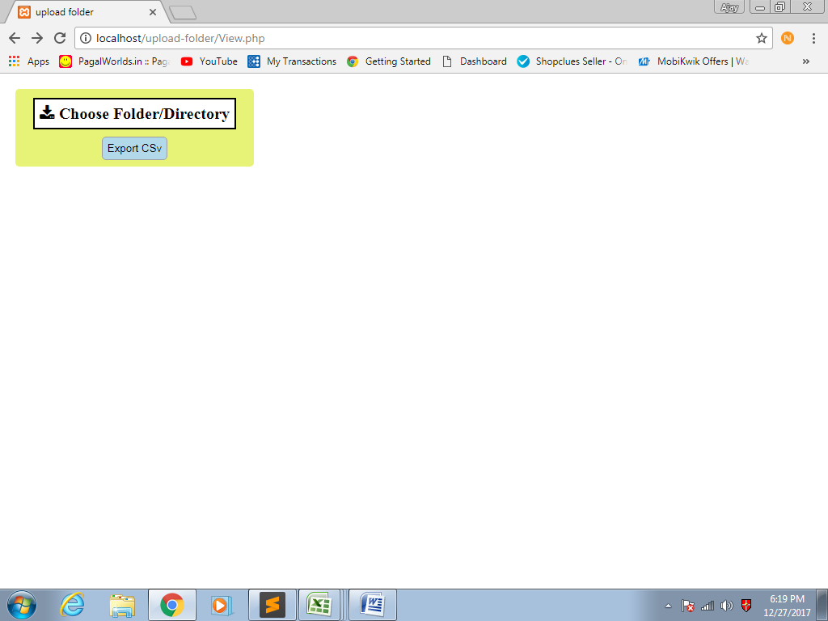

1. Click “Choose Folder/Directory” button ->Browse and select any folder in popup

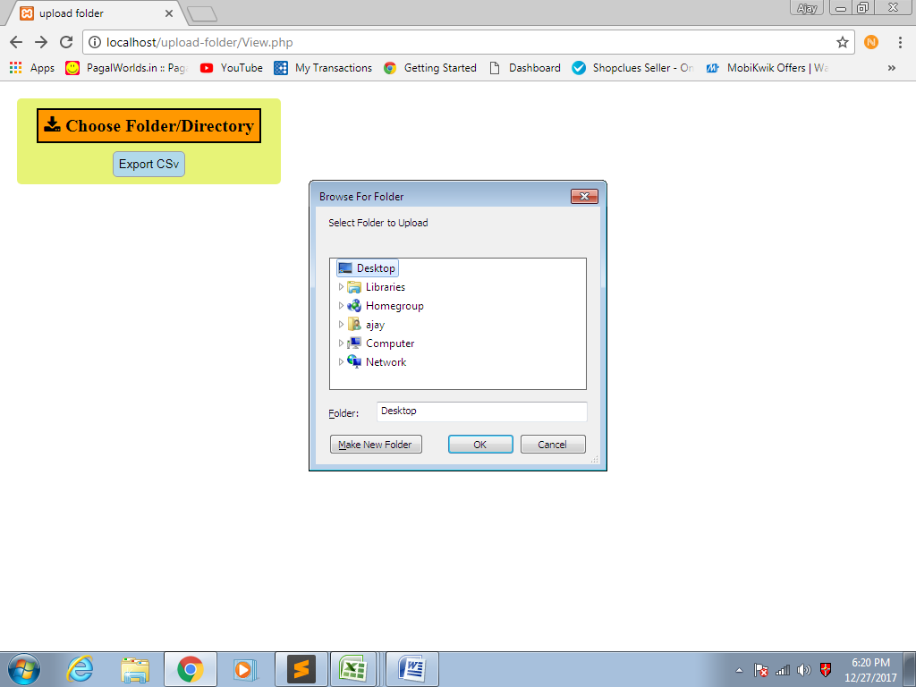

1. Click “Export to CSV” button to export the details of files of selected folder into CSV files .

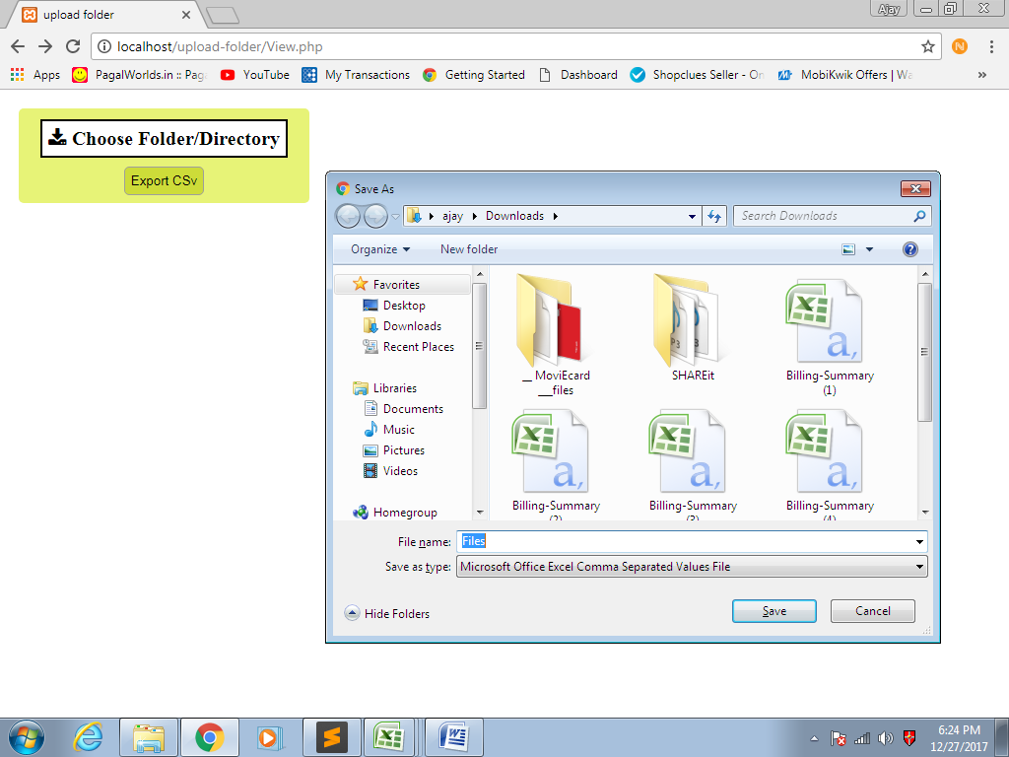

1. CSV file:-

