Absolutely! Let's learn this topic from ZERO, assuming you have never studied statistics before. I'll teach you like a classroom teacher, with simple definitions, real-life examples, Python code, and practice questions.
From your folder path:
Day_3 → 02_Statistics → 01_data_population
I understand that you want to learn Data Population in Statistics.
Let's start from the basics.
Day 3 – Statistics: Data Population
1. First, what is Statistics?
Imagine you are a teacher in a college. There are 100 students in your class, and you want to know their average marks.
You have two options:
- Ask all 100 students about their marks.
- Ask only 10 students about their marks and estimate the average.
Statistics helps you collect, organize, analyze, interpret, and understand data.
Definition: Statistics is the science of collecting, organizing, analyzing, interpreting, and presenting data.
Where do we use Statistics?
- Companies use statistics to understand customer behavior.
- Hospitals use statistics to analyze patient data.
- Banks use statistics to detect fraudulent transactions.
- Data scientists use statistics to build Machine Learning models.
- Colleges use statistics to analyze student performance.
2. What is Data?
Data means a collection of facts, values, or information.
For example, suppose we have marks of five students:
Student | Marks
A | 80
B | 70
C | 90
D | 60
E | 100
This table is called data.
In Python, we can represent this data using a list:
marks = [80, 70, 90, 60, 100]

print(marks)
Output:
[80, 70, 90, 60, 100]
3. What is Population?
Important concept
Population means the entire group of individuals or objects that we want to study.
Let's understand with an example.
Imagine your college has 1,000 students.
You want to calculate the average height of all students in your college.
Here:
- Total students = 1,000
- Every student belongs to your study.
- All 1,000 students together are called the Population.
Large group of people
Example:
population = [150, 155, 160, 165, 170,
172, 175, 180, 185, 190]

print("Population:", population)
print("Total people:", len(population))
Output:
Population: [150, 155, 160, 165, 170, 172, 175, 180, 185, 190]
Total people: 10
Here, our population contains 10 people.
Remember: Population does not always mean people. It can be:
- All products manufactured by a company.
- All transactions made by a bank.
- All students in a college.
- All houses in a city.
- All cars manufactured in a year.
4. What is a Sample?
A sample is a small part of the population selected for analysis.
Let's continue our college example.
Your college has 1,000 students, but collecting height information from everyone takes time.
So, you select 100 students randomly.
Now:
- Population = 1,000 students.
- Sample = 100 selected students.
Why is Sampling Important?
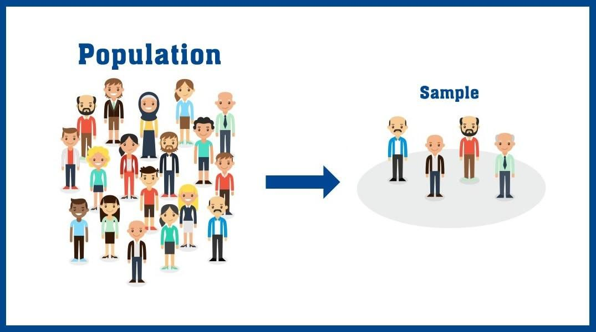
linkedin.com
Why do we use samples?
- Saves time.
- Saves money.
- Makes data collection easier.
- Helps us understand a large population.
Python example
import random

population = [150, 155, 160, 165, 170,
172, 175, 180, 185, 190]

sample = random.sample(population, 4)

print("Population:", population)
print("Sample:", sample)
Possible output:
Population: [150, 155, 160, 165, 170, 172, 175, 180, 185, 190]

Sample: [160, 170, 185, 150]
Notice that we selected only four values from ten values.
Here, random.sample() selects unique elements randomly.
5. Difference between Population and Sample
This is very important for interviews and examinations.
Population | Sample
Entire group | Small part of the group
Usually larger | Usually smaller
Includes all members of interest | Includes selected members
More expensive to study completely | Less expensive to study
Example: 1,000 students | Example: 100 students
Easy trick to remember:
- Population = Everyone.
- Sample = Selected few.
6. What are Parameter and Statistic?
These two terms are closely related to population and sample.
Let's understand with an example.
Suppose your college has 1,000 students.
You calculate the average height of all 1,000 students.
Suppose the average is 165 cm.
This average is called a Parameter because it describes the entire population.
Now you select 100 students and calculate their average height.
Suppose their average is 163 cm.
This average is called a Statistic because it describes the sample.
Term | Meaning | Example
Parameter | Numerical value describing population | Average height of all 1,000 students
Statistic | Numerical value describing sample | Average height of 100 selected students
Remember:
- Parameter → Population
- Statistic → Sample
7. What is Census?
Census means collecting information from every individual in a population.
For example:
The government wants to collect information about every household in a country.
It collects information from every household rather than selecting only a few.
That is called a Census.
घर-घर कौन गिनता है लोगों को? जनगणना के पीछे किसकी ड्यूटी और कितनी मिलती है कमाई! - Who conducts census which department is responsible what salary they get ngix - AajTak

aajtak.in
Census vs Sampling
Census | Sampling
Studies everyone | Studies selected individuals
Takes more time | Takes less time
Usually more expensive | Usually less expensive
Example: National population census | Example: Surveying 500 voters
8. Let's perform Statistics using Python
Now let's apply what we learned.
We will use NumPy, which is a Python library used for numerical calculations.
First install NumPy if you haven't installed it:
pip install numpy
Step 1: Create population data
import numpy as np

population = np.array([10, 20, 30, 40, 50,
60, 70, 80, 90, 100])

print(population)
Step 2: Calculate population size
print("Population Size:", len(population))
Output:
Population Size: 10
Step 3: Calculate population mean
Mean means average.
Formula:
\[ Mean = \frac{\text{Sum of all values}}{\text{Number of values}} \]
mean = np.mean(population)

print("Population Mean:", mean)
Output:
Population Mean: 55.0
Step 4: Calculate population median
Median means the middle value after arranging data in ascending order.
median = np.median(population)

print("Population Median:", median)
Output:
Population Median: 55.0
Step 5: Calculate population standard deviation
Standard deviation tells us how spread out the values are around the mean.
std = np.std(population)

print("Population Standard Deviation:", std)
Output:
Population Standard Deviation: 28.72
Complete code
import numpy as np

population = np.array([10, 20, 30, 40, 50,
60, 70, 80, 90, 100])

print("Population:", population)

print("Population Size:", len(population))

print("Mean:", np.mean(population))

print("Median:", np.median(population))

print("Standard Deviation:", np.std(population))
9. Test your understanding
Let's check whether you understood today's concepts.
Statistics beginner quiz
0/4 answered
1. A college has 2,000 students. You want to study all students. What is the population?
100 students
2,000 students
500 students
2. You select 200 students from those 2,000 students. What are the 200 students called?
Population
Parameter
Sample
3. The average height of every student in a college is called?
Statistic
Parameter
Sample
4. What is Census?
Studying everyone
Studying selected people
Calculating average
Submit answers
10. What we will learn next
Statistics has several important topics, and we will learn them one by one.
01
Data and Population
Population, sample, parameter, statistic and census
Learning
02
Types of Data
Qualitative, quantitative, discrete and continuous data
Next
03
Measures of Central Tendency
Mean, median and mode
04
Measures of Dispersion
Range, variance and standard deviation
05
Data Distribution
Normal distribution, skewness and kurtosis
06
Sampling Techniques
Random, stratified, systematic and cluster sampling
One important thing: I can see your folder path, but I cannot directly access files on your computer from that path. If you upload the files or screenshots inside 01_data_population, I can teach you according to your actual CDAC classroom material, line by line.
For now, focus on understanding these four concepts:
- Population
- Sample
- Parameter
- Statistic
Don't rush. Understanding these four concepts will make the remaining statistics topics much easier.

