Ejemplo de R Markdown

Curso de Estadística Descriptiva

21/12/2018

## R Markdown

This is an R Markdown document. Markdown is a simple formatting syntax for authoring HTML, PDF, and MS Word documents. For more details on using R Markdown see <http://rmarkdown.rstudio.com>.

When you click the **Knit** button a document will be generated that includes both content as well as the output of any embedded R code chunks within the document. You can embed an R code chunk like this:

summary(cars)

## speed dist   
## Min. : 4.0 Min. : 2.00   
## 1st Qu.:12.0 1st Qu.: 26.00   
## Median :15.0 Median : 36.00   
## Mean :15.4 Mean : 42.98   
## 3rd Qu.:19.0 3rd Qu.: 56.00   
## Max. :25.0 Max. :120.00

## Including Plots

You can also embed plots, for example:

plot(pressure)

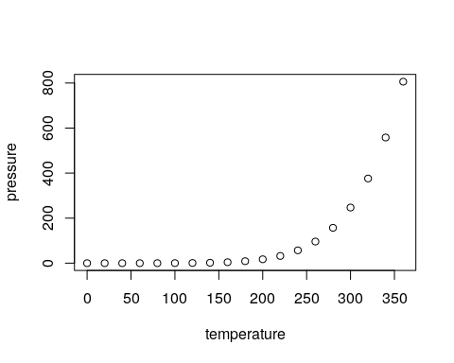

Note that the echo = FALSE parameter was added to the code chunk to prevent printing of the R code that generated the plot.

### Nuestras propias chunks

Vamos a calcular $\sqrt{2}−e^{−2}$:

sqrt(2) - exp(-2)

## [1] 1.278878

x = 1:5  
sqrt(x)

## [1] 1.000000 1.414214 1.732051 2.000000 2.236068

library(magic)

## Loading required package: abind

magic(6)

## [,1] [,2] [,3] [,4] [,5] [,6]  
## [1,] 7 6 35 34 15 14  
## [2,] 8 5 33 36 16 13  
## [3,] 27 26 19 18 11 10  
## [4,] 25 28 20 17 9 12  
## [5,] 23 22 3 2 31 30  
## [6,] 21 24 1 4 29 32

Cuando queremos hacer la raíz cuadrada de dos, podemos hacerlo:

* En $\LaTeX$: $\sqrt{2}$
* En R haciendo 1.4142136
* La frase completa: $\sqrt{2}=$ 1.4142136

El número $π$ empieza por 3.1415927.

Este año he hecho $n=$ 9 examenes, con una media $\overline{x}=$ 6.78 y una desviación típica de $s=$ 2.39.