

|  |
| --- |
| Business Template  **Subject areas** |
| **Logo / Image** |

Contents

1 Business Description 3

1.1 Business background 3

1.2 Problems. Current Situation 3

1.3 The benefits of implementing a database. Project Vision 3

2 Model description 3

2.1 Definitions & Acronyms 3

2.2 Logical Scheme 3

2.3 Objects 3

# 

# Business Description

## Business background

A political campaign involves numerous activities, including various events, fundraising, voter outreach, volunteers activity management, event organization and financial tracking. The campaign collects and processes a vast amount of data related to voters, donors, volunteers, events, surveys, and finances. To efficiently manage this information and ensure data integrity, a structured database is necessary.

## Problems. Current Situation

Assuming that currently is a start of a campaign, it can be stated that with the bigger inflow of volunteers and preparation to upcoming campaign events, it is hard and to properly volunteers activity, events and financial planning and analysis.

## the Benefits of implementing a database. Project Vision

A database implementation will improve integrity of and save manhours on the main processes of planning and management. This relates to finance tracking (expenses/donations, cash inflow/outflow), event and operational planning (easier tracking of volunteers’ availability, etc.).

# Model description

## Definitions & Acronyms

* PK (Primary Key): A unique identifier for a record in a table.
* FK (Foreign Key): A reference to a primary key in another table.

## Logical Scheme

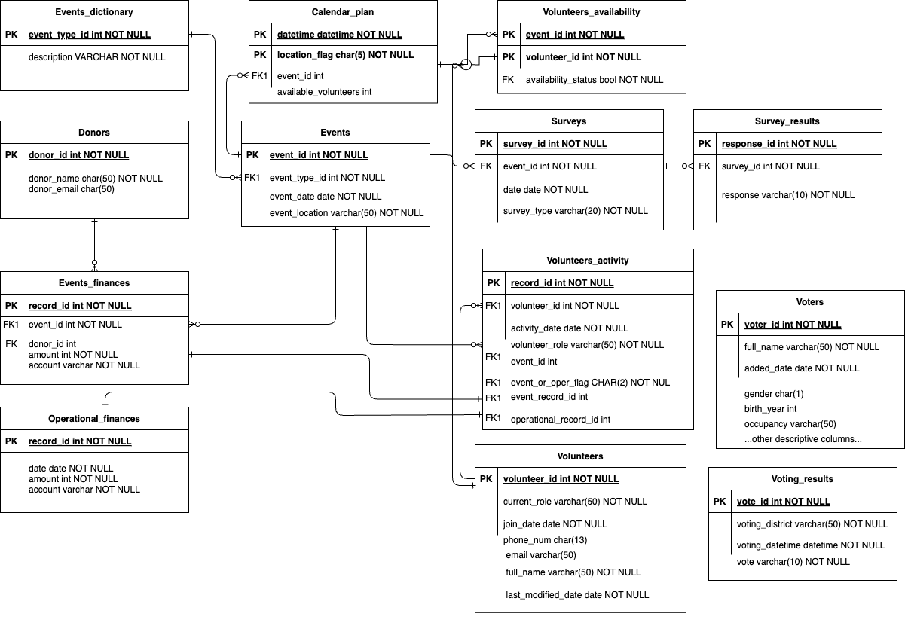

## Objects

|  |  |  |  |
| --- | --- | --- | --- |
| Table Name | Field name | Field Description | Data Type |
| Events | Event_id | PK | Int |
| Event_type_id | FK, a code identifying type of event | Int |
| Event_date | Date of event, either past or planned (upcoming) | date |
| Event_location | Location of event: City, place, online, etc. | text |
| Other descriptive columns can be added |  |  |

Events table provides information on each campaign event.

Many-to-one relationship with events dictionary, one-to-many relationships with calendar plan, event finances, volunteers’ activity.

|  |  |  |  |
| --- | --- | --- | --- |
| Event_id | Event_type_id | Event_date | Event_location |
| 1 | 1 | 01/03/2025 | City Square, Almaty |

|  |  |  |  |
| --- | --- | --- | --- |
| Table Name | Field name | Field Description | Data Type |
| Event_dictionary | Event_type_id | PK | Int |
| Description | description | Text |

Events dictionary provides fuller information on each type of event. It is useful when there are many types of different events, and users would need contextual information.

Many-to-one relationship with events dictionary, one-to-many relationships with events

|  |  |
| --- | --- |
| Event_type_id | Description |
| 1 | Meeting with municipal representatives |

|  |  |  |  |
| --- | --- | --- | --- |
| Table Name | Field name | Field Description | Data Type |
| Calendar_plan | Datetime | Part of composite PK | datetime |
| Location_flag | A type of location (in city, outside of city, online, etc.)  Part of composite PK | Text, char |
| Event_id |  | Int |
| Available_volunteers | Count of available volunteers | int |

Calendar plan table provides on the event and operational daily plans.

Many-to-one relationship with events, one-to-many relationships with calendar plan, event finances, volunteers’ activity.

|  |  |  |  |
| --- | --- | --- | --- |
| Datetime | Location_flag | Event_id | Available_volunteers |
| 01/03/2025 12PM | CITY | 1 | 54 |

|  |  |  |  |
| --- | --- | --- | --- |
| Table Name | Field name | Field Description | Data Type |
| Volunteers_availability | Date | Part of composite PK | Date |
| Volunteer_id | Part of composite PK | Text |

Provides information on each volunteer’s availability. Volunteer’s id is present if he/she is available to work in that day (only full day in this implementation).

Many-to-one relationship with calendar plan (via date), volunteers (via volunteer_id).

|  |  |
| --- | --- |
| Date | Volunteer_id |
| 01/03/2025 | 12 |

|  |  |  |  |
| --- | --- | --- | --- |
| Table Name | Field name | Field Description | Data Type |
| Volunteers_activity | Record_id | PK | Int |
| Volunteer_id | FK | int |
| activity_date |  | date |
| volunteer_role | Role of volunteer in the time of activity | text |
| Event_id | FK | Text |
| Event_or_operational_flag | Indicator whether the activity is related to an event or operational | text |
| Finance_record_id |  | Text |

Provides information on volunteer’s daily activities.

Many-to-one relationship with events, volunteers, volunteers’ availability, operational and event-related financial record tables.

|  |  |  |  |  |  |  |
| --- | --- | --- | --- | --- | --- | --- |
| Record_id | Volunteer_id | Activity_date | Volunteer_role | Event_id | Event_or_operational | Finance_record_id |
| 1 | 1 | 01/03/2025 | Communication Content specialist | (null) | OP | 54 |

|  |  |  |  |
| --- | --- | --- | --- |
| Table Name | Field name | Field Description | Data Type |
| Volunteers | Volunteer_id | PK | Int |
| Full_name |  | Text |
| Current_role |  | text |
| Join_date |  | date |
| Phone_num |  | Text |
| Email |  | Text |
| Last_modified_date | Initial value is date added | Date |

Provides information on each volunteer. One to many relationships with Volunteers activity and Volunteers availability tables.

|  |  |  |  |  |  |  |
| --- | --- | --- | --- | --- | --- | --- |
| Volunteer_id | Full_name | Current_role | Join_date | Phone_num | Email | Last_modified_date |
| 1 | Talgat Talgatuly | Communication Content specialist | 01/01/2025 | +777…. | talga@yahoo. com | 01/01/2025 |

|  |  |  |  |
| --- | --- | --- | --- |
| Table Name | Field name | Field Description | Data Type |
| Event_finances | Record_id | PK | Int |
| Event_id | FK | Text |
| Donor_id | FK | Int |
| Amount | Donated amount, in the specific currency | Decimal |
| Account | Specified account number/code for donated amounts (Accounting-related) | Text |

Provides information on financial activities related to campaign events, donations and expenses related to the events. Should also be linked to the accounting system or schema.

One to one relationship with Volunteers activity, many-to-one relationship with Events, Donors tables.

|  |  |  |  |  |
| --- | --- | --- | --- | --- |
| Record_id | Event_id | Donor_id | Amount | Account |
| 1 | 1 | 12 | 100,000 | 100500.EVENT.DONAT |
| 2 | 1 | null | -10,000 | 100500.EVENT.OVERHEAD |

|  |  |  |  |
| --- | --- | --- | --- |
| Table Name | Field name | Field Description | Data Type |
| Operational_finances | Record_id | PK | Int |
| Date | Date column is included (from accounting system) as expenses are usually analyzed by period | date |
| Expense_Amount | Expenses amount | Decimal |
| Account | Accounting-related | Text |

Provides info on operational expenses. Should also be linked to the accounting system or schema. One to one relationship with Volunteers activity.

|  |  |  |  |
| --- | --- | --- | --- |
| Record_id | Date | Amount | Account |
| 1 | 1 | 10,000 | 200100.ADMINCOST |

|  |  |  |  |
| --- | --- | --- | --- |
| Table Name | Field name | Field Description | Data Type |
| Voters | Voter_id | PK | Int |
| Full_name |  | text |
| Added_date |  | Date |
| Gender |  | Char |
| Birth_year |  | Int |
| Occupancy |  | Text |
| Other columns | Descriptive of voters | Text |

Provides info on voters, collected during the meetups with voters events.

|  |  |  |  |  |  |
| --- | --- | --- | --- | --- | --- |
| Voter_id | Full_name | Added_date | Gender | Birth_year | Occupancy |
| 1 | Samat A. | 01/03/2025 | M | 1975 | Commercial worker |

|  |  |  |  |
| --- | --- | --- | --- |
| Table Name | Field name | Field Description | Data Type |
| Donors | Donor_id | PK | Int |
| donor_name |  | text |
| Email | Contact email info | Text |
| Date_added |  | date |
| Other columns | Descriptive of donors | Text |

Provides information on donors, names and contact info. Columns for affiliates and other descriptive columns can be added.

One-to-many relationship with event finances table.

|  |  |  |  |
| --- | --- | --- | --- |
| Donor_id | Donor_name | Email | Added_date |
| 1 | Marat Maratuly | Marat_business@mail.ru | 01/03/2025 |

|  |  |  |  |
| --- | --- | --- | --- |
| Table Name | Field name | Field Description | Data Type |
| Surveys | Survey_id | PK | Int |
| Event_id |  | int |
| date |  | varchar |
| Survey_type |  | varchar |

Provides information on made surveys.

|  |  |  |  |
| --- | --- | --- | --- |
| Table Name | Field name | Field Description | Data Type |
| Survey_results | Response_id | PK | Int |
| Survey_id |  | Int |
| Date |  | Date |
| Response |  | varchar |

Provides information on survey results. In this case it is only a poll results between candidates.

|  |  |  |  |
| --- | --- | --- | --- |
| Response_id | Survey_id | Date | Response |
| 112 | 112 | 01/03/2025 | Yes |

|  |  |  |  |
| --- | --- | --- | --- |
| Table Name | Field name | Field Description | Data Type |
| Voting_results | vote_id | PK | Int |
| Voting_district |  | Varchar |
| voting_datetime |  | datetime |
| Vote | Vote result itself | varchar |

Provides information on final voting results.

|  |  |  |  |
| --- | --- | --- | --- |
| vote_id | Voting_district | Voting_datetime | Vote |
| 112 | Nauryzbay distr, NY | 06/06/2025 12:10:00 PM | Candidate 1 |