ENVI Workflow
Vegetation Change in Hangzhou, China, 1995 to 2025
GEOG 652 | Daylan Salmeron

1. Introduction
The analysis for this project was carried out in Python, with each script written to mirror a specific ENVI operation. This document records the ENVI side of that work: which ENVI tool corresponds to each script, which files ENVI opens, and what the ENVI session produced.
The purpose is to show that the two implementations agree, and to be explicit about the places where they do not and why.

2. Python workflow and its ENVI equivalent
Each Python script performs one stage of the processing chain. The table below names the ENVI tool that does the same job. The three stages marked as repeated were carried out again in ENVI; the rest were not, because their result is already contained in the exported rasters.
Script | What it does | ENVI equivalent | Repeated in ENVI
00_config.py | Shared settings, no processing | n/a | No
01_get_landsat.py | Downloads the three scenes | File > Open As > Optical Sensors > Landsat | No
02_inspect.py | Metadata, coverage, histograms | Raster Metadata viewer, Histogram tool | No
03_clean.py | DN to surface reflectance, QA masking, reprojection | Radiometric Calibration, Reproject Raster | No
04_indices.py | NDVI and NDBI | Band Math, or Spectral Indices | No
05_figures.py | RGB, index and change maps | Display groups with linked views | No
06_validation.py | Visual check of change sites | Cursor Location / Value, linked windows | No
07_classify.py | Pooled K-Means on NDVI | Classification > Unsupervised > K-Means, or Density Slice | Yes
08_change.py | Post-classification change detection | Basic Tools > Change Detection | Yes
09_accuracy.py | Error matrix and Kappa | Post Classification > Confusion Matrix | Yes
10_export_envi.py | Writes the ENVI files used here | n/a | No

3. The files opened in ENVI
The rasters opened in ENVI were preprocessed in Python rather than in ENVI. Calibration, QA masking and reprojection were applied once in 03_clean.py so that all three dates sit on one identical 30 m grid, which is what makes a pixel-by-pixel comparison between dates possible. Repeating those steps in ENVI would apply the correction twice.
All files are in 03-Output/ENVI/ and are ENVI flat binary, so each product is a pair: an extensionless data file and a .hdr header. The .hdr is the one to open. Masked pixels are stored as -9999, declared in the header as the data ignore value.
File | What it contains
reflectance_1995, reflectance_2010, reflectance_2025 | Six surface-reflectance bands per date: blue, green, red, nir08, swir16, swir22
ndvi_1995, ndvi_2010, ndvi_2025 | NDVI per date, floating point
class_python_1995, class_python_2010, class_python_2025 | The Python classification, as an ENVI Classification file with class names
truth_2025 | The 100 labelled accuracy points, painted as 3 x 3 blocks, as a ground truth image
expected_values.txt | The Python values the ENVI run was checked against

4. ENVI session

4.1 Reflectance stacks
All three reflectance files open in ENVI, with the six bands carrying their names from the header rather than appearing as Band 1 to Band 6.
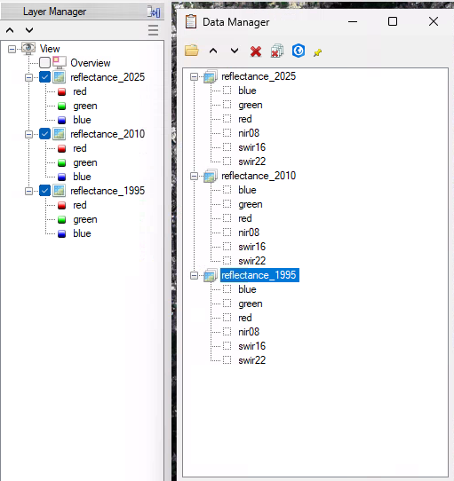
Figure 4.1

4.2 Grid in the metadata
The metadata confirms the grid written by the Python chain: UTM Zone 51 N on WGS-84, 2751 by 2409 pixels at 30 m, with -9999 set as the data ignore value.
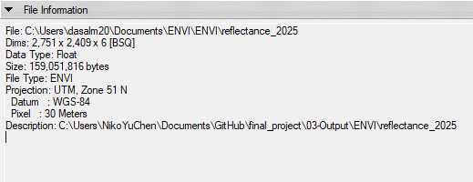
Figure 4.2

4.3 Band statistics
Pixel counts in ENVI match the Python valid-pixel counts exactly for all three dates, which confirms ENVI is excluding the same masked pixels. The band means also show the 1995 scene sitting about 0.03 to 0.05 lower in SWIR1, which is the reason NDBI was reported but not used in the classification.
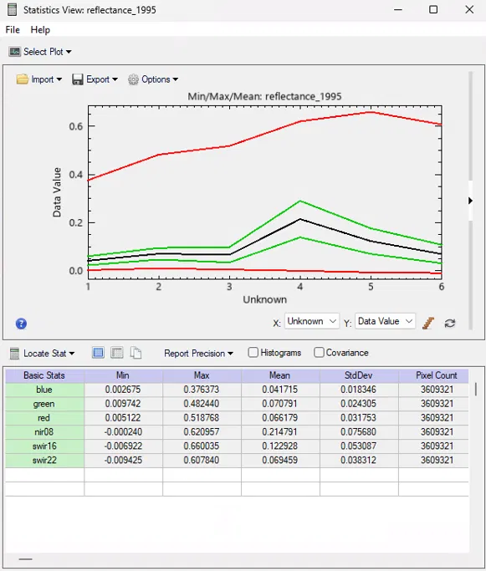
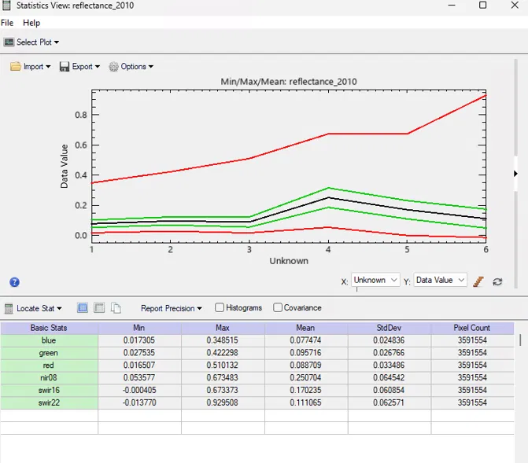
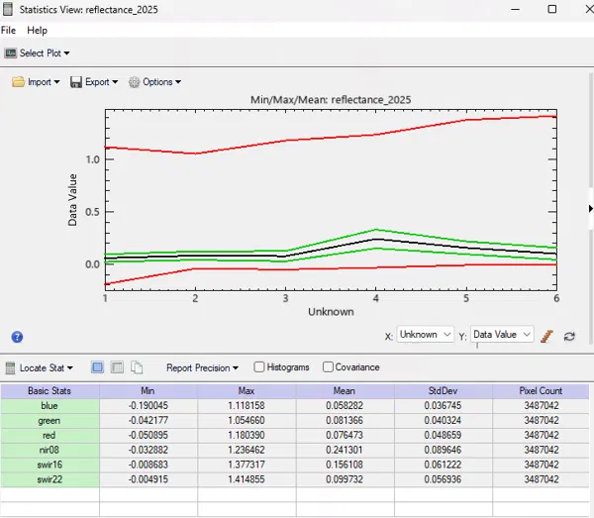
Figures 4.3

4.4 Linked views in false colour
The three dates displayed side by side with NIR in red and the views geo-linked, so the same ground is shown in each. Vegetation appears red, built-up and bare surfaces grey or cyan, water black.
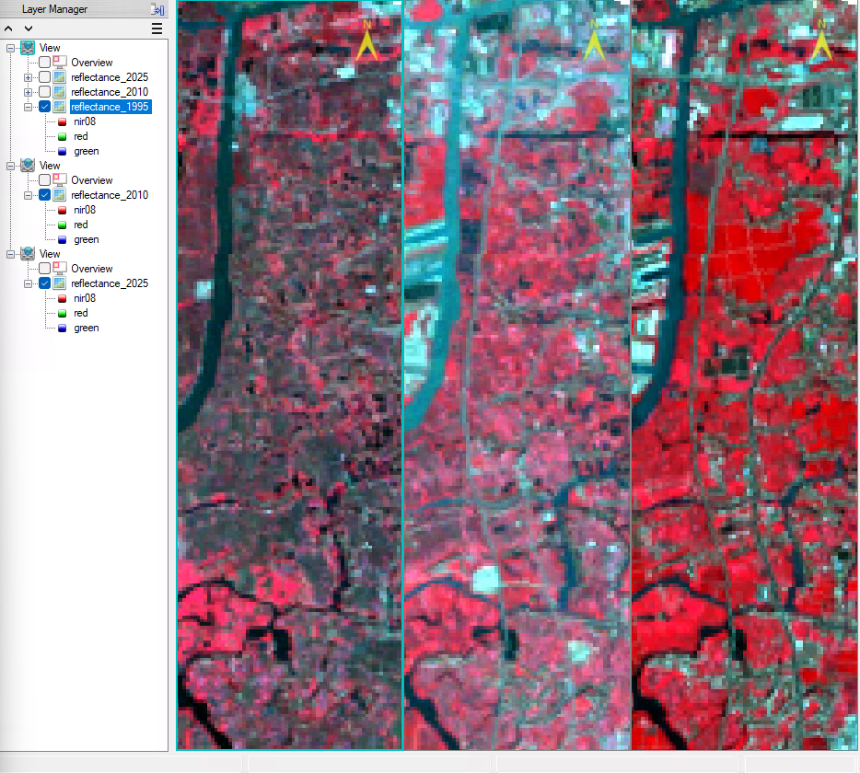
Figure 4.4

4.5 NDVI statistics
The NDVI means in ENVI are about 0.025 below the Python values, because Python computed its means over the common land mask while ENVI used the full per-year valid mask, which still includes water. The 2010 offset of roughly 0.04 below 1995 and 0.025 below 2025.
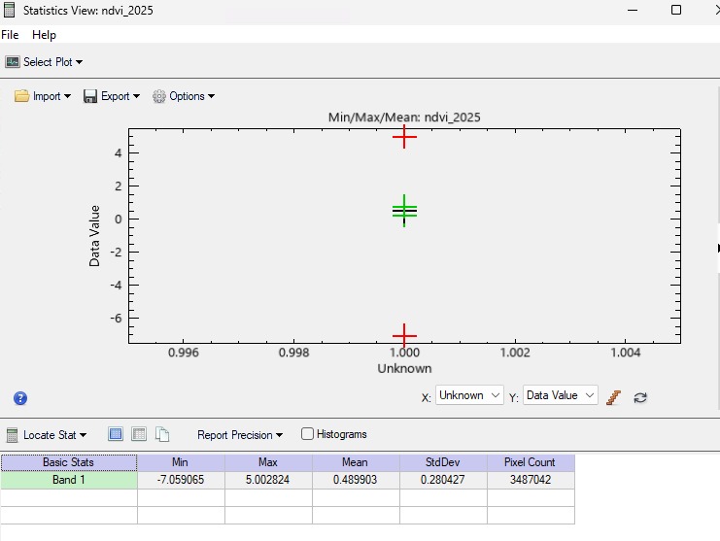
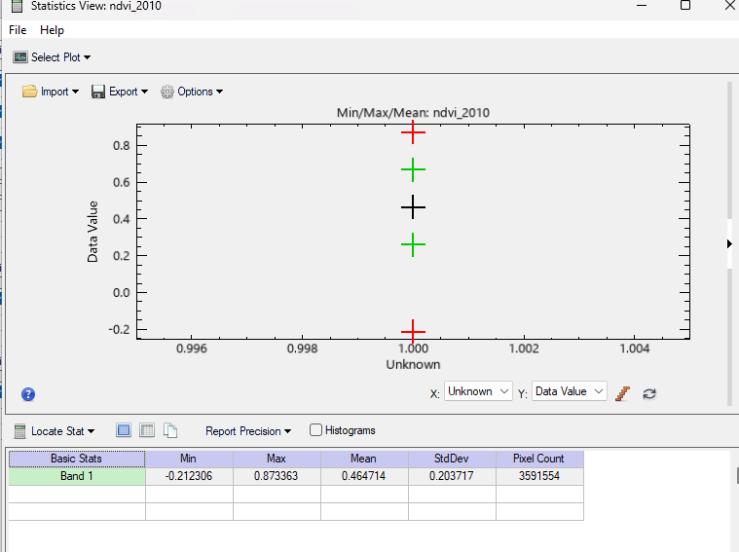
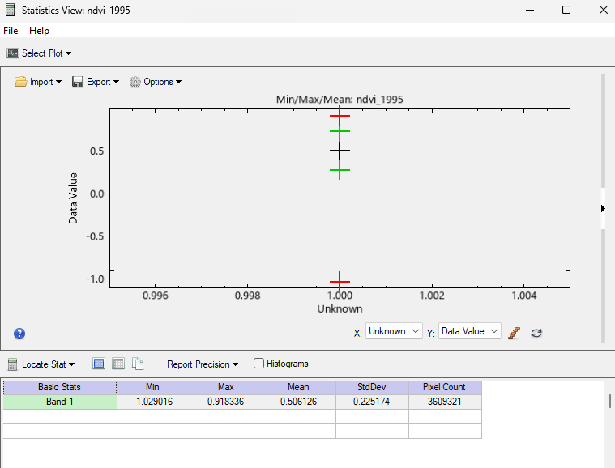

Figures 4.5

4.6 Density slice on NDVI
The classification reproduced in ENVI as a density slice using the NDVI boundaries found by the Python K-Means fit: 0.269, 0.474 and 0.666. It produces four classes rather than five, because water cannot be separated from NDVI alone and falls into low_veg. Only 1995 and 2025 were classified, since 2010 is excluded from the quantitative change analysis.
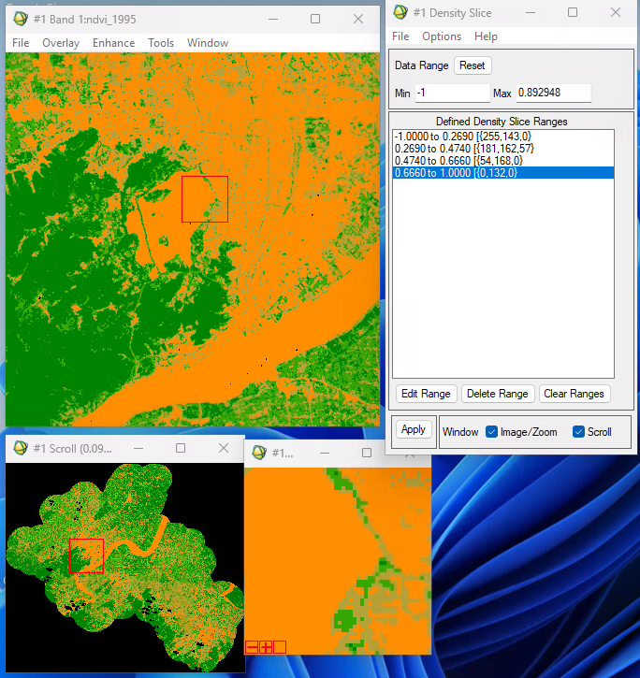
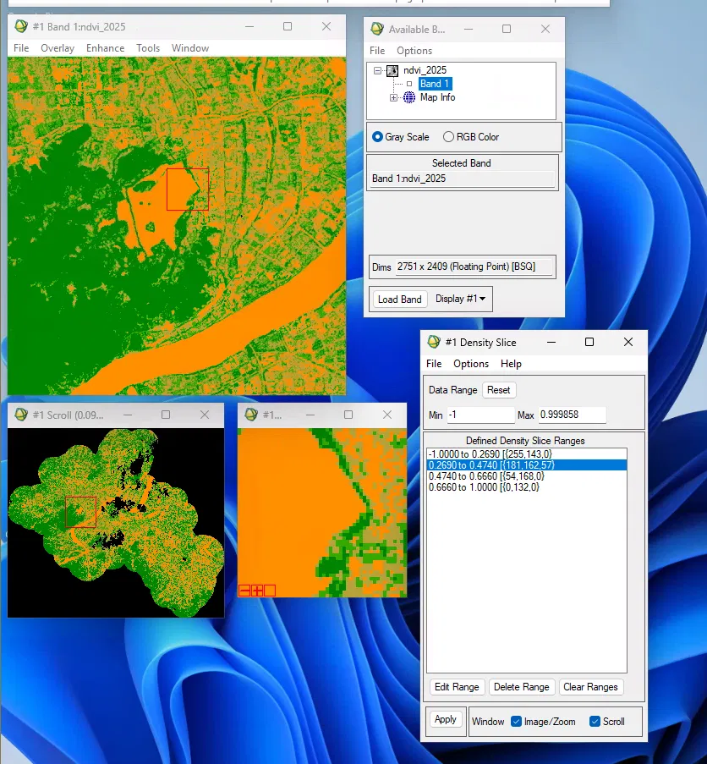
Figures 4.6

4.7 Agreement with the Python classification
Comparing the two 2025 classifications directly gives 99.91 percent agreement, disagreeing on 2,886 pixels that all sit on class boundaries. The one systematic difference is 124.1 km2 of water that Python classified from the QA mask and ENVI placed in low_veg, against the 124.64 km2 Python reported.
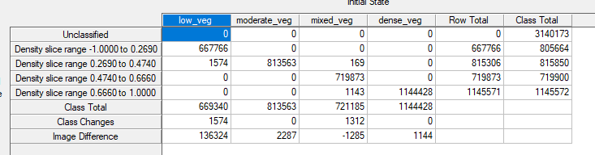Figure 4.7: Water does not appear as a column because the ENVI classification has no water class; it is contained in the low_veg row totals.

4.8 Change detection, 1995 to 2025
The from-to matrix matches the Python result within 1 to 4 percent per cell, with ENVI running slightly high because it used the 1995 footprint of 3,248 km2 rather than the common mask of 3,040 km2. Both show the same pattern: mixed_veg falling by about 400 km2, low_veg nearly doubling, dense_veg growing.
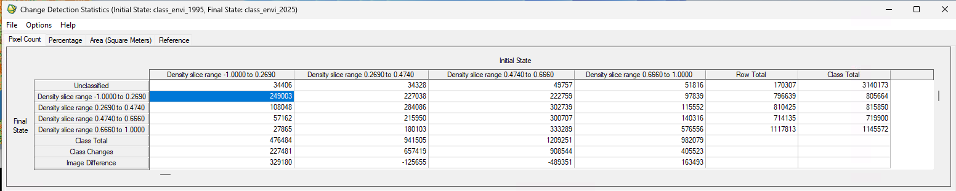
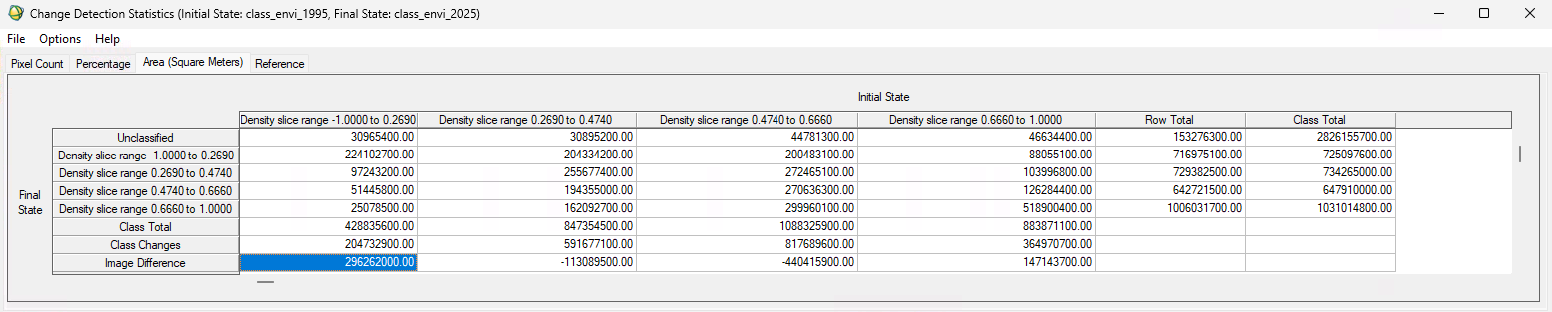
Figure 4.8

4.9 Accuracy using the ground truth image
Run first with truth_2025 as a ground truth image, which returned 47.39 percent and a Kappa of 0.0003. This is an artifact: the truth image labels only 900 pixels and ENVI counted the 6.6 million unlabelled pixels as a sixth class, which dominated the scoring.
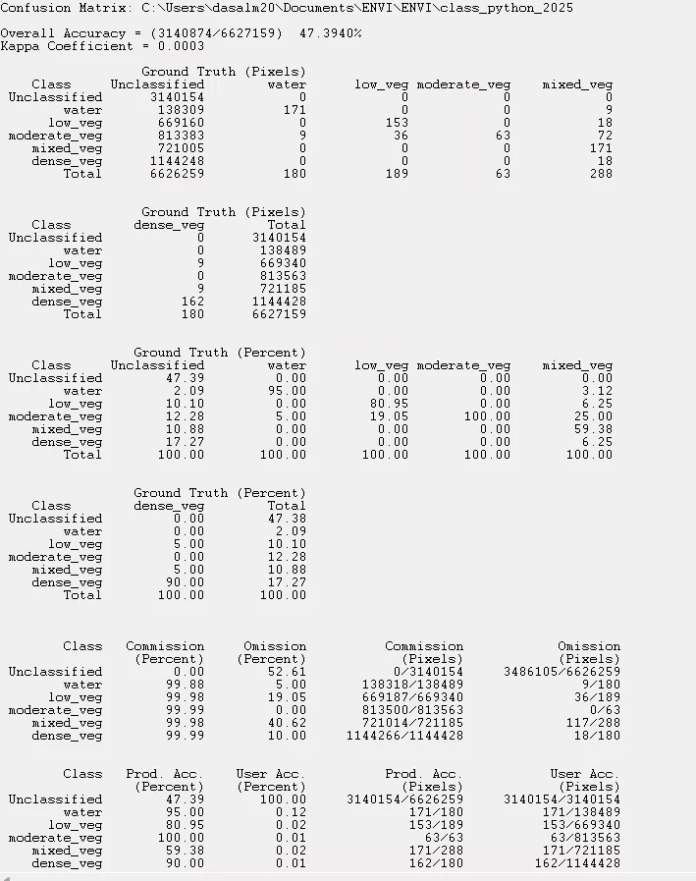
Figure 4.9

4.10 Accuracy using ground truth ROIs
Re-run with one ROI per class, built by thresholding truth_2025 on each class code so that unlabelled pixels never enter the matrix. This gives 80.00 percent and a Kappa of 0.7500, matching the Python result exactly, with every per-class producer and user accuracy also identical.
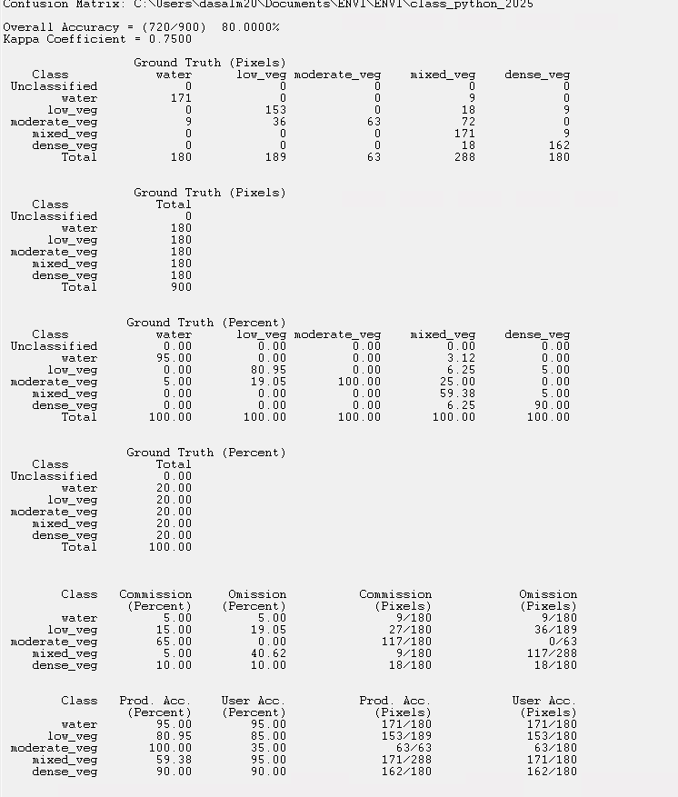
Figure 4.10

5. Summary of the comparison
Every difference between the two implementations has an identifiable cause, and none of them is an error in either one.
Stage | Result
Grid and masking | Pixel counts identical for all three dates
NDVI means | ENVI about 0.025 lower, because Python used the common land mask
Classification | 99.91 percent agreement; 2,886 pixels differ, all on class boundaries
Water | 124.1 km2 in ENVI low_veg against 124.64 km2 in the Python water class
Change detection | Cells agree within 1 to 4 percent; ENVI high because of the larger footprint
Accuracy | Identical: 80.00 percent, Kappa 0.7500

Note on the accuracy matrix
moderate_veg has a producer accuracy of 100 percent but a user accuracy of 35 percent, meaning every true moderate_veg pixel was found but 117 pixels that belong elsewhere were swept in. mixed_veg is the mirror image at 59 percent producer and 95 percent user. These two rows describe the same confusion seen from both sides, and are the main weakness of an NDVI-only classification.

