**Timesheet & Feedback System**

Mini Project

# Contents

* Project Overview
  + Brief introduction of the project
  + Purpose of the project
  + Goals of the project
* Project Scope
  + Platforms and devices the application will support
  + Key features and functionalities of the application
* Architecture and Technology Stack
  + Overall architecture of the application
  + Technology stack (e.g., programming languages, frameworks, libraries)
  + Rationale behind the chosen technology stack
* Website Application Components
  + Main components of the application
  + Purpose of each component
* User Interface Design
  + Admin dashboard
  + Create user
  + Create feedback
  + Add Project
  + Create Timesheet
  + Check Timesheet
  + Profile
  + Employee dashboard
  + Give employee feedback
  + Give general feedback
  + Notification bell
* Data Model
  + External Entities
  + Processes
  + Data Flows
  + Data Stores
  + Data Transformation
* Analysing the Data
  + Employee Performance KPI’s
  + Project Performance KPI’s
* Sentiment Analysis of Company General Feedback
  + Introduction
  + Analysis
  + Implication
  + Recommendation
* Attendance Regularisation & Absence Analysis
  + Introduction
  + Methodology
  + Analysis
  + Implications
  + Recommendations
  + Conclusion

# Project Overview

## Brief introduction of the project.

The Timesheet and Feedback Management System is a comprehensive web application designed to streamline the process of managing work hours, gathering feedback, and facilitating communication within an organization. The system caters to both administrative users and regular employees, providing distinct functionalities tailored to their roles and responsibilities.

## Purpose of the project.

The purpose of the Timesheet and Feedback Management System is multifaceted, encompassing several key objectives aimed at enhancing organizational efficiency, communication, and performance. Below are the primary purposes of the project:

* Streamline Workflow Management: The system aims to streamline the management of work hours, projects, and feedback within the organization. By providing intuitive interfaces for timesheet submission, feedback provision, and administrative tasks, the system simplifies workflow management processes and reduces administrative overhead.
* Facilitate Data-driven Decision Making: Through effective timesheet and feedback management, the system facilitates data-driven decision-making within the organization. By collecting and analysing timesheet data, project feedback, and employee input, administrators can gain valuable insights into project performance, resource utilization, and team dynamics, enabling informed decision-making and strategic planning.
* Foster Employee Engagement and Collaboration: By providing mechanisms for feedback submission and communication, the system fosters employee engagement, collaboration, and empowerment. Employees are encouraged to provide feedback on projects, colleagues, and organizational processes, contributing to a culture of continuous improvement and open communication within the organization.
* Enhance Performance Evaluation and Accountability: The system enables administrators to track work hours, monitor project progress, and evaluate employee performance effectively. By automating timesheet submission processes, generating feedback questions, and providing reporting functionalities, the system enhances accountability, transparency, and performance evaluation within the organization.
* Improve Organizational Productivity and Effectiveness: Ultimately, the overarching purpose of the project is to improve organizational productivity and effectiveness. By streamlining workflow management processes, facilitating data-driven decision-making, fostering employee engagement and collaboration, and enhancing performance evaluation and accountability, the system contributes to improved organizational outcomes, efficiency, and competitiveness.

## Goals of the project:

* Simplify timesheet submission and feedback provision processes.
* Enhance communication and collaboration within the organization.
* Improve project management and resource allocation.
* Foster a culture of continuous improvement and feedback.
* Enable data-driven decision-making and performance evaluation.
* Ensure data privacy and security.
* Enhance user experience and satisfaction.
* Increase organizational productivity and effectiveness.

# Project Scope

## Platforms and devices the application will support.

The Timesheet and Feedback Management System is designed to be accessible across various platforms and devices, ensuring flexibility and convenience for users. Here are the platforms and devices it supports:

Web Browsers:

* + Google Chrome
  + Mozilla Firefox
  + Safari
  + Microsoft Edge
  + Opera
  + Other modern web browsers
  + Desktop

Operating Systems:

* + Windows
  + macOS
  + Linux
  + Mobile

Devices:

* + Android smartphones and tablets
  + iOS devices (iPhone and iPad)

The system is responsive and can adapt to different screen sizes, including desktop monitors, laptops, tablets, and smartphones.

It supports both touch and non-touch input methods, ensuring compatibility with a wide range of devices.

By supporting multiple platforms and devices, the Timesheet and Feedback Management System aims to provide users with seamless access and functionality regardless of their preferred device or operating system.

## Key features and functionalities of the application.

1. User Authentication and Authorization:

- Objective: The primary goal is to ensure secure access to the system for both administrators and employees. By implementing authentication mechanisms, users can securely sign up for new accounts and log in with their credentials. Additionally, user roles and permissions are defined to control access to various features and data within the application.

2. Admin Functionalities:

- Objective: Administrators play a pivotal role in managing the system and overseeing its operations. Admin functionalities include creating and managing user accounts, projects, and feedback questions. CRUD operations are implemented to facilitate the management of users, projects, and feedback questions, providing administrators with the necessary tools to administer the system effectively.

3. Employee Functionalities:

- Objective: Employees form the backbone of the organization and are key users of the system. Employee functionalities focus on enabling employees to submit timesheets, provide feedback, and stay informed about pending tasks. Employees can submit timesheets for their assigned projects on a weekly basis and provide project-specific and general feedback as required.

4. Timesheet Management:

- Objective: Timesheets are critical for tracking work hours and project progress. The objective of timesheet management is to provide employees with a user-friendly interface for creating, editing, and submitting timesheets. Validation checks are implemented to ensure the accuracy and completeness of timesheet submissions, while feedback questions are generated automatically upon successful submission.

5. Feedback Management:

- Objective: Feedback is instrumental in fostering a culture of continuous improvement within the organization. Feedback management aims to facilitate the collection, review, and analysis of feedback data from employees. Employees can provide feedback on specific projects and colleagues, while administrators can review and analyse feedback data to identify trends and areas for improvement.

# Architecture and Technology Stack

## Overall architecture of the application.

The system follows a client-server architecture, with separate frontend and backend components communicating over HTTP.

Frontend:

* The frontend is built using React.js, a popular JavaScript library for building user interfaces.
* Tailwind is utilized for styling.
* Axios is employed for making HTTP requests to the backend server.

Backend:

* The backend is developed using Node.js with Express.js, a lightweight web application framework for Node.js.
* MongoDB is chosen as the database management system for storing user data, timesheets, feedback, and other related information.
* Express sessions are employed for managing user sessions and authentication.

## Technology stack (e.g., programming languages, frameworks, libraries).

Frontend:

* Framework/Library: React.js
* Styling: Tailwind CSS
* HTTP Requests: Axios

Backend:

* Framework: Express.js (Node.js)
* Database: MongoDB

## Rationale behind the chosen technology stack.

React.js: Chosen for its component-based architecture, virtual DOM rendering, and extensive ecosystem of libraries and tools, making it ideal for building dynamic and interactive user interfaces.

Express.js: Selected for its simplicity, flexibility, and robust middleware support, allowing for the rapid development of RESTful APIs and web servers.

MongoDB: Chosen for its reliability, performance, and support for advanced features such as transactions, indexing, and data integrity constraints, making it suitable for handling JSON data in a production environment.

# Website Application Components

## Main components of the application.

* React.js: The core framework for building the user interface of the web application. React.js facilitates the creation of interactive and dynamic UI components.
* React Router: A routing library for React.js applications. React Router is used for handling navigation and defining routes within the web application.
* Axios: A promise-based HTTP client for making asynchronous requests in the web application. Axios simplifies the process of sending and handling HTTP requests to the backend server.

## Purpose of each component.

* React.js: Provides a declarative and component-based approach to building user interfaces, making it easier to create interactive and reusable UI components.
* React Router: Handles client-side routing and navigation within the web application, allowing users to navigate between different views and pages.
* Axios: Facilitates communication with the backend server by making asynchronous HTTP requests, enabling the web application to fetch and send data seamlessly.

# User Interface Design

## Admin Dashboard

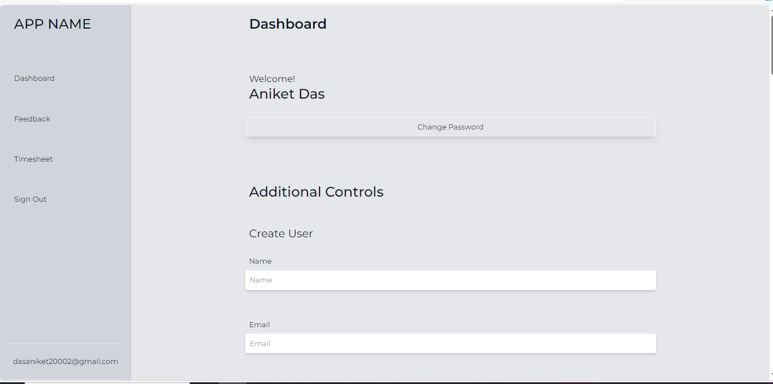

## Create User

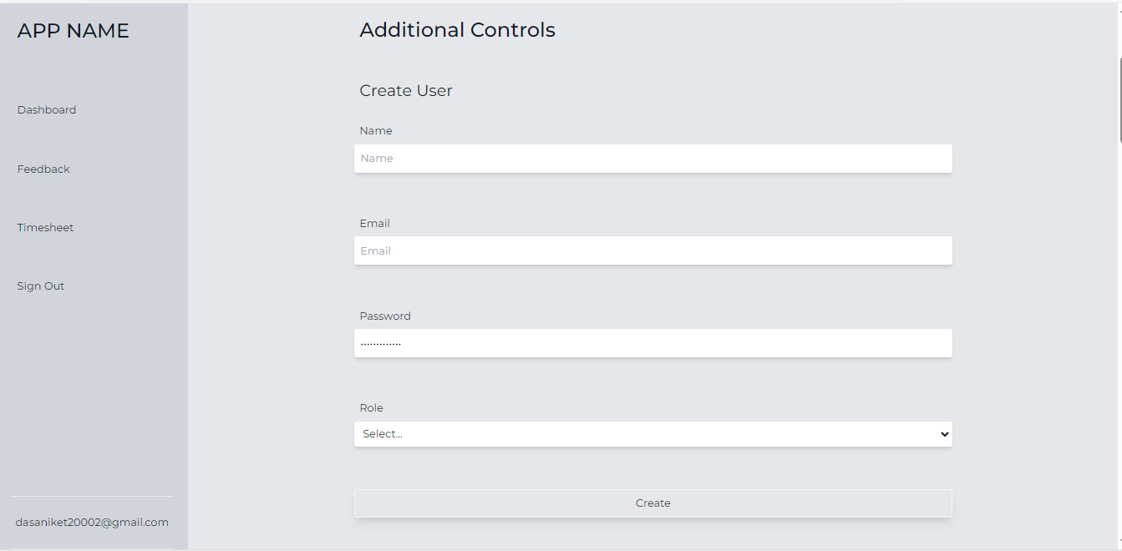

## Create Feedback

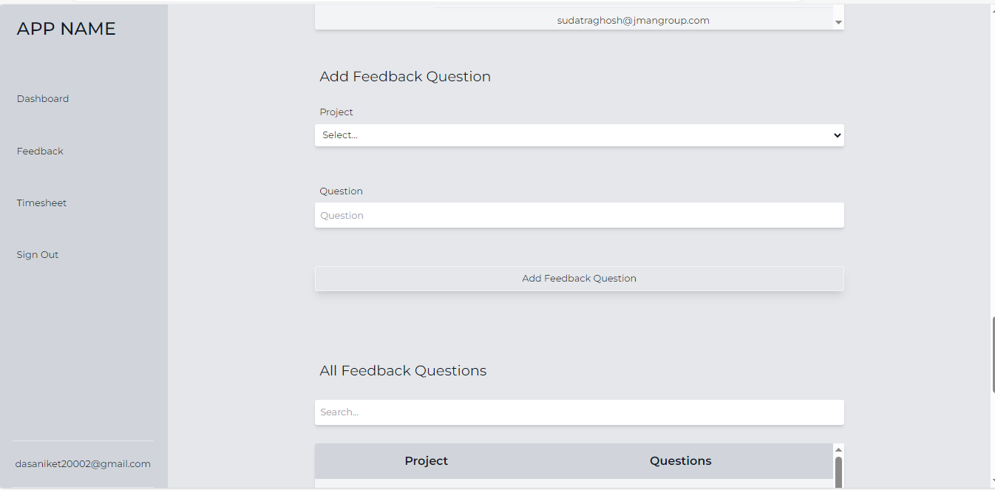

## Add Project

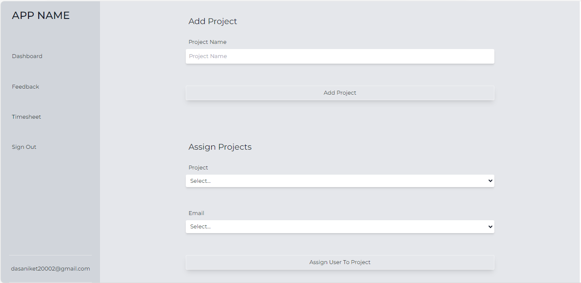

## Create Timesheet

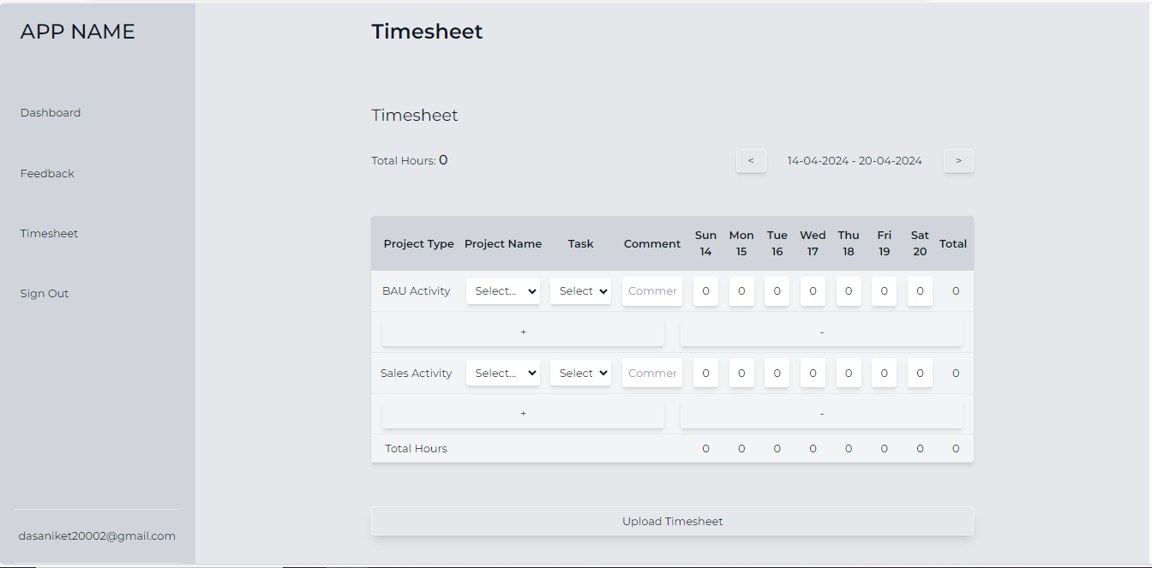

## Check Timesheet

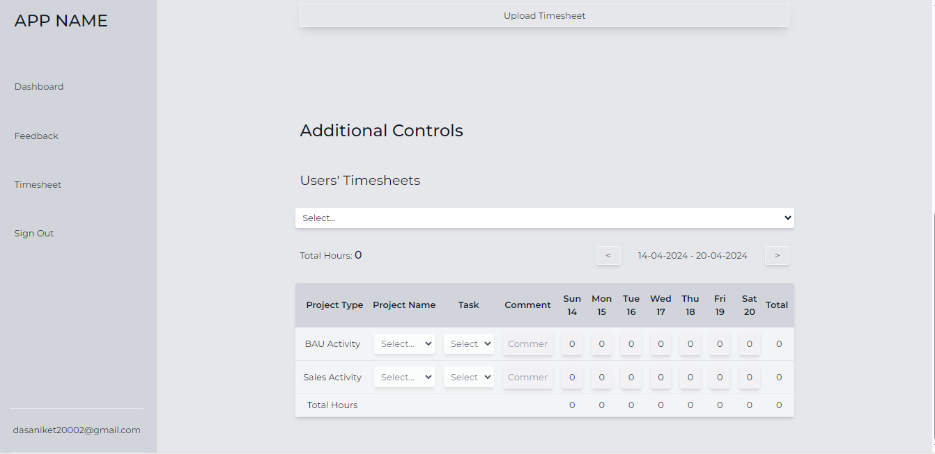

## Feedback Question

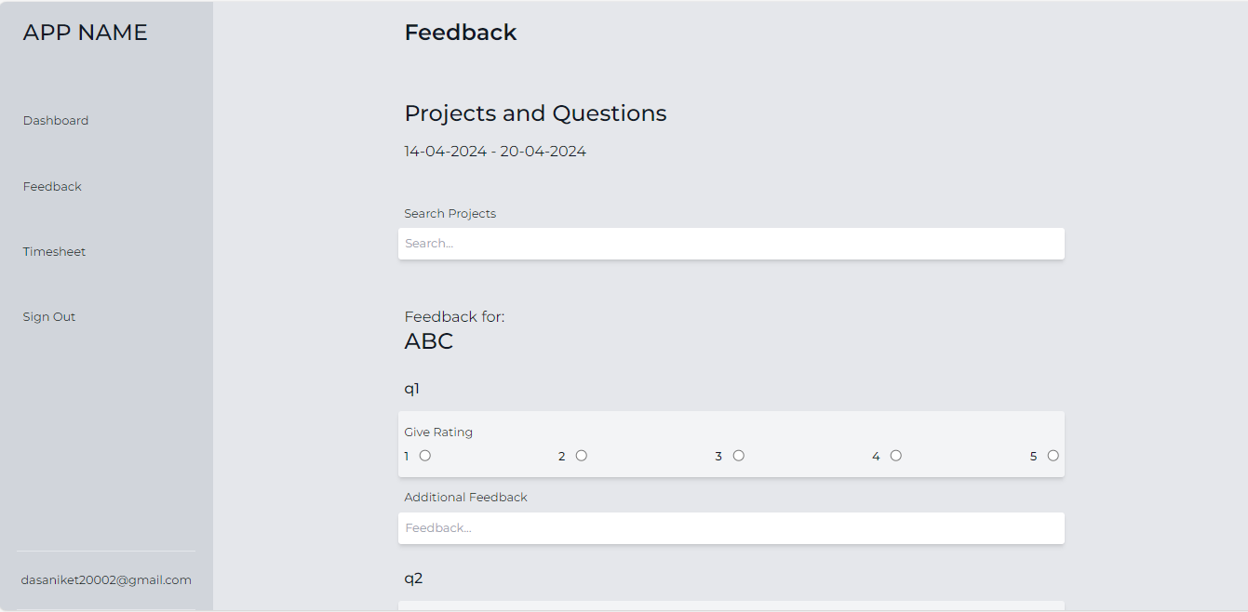

## Check Feedback Answers

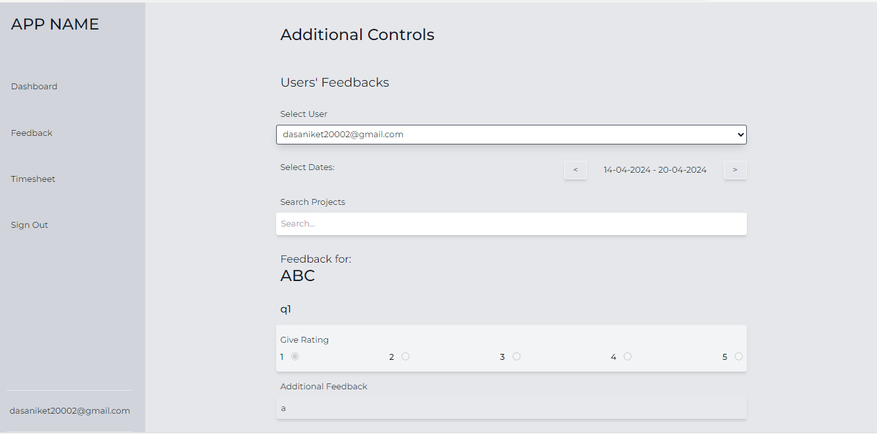

## External Entities:

* + Users: Employees and administrators who interact with the system.
  + External Systems: Any external systems or databases that exchange data with the Timesheet and Feedback Management System.

## Processes:

* + User Authentication: Process of verifying user credentials and granting access to the system.
  + Timesheet Submission: Process of submitting work hours for different projects and tasks.
  + Feedback Provision: Process of providing feedback on projects, colleagues, and organizational processes.
  + Data Analysis: Process of analysing feedback data, timesheet submissions, and other system data to derive insights and make informed decisions.

## Data Flows:

* + User Input: Data entered by users, including timesheet information, feedback ratings, comments, and user preferences.
  + System Outputs: Processed data generated by the system, such as timesheet reports, feedback summaries, and notification messages.
  + Database Interaction: Data exchanged between the system and the database, including read and write operations for storing and retrieving user data, timesheets, feedback, and system configurations.
  + External System Integration: Data exchanged between the Timesheet and Feedback Management System and external systems or databases, enabling data synchronization and interoperability.

## Data Stores:

* + User Database: Repository for storing user accounts, profiles, authentication credentials, and access permissions.
  + Timesheet Database: Storage location for recording timesheet submissions, project details, and work hour records.
  + Feedback Database: Database for storing feedback data, including feedback ratings, comments, and related metadata.
  + System Configuration Database: Storage location for system configurations, settings, and preferences.

## Data Transformations:

* + Data Validation: Validation of user input to ensure accuracy, completeness, and compliance with data integrity constraints.
  + Data Aggregation: Aggregation of timesheet data and feedback submissions to generate summary reports and analytics.
  + Data Encryption: Encryption of sensitive data, such as user passwords and authentication tokens, to ensure data security and privacy.
  + Data Filtering: Filtering of data based on user preferences, access permissions, and system configurations to customize user experiences and data views.

# Analysing the Data

## KPIs

#### UserPerRole:

Counts the number of Users per Role

#### TotalHoursPerUserPerActivity:

Contains the hours worked by user for every activity.

Contains Total Hours, Total Hours worked in Weekend, Total Hours Worked in Weekdays.

#### TotalHoursPerUser:

Contains the hours worked by user.

Contains Total Hours, Total Hours worked in Weekend, Total Hours Worked in Weekdays.

#### TotalHoursPerProjectPerUser:

Total Hours worked by a user on a project.

Contains Total Hours, Total Hours worked in Weekend, Total Hours Worked in Weekdays.

#### TotalHoursPerProjectPerActivity:

Total Hours spent on a Project per Activity.

Contains Total Hours, Total Hours worked in Weekend, Total Hours Worked in Weekdays.

#### TotalHoursPerProject:

Total Hours spent on a Project.

Contains Total Hours, Total Hours worked in Weekend, Total Hours Worked in Weekdays.

#### NumberOfProjectPerDomainPerUser:

Contains Number of projects in a Domain as well as their Average Rating.

#### DaySpansForProject:

Contains initial date start and final date end of a project.

Also has Total Days for the Project, Total Days Worked for the Project, Gaps Taken, and how Efficiently the Project is delivered.

#### AverageRatingsForProjects:

Contains the Average Ratings for each Project.

# Attendance Regularization and Absence Analysis

## Introduction:

In our ongoing analysis of employee data within the Timesheet and Feedback Management System, we have conducted an in-depth examination of timesheet data to identify periods of absence for individuals over the specific last year. This analysis involved regularizing attendance records and identifying instances of absence based on defined criteria.

## Methodology:

Data Preparation: Timesheet data from the previous year was collected and cleaned to ensure accuracy and consistency.

Attendance Regularization: Attendance records were analyzed and regularized based on predefined criteria, including approved leave, holidays, and other permissible absence reasons.

Absence Identification: Using the regularized attendance data, periods of absence for each individual were identified and categorized based on duration and frequency.

## Analysis:

Absence Duration: The analysis revealed varying durations of absence for individuals, ranging from short-term absences (e.g., single days) to longer-term absences (e.g., consecutive days or weeks).

Absence Frequency: Some individuals exhibited sporadic periods of absence throughout the year, while others had more consistent patterns of attendance.

Reasons for Absence: Absences were attributed to a range of reasons, including:

* + Approved leave (e.g., vacation, sick leave)
  + Unplanned absences (e.g., personal reasons, emergencies)
  + Company holidays and closures

## Implications:

Employee Well-being: Understanding patterns of absence can provide insights into individual well-being and potential factors impacting attendance, such as health issues, work-life balance, or job satisfaction.

Operational Impact: Identifying periods of absence allows for better workforce planning and management, ensuring adequate coverage and minimizing disruptions to project timelines and deliverables.

Policy Compliance: Regularizing attendance records helps ensure compliance with company policies and regulations regarding attendance and leave management.

## Recommendations:

Supportive Policies: Review and update attendance and leave policies to accommodate employee needs while maintaining operational efficiency.

Employee Engagement: Provide support and resources to employees to address factors contributing to absenteeism, such as health and wellness programs, flexible work arrangements, and employee assistance programs.

Communication and Transparency: Foster open communication and transparency regarding attendance expectations, leave policies, and procedures for requesting and reporting absences.

## Conclusion:

The analysis of attendance regularization and absence patterns provides valuable insights into individual attendance trends and organizational considerations. By leveraging these insights and recommendations, we can support employee well-being, optimize workforce management practices, and ensure compliance with attendance policies, ultimately contributing to a productive and engaged workforce.