Reinforcement Fine-Tuning a Wordle Agent with GRPO
Training a language model to play Wordle with programmatic, verifiable rewards

1. Introduction
Wordle is a word game in which a player has six attempts to identify a hidden five-letter word. After each guess the player receives per-letter feedback indicating which letters are correct and correctly placed, which appear in the word but in a different position, and which are absent. Playing well requires both following a strict response format and using the accumulated feedback to narrow the set of possible words. This project fine-tunes a language model to play Wordle using Group Relative Policy Optimization (GRPO), a reinforcement-learning method that improves a model directly from programmatic reward signals rather than from labeled example answers.

1.1 Problem Statement
A general-purpose instruction-tuned language model plays Wordle unreliably: it frequently breaks the required output format, disregards feedback from earlier guesses, or proposes words that cannot be valid given what is already known. Because there is no single “correct” completion to imitate — many guesses can be reasonable at a given moment — ordinary supervised training is a poor fit. The problem is therefore to improve the model’s play through reinforcement learning driven by automatically computable rewards that capture what a good guess looks like: correctly formatted, consistent with prior feedback, and maximally informative.

1.2 Scope of the Project
In scope: a transparent, from-scratch implementation of the GRPO loss (the probability ratio, PPO-style clipping, and the KL penalty) for clarity; a complete GRPO training pipeline for Wordle; the design and use of three complementary reward functions; and supporting supervised fine-tuning (SFT) and SFT-then-GRPO training recipes. Out of scope: inventing new reward criteria, large-scale hyperparameter search, and model serving or deployment.

1.3 Project Workflow
The pipeline proceeds as follows: load a dataset of Wordle game states; cache the dictionary of valid words locally so reward scoring is fast; define the reward functions; configure GRPO (a LoRA adapter, the number of sampled guesses per state, and the clipping and KL settings); train the adapter on the base model; and evaluate it by having the trained model play held-out games, comparing against the untrained base. An optional supervised warm-start can precede GRPO to first establish the required output format.

2. Dataset and Experimental Setup
Data. Training uses a dataset of Wordle game states. Each example provides a prompt encoding the current situation — the instructions, the guesses made so far, and the per-letter feedback for each — together with two auxiliary fields the reward functions consume: a dictionary of valid five-letter words, and a serialized history of prior guess/feedback pairs. Each prompt is prefilled with an opening <think> tag so the model continues a short chain of thought before committing to a guess.
Model and software. The base model is Qwen2.5-7B-Instruct, loaded in bfloat16 and adapted with a LoRA adapter (rank 64) on the attention and feed-forward projection layers; only the adapter is trained, which keeps memory and compute modest. The pipeline is built entirely on open-source libraries: HuggingFace TRL provides the GRPO trainer and configuration, PEFT provides LoRA, and the Datasets library handles data loading. Training samples 16 candidate guesses per game state within a 4096-token generation budget, with optional vLLM acceleration for faster sampling.
Hardware. Training runs on a single CUDA GPU. Because 16 completions are sampled per state, the 7B configuration is best suited to an A100/H100-class card; a lightweight “quick” mode substitutes a smaller model and a data subset to validate the full pipeline on modest hardware.

3. Methodology
GRPO objective. For each game state, the policy samples a group of candidate guesses, and each guess receives a scalar reward equal to the sum of the reward functions. Advantages are computed group-relative — each guess’s reward minus the group mean, divided by the group standard deviation — which lets the method dispense with a separate value network. The per-token loss is the PPO-clipped product of the importance ratio (the probability the current policy assigns to a token versus that of a frozen reference policy) and the advantage, minus a KL penalty that keeps the policy close to the reference. Clipping the ratio to [1−ε, 1+ε] bounds the size of each update, while the KL term (weight β) discourages the model from drifting too far.
Reward design. Three complementary functions shape behavior. output_format_check rewards a well-formed think/guess response whose guess is a valid five-letter word, with graded partial credit for near-misses. uses_previous_feedback rewards guesses consistent with earlier feedback — reusing confirmed letters in confirmed positions and known-present letters in new positions, while penalizing reuse of letters already known to be absent. guess_value rewards expected information gain, scoring how much a guess is expected to reduce the uncertainty over the remaining candidate words. Together they cover format validity, feedback consistency, and strategic value; summing them yields the single reward that GRPO optimizes.
Reward integration. Each reward function scores a single (prompt, guess) pair, but the trainer invokes rewards once per batch of grouped completions. A lightweight adapter therefore maps the batched call onto the per-completion scoring logic and returns aligned scores, ignoring auxiliary keyword arguments the trainer supplies (such as the current training state).

4. Experimental Results and Analysis
Two metrics summarize play on the evaluation games: the number of games solved, and, among solved games, the average number of guesses used (the game allows six; fewer is better). Results for the untrained base model and the GRPO-trained model are shown below.
Model configuration | Solved games | Avg # guesses (solved)
Qwen 2.5 7B Instruct (Base) | 0 | — (no solves)
Qwen 2.5 7B Instruct (GRPO) | 3 | 4
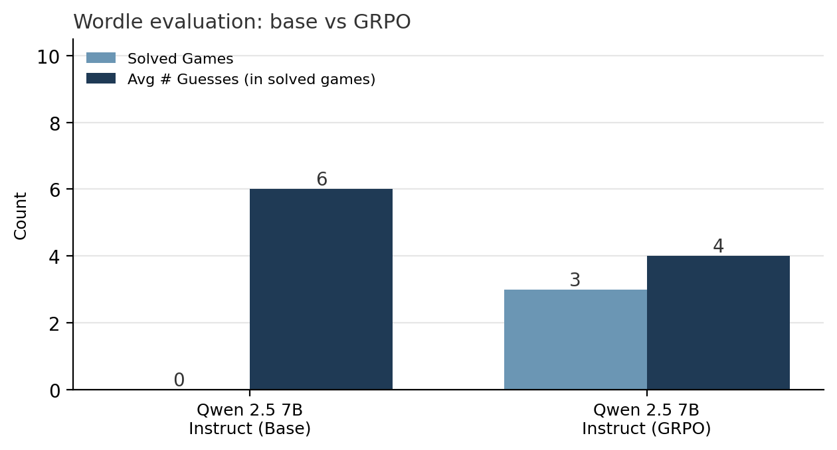
Figure 1. Wordle evaluation: untrained base vs. GRPO-trained Qwen2.5-7B-Instruct.
Analysis. GRPO produced a capability the base model lacked entirely: the untrained model solved 0 games within the six-guess limit, whereas the GRPO-trained model solved 3, averaging 4 guesses per solved game. This improvement indicates that the reward signal successfully shaped valid, feedback-consistent, and informative guessing. The base model’s nominal average of six guesses simply reflects exhausting the attempt limit without ever winning; with zero solves it has no meaningful in-solved-game average, so it is shown as “no solves.” The trained model’s four-guess average is competitive with much larger systems on this evaluation, although its lower solve count shows that clear headroom remains.

5. Discussion
The results show that GRPO can teach a mid-sized instruction model to play Wordle: a model that initially solved no games learned to solve several, with efficient guess counts on the games it won. Several lessons and limitations stand out. Format adherence is the dominant early bottleneck — a model that cannot reliably emit a parseable guess earns no reward and cannot improve — which is why a supervised warm-start before GRPO tends to help substantially. The evaluation set is small and sampling is stochastic, so absolute counts carry variance and the conclusions are directional rather than precise. GRPO is compute-intensive, since sampling many candidate guesses per state dominates cost, making LoRA and accelerated generation important for feasibility. Finally, reward design is load-bearing: because the rewards are summed, their relative magnitudes implicitly trade off format against strategy, and a poor balance can encourage safe but low-information guesses. Natural next steps are an SFT warm-start followed by GRPO, a larger standardized evaluation, and tuning of the reward weights and KL coefficient.

