**K-Means Clustering:**

*Algorithm:*

*Rscript*

#load the required packages

#ggplot is used to create plots

library(ggplot2)

#plot the iris data set

ggplot(iris, aes(Petal.Length, Petal.Width, color = Species)) + geom_point()

#clustering

set.seed(20)

#forming a kmeans cluster

irisCluster <- kmeans(iris[,3:4], 3, nstart=20)

irisCluster

#plot to see the clusters

irisCluster$cluster <- as.factor(irisCluster$cluster)

ggplot(iris, aes(Petal.Length, Petal.Width, color = irisCluster$cluster)) + geom_point()

*Iris data set*

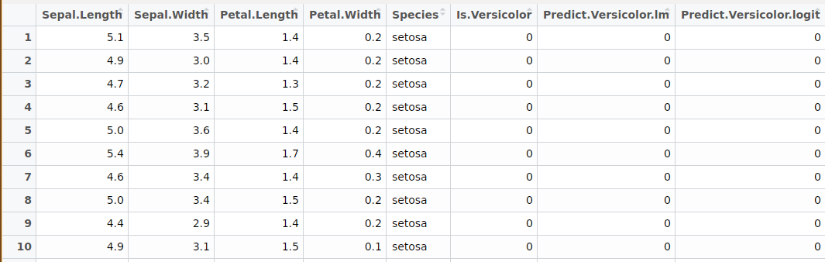

*Plotting iris data set*

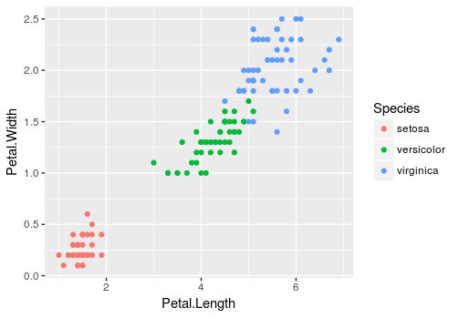

*Output:*

K-means clustering with 3 clusters of sizes 50, 52, 48

Cluster means:

Petal.Length Petal.Width

1 1.462000 0.246000

2 4.269231 1.342308

3 5.595833 2.037500

Clustering vector:

[1] 1 1 1 1 1 1 1 1 1 1 1 1 1 1 1 1 1 1 1 1 1 1 1 1 1 1 1 1 1 1 1 1 1 1 1 1 1 1 1 1 1 1 1 1 1 1 1 1 1 1 2 2 2 2 2 2 2 2 2 2 2 2 2 2 2 2

[67] 2 2 2 2 2 2 2 2 2 2 2 3 2 2 2 2 2 3 2 2 2 2 2 2 2 2 2 2 2 2 2 2 2 2 3 3 3 3 3 3 2 3 3 3 3 3 3 3 3 3 3 3 3 2 3 3 3 3 3 3 2 3 3 3 3 3

[133] 3 3 3 3 3 3 2 3 3 3 3 3 3 3 3 3 3 3

Within cluster sum of squares by cluster:

[1] 2.02200 13.05769 16.29167

(between_SS / total_SS = 94.3 %)

*Clusters Formed:*

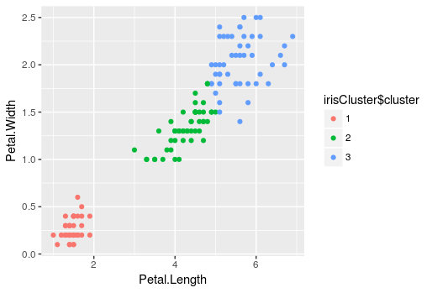

**Density based Clustering: (DBSCAN)**