1. Conclusions
   1. From Figure 1
      1. The top 4 types of projects have been in theatre, music, technology, and films and video.
      2. There have only been a couple of projects in journalism and those have all been cancelled. That could be because of lack of funding
      3. Music has the largest percentage of successful projects.

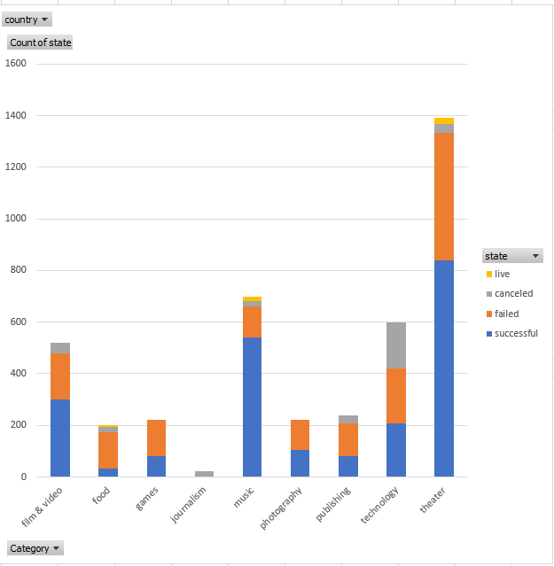

Figure

* 1. From Figure 2
     1. Plays by far have the most successful, live, and failed projects
     2. Very few projects are live
     3. 19 of the 41 categories have not had any successful or live projects

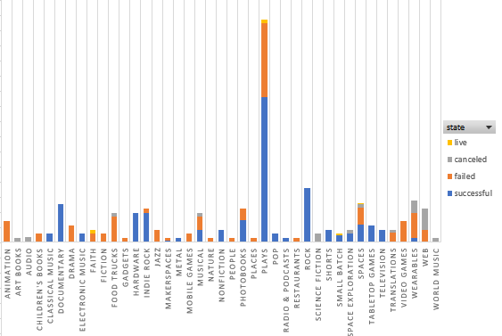

Figure

* 1. From Figure 3
     1. The information of this chart is not very useful
     2. It does seem to show that there are more successful projects that failed projects
     3. And live and failed projects are pretty much equal consistently

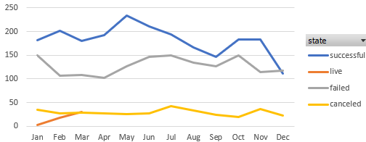

Figure

* 1. Other observations
     1. 441 of 4114 of the projects did not receive any funding
     2. 2002 of 4114 projects received more than 100% of the project cost. In fact, funding for over 259 projects were funded for more than 200% of the funding goal. And 28 of those have received funding for more than 1000% of the funding goal.

1. Limitations of included charts
   1. Having the number of projects by country would be good
   2. The categories of staff pick, and spotlight are not very informative. What are the criteria for these values?
   3. There is no currency conversion included in the data
   4. Is there any payback to the people that did donate?
   5. It would be very beneficial to know what companies or corporations are responsible for these different projects. This would make it easier to corelate success and failure to a person or company. This would allow donors to identify project leaders that have been successful in the past
   6. The success is only broken down by percentage of financial backing. That does not give us any idea of how commercially successful the project is. Having this data would allow investors to make better decisions regarding the risk of investing on projects based on some measurable data or another.