EXPNO 10: CREATE A CLONING OF A VM AND TEST IT BY LOADING
THE PREVIOUS VERSION/CLONED VM.
DATE:5/11/25
AIM:
To create a cloning of a vm and test it by loading the previous version/cloned vm.
PROCEDURE:
STEP 1: GO TO VM AND GOTO MANAGE AND CLICK CLONE
STEP 2: CLICK CLONE
STEP 3: SELECT THE FULL CLONE
STEP 4: AFTER CLONE AGAIN OR VM IS OPENED.

IMPLEMENTATION:

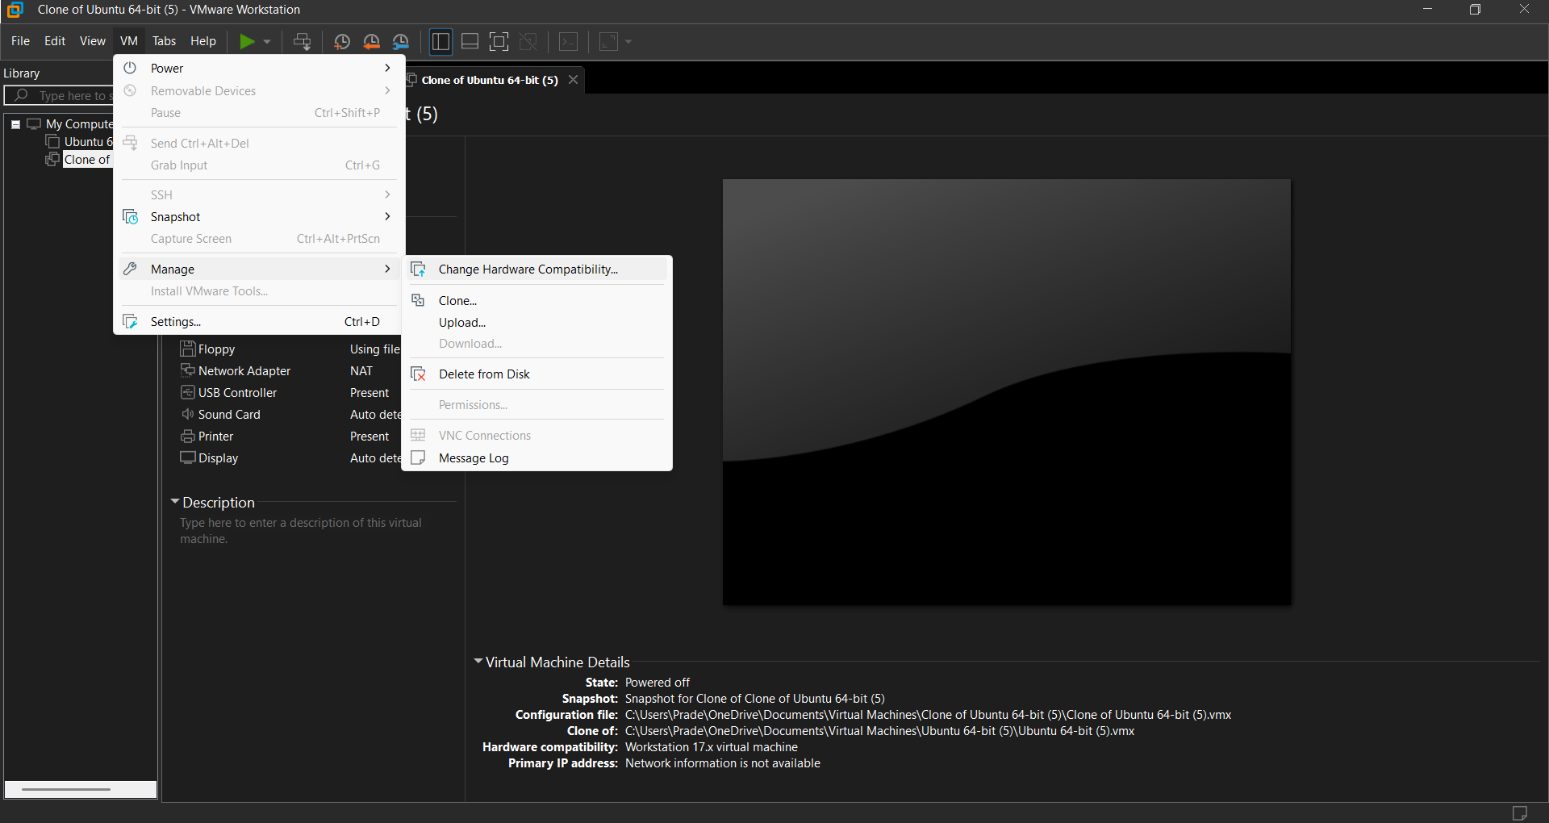
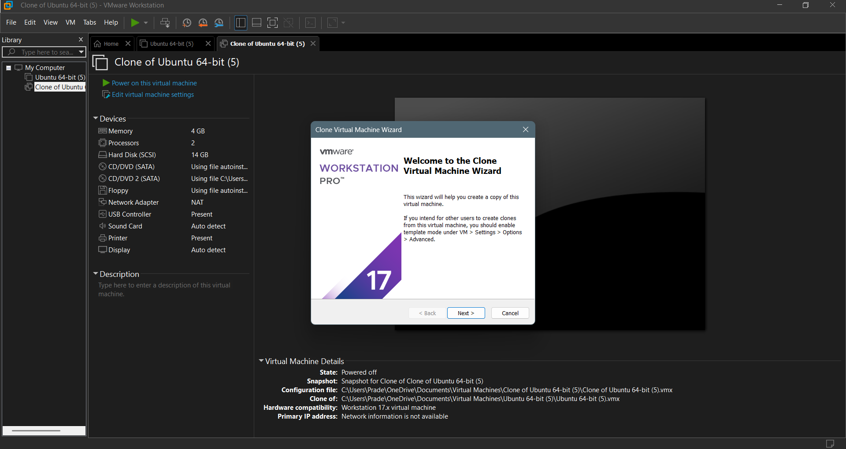

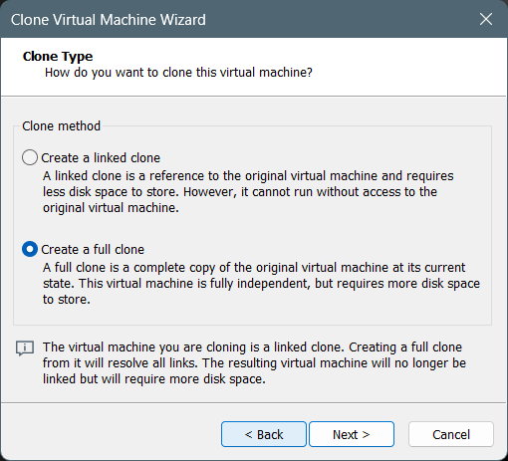
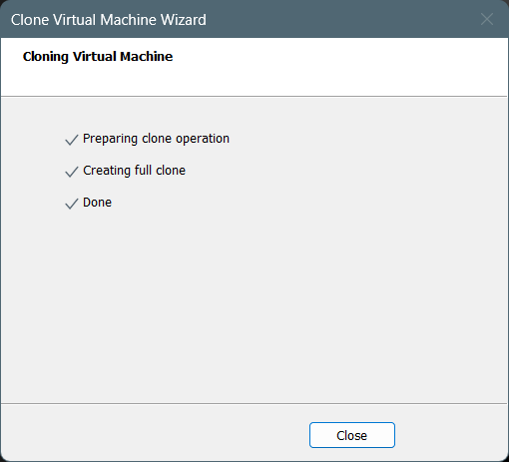

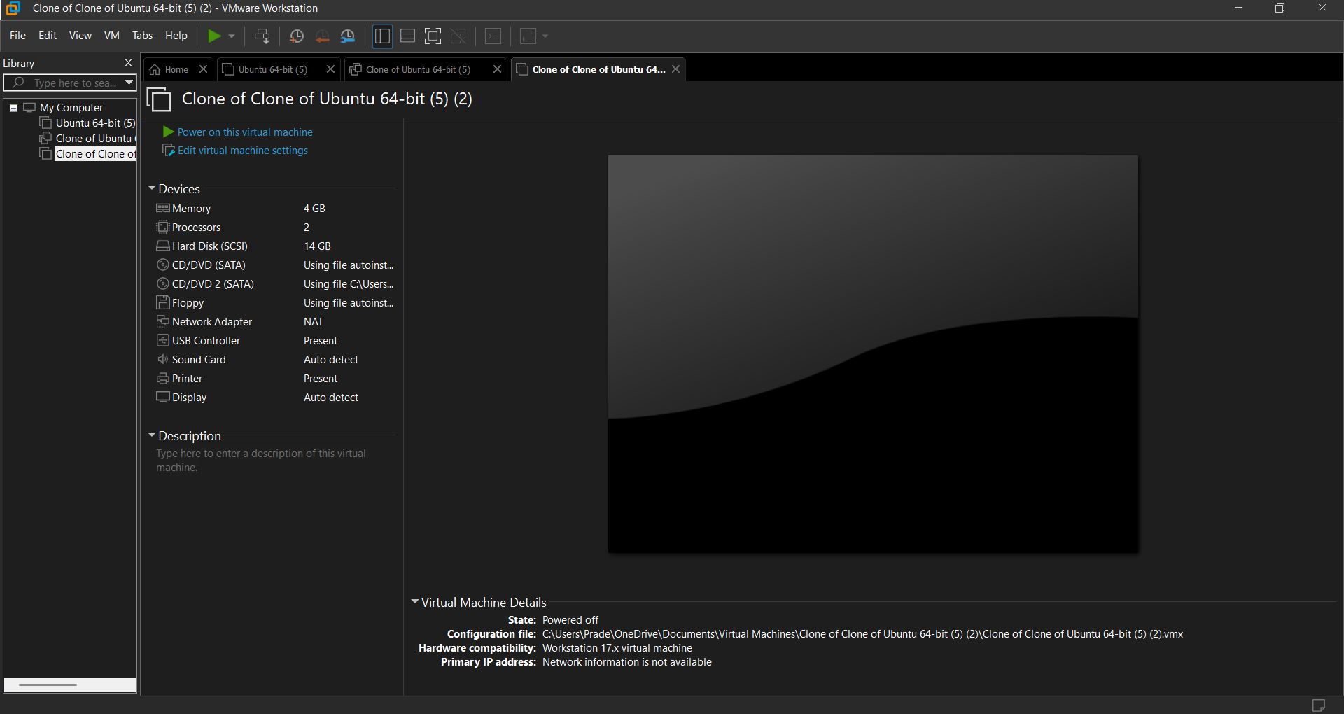

RESULT:
A cloning of a vm and test it by loading the previous version/cloned vm is created.

