
EXPERIMENT - 12

Aim
To demonstrate virtualization by installing a Type-2 Hypervisor (VMware Workstation), creating and configuring a Virtual Machine (VM) image with a host operating system (Windows/Linux).


Procedure
- Download and install VMware Workstation Player from the official website: https://www.vmware.com/products/workstation-player.html.
- Launch VMware Workstation Player after installation.
- Click on 'Create a New Virtual Machine'.
- Choose the installation method for the guest OS (Installer disc/ISO image).
- Select the ISO file of the desired operating system (e.g., Ubuntu or Windows).
- Name the virtual machine and choose a storage location.
- Allocate disk space (e.g., 20 GB or more) and memory (e.g., 2–4 GB RAM).
- Configure the network settings (NAT or Bridged).
- Start the VM and install the guest operating system by following the on- screen instructions.
- After installation, install VMware Tools for better integration and performance.
- Configure additional settings like screen resolution, shared folders, and drag-and-drop functionality.

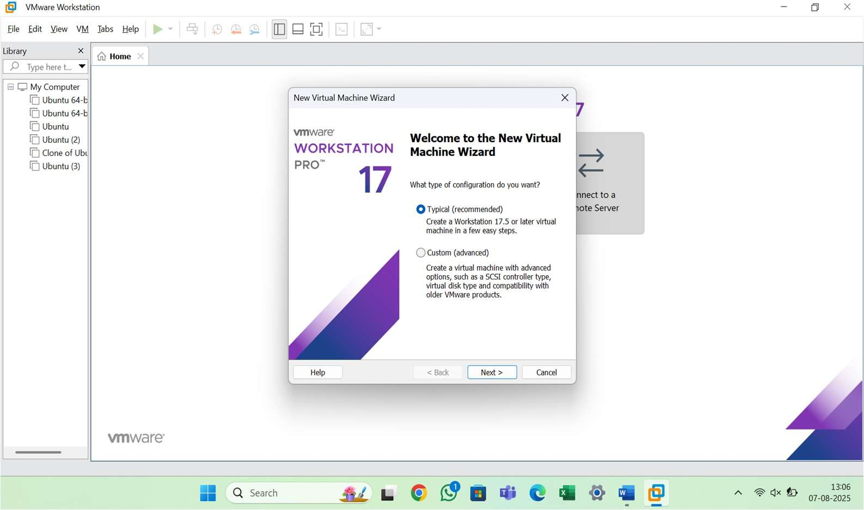
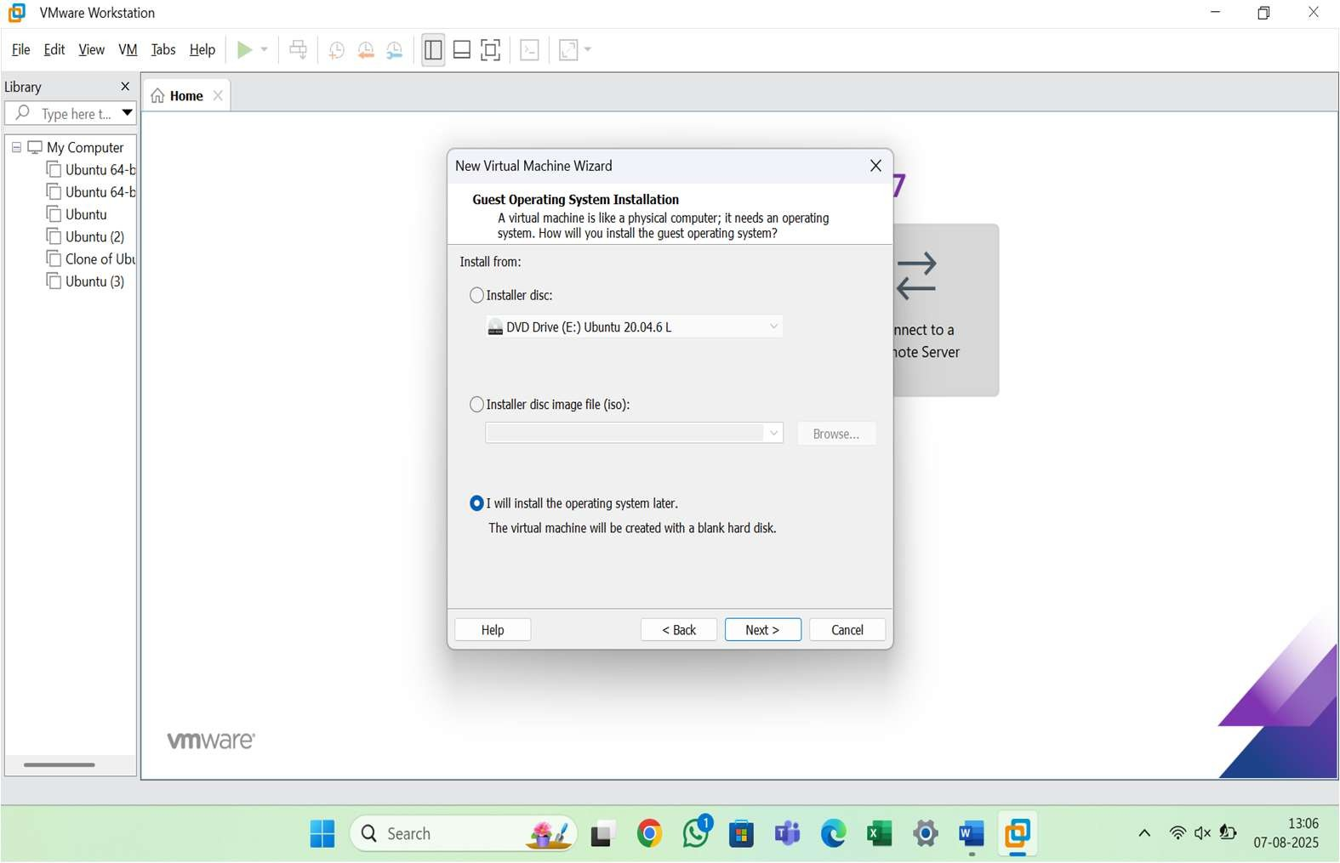

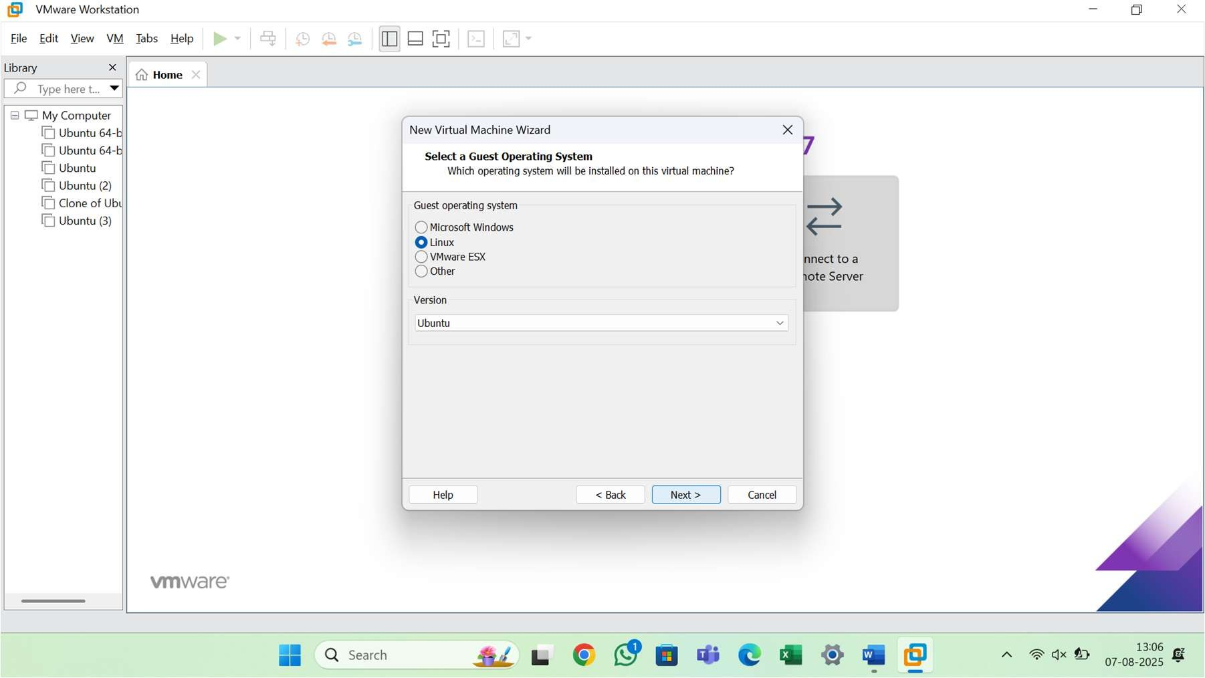
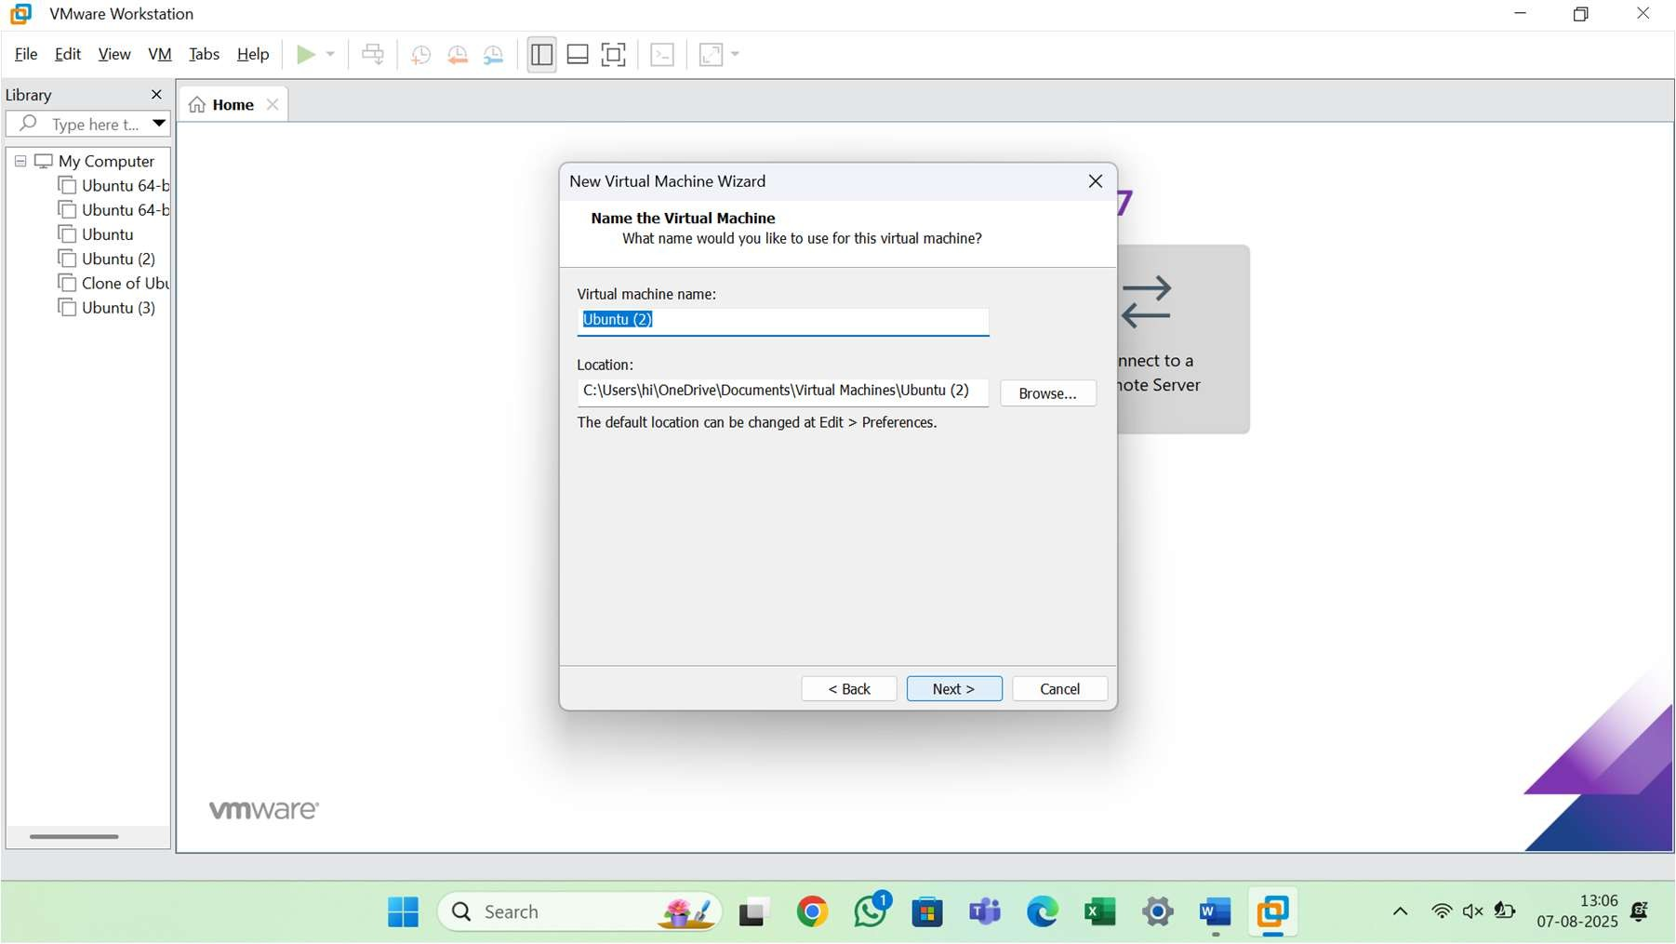

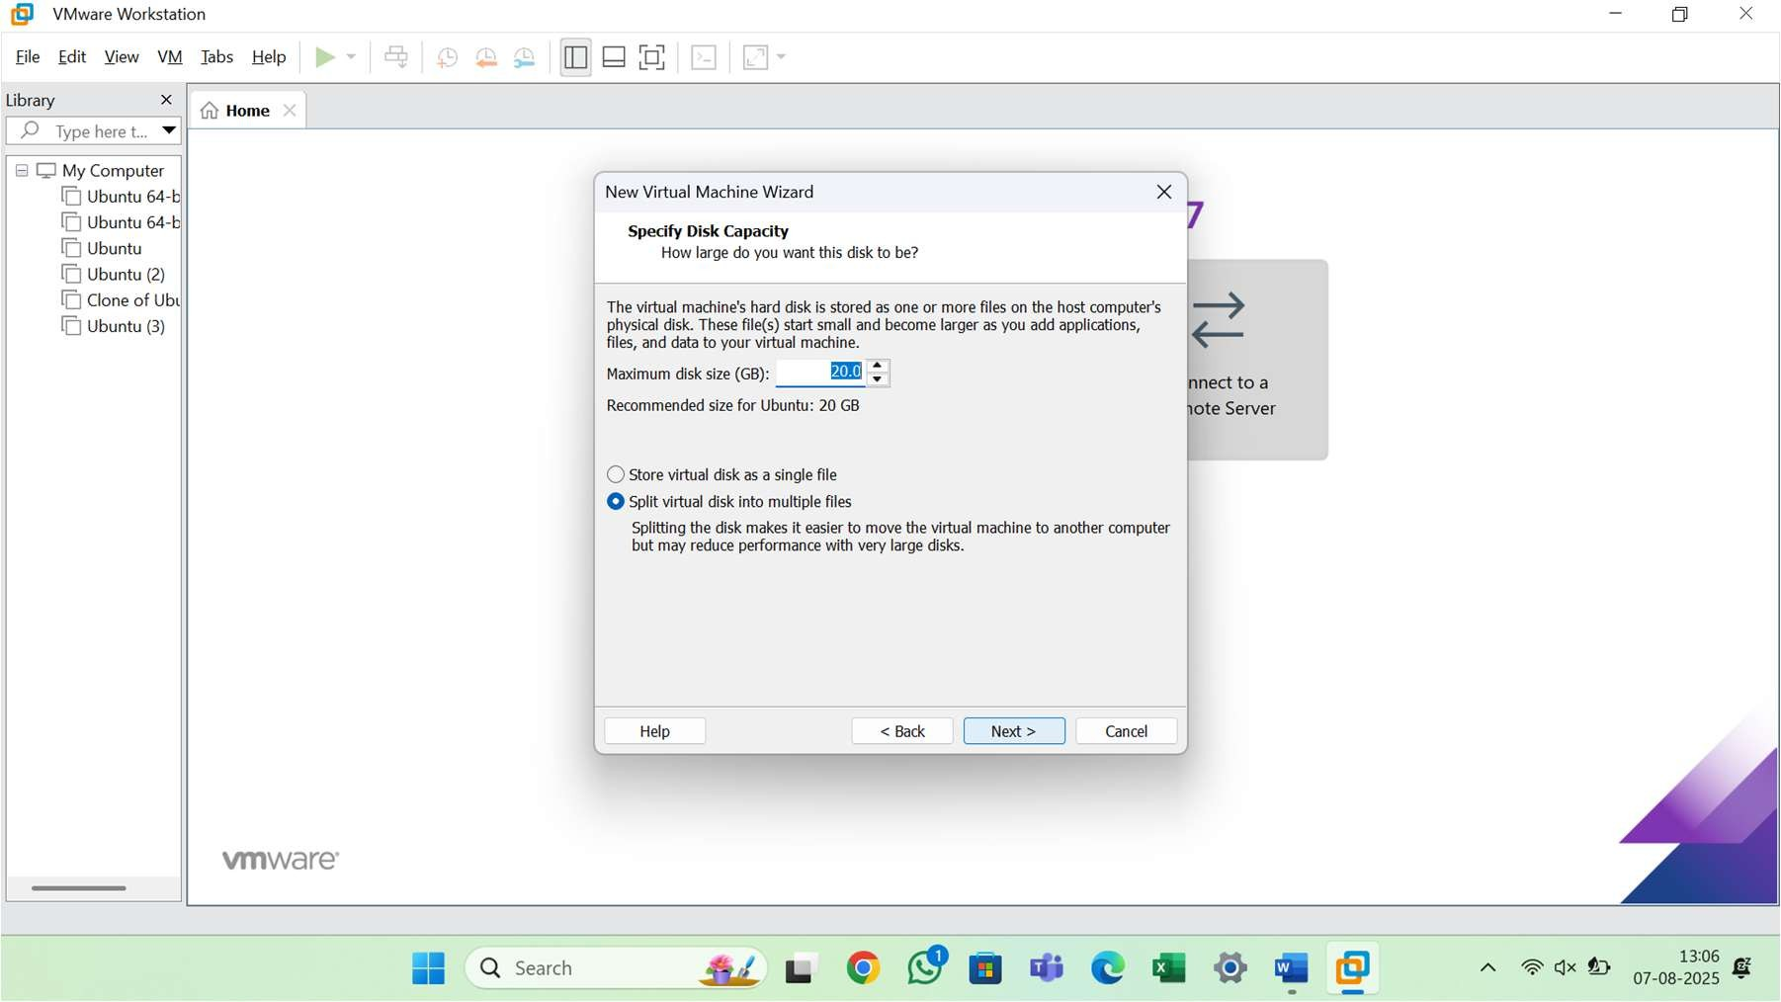
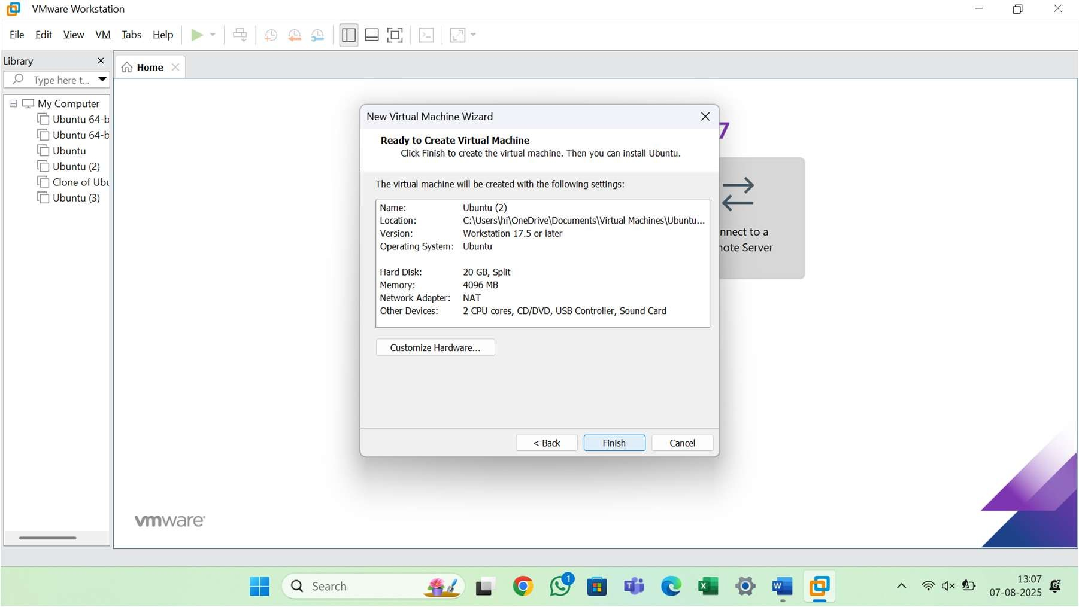

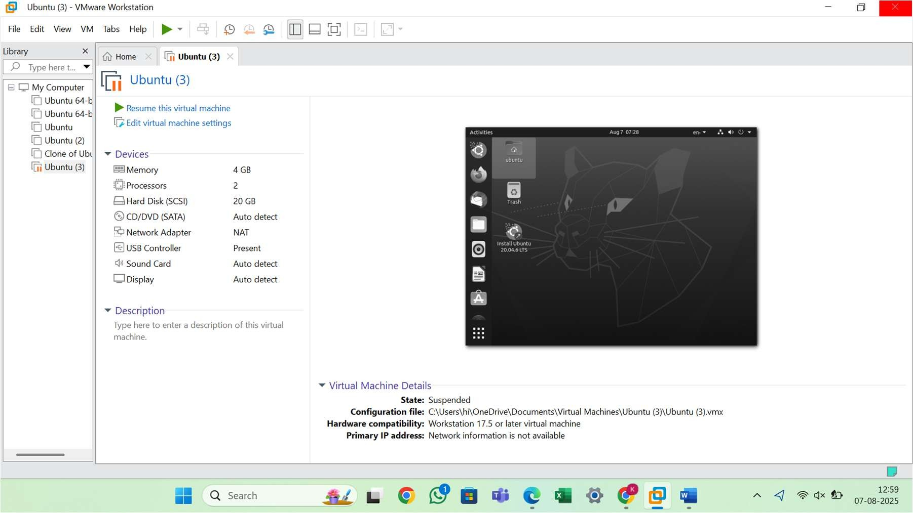


Result
Successfully installed and configured VMware Workstation Player (Type-2 Hypervisor) on the host machine. A virtual machine was created and a guest operating system (Ubuntu 22.04 LTS) was successfully installed and configured. VMware Tools were installed to enhance VM performance.

