
EXPERIMENT - 14

Aim
To create and allocate a Virtual Hard Disk (VHD) using VMware Workstation for a virtual machine.


Procedure
- Launch VMware Workstation Player or Pro on your host machine.
- To create a VHD during VM creation:
  - Click on 'Create a New Virtual Machine'.
  - Select installation method (ISO file or install later).
  - Choose the guest operating system type and version.
  - Name the virtual machine and select storage location.
  - When prompted, set the disk size (e.g., 15 or 20 GB).
  - Choose 'Store virtual disk as a single file' or 'Split into multiple files'.
  - Click 'Finish' to create the VM along with the VHD.
- To add a VHD to an existing VM:
  - Select the existing VM and click on 'Edit virtual machine settings'.
  - Click 'Add…', then choose 'Hard Disk' and click 'Next'.
  - Choose 'SCSI' (recommended) and click 'Next'.
  - Select 'Create a new virtual disk', then click 'Next'.
  - Enter the desired disk size (e.g., 15 GB).
  - Choose whether to store the disk as a single file or multiple files.
  - Name the VHD file (e.g., new_disk.vmdk) and click 'Finish'.
- The virtual hard disk will now appear in the VM’s hardware settings and be usable after formatting inside the guest OS.

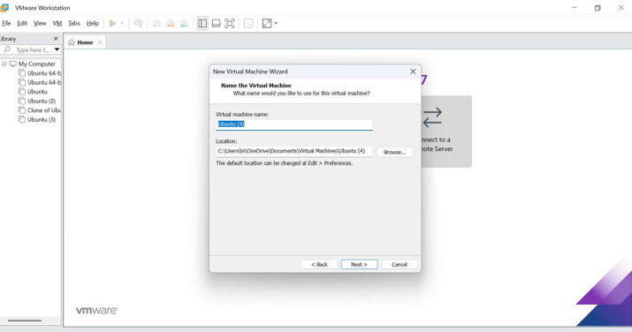

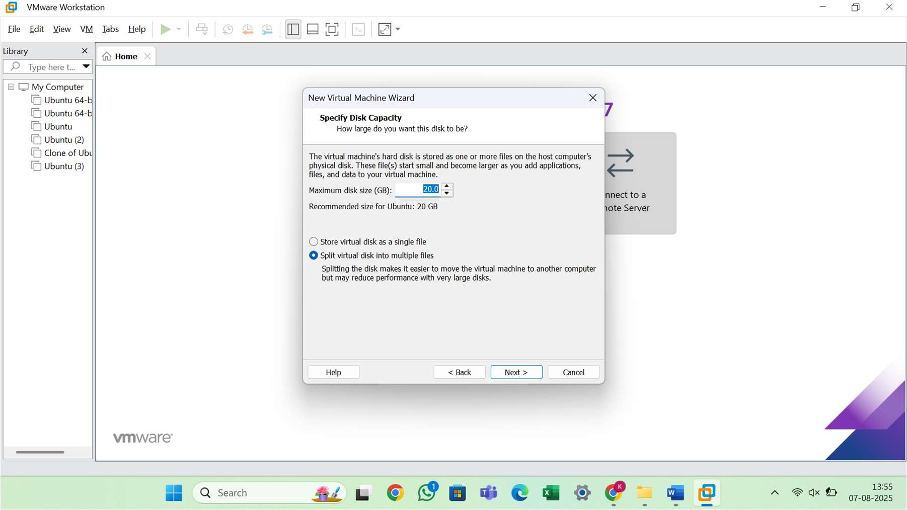

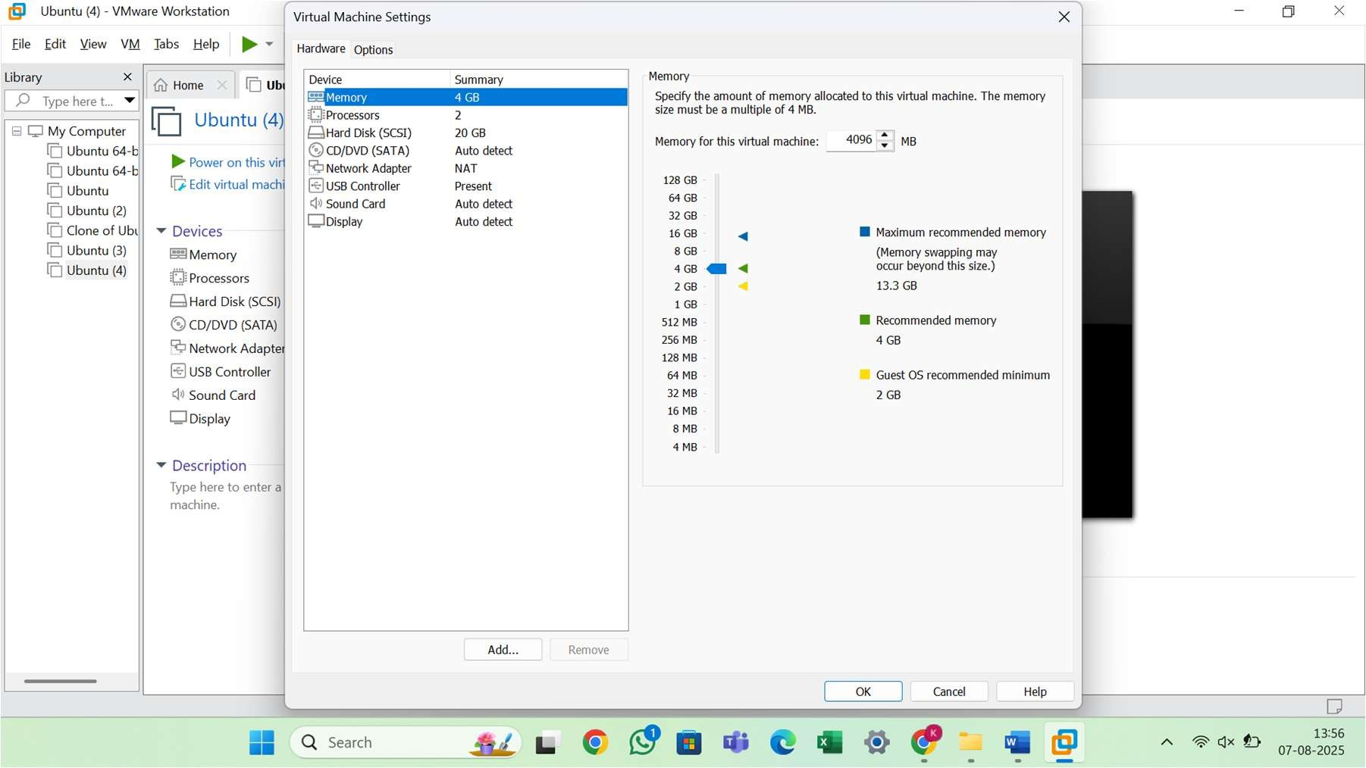

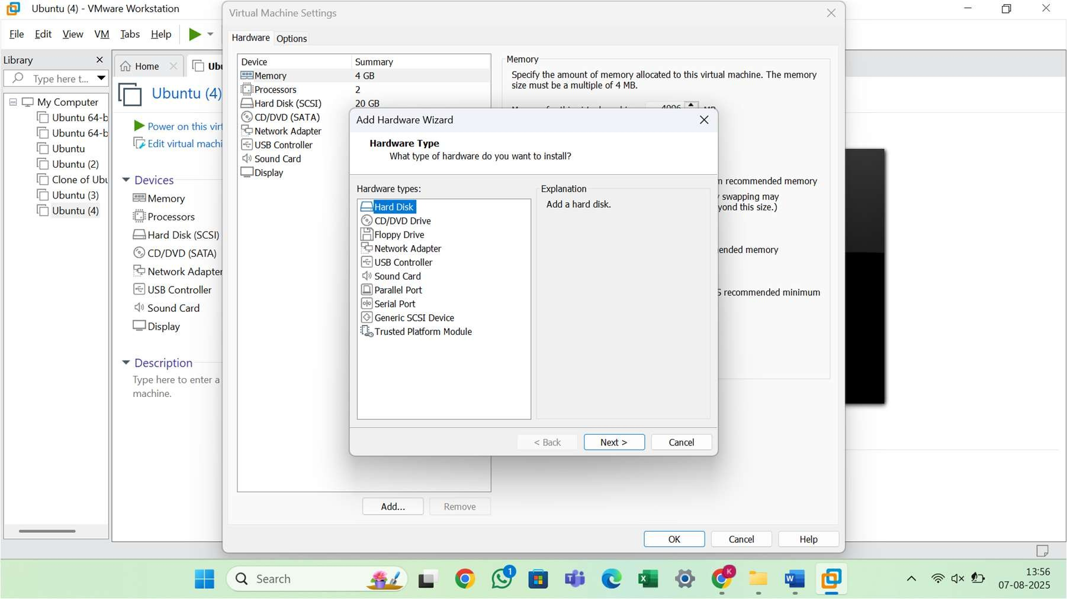

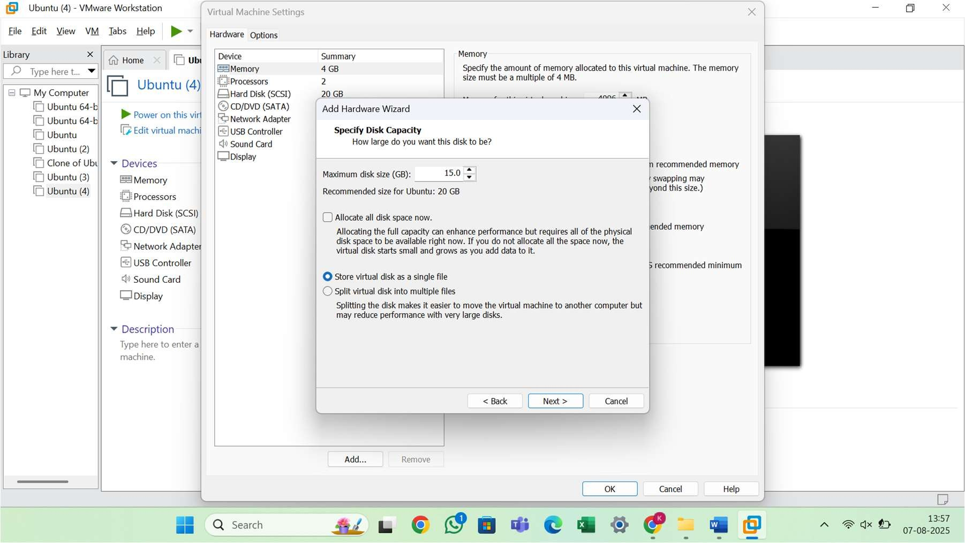

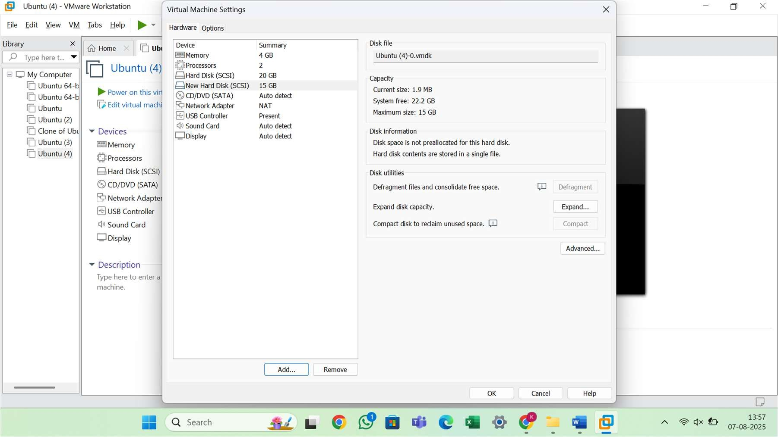

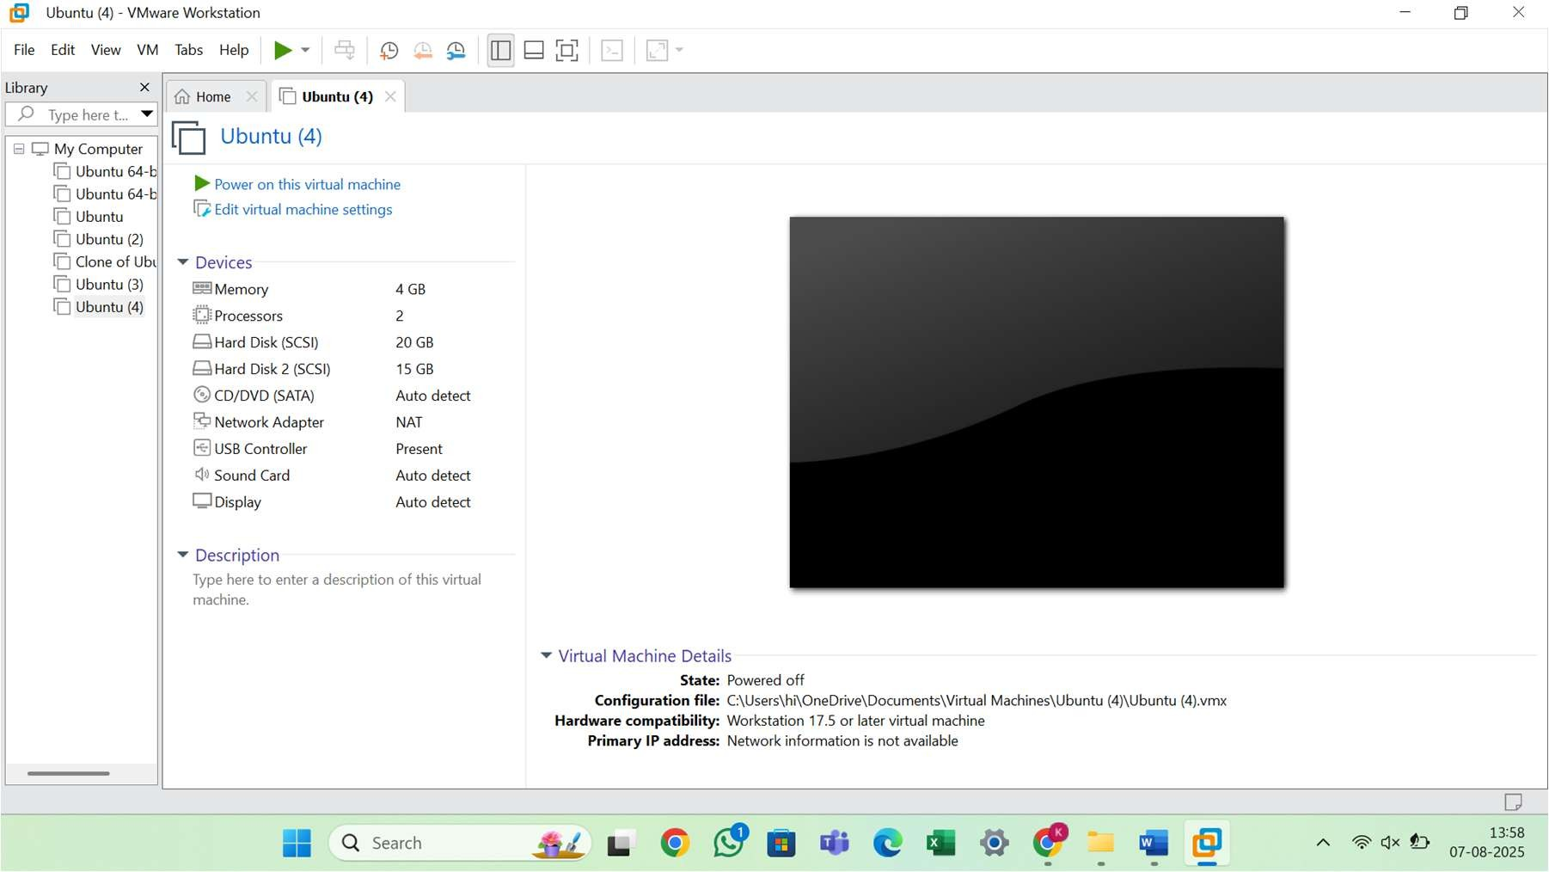


Result

A virtual hard disk was successfully created and allocated using VMware Workstation. The disk is now available to the virtual machine for storage purposes.

