EXPERIMENT -15

Aim
To create a snapshot of a virtual machine (VM) using VMware Workstation and verify its functionality by reverting to the snapshot or creating and running a cloned VM.

Procedure

Step 1: Launch VMware Workstation
- Open VMware Workstation on your system.
- Select the virtual machine you wish to manage from the left panel.

Step 2: Shut Down the Virtual Machine
  - Shut down the VM to ensure a clean snapshot (optional but recommended).

Step 3: Take a Snapshot
- Click on the VM menu.
- Select Snapshot → Take Snapshot.
- Enter a name (e.g., "Before Update") and an optional description.
- Click Take Snapshot to save the VM's current state.

Step 4: Make System Changes (Optional)
  - Start the VM and install software or make system changes for testing purposes.

Step 5: Revert to the Snapshot
- Go to VM → Snapshot → Snapshot Manager.
- Select your previously saved snapshot.
- Click Go To to restore the VM to that state.

Step 6: Clone the VM (Optional Alternative)
- Shut down the VM again.
- Go to VM → Manage → Clone.
- Choose:
  - Clone from Snapshot (to use saved snapshot)
  - Create a Full Clone (for independent use)

- Name and save the clone in your desired location.

Step 7: Run the Cloned VM
- Power on the cloned VM and verify that it runs as expected, matching the state of the snapshot.
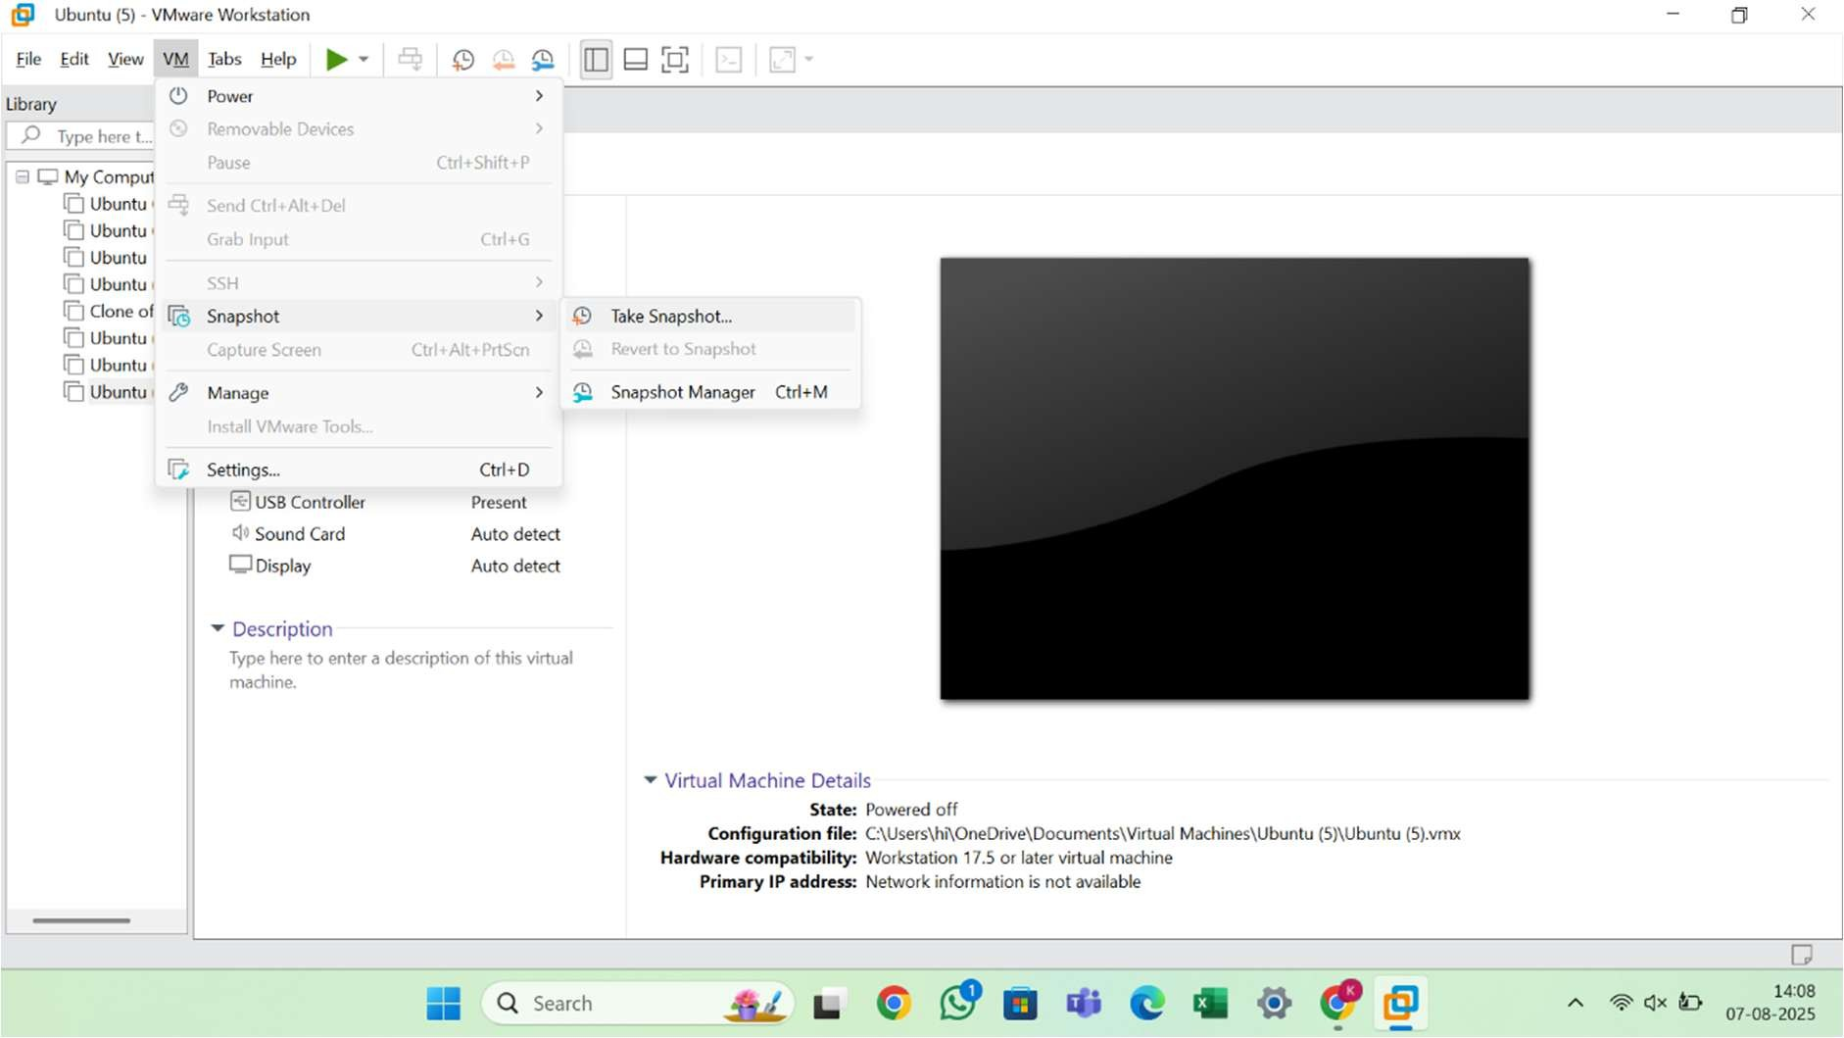

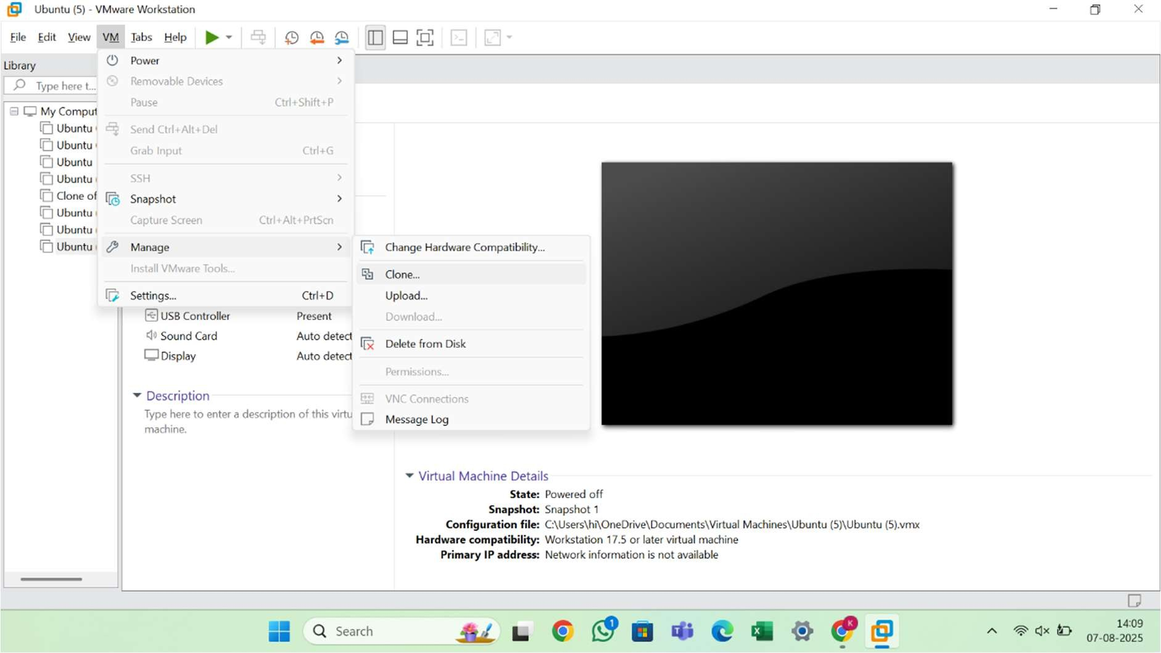

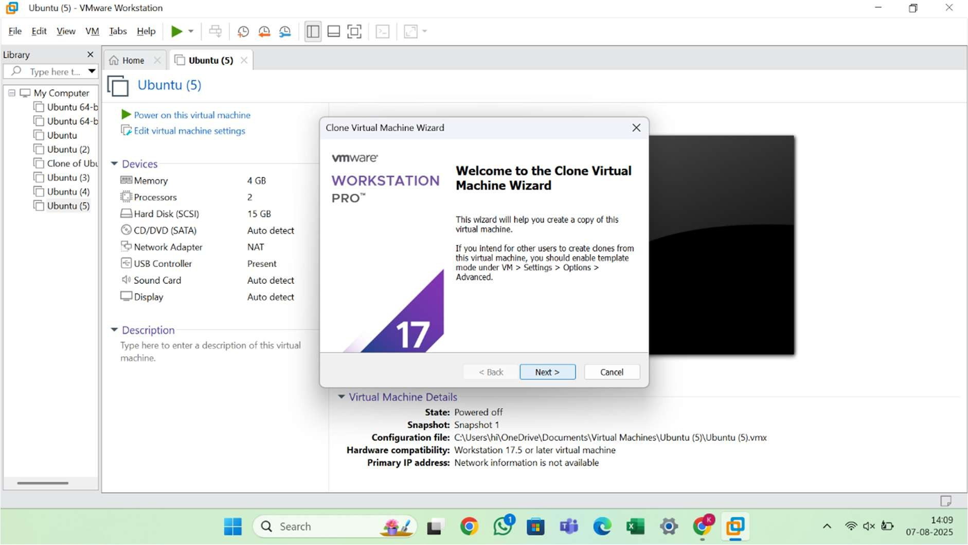
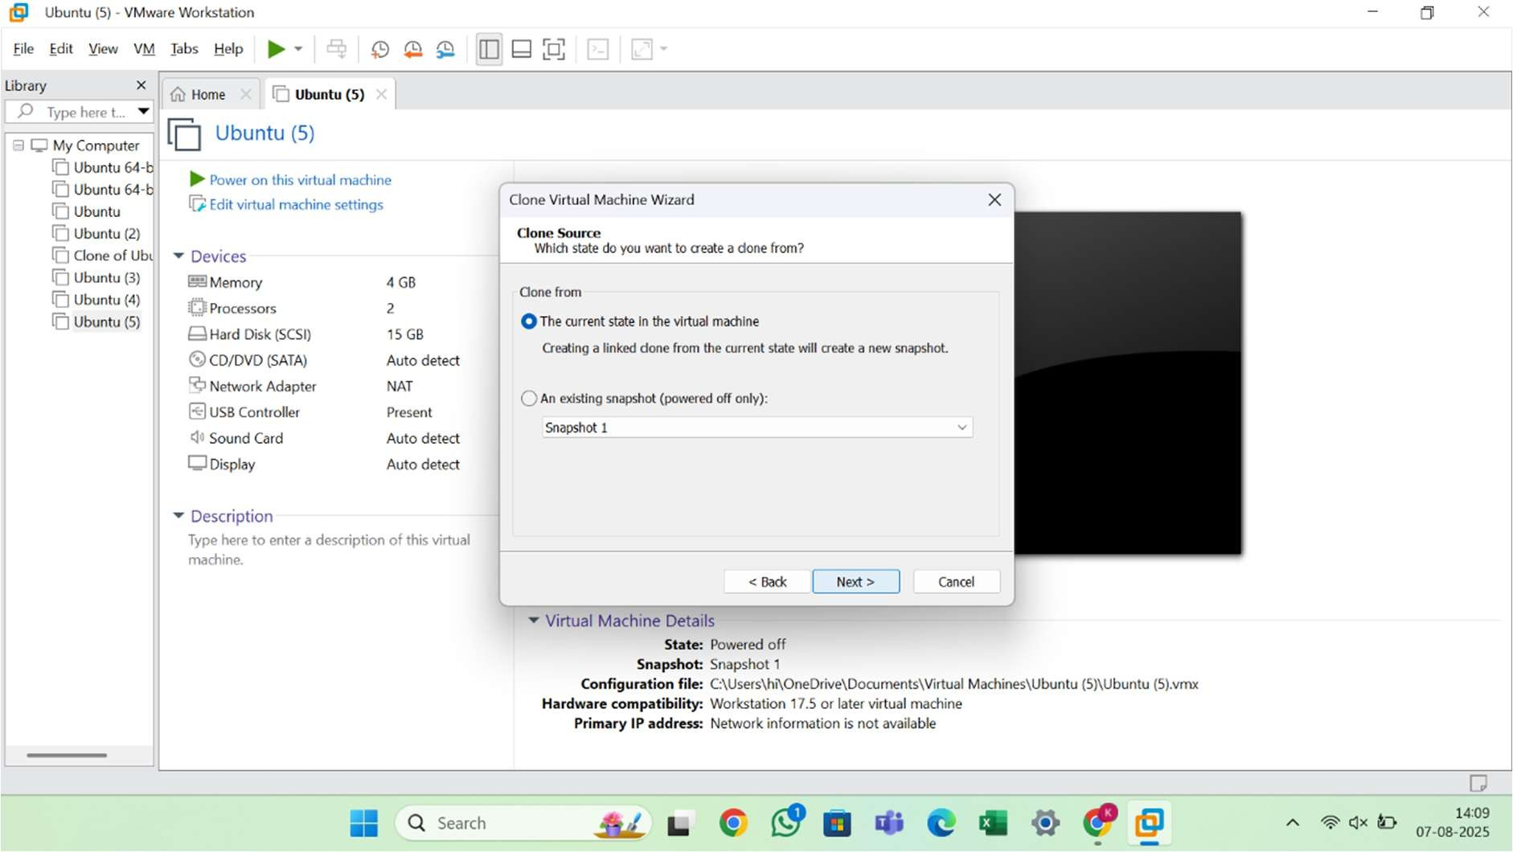

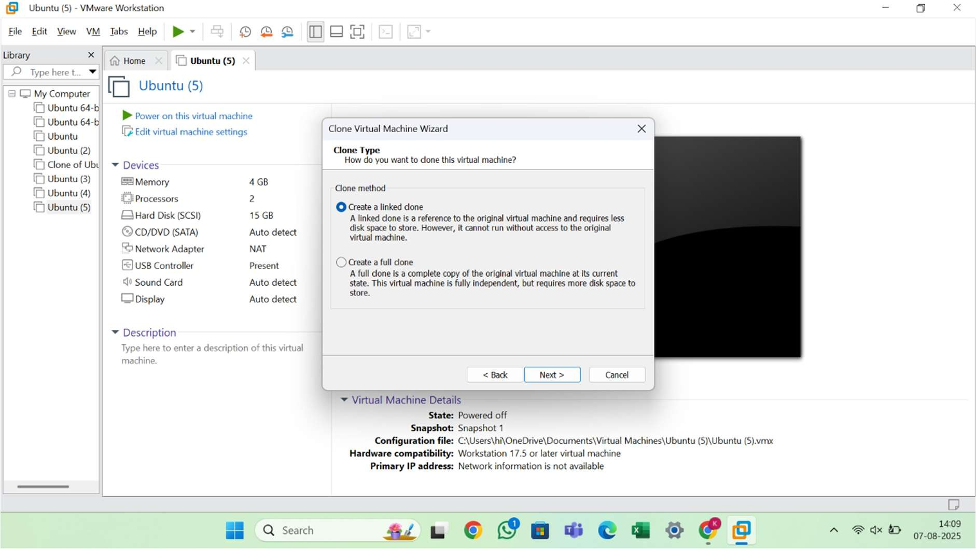
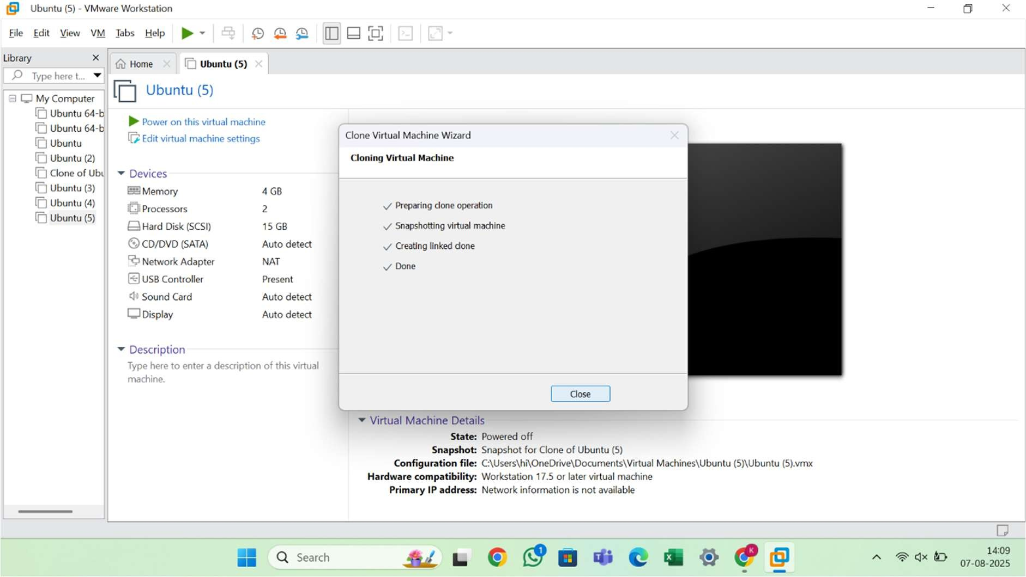

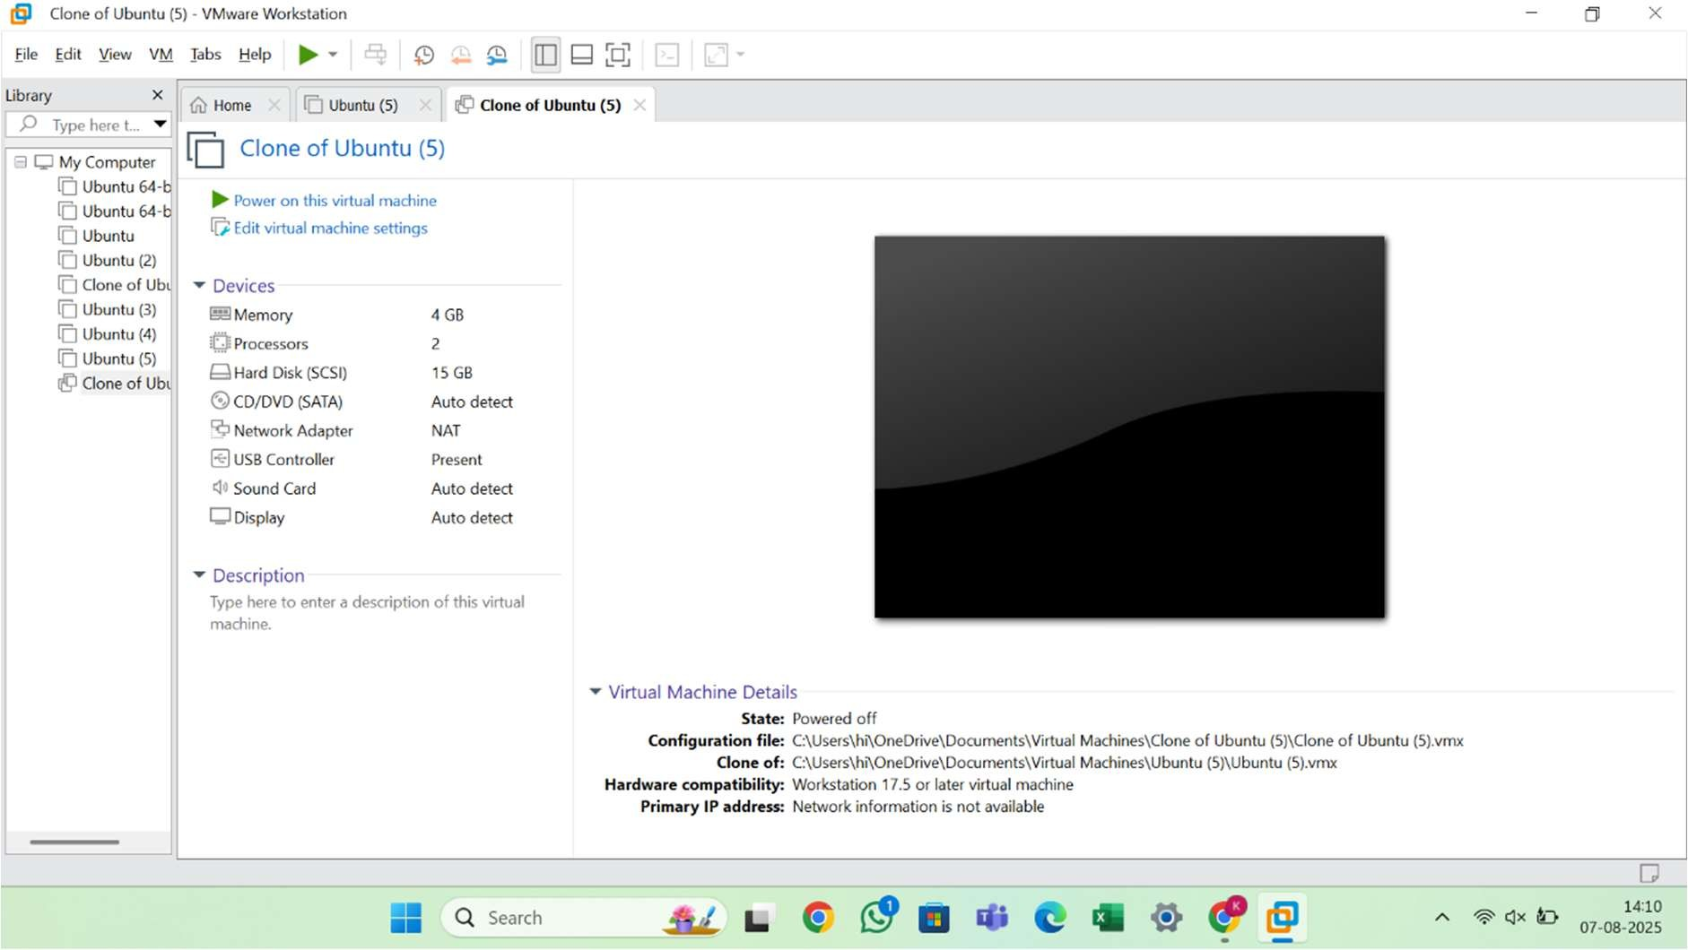

Result
The virtual machine snapshot was successfully created. The system was reverted to the snapshot state without data loss. Additionally, a cloned VM was created and verified to run correctly from the selected snapshot state.

