EXPERIMENT – 16

Aim
To clone a virtual machine using VMware Workstation and verify the cloned VM by running and testing it independently from the original VM.

Procedure

Step 1: Launch VMware Workstation
- Open VMware Workstation on your system.
- In the Library, select the virtual machine you want to clone.

Step 2: Shut Down the Virtual Machine
  - Make sure the VM is powered off before cloning to prevent issues and ensure the current state is saved properly.

Step 3: Create a Clone of the VM
- Click on the VM menu.
- Go to Manage → Clone.
- In the Clone Wizard, select:

Clone from the current state or
  - Clone from an existing snapshot
- Click Next.
- Choose the clone type:
  - Full Clone: An independent copy of the VM.
  - Linked Clone: A dependent copy that uses the base VM’s disk (saves space but relies on the original VM).
- Click Next, give the clone a name, and select the storage location.
- Click Finish.

Step 4: Run the Cloned VM
- Find the cloned VM in the Library or in the folder you saved it to.
- Power on the cloned VM.
- Test the cloned VM to ensure it runs independently and behaves like the original VM.

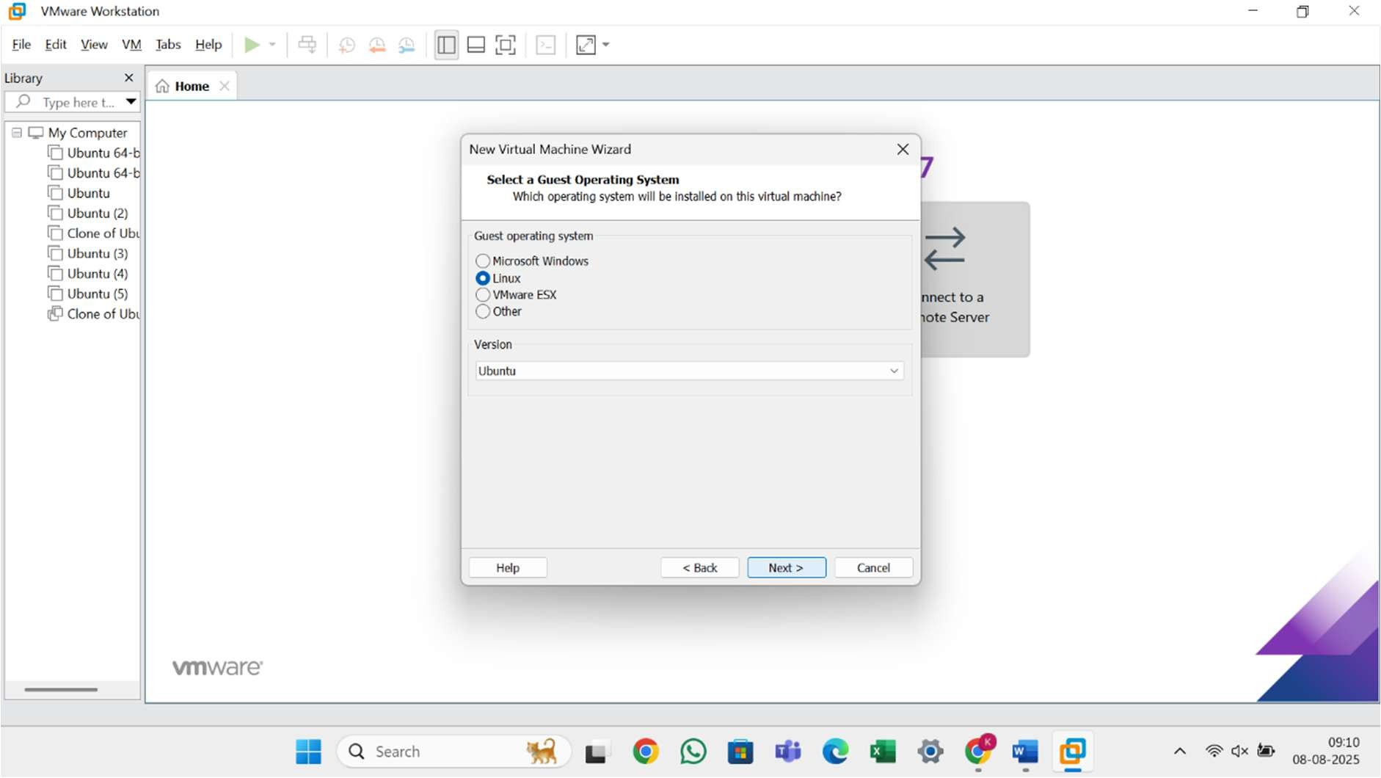
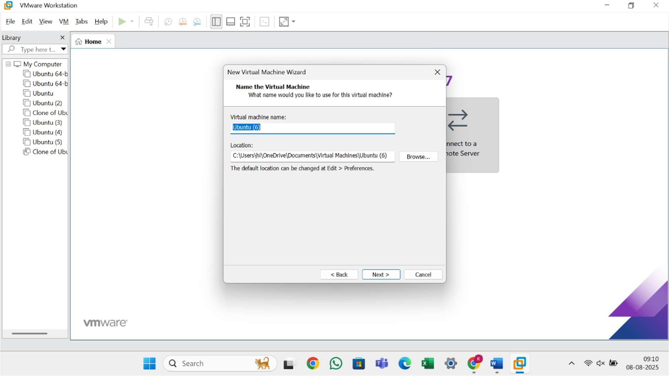

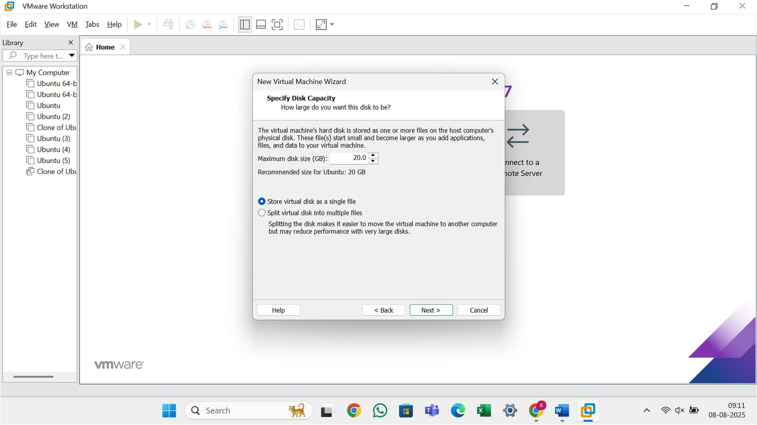

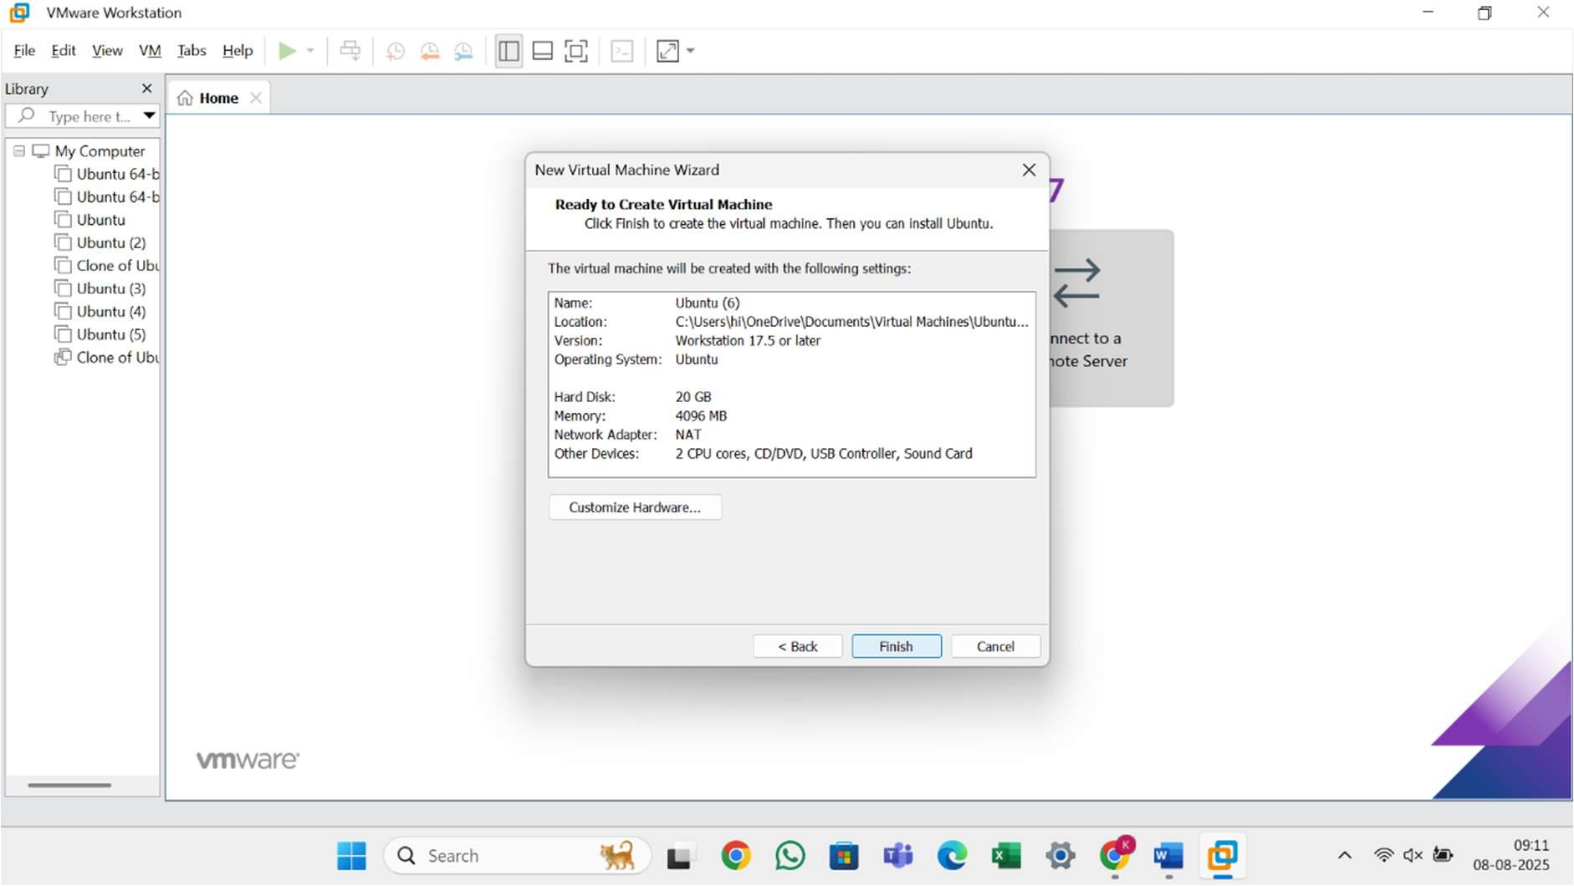

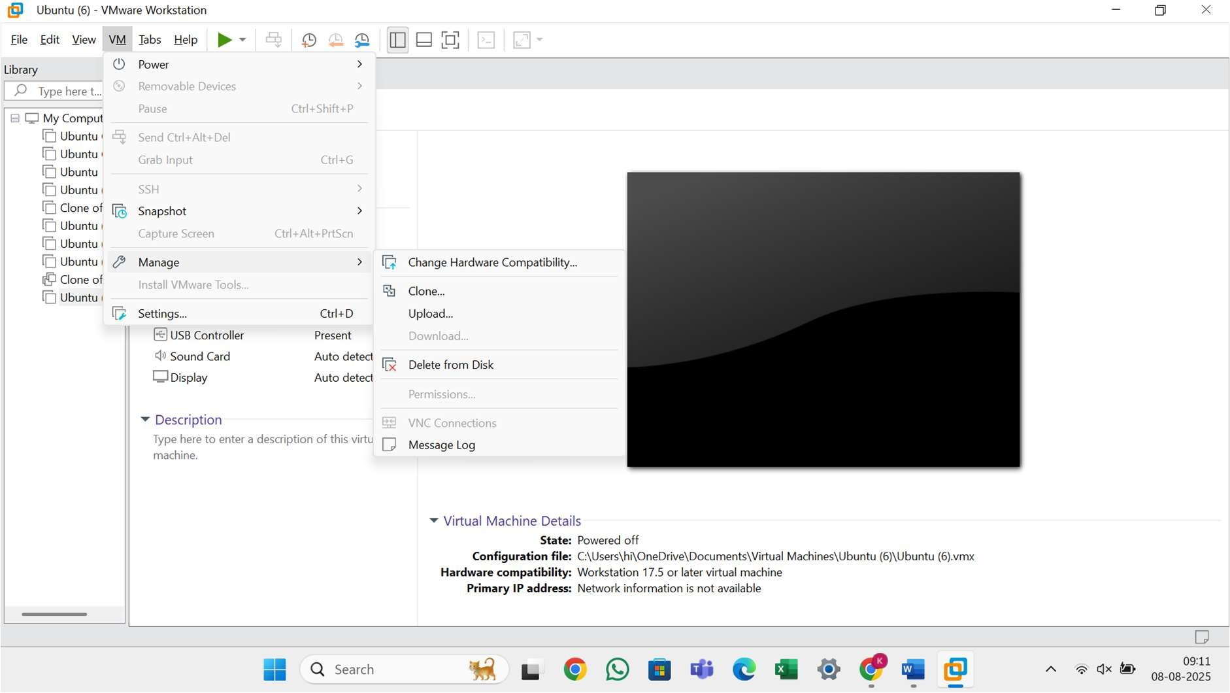

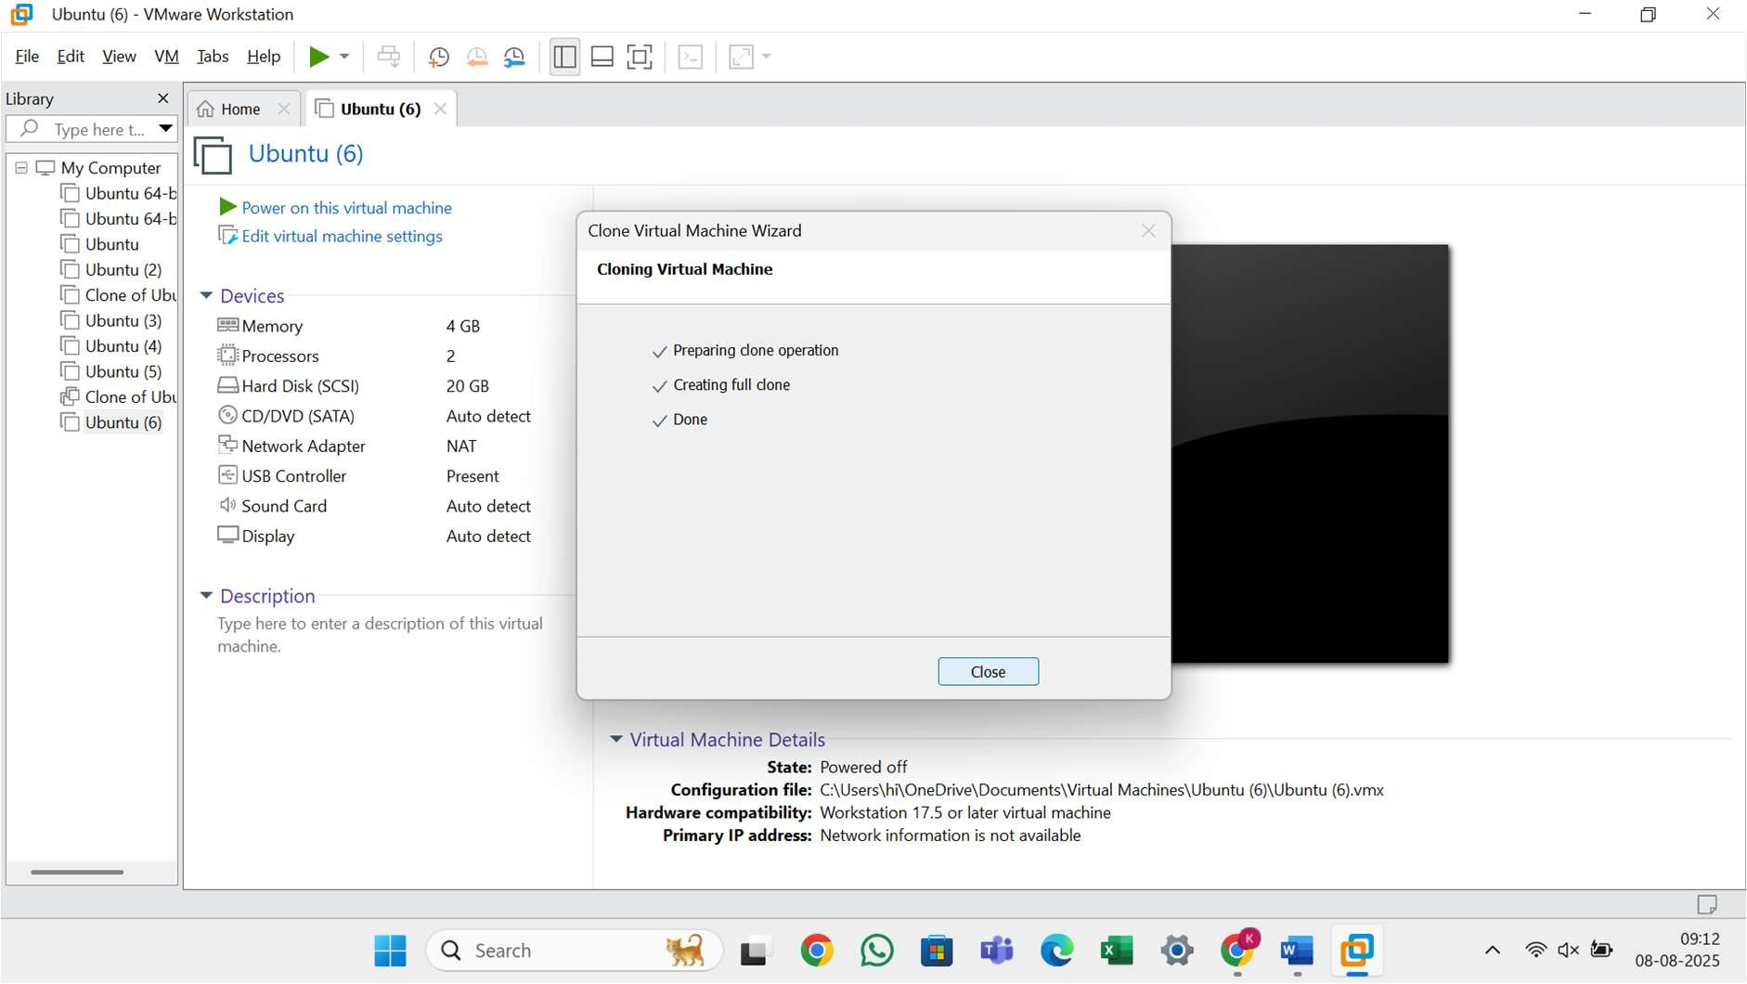

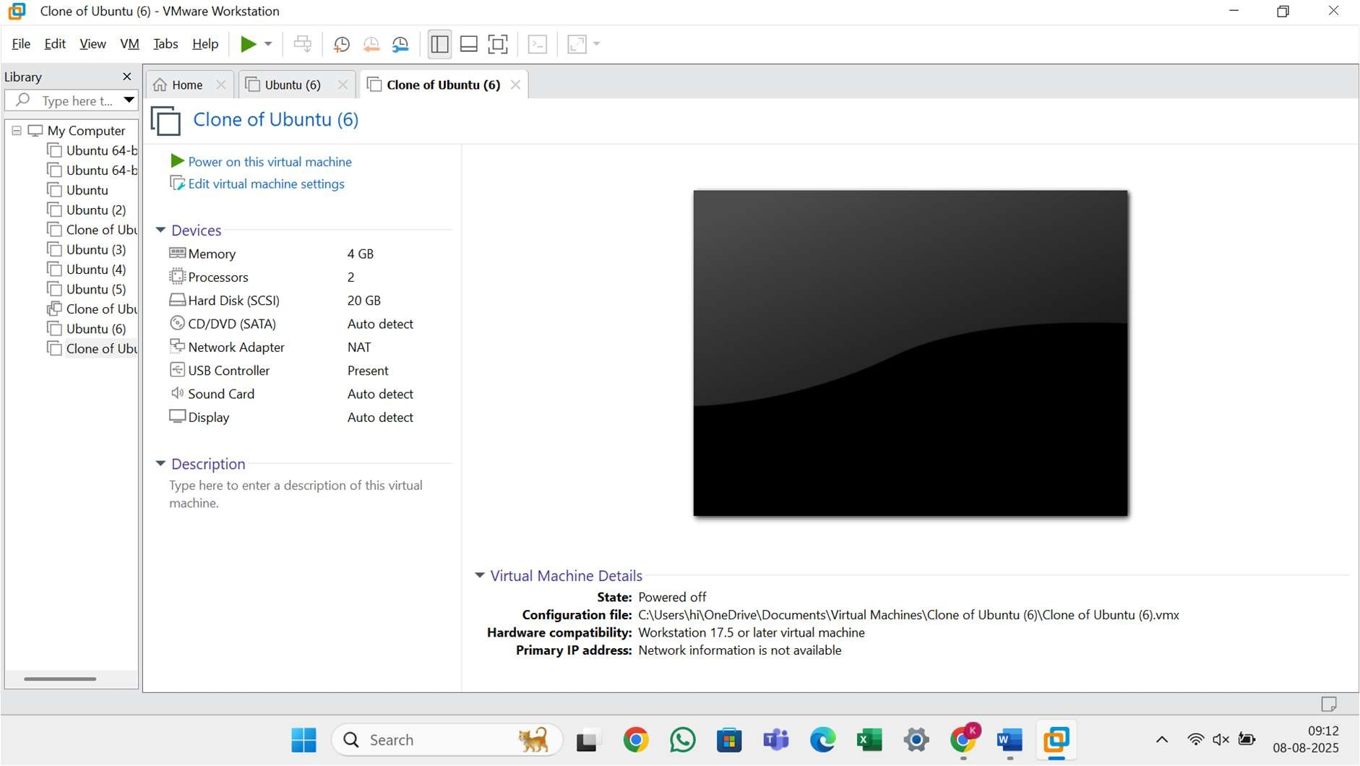

Result
A virtual machine was successfully cloned using VMware Workstation. The cloned VM booted independently and retained the original VM’s configuration and state. Testing confirmed that it functioned correctly without relying on the original VM.

