AIM:
HARDWARE COMPATIBILITY EXPERIMENT – 17

To change the hardware compatibility of a virtual machine (VM) by

cloning or creating a new VM using Oracle.

PROCEDURE:
- Open Oracle VM VirtualBox and ensure the virtual machine is powered off.
- Select the existing virtual machine from the left pane. To change hardware compatibility, it is recommended to clone the VM or create a new one with the desired configuration.
- Right-click on the VM and select Clone.
- In the cloning wizard, enter the name for the new VM and select Reinitialize the MAC address of all network cards.
- Choose the cloning type:
- Full Clone (creates a complete independent VM)
- Linked Clone (shares virtual disk with the original VM)
- Once the VM is cloned, go to Settings of the new VM.
- Under the System section, modify the base memory (RAM), boot order, and chipset/pointing device options according to desired hardware compatibility.
- In the Processor tab, adjust the number of processors or enable PAE/NX if required.
- Under Display, adjust video memory, enable 3D acceleration or 2D acceleration depending on what the target environment supports.
- You can also update Storage, Network Adapter types, and USB Controller version (USB 1.1/2.0/3.0) to ensure compatibility with newer VirtualBox versions.
- Once all hardware settings are changed, click OK to save and then start the VM to verify successful execution.

OUTPUT:

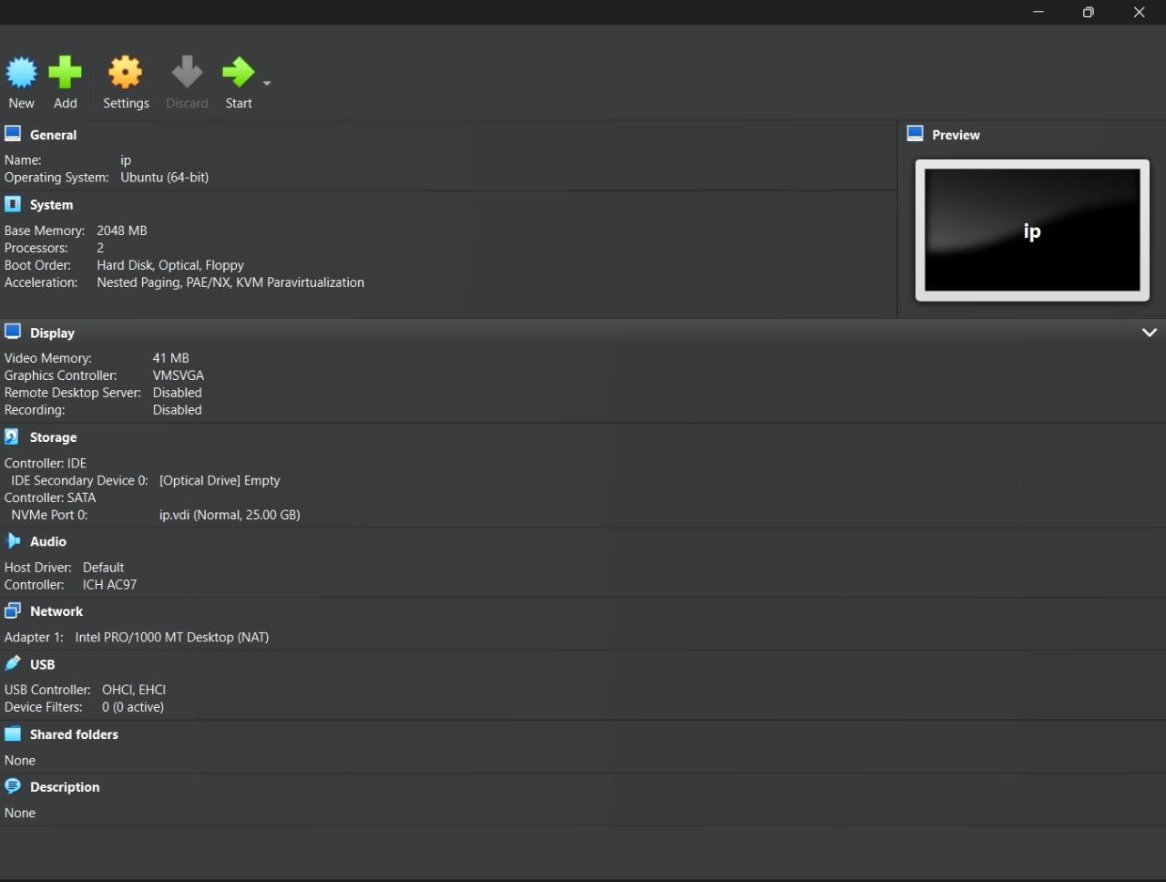

RESULT:
Successfully changed the hardware configuration of a Virtual Machine using Oracle VM VirtualBox by cloning and modifying settings.

