EXP NO 18. Demonstrate Infrastructure as a Service (IaaS) by creating a resources group using a Public Cloud Service Provider (Azure), configure with minimum CPU, RAM, and Storage.

Aim:
To demonstrate Infrastructure as a Service (IaaS) by creating a Resource Group using a public cloud service provider (Microsoft Azure) and configuring it for minimal resource usage.

STEP1: CREATE AN ACCOUNT IN MICROSOFT AZURE. STEP 2: CREATE A NEW RESOURCE GROUP
STEP 3: VERIFY THE RESOURCE GROUP STEP 4: (OPTIONAL) ADD A RESOURCE
STEP 5: STOP / DELETE RESOURCE GROUP (OPTIONAL) DESIGN:
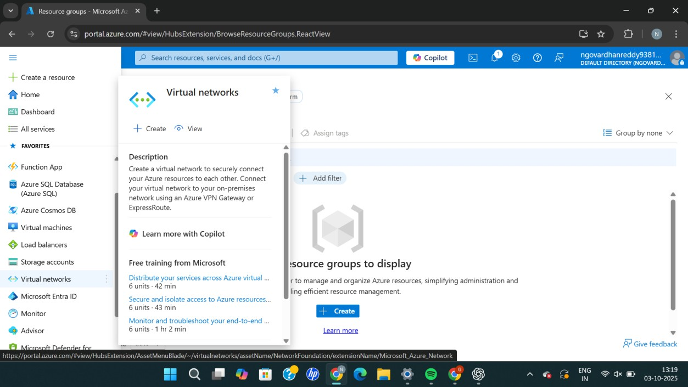

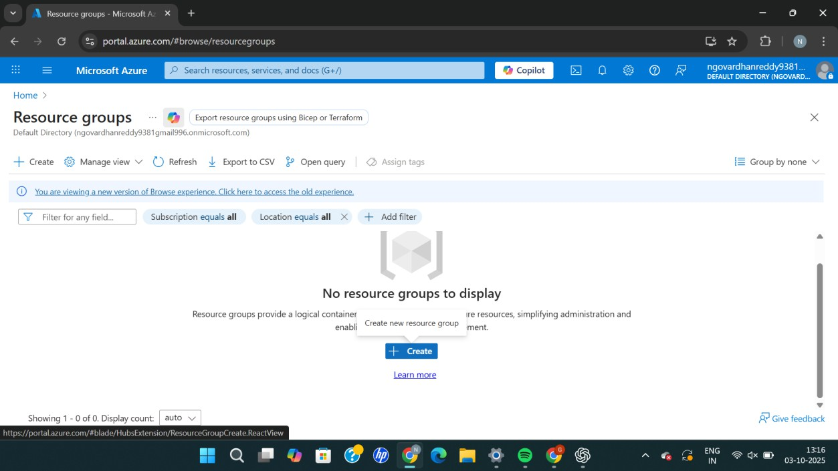

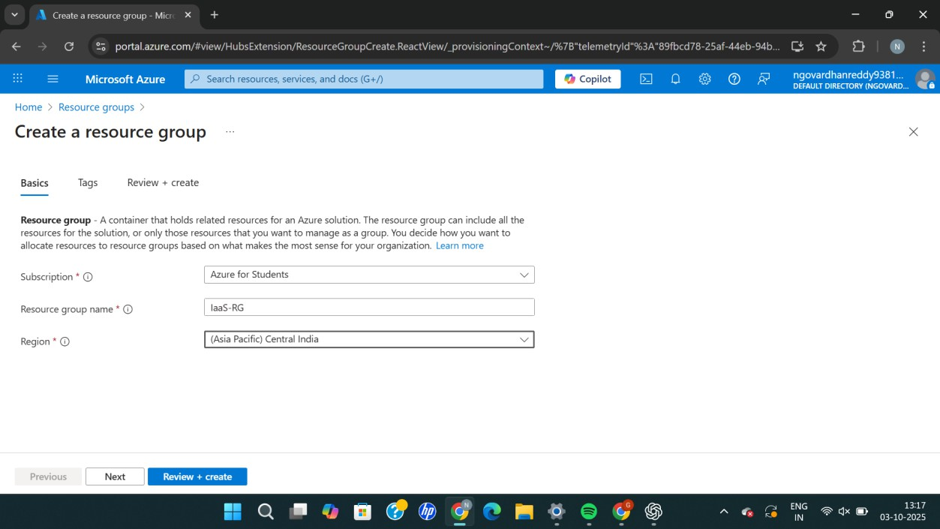

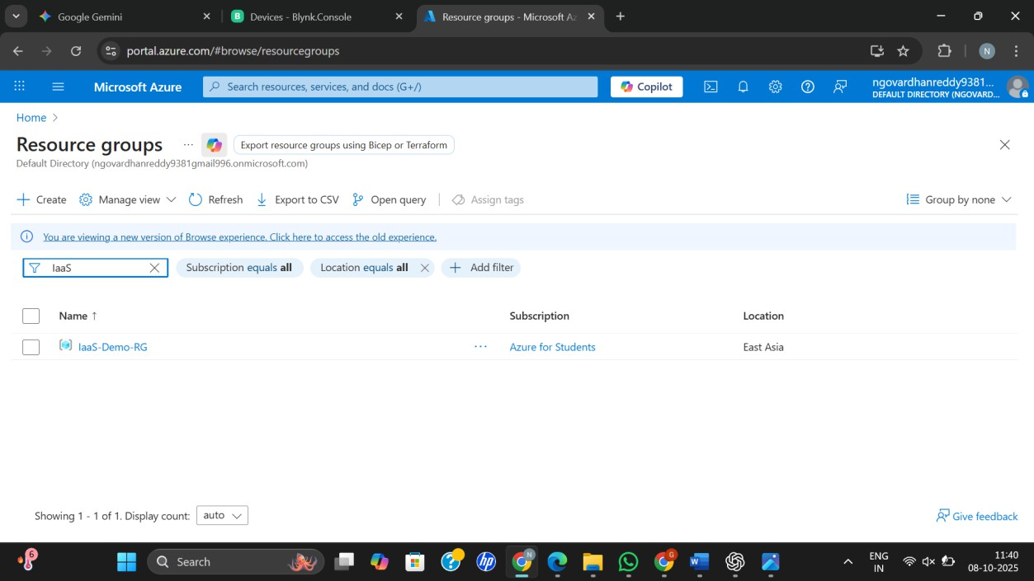
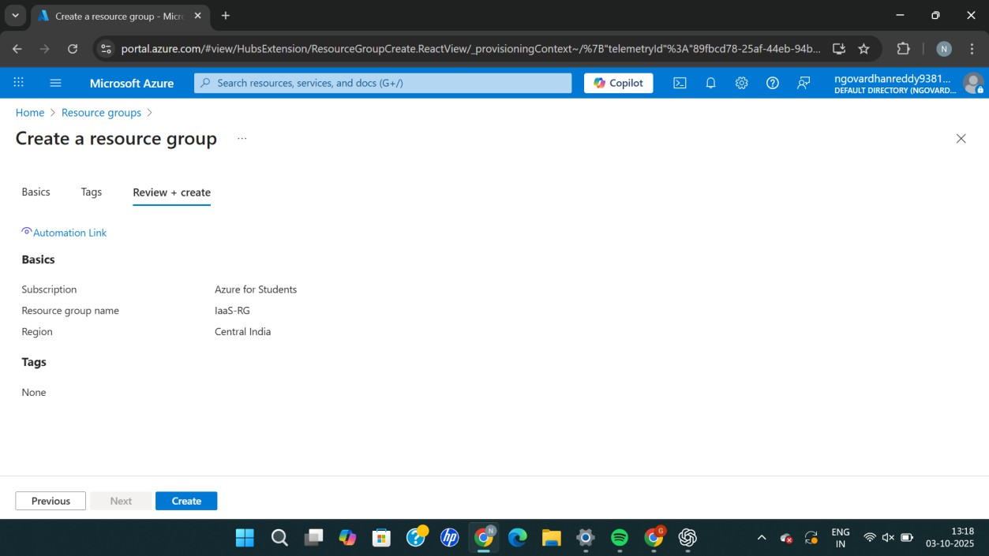

Result:
A Resource Group was successfully created in Microsoft Azure, demonstrating the initial step of Infrastructure as a Service (IaaS) setup.

