EXPERIMENT – 1

EXP NO 1: CREATE A SIMPLE CLOUD SOFTWARE APPLICATION AND PROVIDE IT AS A SERVICE USING ANY CLOUD SERVICE PROVIDER TO DEMONSTRATE SOFTWARE AS A SERVICE (SAAS).
DATE:17/10/25
AIM:
To create a simple cloud software application and provide it as a service using
any cloud service provider todemonstrate software as a service (saas).
PROCEDURE:
STEP1: GOTO ZOHO.COM
STEP 2: LOGIN TO THE ZOHO.COM
STEP 3: SELECT ONE APPLICATION
STEP 4: ENTER APPLICATION NAME
STEP 5: CREATED NEW APPLICATION
STEP 6: SELECT ONE FORM
STEP 7: THE SOFTWARE HASE BEEN CREATED.
OUTPUT:
FORM 1 – Patient Registration Form
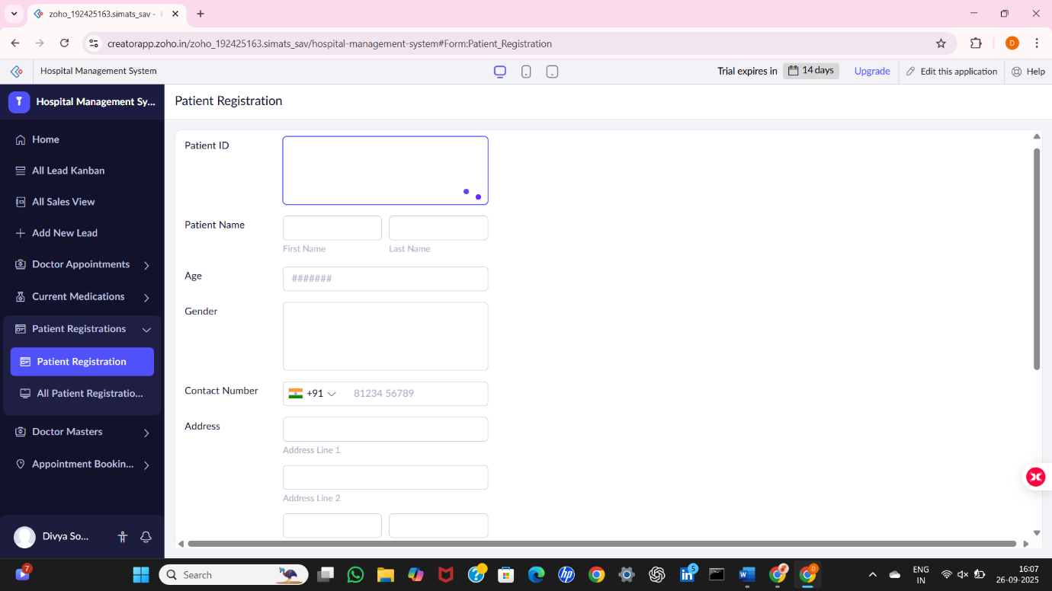
FORM 2 – Doctor Master Form

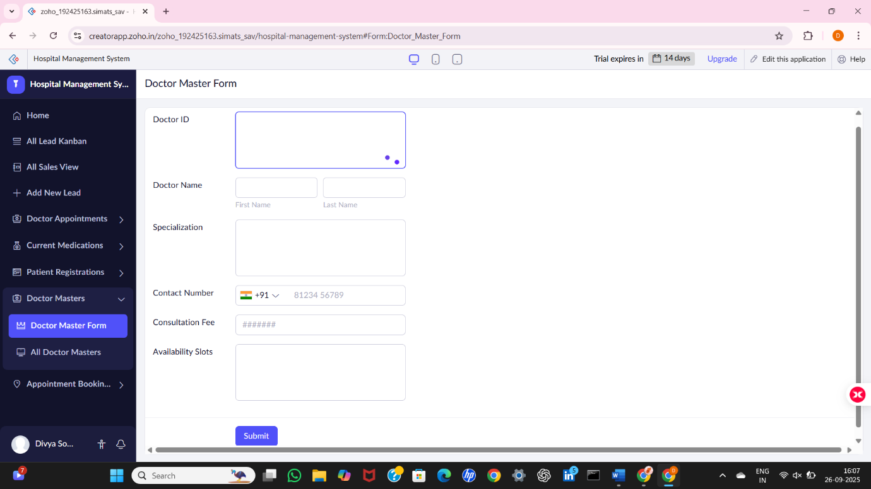

FORM 3 –Appointment Booking Form

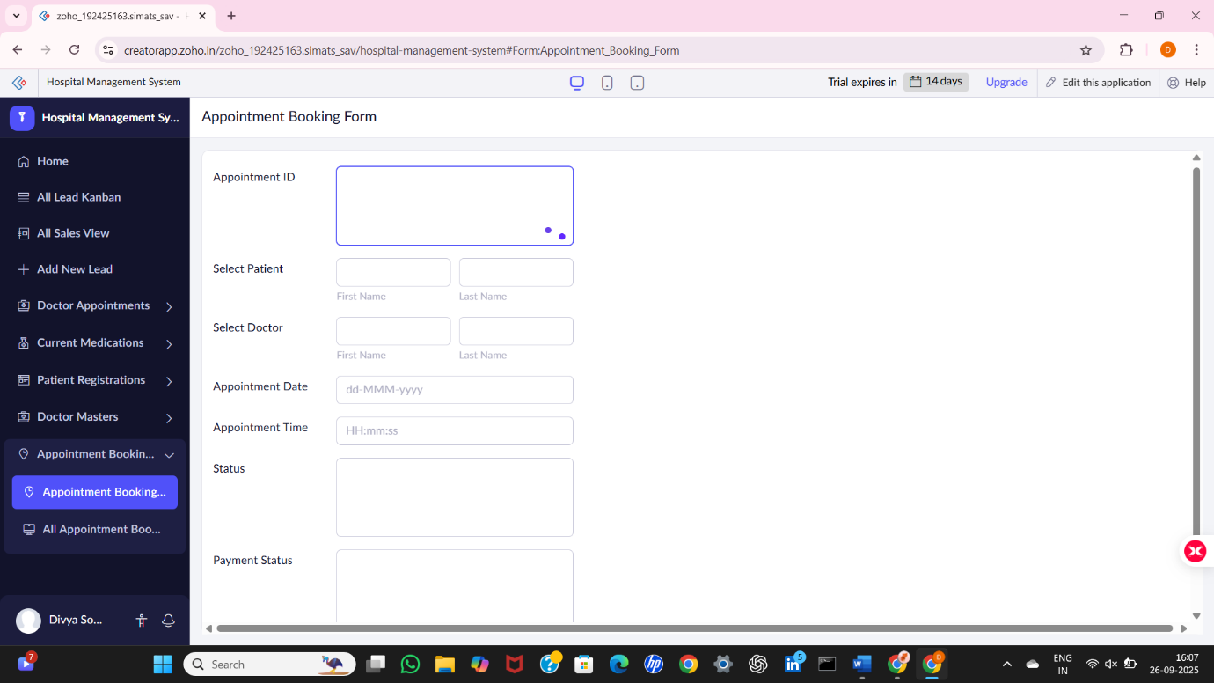

FORM 1 – Patient Registration Form

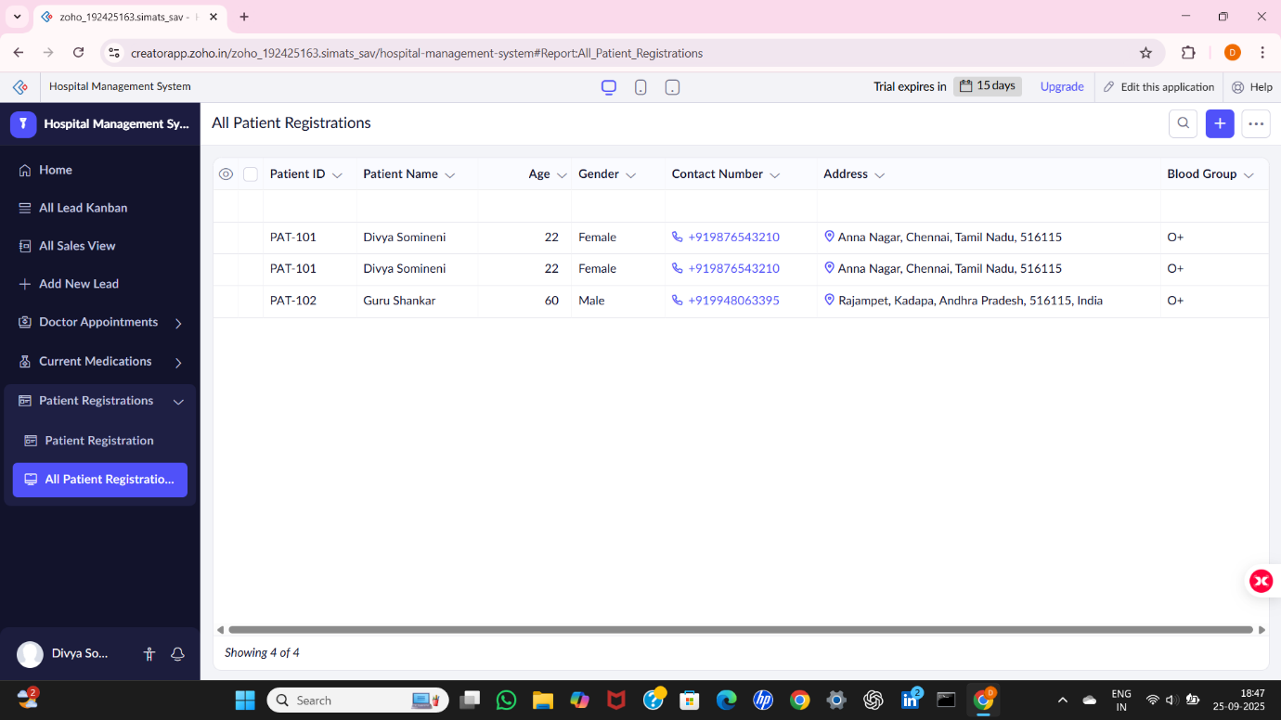

FORM 2 – Doctor Master Form

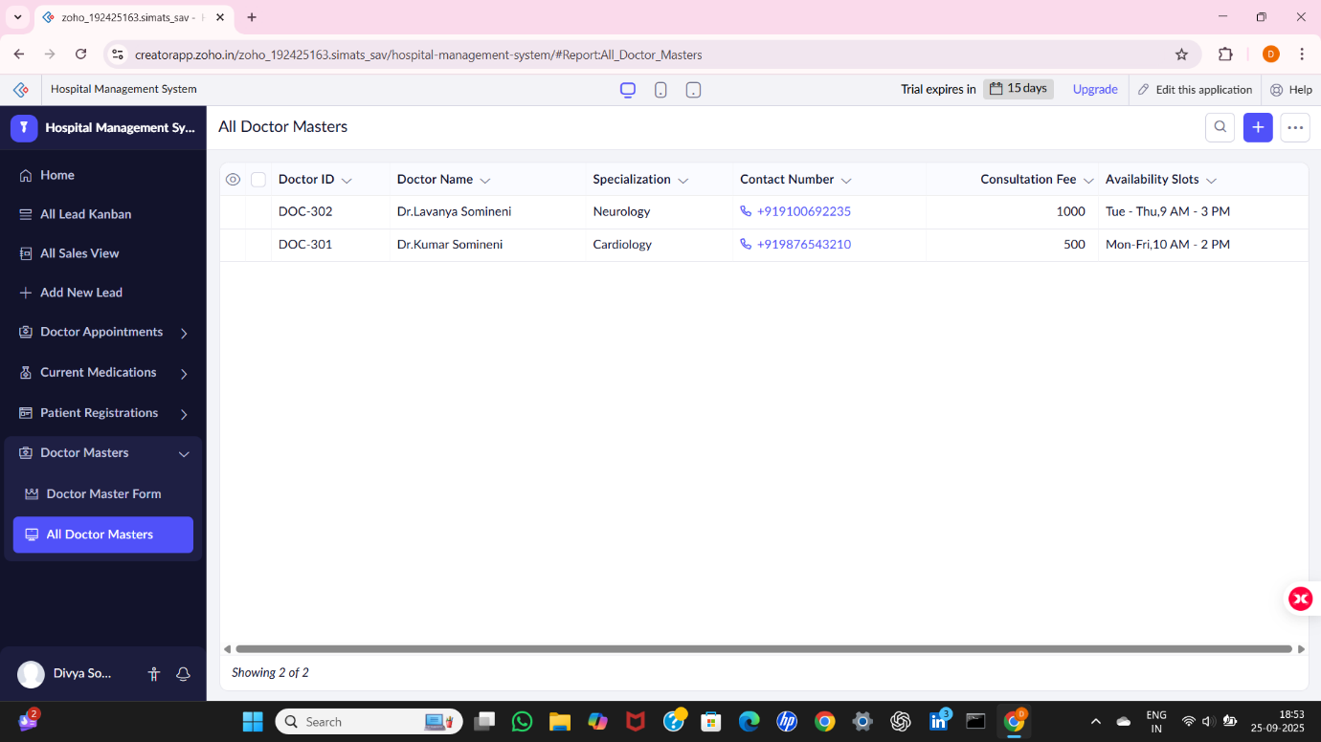

FORM 3 –Appointment Booking Form

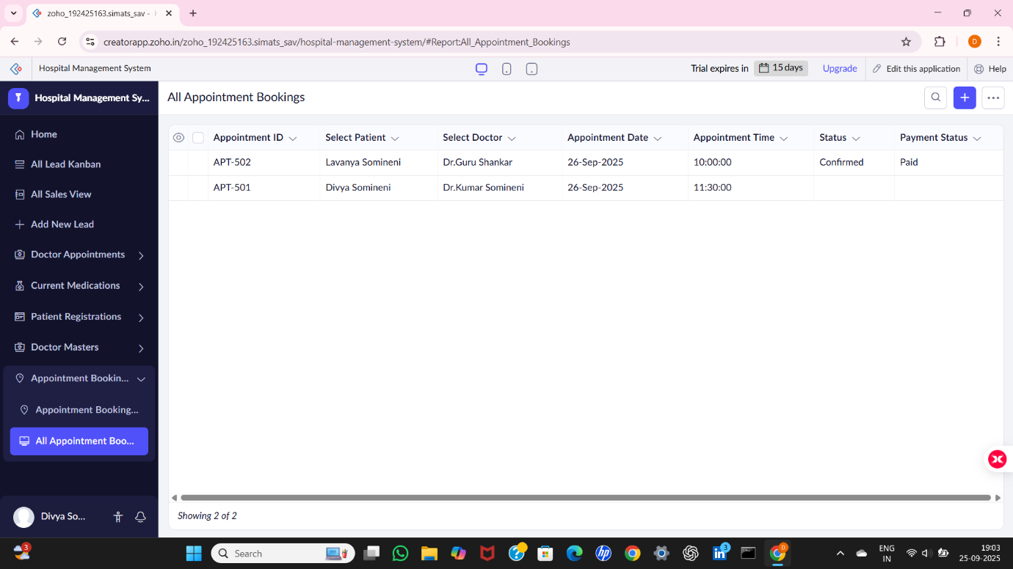

RESULT:
Thus, a Hospital Management System application was successfully created using Zoho Creator (Cloud SaaS platform) with the forms:
- Patient_Registration
- Doctor_Master
- Appointment_Booking
This demonstrates Software as a Service (SaaS), where the hospital staff and patients can access the system anytime through the cloud without installing any software.

