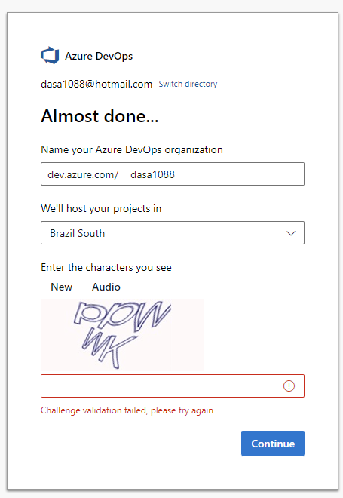

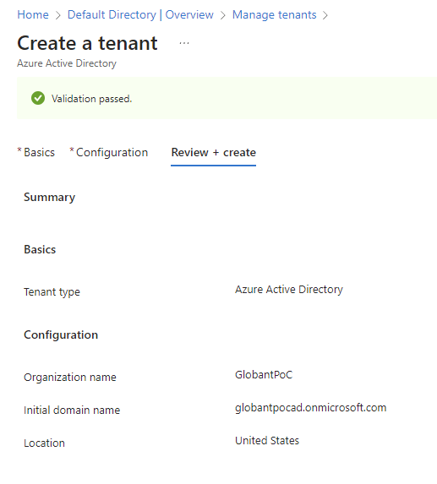

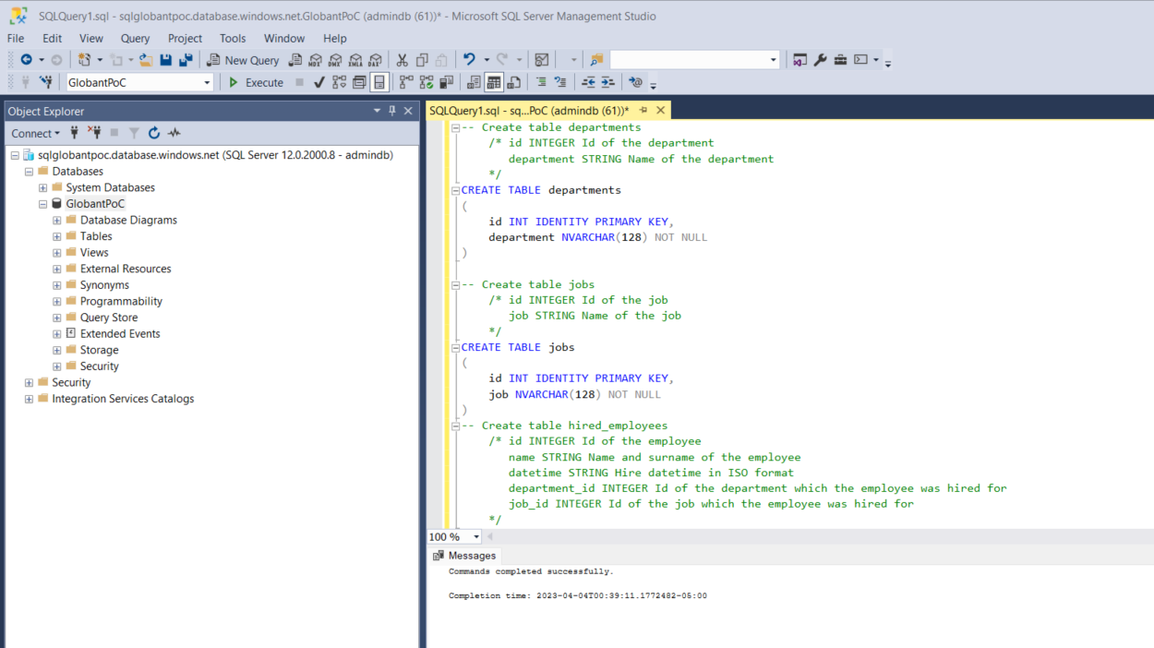

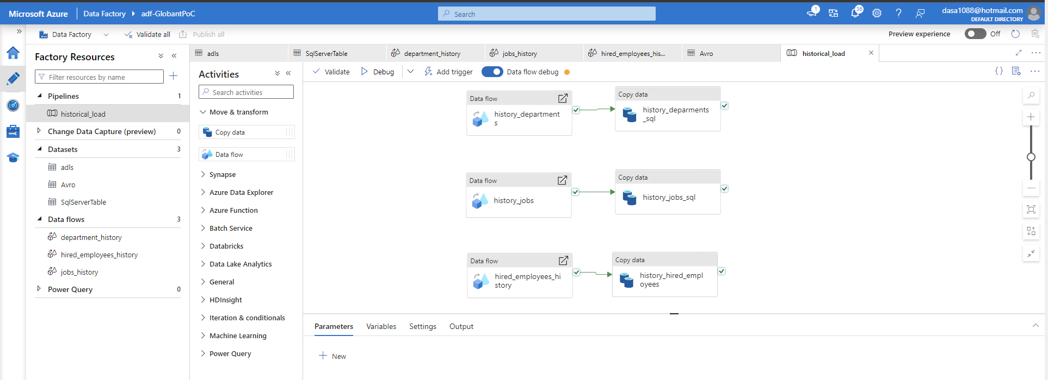

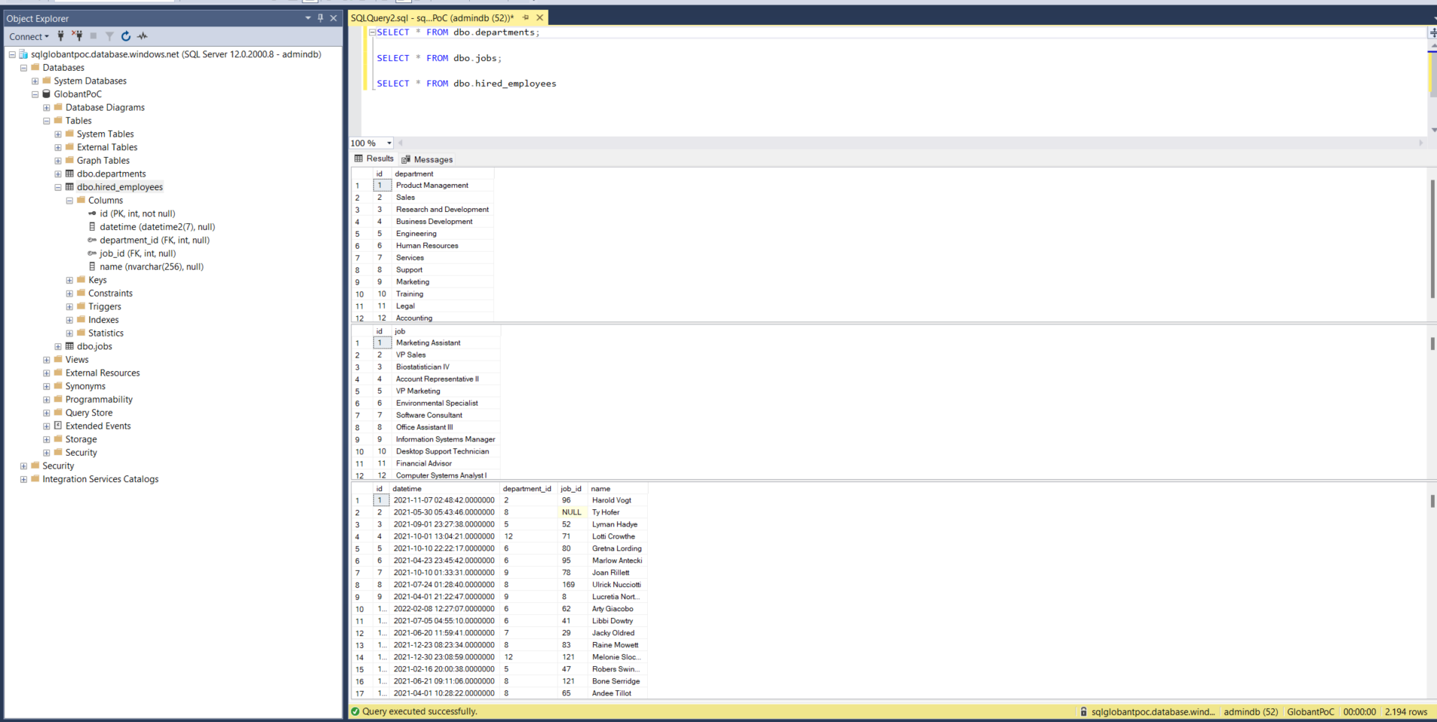

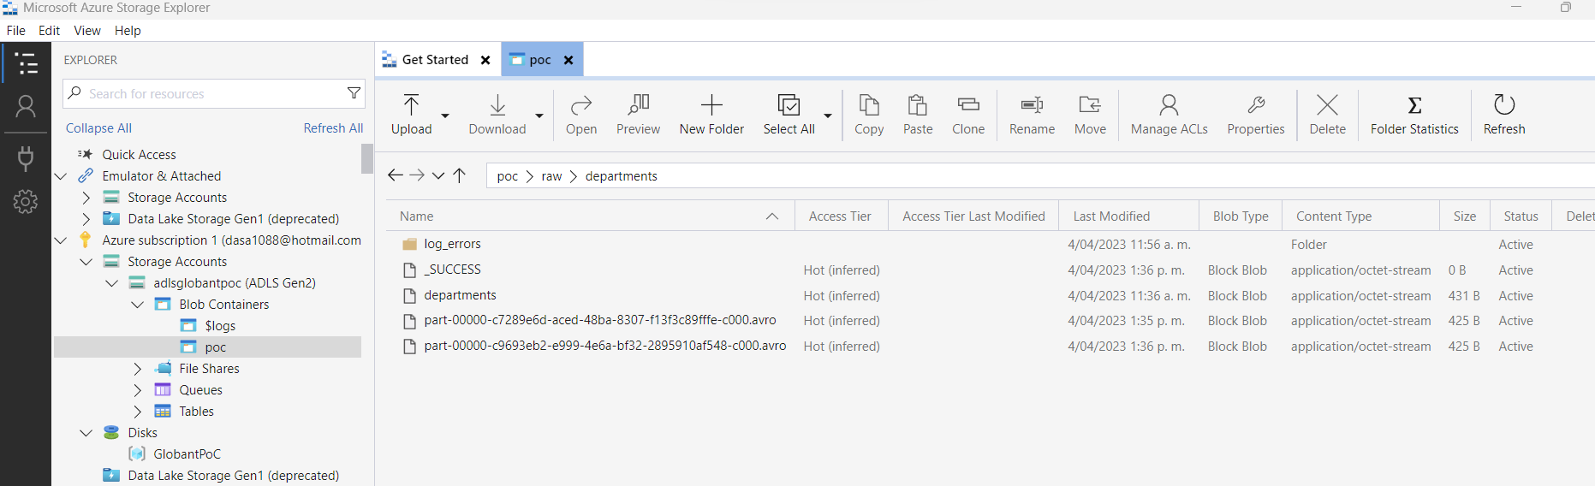

***Challenge #2***



