Scrum Implementation in CBMS Project at
Future Focus Infotech

Prepared by: Hari Thapliyal, PMP, MBA
Prepared on: 02-Jul-12

Contents
Problem statement 4
High level suggestion for resources & projects 4
Responsibilities 4
Best Practices 4
Product Backlog- Development/ Support 4
Release backlog - Development 5
Sprint backlog- Development 5
Release Planning- Development 6
Sprint Planning- Development 6
Sprint Planning- FFI 7
Process for picking job 8
Support Team- Everyday Planning 8
Planning Poker 8
Scrum Meeting/ Daily Standup Meeting 9
Regular standup meeting - FFI 10
Task Dashboard 11
Sprint Review Meeting 11
Sprint Restrospective Meetings 11
Peer review 12
Reports 12
Process of Doneness 13
Trainings 13
Knowledge Management System 13
Guidelines 13
Notes 14
Existing Development Workflow 15
Proposed Development Workflow 16
Existing Support Workflow 17
Proposed Support Workflow 18

Problem statement
- Agile/Scrum implementation in distributed team.
- Agile/Scrum implementation when the same team is working on both support and product enhancement projects
- Provide visibility to the customer in the form of templates provided by them
- Team is over working everyday but neither customer is happy about the outcome nor is the team happy because of burn out.

Stakeholders Involved in Discussions & Reviews
- One on one
  - Mr. Bharat Saji
  - Mr. Seshan TR
  - Mr. Senthil
  - Mr. Padmanabham (Pad)
  - Mr. Veeren
  - Mr. Nathan
- Team Discussion
  - Mr. Ramesh
  - Mr. Pawan
  - Mr. Eliwaran
  - Mr. Allwin
  - Mr. Radha
  - Mr. Kathikeyan
  - Mr. Thilaga
  - Mr. Aswin
  - Mr. Sukumar

High level suggestion for resources & projects
Some of these assignments are already in place but message need to be communicated clearly with attached responsibilities. Other assignments are part of this consulting exercise.

- Ralph is Product Owner (PO)
- Darrel is Proxy Product Owner (PPO).
- Seshan is Scrum Master (SM).
- Identify three team and their members clearly to carry out support and development work smoothly.
  - Development Team Members:
    - Onsite Team Member: Darrel
    - Offshore Team Members: Allwin, Pawan, Eliwaran, Senthil
  - Support Team Members
    - Onsite Team Member: Pad
    - Offshore Team Members: Radha, Karthikeyan, Thilaga
  - QA Team Members
    - Sukumar, Aswin

Note: This is high level suggestion and members can be swapped between dev and support team from one release to another and this depends upon their competency. Senior developers/ Old team members should not remain tied to support activities but they need to build competency of junior or new developers. Objective of the above team is to improve competency of team members and ensure support work, which need much experience of the system and business, is not delivered by new or junior developer.

Responsibilities
- Product Owner (PO) / Proxy Product Proxy (PPO): Product Demo, ultimate decision maker on requirement inclusion/exclusion from product backlog, final decision maker for requirement clarification. (Ralph)
- Proxy Product Owner1- (PPO1): For development work he is a single point of contact to make decision or convey decisions, requirement prioritization, explaining business requirements, review user stories and test case and remain available on need. We can agree for so some overlapping time. Prioritization can be done in rank field of Squish. Ensure information on Squish is latest always so that all team members and SM should refer to Squish system only. Without exception he shall ensure that requirement prioritization, ranking, clarification happen in the Squish system only. No emails for this work! (Darrell)
- Proxy Product Owner2- (PPO2): Ensure that support ticket is evaluated and team picks up the work from backlog. Ensure that work required has been estimated by the team and communicated to scrum master before team start working on the item. (Pad)
- Proxy Product Owner3- (PPO3): Trade-off of between sprint activities and maintenance activities. (Bharat)
- Scrum Master- (SM): Remove blocks, maintain necessary documentation, develop processes and ensure people following scrum processes, guard the scrum team and sprint goal so that the team can achieve the goal set for the sprint.
- Scrum Team- (ST): Write user stories, test cases, estimate stories of the work in sprint backlog, enter actual efforts and status of work taken in systems, report status in daily standup meetings and ensure workable product is shipped to customer. Team includes developers, testers, architect etc.

Best Practices

Product Backlog- Development/ Support
- A typical product backlog comprises the following different types of items:

  - Features (product functionality)
  - Bugs reported from previous sprint or current sprint
  - Technical work (like feasibility, R&D, data migration, security etc)
  - Knowledge acquisition (knowledge transfer, necessary documentation etc)
- Support ticket is any work into product backlog which is not planned while sprint planning and set by the customer to deliver within the sprint. It should not be hot fix.
- While development items keep coming into Squish product backlog during the sprint is in progress, PO or his representative keep assigning release number to these items and alter release number of existing not completed work items.
- No work items whether it is support or development should be done without entering into the product backlog. Assigning release number for tickets.

The product backlog is a prioritized features list, containing short descriptions of all functionality desired in the product. When using Scrum, it is not necessary to start a project with a lengthy, upfront effort to document all requirements.

- No requirement should be email to dev team.
- Product owner or Proxy product owner should make sure that no development ticket has duplicate rank
- Product owner or Proxy product owner should make sure that no support ticket has duplicate rank
- Support team should not entertain email to individual id. Create a group. Create a rule on every developer's outlook that if any email is coming from customer he will get reminder to send email to group.
- Support team should ensure that before they start working on any support ticket that must be in Squish.

Release backlog - Development
  - Release backlog should have release goal
  - Maintaining release backlog is PPO or PO’s responsibility
  - For the practical reasons release log is also maintained into the Squish system.
  - Release log items are those which has release number assigned and have priority
  - Each release is comprised of 4 sprints
  - Items need to be delivered in any release must be pulled into release backlog from product backlog
  - Before committing items into a release backlog development team should conduct one release planning session

Sprint backlog- Development
  - Sprint backlog should have sprint goal.
  - For the practical reasons sprint backlog is also maintained into the Squish system.
  - Only those items which are into release backlog can be part of sprint backlog
  - Due to business need pending work items in product backlog can update, delete and add any time. Any change request in sprint backlog should follow the change request process.
  - Priority can be defined in rank column of Squish system
  - Sprint backlog should be developed while sprint planning at the start of every sprint
  - PO or Proxy PO should set the priority but not allocate, efforts, time and team members.
  - PO should also prioritize the work in product backlog based on the release.

Release Planning- Development
- Every release is comprised of 4 sprints
- Before start of first sprint of any release scrum team must spent 10% of the complete release’s planned development efforts in discussing and evaluating complexity of the squish development tickets. For example if one development sprint has allocated 200 hours of development then 4 sprints would have allocated 800 hours. This is required because CBMS project is about enhance of existing system.
- Output of this process should be user stories and technical WBS of the squish work items. These items should be detailed enough so that development team can do the self assignment.

Sprint Planning- Development

The Sprint Planning Meeting is attended by the product owner, Scrum Master, and the entire Scrum Team.

During the sprint planning meeting the product owner describes the highest priority features to the team. The team asks enough questions that they can turn a high-level user story of the product backlog into the more detailed tasks of the sprint backlog.

The product owner doesn't have to describe every item being tracked on the product backlog. A good guideline is for the product owner to come to the sprint planning meeting prepared to talk about two sprint's worth of product backlog items. To make an example really simple, suppose a team always finishes five product backlog items. Their product owner should enter the sprint planning meeting prepared to talk about the top ten priorities.

There are two defined artifacts that result from a sprint planning meeting:

- A sprint goal
- A sprint backlog
A sprint goal is a short, one- or two-sentence, description of what the team plans to achieve during the sprint. It is written collaboratively by the team and the product owner. The following are typical sprint goals on an eCommerce application:

- Implement basic shopping cart functionality including add, remove, and update quantities.
- The checkout process—pay for an order, pick shipping, order gift wrapping, etc.
The sprint goal can be used for quick reporting to those outside the sprint. There are always stakeholders who want to know what the team is working on, but who do not need to hear about each product backlog item (user story) in detail. The success of the sprint will later be assessed during the Sprint Review Meeting against the sprint goal, rather than against each specific item selected from the product backlog.

The sprint backlog is the other output of sprint planning. A sprint backlog is a list of the product backlog items the team commits to delivering plus the list of tasks necessary to delivering those product backlog items. Each task on the sprint backlog is also usually estimated. Planning poker can be used for estimation.

An important point to reiterate here is that it is the team that selects how much work they can do in the coming sprint. The product owner does not get to say, "We have four sprints left so you need to do one-fourth of everything I need." We can hope the team does that much (or more) but it is up to the team to determine how much they can do in the sprint.

- Use the concept of substories for big stories
- Use the concept of technical spikes for unknown technical complexities. Allocate hours for technical spike so that story writing and estimation can be done.
- Use the concept of epic for big feature to be implemented
- Use the concept of story telling and then story writing to know the detail of work involved in delivering a feature

Sprint Planning- FFI
- Team members should have a prioritized items into release backlog with them before they start this process
- Developing User Stories
  - Team members should detail user stories while sprint planning. That may be high level items and can be refined while actual development.
  - Refined user stories should be reviewed and approved by Proxy PO.
  - User stories should be self assignable.
- Planning Poker : Use planning pocker for estimating the story points sizing of the sprint backlog items. Two workshop has been conducted for this.
- Sprint Backlog: After story sizing team should decide how many work items they can commit based on the story points. This commitment depends on team velocity and not on any individual.

Process for picking job
- Agile team should be a self disciplined team and they should pick the job without intervention based on their competency and ensure that all sprint items are picked up.
- If required they can help each other.
- It is not ticket based commitment that how many tickets an individual is doing. No completion between team members.

Support Team- Everyday Planning
- Suppot scrum team should review inflow of ticket for everyday
- Write user stories of the work
- Estimate the work
- Validated that team has not exhausted number of support hours allocated. If yes then scrum master need to take approval from VP IT to continue the work on support items.

Planning Poker
- Guidelines
  - Participants in Planning Poker include all of the developers on the team. Remember that developers refers to all programmers, testers, database engineers, analysts, user interaction designers, and so on.
  - At the start of Planning Poker, each estimator is given a deck of cards. Each card has written on it one of the valid estimates, card reads like 0, 1, 2, 3, 5, 8, 14, 20, 40, and 100. The cards should be prepared prior to the Planning Poker meeting, and the numbers should be large enough to see across a table.
  - Complexity definition
    - 0- No work involved
    - 1,2,3- Very Simple Complexity
    - 5,8 – Simple Complexity
    - 14- Middle Complexity
    - 20- Complex
    - 40- Very Complex
    - 100- Unknown Complexity
- Steps
  - Moderator, usually the product owner or an analyst, read items from product backlog
  - Team discusses the items and comes up with user stories for each item and put those items in sprint backlog
  - Each user story or theme to be estimated, a moderator reads the description.
  - To estimate the complexity of each story, estimators discuss the story and the product owner answers any questions that the estimators have. However, everyone should remember that at some point additional discussion does not lead to improved accuracy. The goal in planning poker estimating is not to derive an estimate that will withstand all future scrutiny. The goal is to develop estimate that can be arrived at cheaply.
  - After all questions are answered, each estimator privately selects a card representing his or her estimate. Cards are not shown until each estimator has made a selection. At that time, all cards are simultaneously turned over and shown so that all participants can see each estimate.
- Guidelines
  - It is very likely at this point that the estimates will differ significantly. This is actually good news. If estimates differ, the high and low estimators explain their estimates. It’s important that this does not come across as attacking those estimators. Instead, you want to learn what they were thinking about.
- Step
  - The group can discuss the story and their estimates for a few more minutes. The moderator can take any notes he thinks will be helpful when this story is being programmed and tested.
  - After the discussion, each estimator re-estimates by selecting a card. Cards are once again kept private until everyone has estimated, at which point they are turned over at the same time.
- Guidelines
  - In many cases, the estimates will already converge by the second round. But if they have not, continue to repeat the process. The goal is for the estimators to converge on a single estimate that can be used for the story. It rarely takes more than three rounds, but continue the process as long as estimates are moving closer together. It isn’t necessary that everyone in the room turns over a card with exactly the same estimate written down. If I’m moderating an estimation meeting, and on the second round four estimators tell me 5, 5, 5, and 3, I will ask the low estimator if she is OK with an estimate of 5. Again, the point is not absolute precision but reasonableness. Do the Right Amount of Discussion
  - Some amount of preliminary design discussion is necessary and appropriate when estimating. However, spending too much time on design discussions is often wasted effort. Here’s an effective way to encourage some amount of discussion but make sure that it doesn’t go on too long.
  - Place a two-minute timer tool in the middle of the table where planning poker is being played. If agreement isn’t reached, the discussion can continue. But someone can immediately turn the timer over, again limiting the discussion to two minutes. The timer rarely needs to be turned over more than twice. Over time this helps teams learn to estimate more rapidly.

Scrum Meeting/ Daily Standup Meeting
- Remember the "Ham and Eggs" story, only committed people should speak in standup meetings.
- It helps setting the context of day's work.
- All team members are required to attend the meeting.
- This is information dissemination meeting therefore anybody who is interested in project status should join there as an observer.
- The daily scrum is not used as a problem-solving or issue resolution meeting. Issues that are raised are taken offline and usually dealt with by the relevant sub-group immediately after the meeting.
- Three questions of standup meeting are What did you do yesterday? What will you do today? Are there any impediments in your way? Typical example of impediments are
  - My ABCD broke and I need a new one today.
  - I still haven't got the software I ordered a month ago.
  - I need help debugging a problem with Rakesh.
  - I'm struggling to learn XYZ and would like to pair with someone on it.
  - I can't get the vendor's tech support group to call me back.
  - Our new contractor can't start because no one is here to sign her contract.
  - I can't get the ABC group to give me any time and I need to meet with them.
  - The department VP has asked me to work on something else "for a day or two."
- The daily Scrum meeting is not a status update meeting in which a boss is collecting information about who is behind schedule. Rather, it is a meeting in which team members make commitments to each other. If a programmer stands up and says "Today I will finish the data storage module" everyone knows that in tomorrow's meeting he will say whether or not he did finish. This has the wonderful effect of helping a team realize the significance of these commitments and that their commitments are to each other, not to some far-off customer or salesman.
- In cases where the ScrumMaster cannot remove these impediments directly himself (like technical issues) he still takes responsibility for making sure someone on the team does quickly resolve the issue.

Regular standup meeting - FFI
- Every day standup meeting on phone at 8PM (IST)
- People have to give status update on 4 questions: a- what have they done, b- any blocker, c- what are they planned for today/ (tomorrow for offshore team), d- any help needed.
- Every team member must attend the call in case of telephonic standup meeting or must be in team area when standup meeting is happening.
- Due to any unavoidable situation if any skip is happening then update must be given to the peer team member before standup meeting starts and peer should update that status in standup meeting.
- This is one important ritual from team bond perspective also therefore even if everybody is convinced that there is no update today and no standup meeting needed today. I suggest meeting each other share hello and bye.
- Requirement change process. In between the sprint if any work comes or existing requirement changes then following steps should be followed.
- Review the work complexity, feasibility, waste, impact on other aspects of functionality
- Access the impact on schedule, quality and functionality
- Tradeoff between existing work items of sprint and new work items
- Commit only which is possible with little stretch. Do not commit impossible or where team need to work more than 20% of their capacity.
- If change is huge then complete sprint can be cancelled and sprint re-planning need to be done.

Task Dashboard
- Story–The story description (“As a user I want to…”) shown on that row.
- To Do–This holds all the cards that are not done or in process.
- Work In Process–Any card being worked on goes here. The programmer who chooses to work on it moves it over when she's ready to start the task. Often this happens during the Daily Scrum when someone says, “I'm going to work on the boojum today.”
- To Verify–A lot of tasks have corresponding test task cards. So, if there's a “Code the boojum class” card there is likely one or more task cards related to testing: “Test the boojum”, “Write FitNesse tests for the boojum,” “Write FitNesse fixture for the boojum,” etc. Some task cards don't often get corresponding test cards (“Fix Bug #321 in Bugzilla”) so those are placed in the “To Verify” column.
- Done–Cards pile up over here when they're done. They're removed at the end of the sprint. Sometimes I remove some or all during a sprint if there are a lot of cards.

Sprint Review Meeting
At the end of each sprint a sprint review meeting is held. During this meeting the Scrum Team shows what they accomplished during the sprint. Typically this takes the form of a demo of the new features.

The sprint review meeting is intentionally kept very informal, typically with rules forbidding the use of PowerPoint slides and allowing no more than two hours of preparation time for the meeting. A sprint review meeting should not become a distraction or significant detour for the team; rather, it should be a natural result of the sprint.

Participants in the sprint review typically include the PO, PPO, Scrum Team, Scrum Master, management, customers, and developers from other related projects.

During the sprint review the project is assessed against the sprint goal determined during the Sprint Planning. Ideally the team has completed each product backlog item brought into the sprint, but it is more important that they achieve the overall goal of the sprint.

Sprint Restrospective Meetings
No matter how good a Scrum team is, there is always opportunity to improve. Although a good Scrum team will be constantly looking for improvement opportunities, the team should set aside a brief, dedicated period at the end of each sprint to deliberately reflect no how they are doing and to find ways to improve. This occurs during the sprint retrospective.

The sprint retrospective is usually the last thing done in a sprint. Generally it is done immediately after the sprint review. The entire team, including both the ScrumMaster and the product owner should participate. I like to schedule retrospectives for up to an hour, which is usually quite sufficient. However, occasionally a hot topic will arise or a team conflict will escalate and the retrospective could take significantly longer.

Although there are many ways to conduct a sprint retrospective, my recommendation is to conduct it as a start-stop-continue meeting. This is perhaps the simplest, but often the most effective way to conduct a retrospective. Using this approach each team member is asked to identify specific things that the team should:

Start doing
Stop doing
Continue doing

The ScrumMaster can facilitate this meeting by asking everyone to just shout out ideas. The ScrumMaster can go around the room asking each person to identify any one thing to start, stop or continue.

After an initial list of ideas has been brainstormed, teams will commonly vote on specific items to focus on during the coming sprint. At the end of the sprint the team should review the list of things selected for attention in the prior retrospective.

Peer review
- Develop standard code review and test case checklist. So that reviewer keep the items in mind when he is reviewing
- Review should keep the checklist before him while conducting review
- Every code or test case should be reviewed by peer.
- Three purpose of review: a- Refining work, b- other person getting insight what is happening in team c- new people learning
- Code review should be peer developer
- Test cases should be reviewed by ticket originator
- User stories should be reviewed by ticket originator

Reports
Burn up and burn down chart for

Effort burn down chart
Product burn down chart
Release burn down chart
Story point burn down chart

Separately captures efforts for development, maintenance and technical spikes.
Showing the number of stories done per sprint is more useful for customer.
Report the velocity in terms of SP/Hours and SP/Sprint

Process of Doneness
- I suggest following ticket life-cycle and weightage for measuring the doneness of any work items in squish.
Step No. | Step Name | % | Cumulative %
 | Impact Analysis | 5% | 5%
 | User Story | 5% | 10%
 | Review of user story | 2% | 12%
 | Acceptance Test Case | 5% | 17%
 | Review of acceptance test case | 2% | 19%
 | Coding | 45% | 64%
 | Code Review | 5% | 69%
 | Unit Testing | 10% | 79%
 | QA Build & Deployment | 4% | 83%
 | QA Testing | 10% | 93%
 | UAT Build & Deployment | 4% | 97%
 | UAT | 3% | 100%
 | Product Build & Deployment
- It can be mapped to customer supplied life-cycle of each work item.

Trainings
- Time to time before including any new dev or test team member in scrum conduct following basic trainings
  - CBMS
  - Scrum processes
  - Ground rules of team work

Knowledge Management System
- Develop system for knowledge transfer and capturing the knowledge into SharePoint system

Guidelines
- Utilization should be taken from availability of the team member to project sprint work
- Do not count 8 hours of each person for everyday productivity. IEH for every person should not be more than 7 hours/day (if person is fully committed for the project). Globally people in project management has feeling that utilization of engineers on engineering activities is never 100% and % utilization varies from project to project, team to team.
- We can consider that it is 80%. This utilization can be calculated when team start entering their actual on projects. They should report their actual time consumed on meetings & reporting, job switching and engineering activities.
- At present there are three systems to report actual a- Squish, b- FFI timesheet, c- Template provided by customer. I suggest unifying them in such a way that team need not to report on more than one place. Ideas have been discussed with Seshan.
- At present team is committed to one customer therefore they can enter their actual into Squish system. But they should also report non-productive hours.
- Till velocity is not benchmarked, work items commitment for any sprint should be based on complexity and team’s gut feel.
- After velocity is benchmarked. Number of user stories and velocity should be used to commit the work items.
- Developers must write user story and keep refining it based on the need. Take the approval of user stories from proxy product owner
- Proxy product owner must be available at the time of sprint planning. Identify some overlapping hours for sprint planning.
- Retrospective meeting is must after each sprint and before next sprint planning. Avoid doing this in same day.
- Tester must write test cases and take approval from proxy product owner.
- Do not assign any work items to developers. Scrum master should create a environment and self disciplined team so that team pick up the work items willingly.
- Do not put items in sprint backlog without tradeoff of existing items.
- Keep maintenance and support tickets on separate track
- There should be only one proxy product owner for all requirement clarification purposes so that the team does not waste time in running after many people.
- Proxy product owner should assign unique priority (squish rank) to the work items in product backlog (squish release backlog)
- Do not take regression testing away from development work. It should be part of sprint planning and scrum team should own the delivery of quality product
- Determine team velocity in next 3-4 sprints, so that team know how much work (story points) can be committed for any particular release
- Do not change team members or introduce team members frequently it affects velocity by some unknown coefficient.
- Team members should be aware about who is doing what work. Team should take responsibility not the individuals. Team need to understand that we are responsible for workable product not for lines of code. They should help each other, even if they think that their work item is done.
- User story should be calculated for project management activities like reporting etc.
- When counting user stories for any ticket take care of integration user stories also.

Notes
- At present in the absence of velocity we will commit based on team’s gut feel. Estimate may not be true and it is possible that 3-4 sprint spill over will happen. After 3-4 sprint it can minimized to a great extent.
- Today big reason for spill over is unknown-velocity, requirement change, support tickets and not capturing efforts of support tickets.

Existing Development Workflow
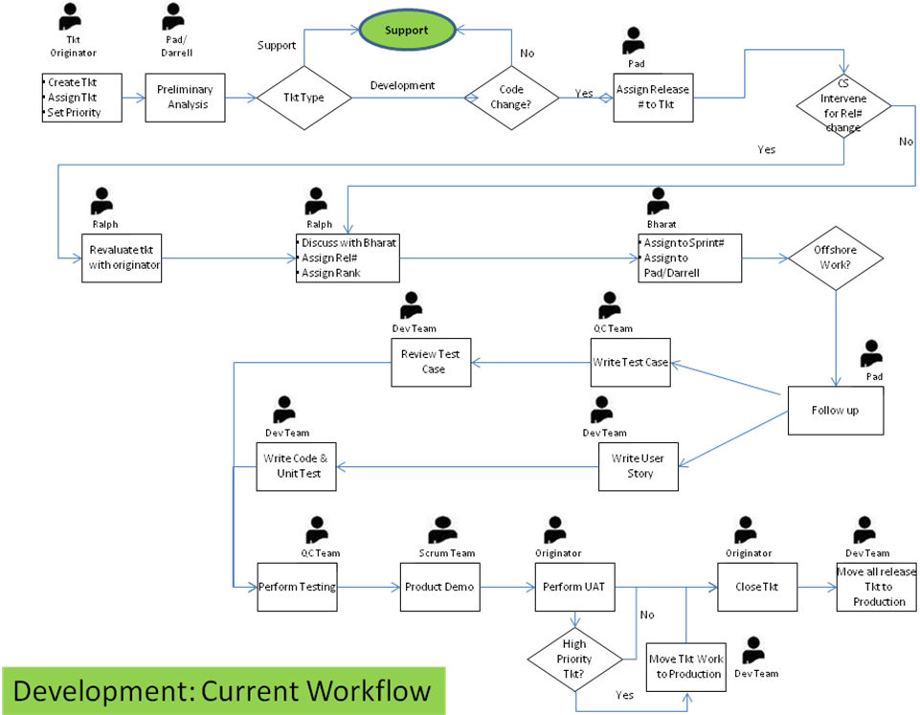

Proposed Development Workflow
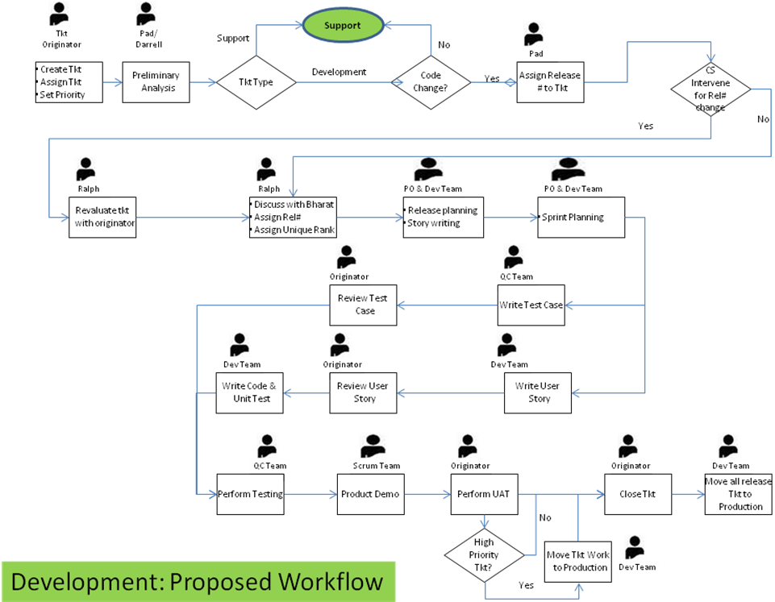

Existing Support Workflow
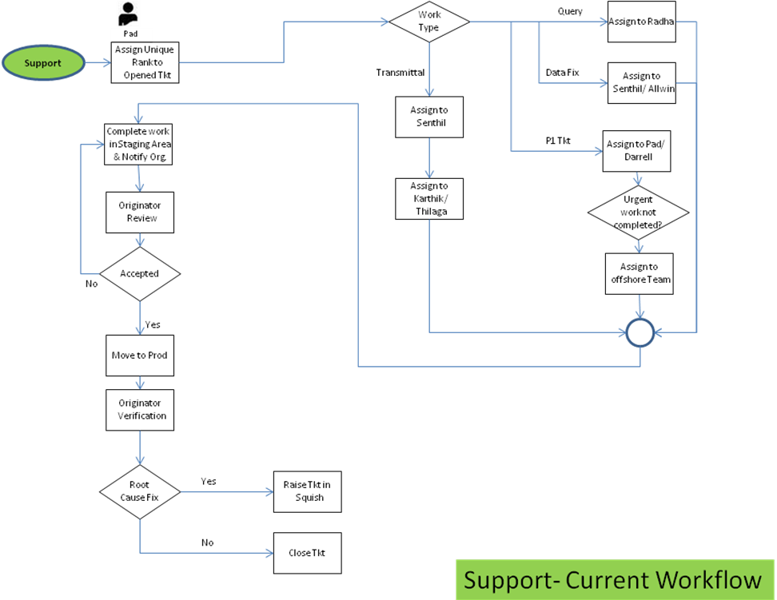

Proposed Support Workflow
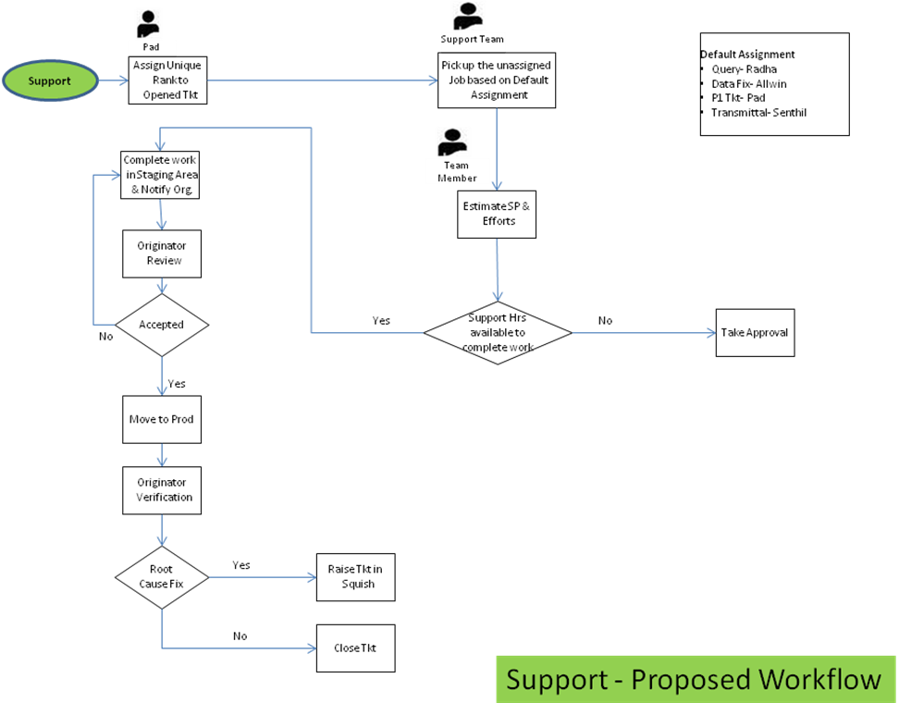

End of report

