Today’s Date: 25-Jun-09
Tuesday, September 23rd, 2008 Webinar
Topic: Big Scrum - Scaling Team to Program
Presenter: Giora Morein, CSP, PMP, MBA & George Schlitz, CSP, PMP, MBA
George Schlitz &Giora Morein are Principal Agile Coach

Abstract: The bulk of the widely-published information about Scrum is focused on team-level efforts. As Agile and Scrum adoption rates at mid to large-scale companies expand, they become increasingly main-stream. Experience is showing that Agile methods have much to offer the large program. Establishing a successful Agile program requires an emphasis on creating an environment that is both enabling and supportive of continuously optimizing and adapting teams. There is no "one-size-fits-all" approach to kicking-off a Scrum program. Projects and programs are very different depending on the nature of the business objectives, the project, the stakeholders or the envisioned product. The session provides a framework for effectively initiating Scrum projects and establishing scalable program models that support sustainable value-focused delivery teams. The session covers topics such as:
♦ Scrum project kickoff
♦ Program roles and organization
♦ Team formulation and training programs
♦ Program ramp-up strategies
♦ Distributed vs. Virtual teams
♦ Providing support for continuous improvement
♦ Common challenges in large-program Scrum
Participants will be introduced to the common aspects of getting a large program initiated quickly using Scrum methods, and detail of one approach that has worked on numerous multi-team programs ranging from 15 to 250+ people.

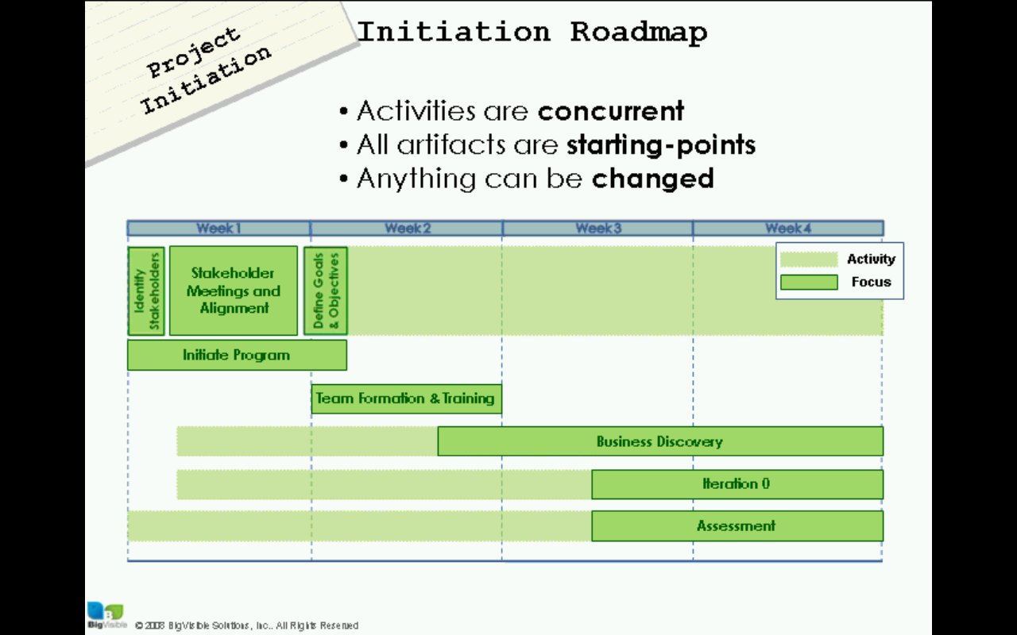

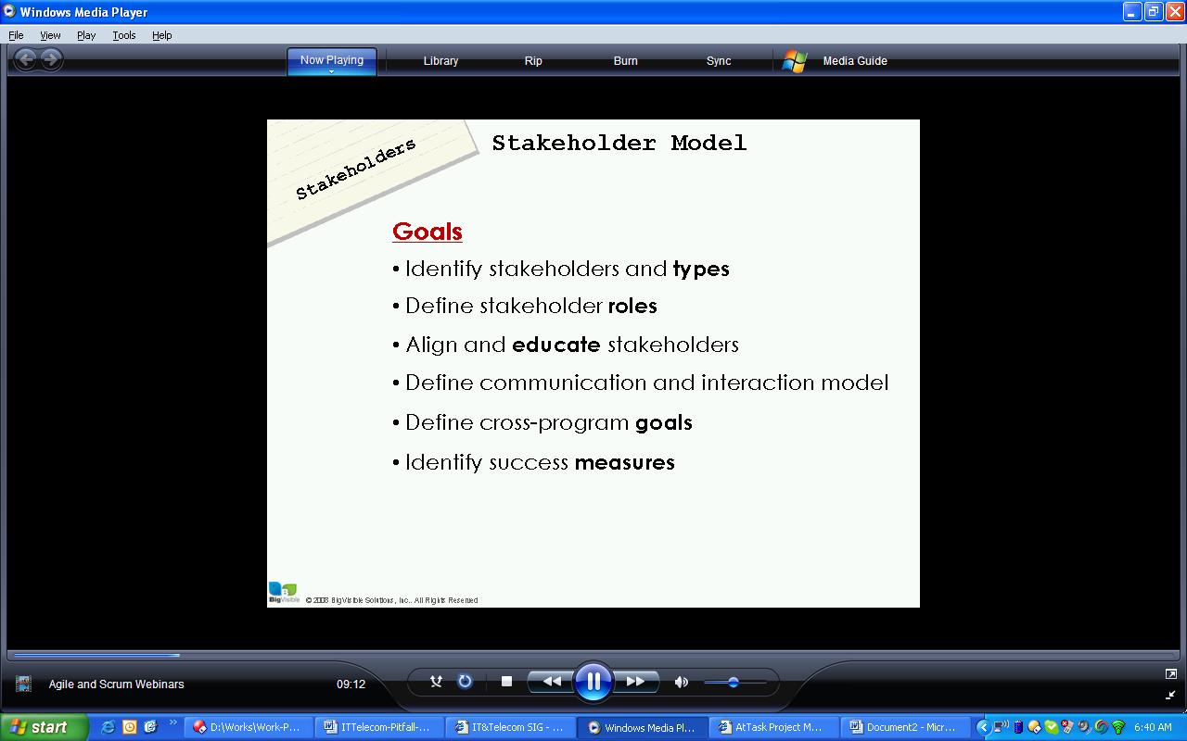

Stakeholder Interaction
Level of interactions
High- Daily, Med- Weekly, Low- Monthly

Stakeholder Collaboration
Level of collaboration depends on type of stakeholder
High: On the team/Program
Med: Extended team/Program
Low: External to the team

5 Stakeholder types
- Project Consumers: Consume deliverables of the product (have to do something with the final application delivered)
  - Interaction/Collaboration: High/High
- Project Implementers (developer, tester): Responsible for delivering the product
  - Interaction/Collaboration: High/High
- Visitors and Guests (like SME) Res
  - Interaction/Collaboration: High/Med
- Project Depdendency (any external entity group/person like infra group, third party vendor, product providers
  - Interaction/Collaboration: Med/low
- Organizational Stakeholders (Interested parties not directly impacted by program (may participate in demos, other feedback)
  - Interaction/Collaboration: Lol/low
Truth: Agile Programs are different
New principles, practices and artifacts
New vocabulary
Many traditional artifacts disappear
Education is required
It takes time to learn
It takes time to adjust
Stakeholders will need guidance

Education: Example: Stories
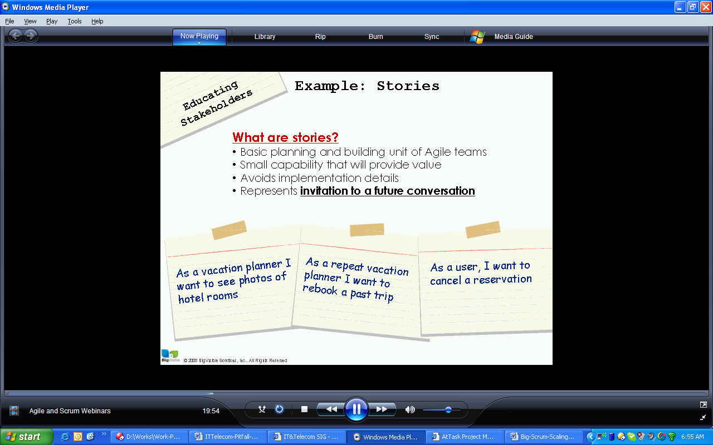

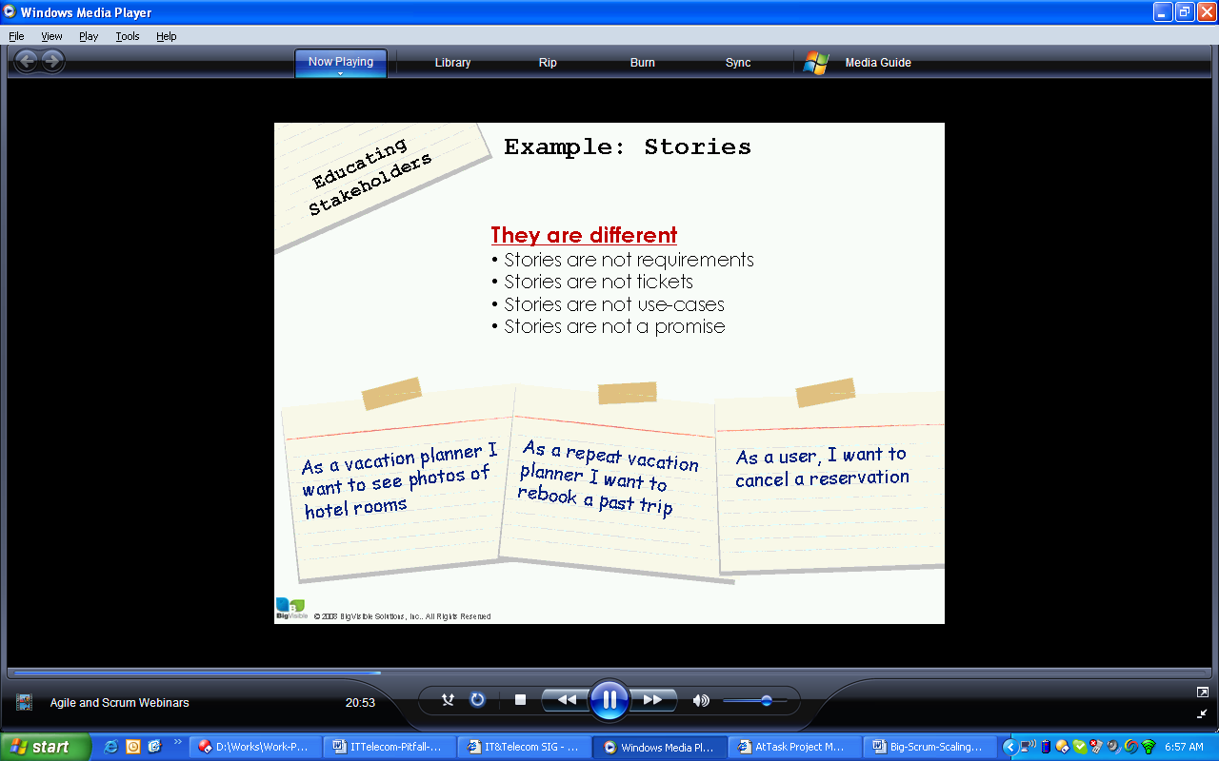

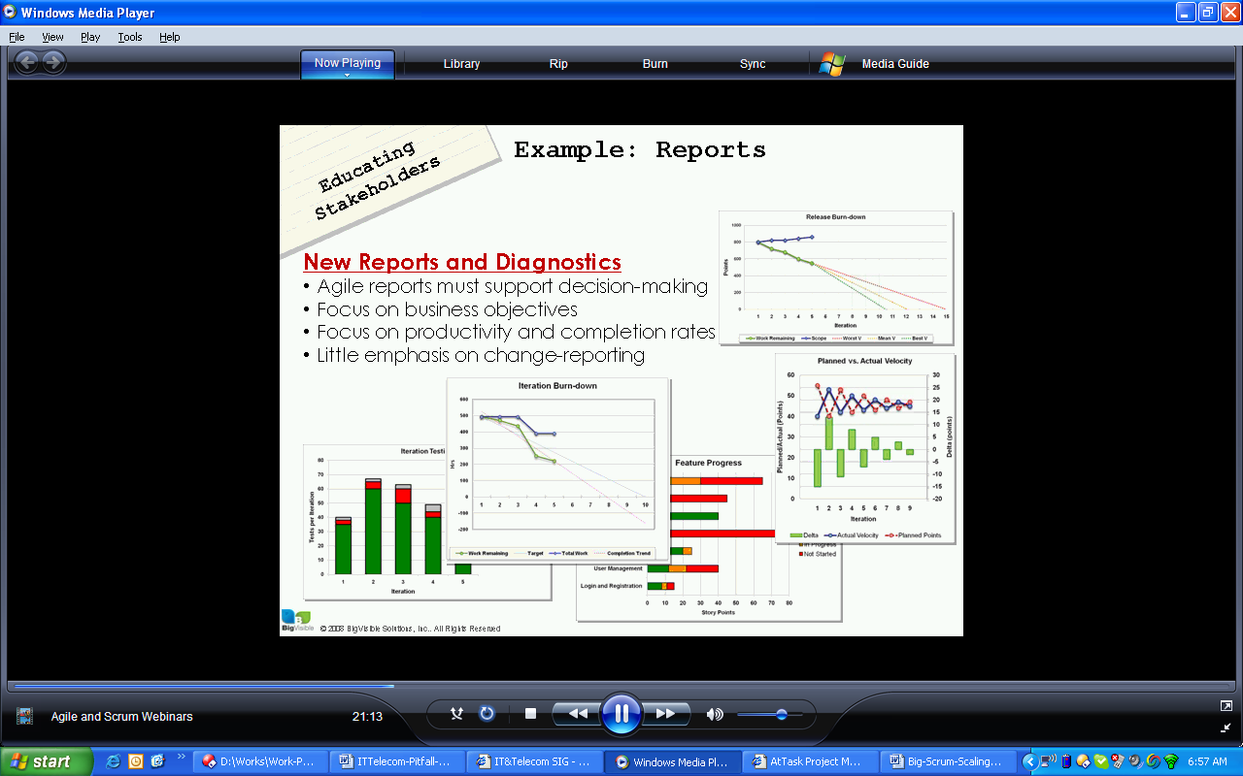

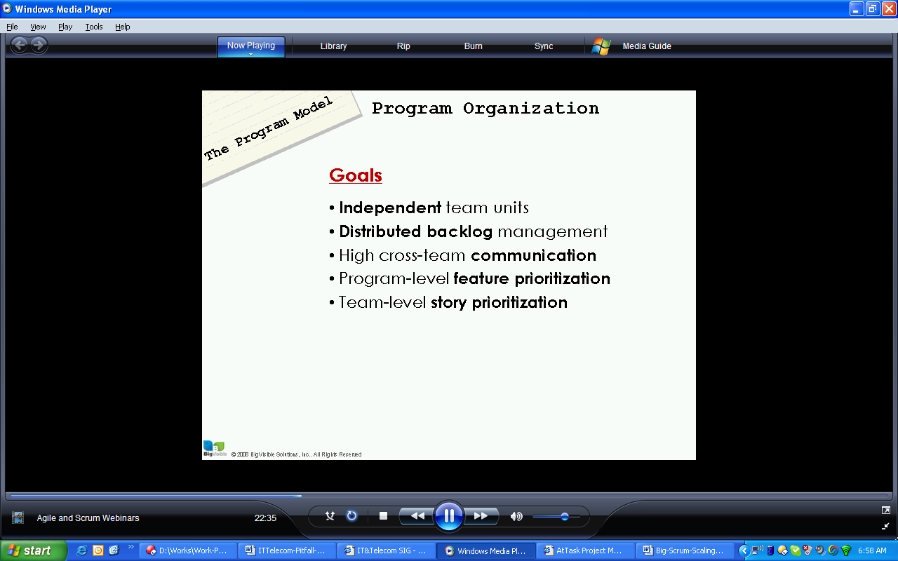

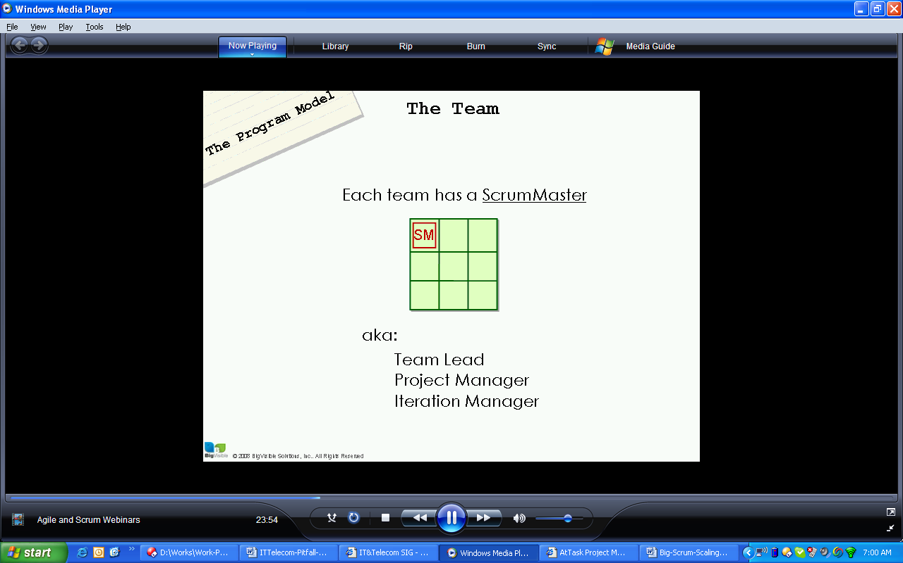
SM- Scrum master
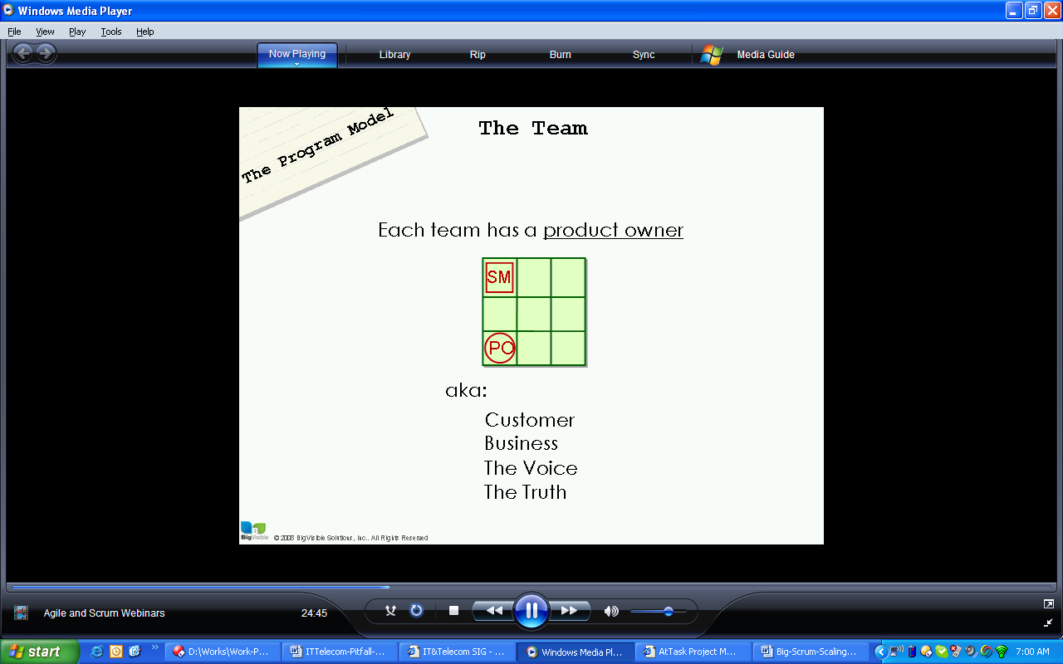
PO is responsible for tradeoff, priority
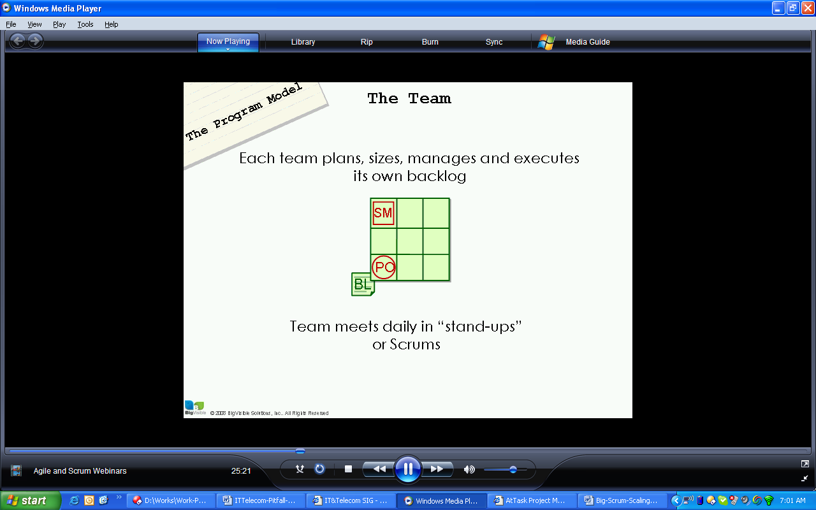

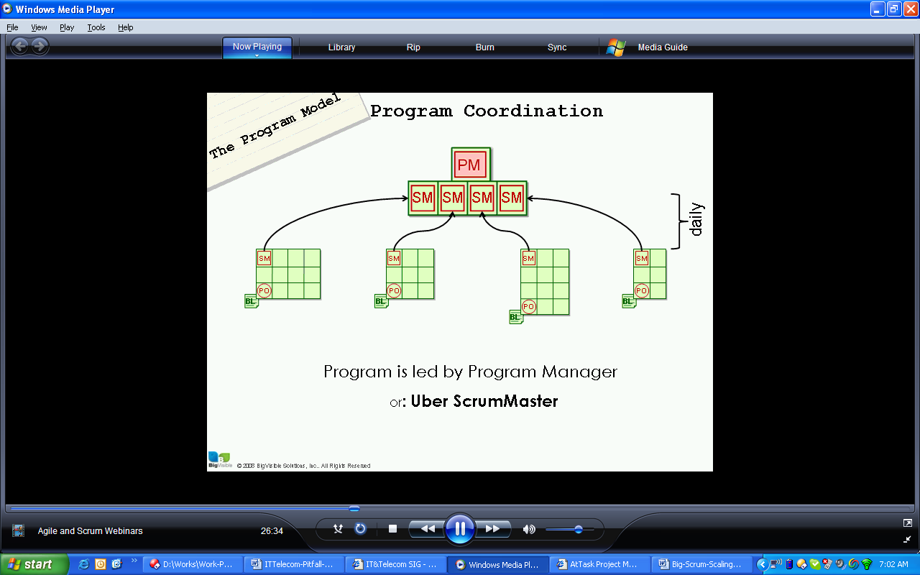

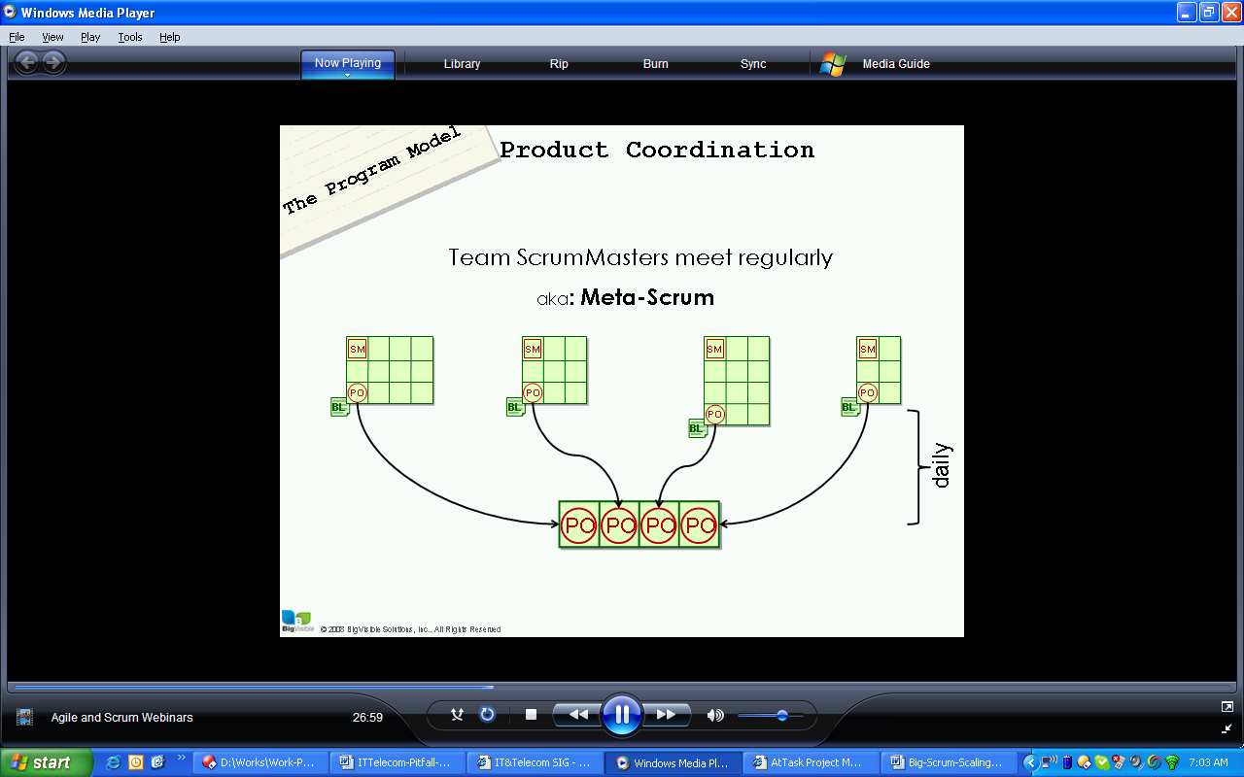

Uber Product owner (ultimately sets the goal for project/product ability
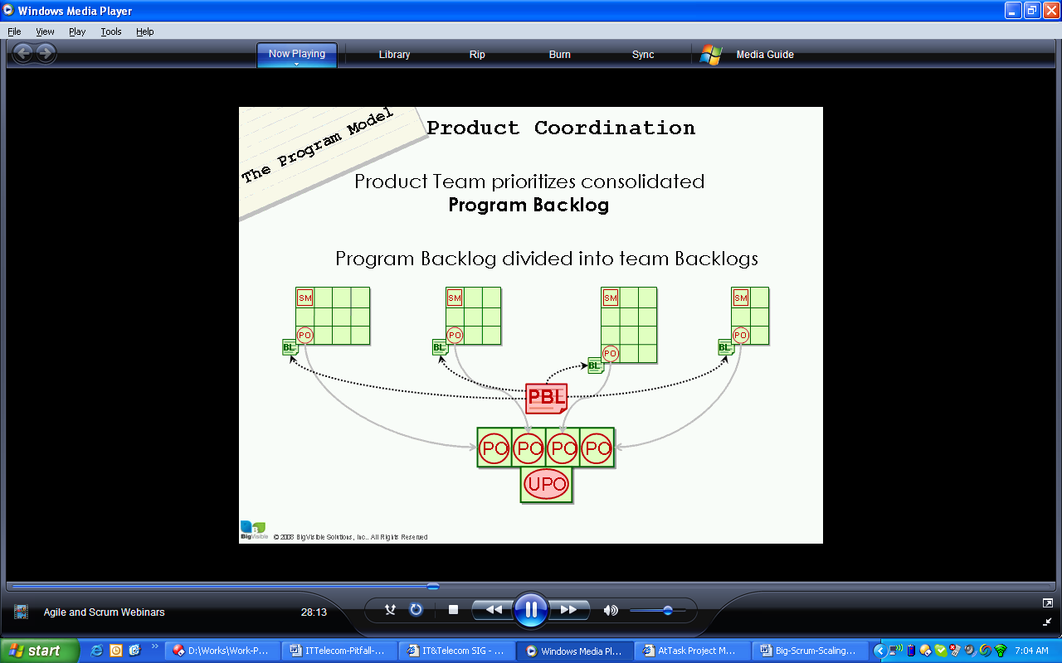

3 Product Management Models
Extensive investment in project ownership
Same domain, same application, same technology then this approach is good.

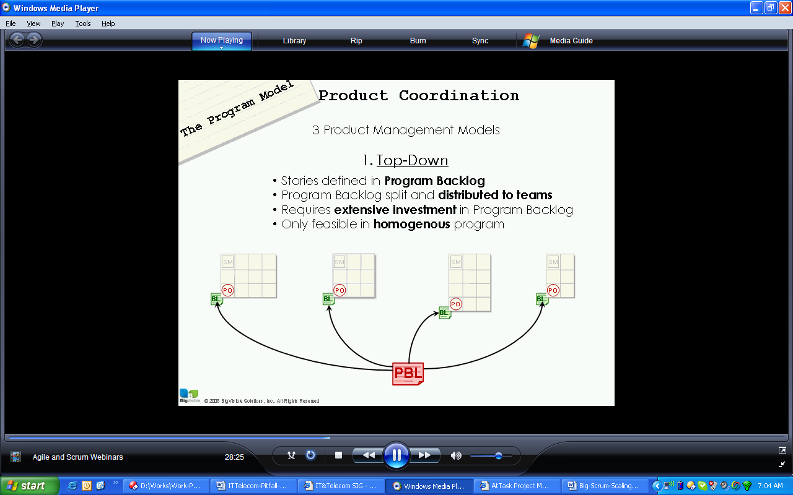

Hetrogenous technology, domain, (different domain experts)

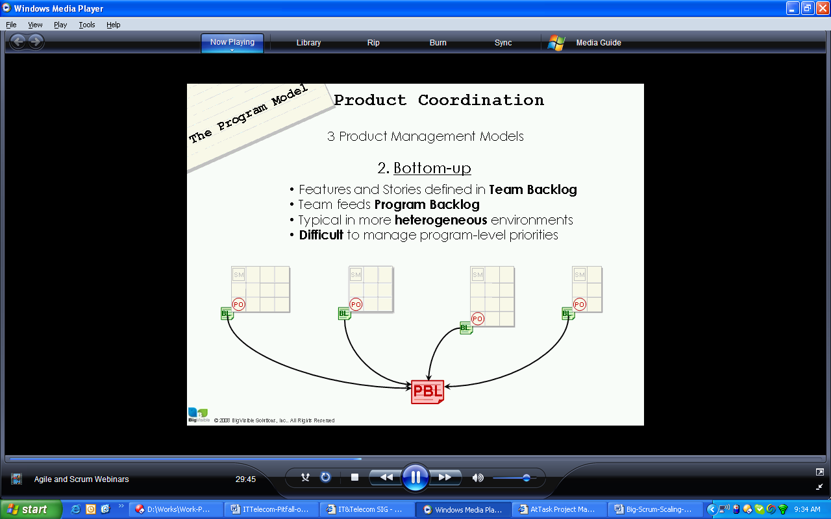

Feature is collection of stories
Features are priorities (all stories of a high priority feature may not be high priority stories)
Stories are prioritized
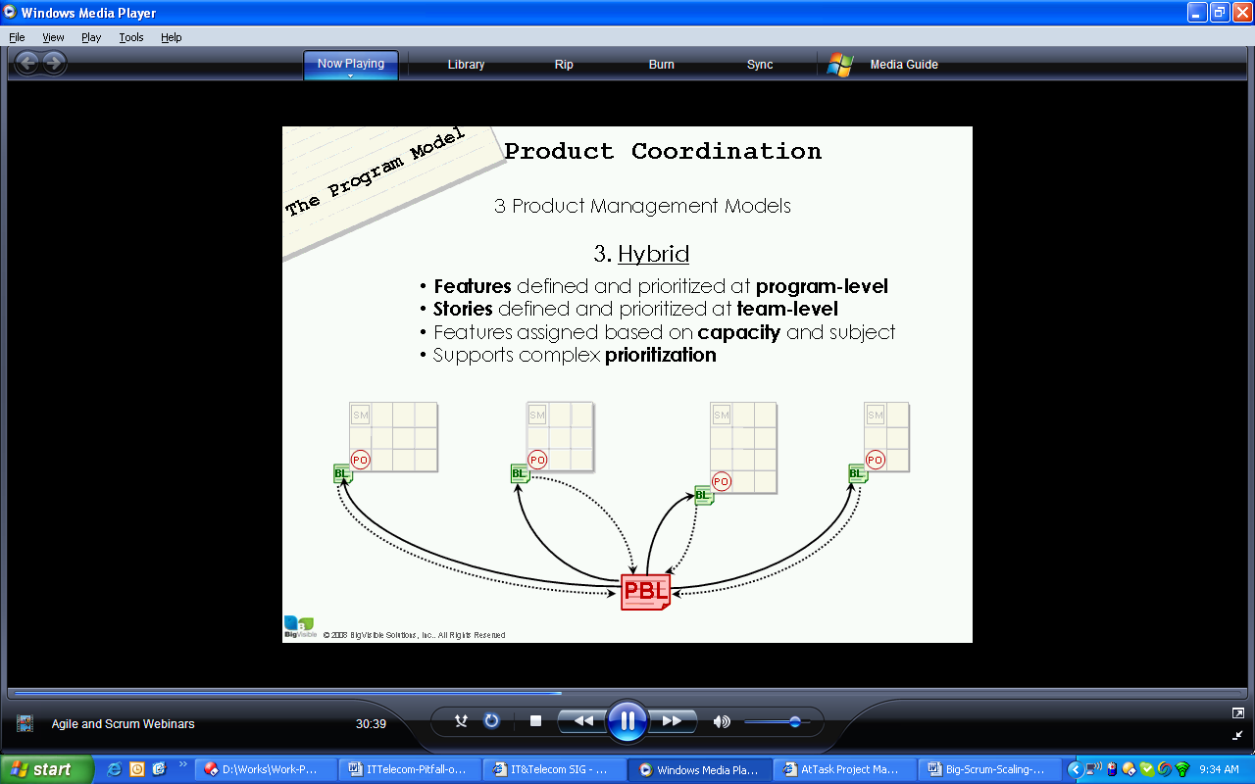

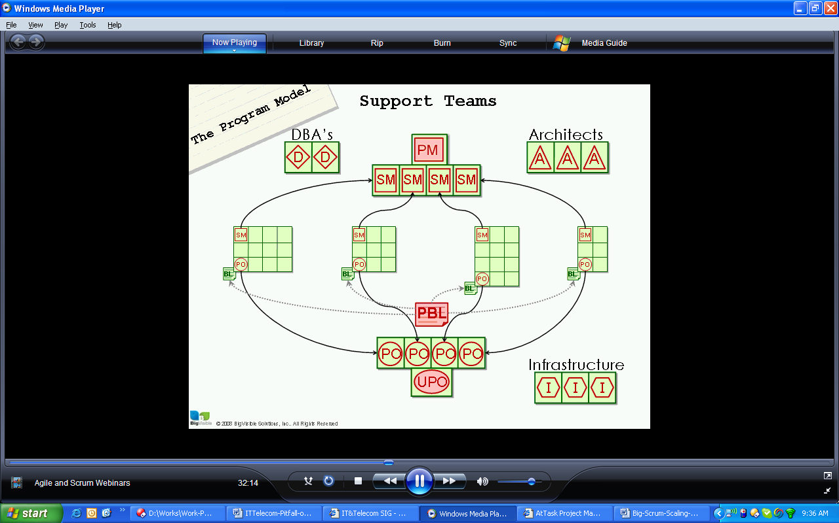

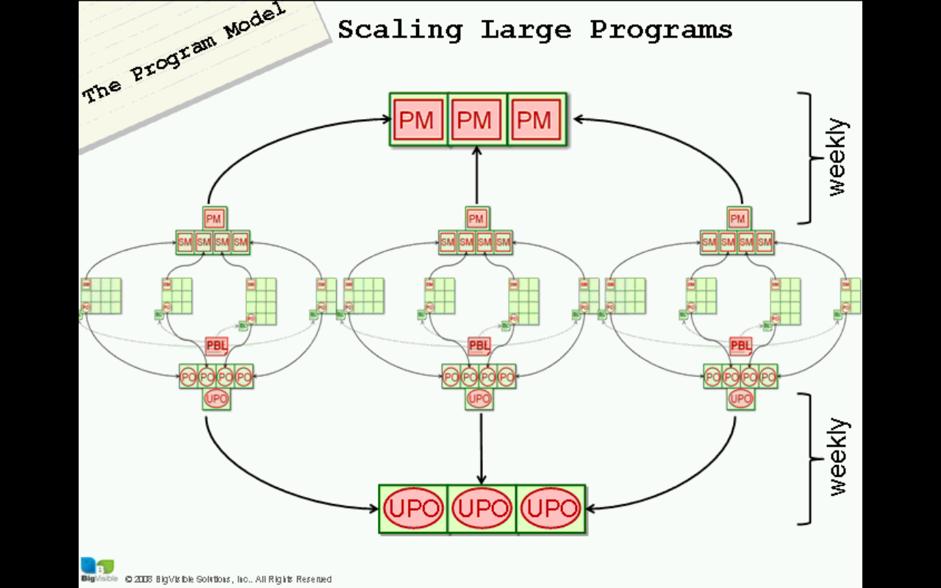

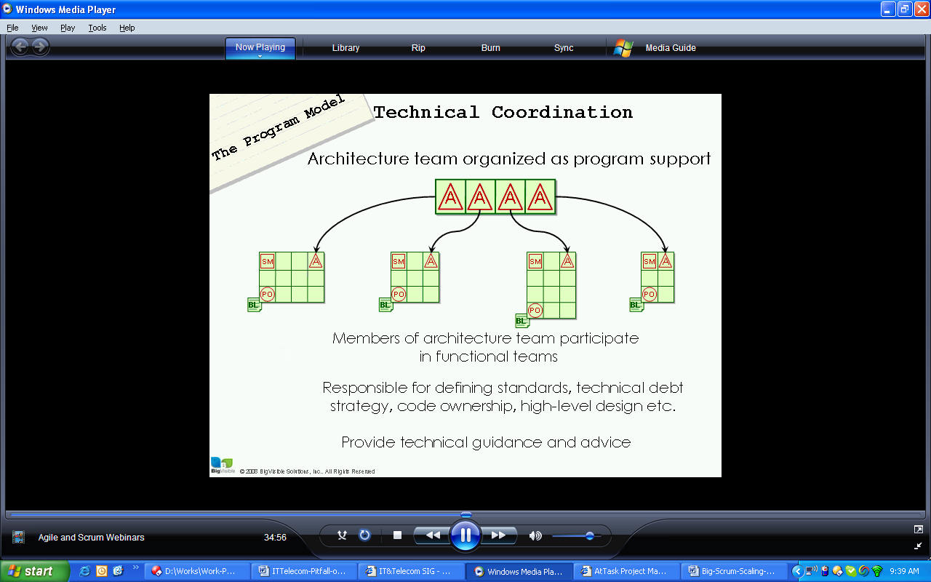

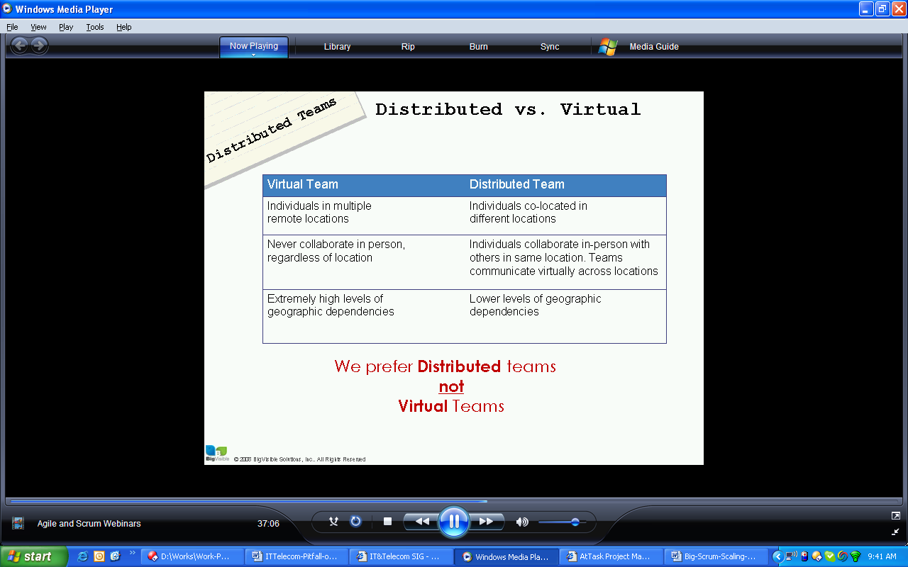

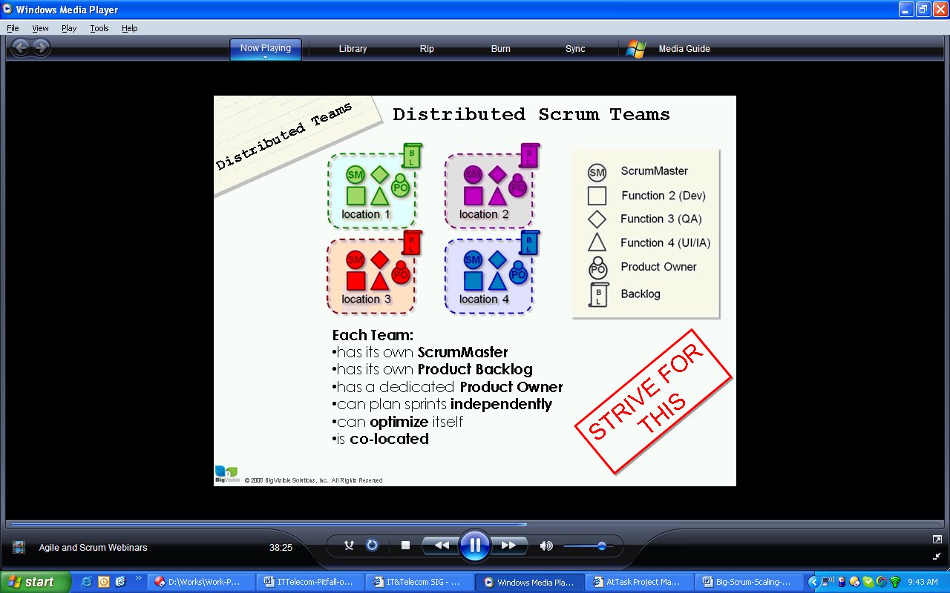

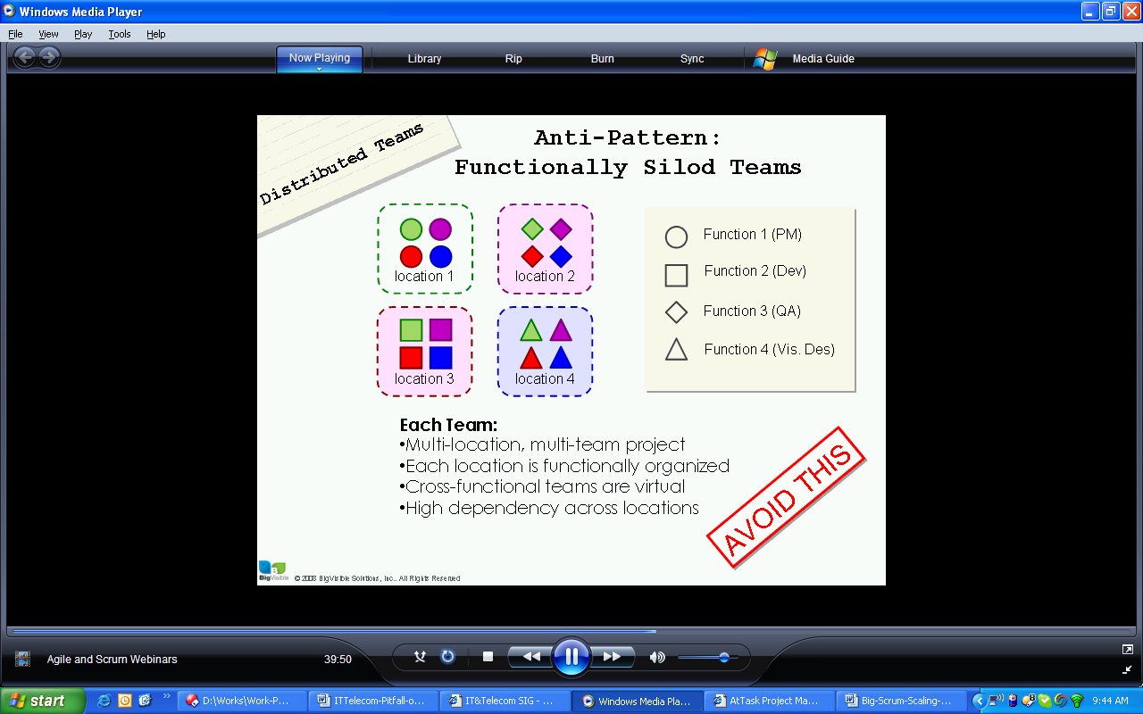

Scaling Strategies
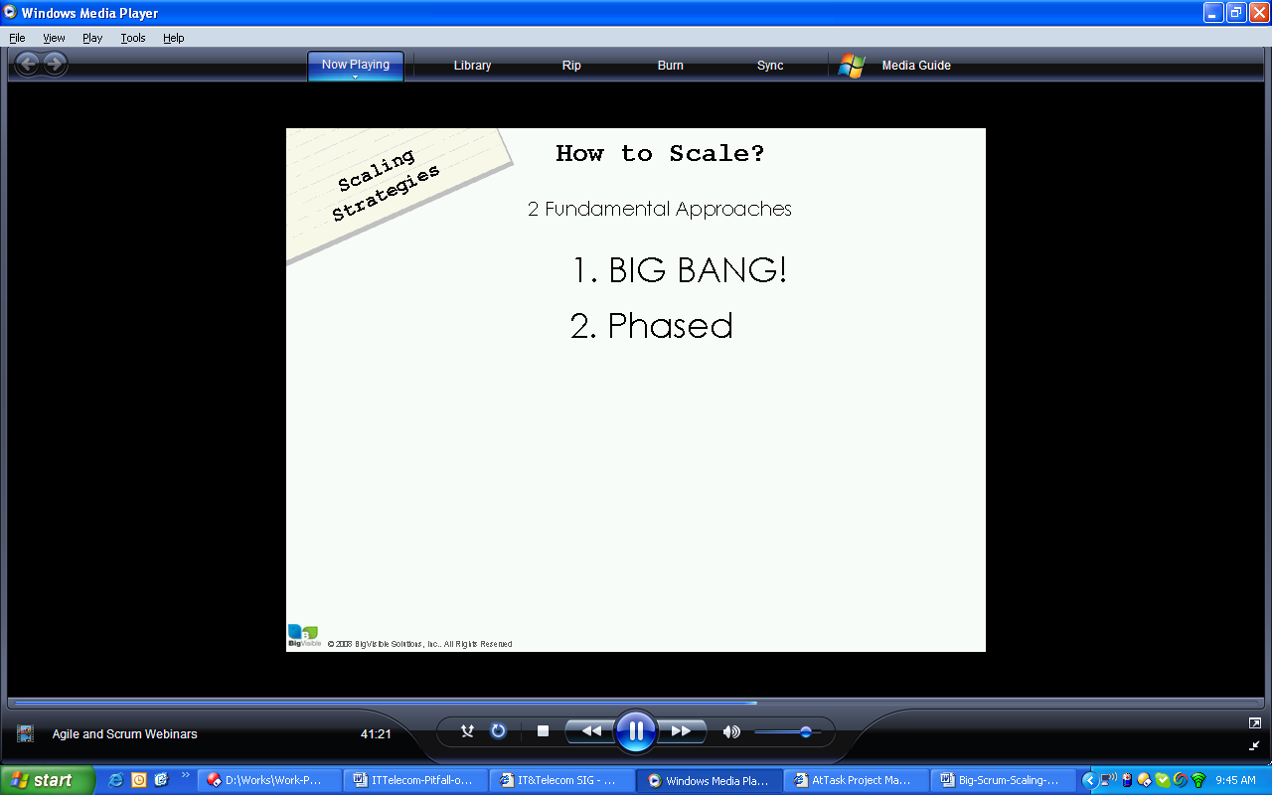

Phase (gradual, takes more time)

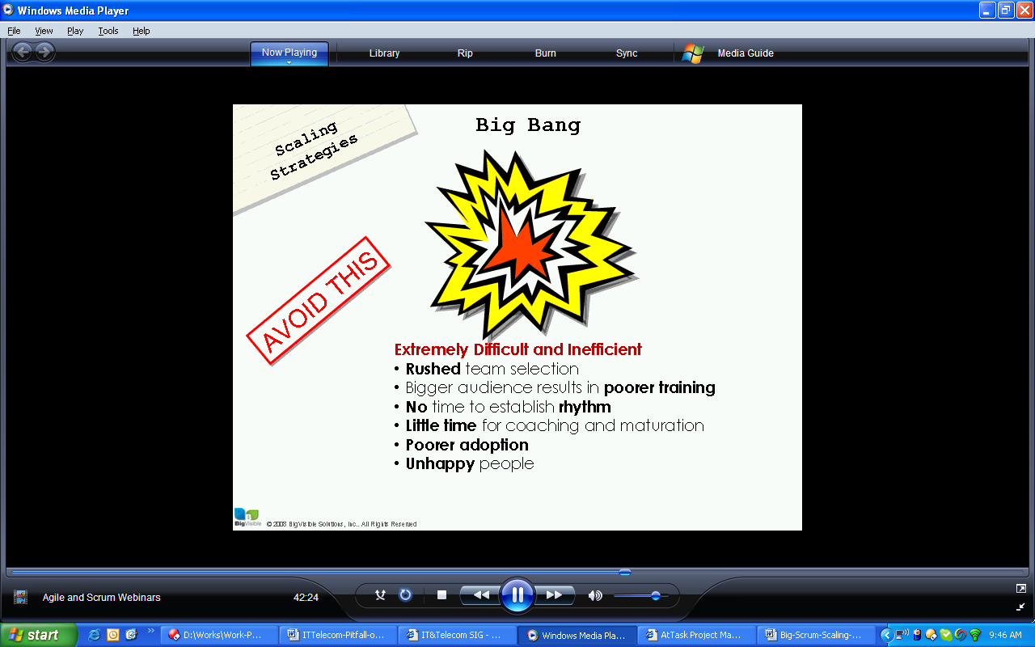

Big bang is too much too fast

Phased
Can be rapid or slow phased approach
- 1-2 team ramped up at a time
- Wider window to find the right peope
- Easier to schedule
- Smaller audience being trained
- Easier for program to focus efferts
- Work best with coaching or mentoring
- Better Adoption
- Happier people
Coacher and trainers are few and clostly o coach.

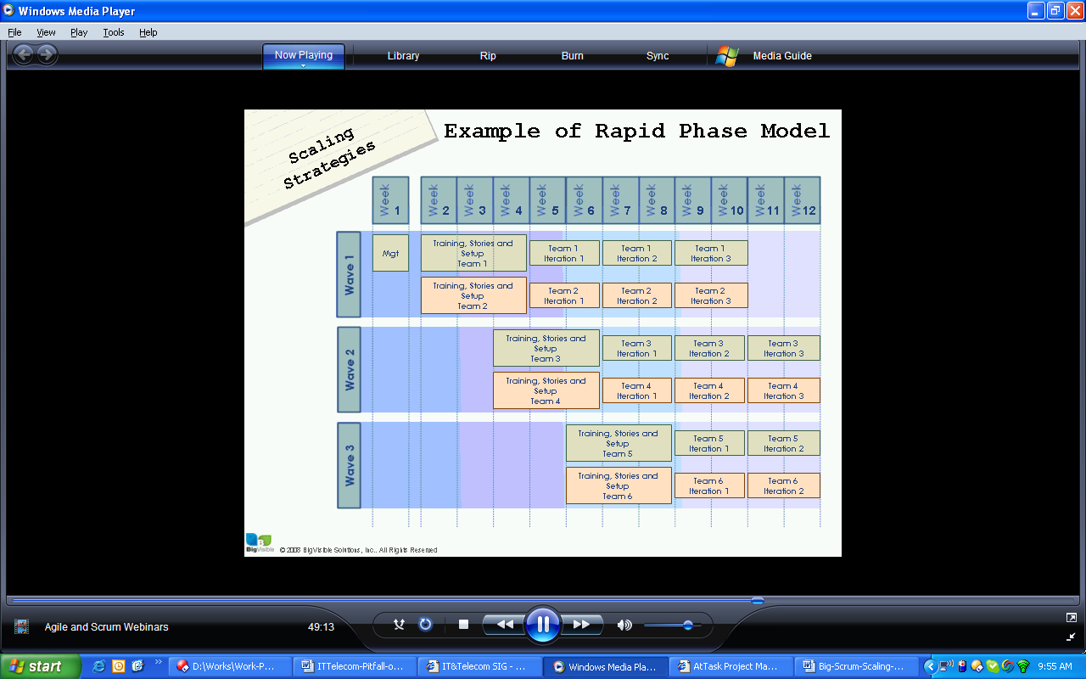

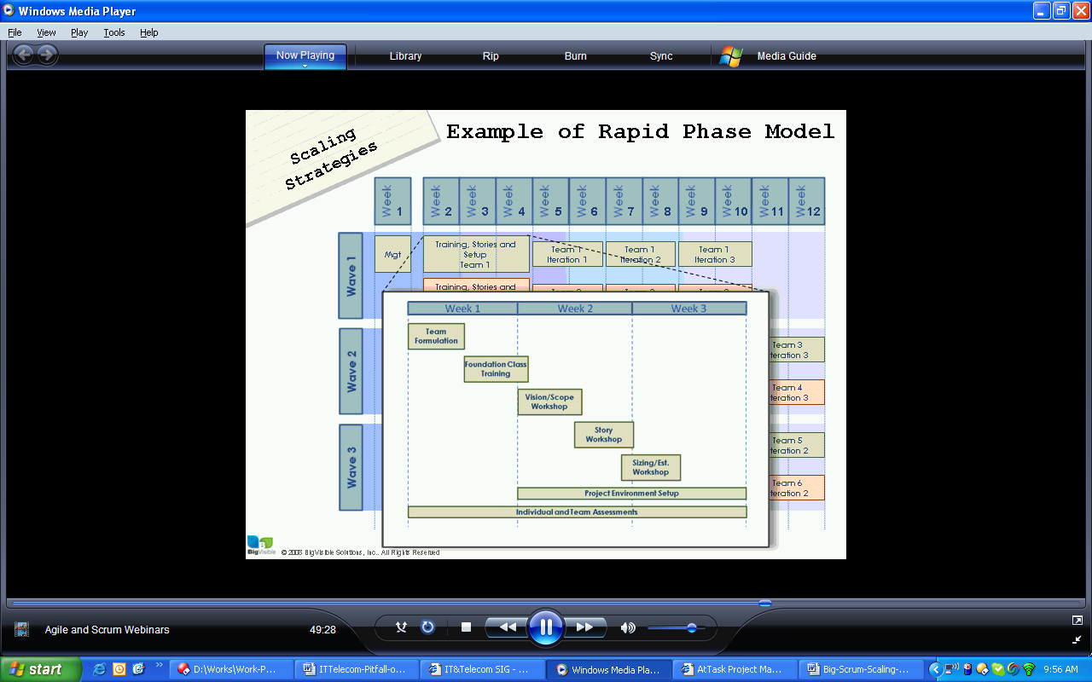

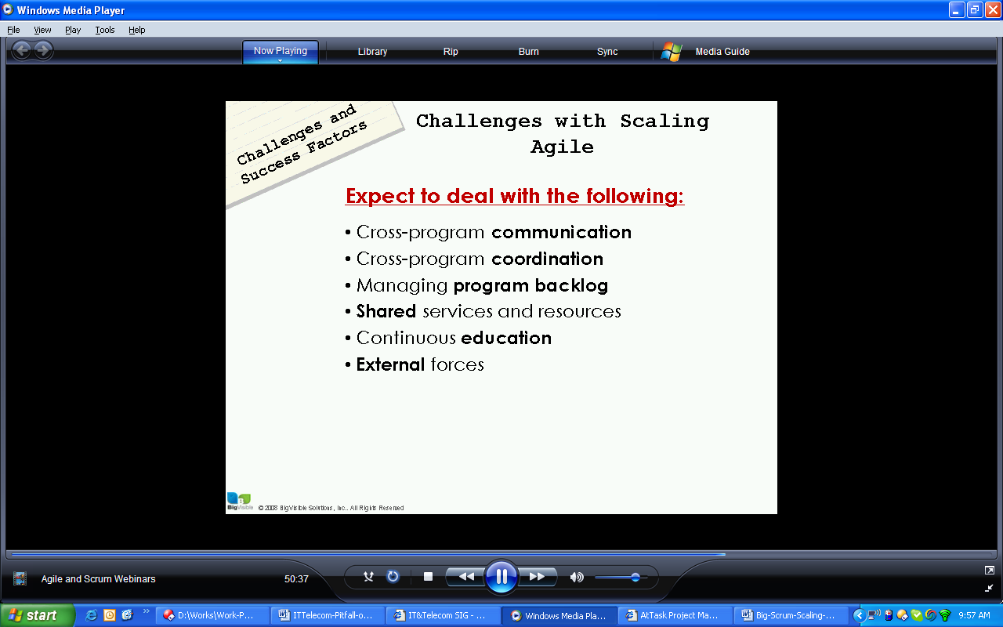

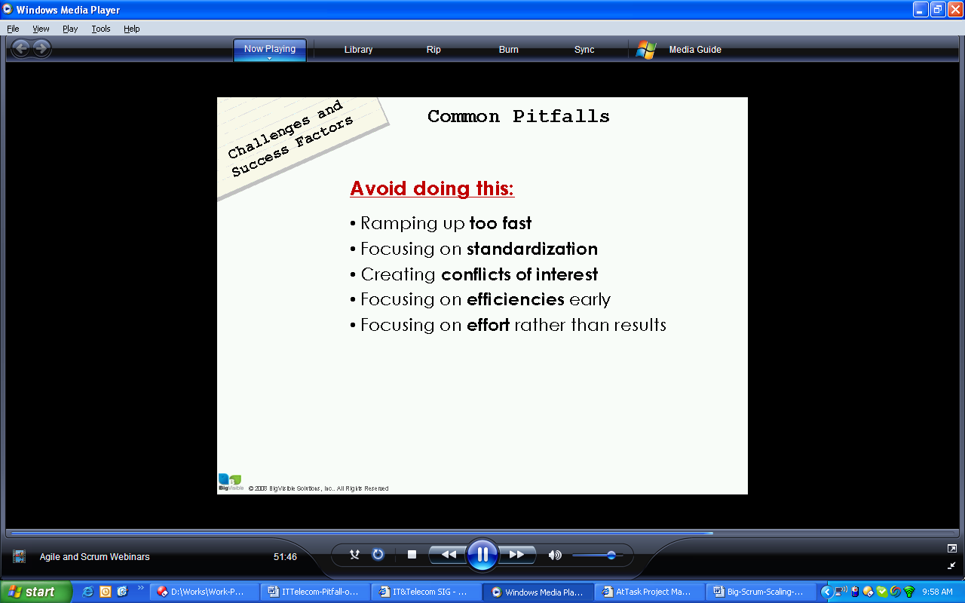

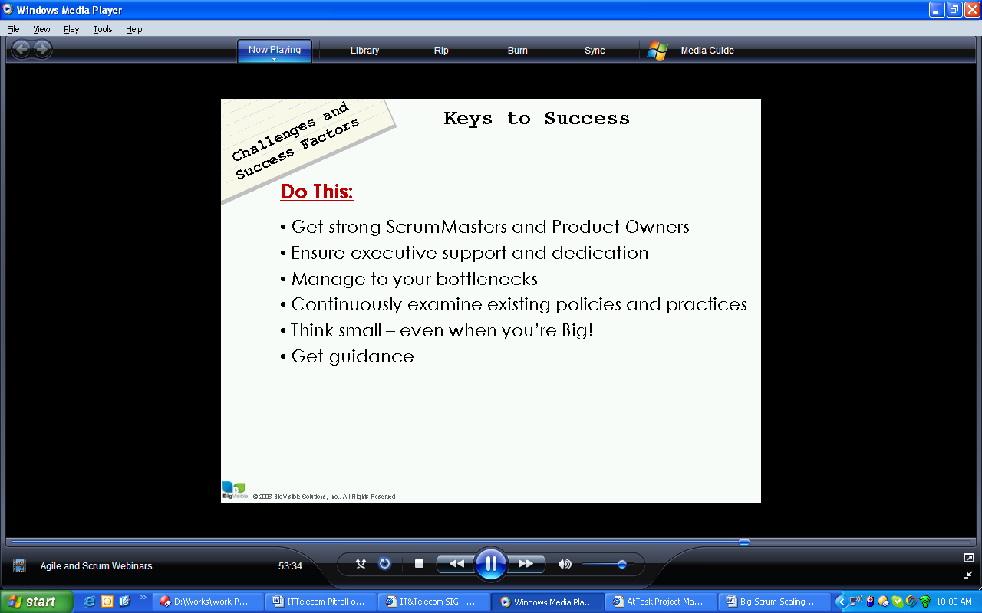

Deliver completed quality product every iteration
Allow people getting approach, focus on them

Have good product owner and scrum masters in project.

How difficult it is to traditional PM to work in agile program
Try to implement agile process in project
How to implement BA activites in agile processes?
Typical is to figure out the detail and estimate
Fix from documentation to analysis role
Based on the priorization of these stories, get the detail and analyze
Example to implement these phases

How important is automated testing, Executable requirements

How does is system design changes in agile
Incremental evolutionary design technique preferred, agile uses concept of refactoring

