Thursday, July 19th, 2007 Webinar
Topic: Leading the Virtual Team
Presenter: Jim De Piante
Abstract: Virtual teams can actually be more effective than co-located teams. This requires particularly effective leadership and communication skills on the part of the project manager. Project managers can exploit the trend toward virtual teams by better understanding the nature of the virtual team, and by honing leadership and communication skills. "Virtual" describes how individuals on teams interact, not where they work. There are many myths associated with virtual teams. These are easily debunked. Virtual teams have their virtues. Of necessity, virtual teams typically are better at documenting, and at communicating unambiguously. To successfully lead virtual teams, project managers should re-examine the means of communication available to them and strive to get better at communicating with brevity and clarity. Ultimately, the success of any project team depends on the leadership abilities of the project manager. Leading the virtual team requires even greater emphasis on the leadership practices used with any team. The trend toward virtual teams provides today's project manager with exciting opportunities to break new ground and develop the art of leading the virtual team. To succeed, the project manager must focus on understanding the strengths and weaknesses of the virtual team and must cultivate essential communication and leadership skills.

Conference line, instant messages
Virtual Team gives access to right people regardless of location
More empowered teams
Better communication
Better documentation
Better meetings
Less “group-thin”

Virtual team rely more on what is said/ written.
Virtual Board
PM Certification Board

Focus to deliver better jobs

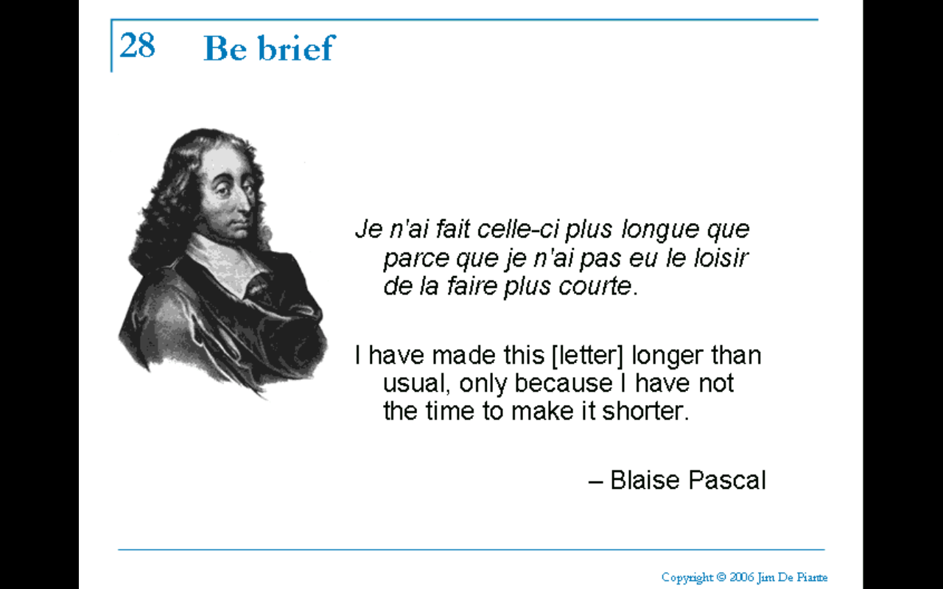

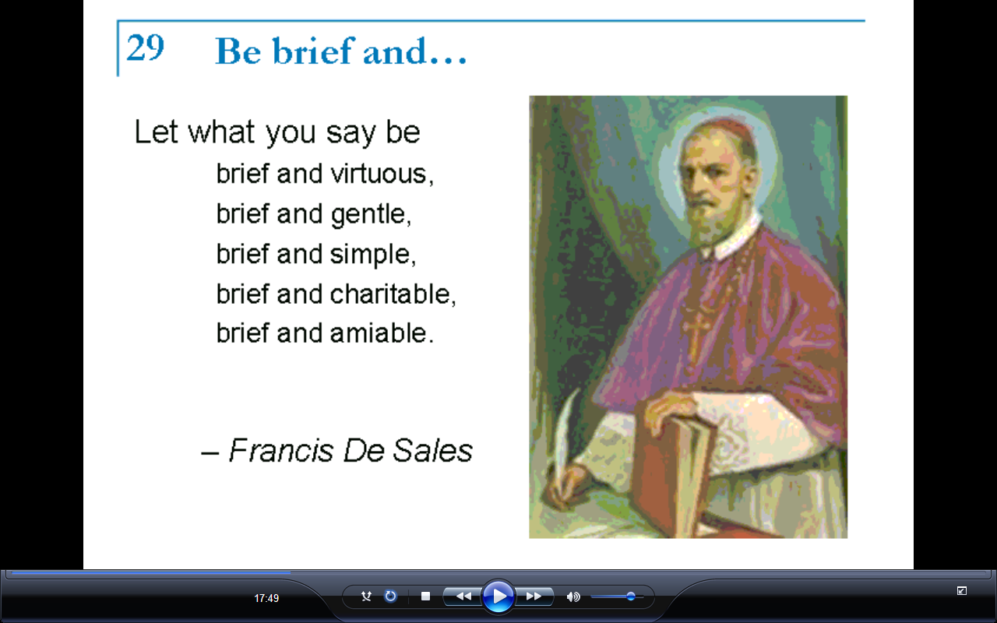

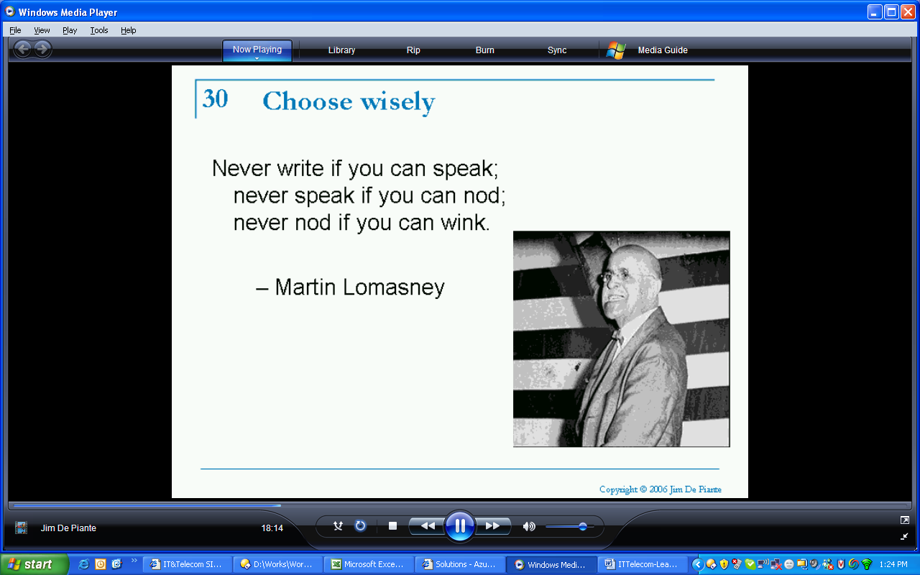

User of alerts (IP msgs)

A good workman is known by his tool (highquality headset/ speaker phone)/ set set microphone

Don’t use a spaker phone/ tell who you are not don’t guess
You guess wrong it is bad deal

Voice Call
Conference Calls (you may be leader or host or participant)

If you get their first, you are the host

The good leader can maintain a reassuring level of control over the meeting while at the same time exhibiting the thoughtfulness and consideration of the good host.

Develop site
Digital coffee break
Managing by walking around
Go to msg instant list and chat with them
Call on phone with no agenda
Upload photographs

When big day arrives, remind them the purpose
Create a photo CD
Communication skills/ Leadership skills/ Virtaul team skills
jd@us.ibm.com (linkedin)

Value of video conferencing or webcam (I have not seen the value)

|||||||||||||||||||||||||||||||||||||||||||||||||||||||||||||||||||||||||||||||||||||||||||||||||||||||||||||||||||||||||||||||||||||||||||||||||||||||||||||
Managing Virtual Team

Mode of communication
- Instant Messenger
- Chatting tool
- Email
- Voice Mail
- Telephone
- Teleconference
- Video Conference
- Webex
- SMS
- MMS
- Hand written mail
- Face to face
- Webcam
- Collaboration website

While make communication plan consider following
- Urgency of messages
- Privacy of messages
- Details required
- Distance to recipients
- Timeliness
- Need of feedback
- Size of audience
- Need for human connection cost
- Need for collaboration

Telephonic talk
- If you want to leave out from the call say “I am really enjoying the chat, however I have to go”

Conference Call tip
- If you could not listen the conversation in conference call say “I am sorry, I was distracted, could you please repeat the question”
- Introduce like “Hey this is Hari, who just joined the call. Good morning everybody”
- When people are joining conference call and you are host then ask people “about weather, ask from where they are calling, who else is on the call, ask about their family, any off the track things”
- Avoid asking “who is on the call”
- Record the meeting
- Recap before finish
- Documented agenda/mom/participants
- If you have behind or ahead on your slide then give them you slide number and them there slide number.
- To ask for a feedback say “Does anybody has anything to add.” Then wait for long time
- You can do it by saying it like “Raj do you have any thing to add” (ask individually)
- Silence becomes unbearable and people will say something.
- If somebody joined in mid and you want to ask him some question, send him brief of conversation my instant message and ask for feedback.
- Ask if things are not clear of unambiguous

Instant Message
- Dealing with multiple languages & influencing languages is challenging especially in instant messaging

Collaborative Space
- Avoid using e-mail for things you could do in the collaborative
- Remove the ability to delete content from collaboration site.

Status Reporting
- Use collaboration side to publish status report and send message to the relevent stake holders, instead make different report for different people and then presenting them.
- Never surprise to people, keep updating them from time to time
- Picture speaks thousands words but everyone has his own version of words, therefore use pictures with words so that once message is grasped quickly by everybody.
- Don’t send presentation around without you going there. Go with presentation

Managing the client
- Stay in constant touch
- Be accessible
- Reassure
- Communicate status immediately
- Cultivate the relation
- Be confident
- No surprise ever.

Leadership
- They need to know that you genuinely care about them
- Listen carefully when people are saying
- Make people comfortable, be gracious
- Learn about them face to face, personally
- Specially be sensitive to the problem which are not visible to you
- Need to work hard to show the commitment.

How to bring people on board
- Talk to them one to one.
- Let them read team charter.
- Introduce that person to board.
- Let him feel comfortable to talk and discuss.

How to tackle with people who do not respond
- First, send them email.
- If does not respond then call them on all possible phones which I have with me.
- If there is no reply then send them offline message.
- Finally if no reply then send them registered letter
Rules of email
- Avoid attaching files, if possible put the information in main body.
- Real mail: Never underestimate the handwritten letter
- Understand the rule of To, CC & BCC
- Write structured email, make point using bullets
- Use fonts type, font size, underline, bold, color to emphasize on important content
- Always keep disclaimer at the bottom
- Always keep signature at the last of your message
- Always write greetings and salutation
- Do not use email as messenger
- Never pressure send button if you have not reviewed content, meaning, spelling and message. Mostly you will find that bad message is better than no message
- Never write and send any email in bad mood. They are documentary evidences!
- Balance the use of messenger and email. Do not write email if messenger can server the purpose

General
- "Virtual" describes how individuals on teams interact, not where they work.
- To successfully lead virtual teams, project managers should re-examine the means of communication available to them and strive to get better at communicating with brevity and clarity.
- Co-location happens because of business compulsion or technology makes it necessary, easy and feasible
- It it’s not written down, it doesn’t exist
- I have made this longer than usual, only because I have not the time to make it shorter- Blaise Pascal
- Be brief: Let what you say be brief and virtuous, brief and gentle, brief and simple, brief and charitable, brief and amiable- Frainçis De Sales
- If some this urgent and important say it 3 times in 3 different way
- You do the survey with question then often the last question is replied, occasionally the first question is replied and usually most interested question is replied by the audience.
- Publish Team Charter at collaborative website. It is an excellent place to communicate. It can have information like how to use collaboration space, How to use instance message etc.

