Today’s Date: 26-Jun-09
Tuesday, February 17, 2008 Webinar
Topic: Selling Agile to Upper Management
Presenter: Richard Sheridan
Abstract: As the Vice President of Product Development, Rich Sheridan transformed his organization by adopting radical co-location and Extreme Programming practices. In this presentation, Rich will share the history of this transformation including the tactics he used in selling this idea to his peers, his CEO, the Board of Directors, and ultimately to his team members. Rich now runs a software design and development company that was built from the ground up with an Agile culture and Agile processes. As the CEO of this company, Rich routinely has to sell customer executives on why they will realize business value from practices such as unit testing and paired-programming.
Rich will share with you his perspective on answering business leadership questions such as...
- "Why should I pay for two programmers to do the job of one?"
- "Why should I pay for unit testing, why not just write it correctly the first time?"
- "We paid a ton for those cubes and now you want me to take them down?"
- "Why should we have to visit with you every week, didn't you read our requirements document?"
- "How could people work in a loud environment like yours?"
- "If you use paired programming, how can you tell who the best programmers are?"

Edision: Edision mentioned that he did not invented any thing great but the processes through which he invented all those.

PM’s Table: Factory for management table
PM’s Job: How many people we need, who should be paired with whom, assignment of coming week, add/remove paired tables, Publish task on board, Team prefered space

Work Authorization Board (using paper even when running a software company)
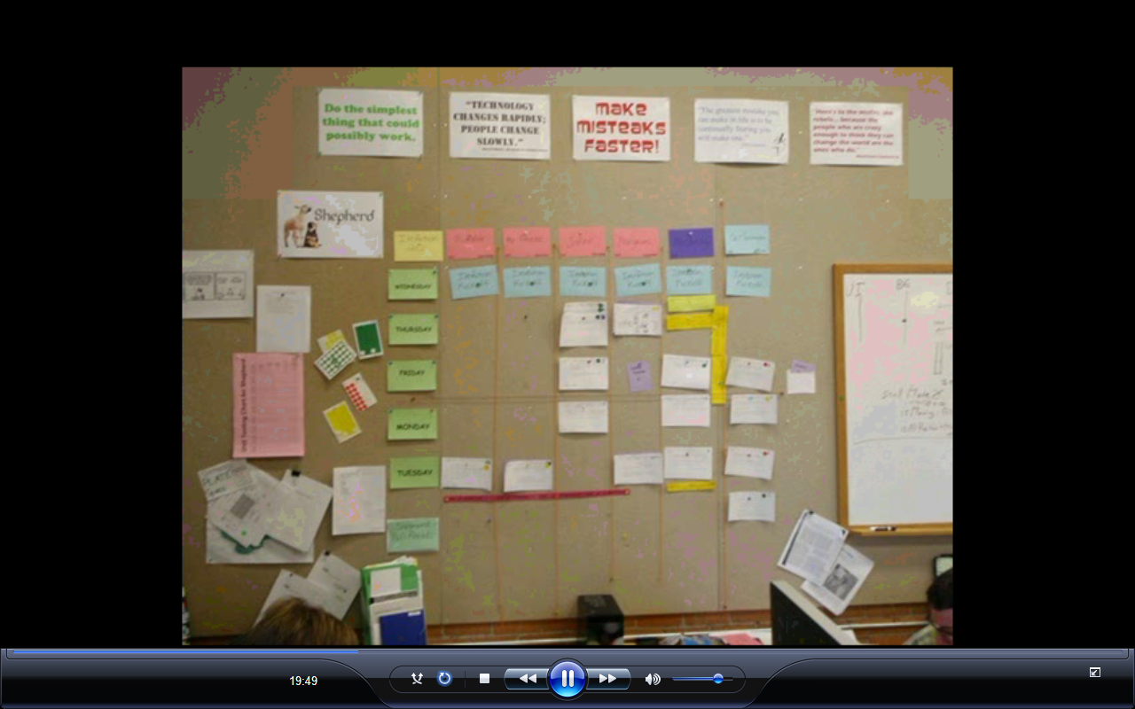
Board works for the human beings.
This excellent system to communicate

B oard has
30 weeks project (starts on wed and ends on tue, client comes on tues)

Planning activity
Scope authorization process

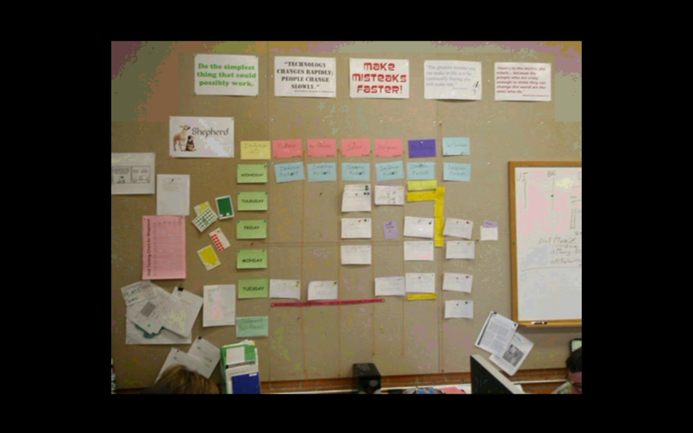

Typical size is 2500 to 7500 hours $100/per hour

Company is in business since last 8 years exp of people around 6 years.
Cross training and mentoring (what people can learn from each other) Mostly junior people has technology

We keep 4-5 people in bench and keep engaged in internal work. Expend the team as necessary.

Normally programmer fight with each others (formally/informally/finding fault at the time of integration/ ) so pair time to time

In fact starting company face problem in implementing agile

This is cultural and behavioural change, which is hardest. Read some book about organizational development peter senge “Fifth Discipline”/ five dis-function of team/ change the way we change/ consider the reward what we are taking from the team/ put more cheese at some other place/ more learning/ more customer engagement/ more feedback/ training/

How to manage maintenance/development project?
Both are same using the story card/ estimate by team/ prioritize by the client

Fixed date & Fixed budget
Ability to focus on higher business value thing first. Earlier months of infrastructure work done before delivery contrary to agile.

Knowledge management.
We online resources and lot of book on quality/ organizational book/ engineering

Virtual team:

What is attrition rate: Negative iteration rate. Some time people go away but they come back.

We have certified scrum trainer in the project & Project managers are PMP

www.Menloinnovations.com

What about High level estimate:
Agile is about making an effective collaboration team between client and technical team. Normally PM is torch bearer of bad news between these two team.

- Switch the pair every week
- Very noisy environment
- Name to the team
- Little to share by email.
- One to one communication
- No conference room to book
- Easy to add people or move people from one team team to other.
- We never worked weekend. We added more people, if more work required to be done.
- Work authorization board with different color and size of cards.
- Cards for story, weekdays, name of pair & team, backlog
- Different color of papres
  - Green cards are day cards
  - Pink cards for programs (4 pair)
  - Purple (QA pair)
  - White card are story card
- 32 hours is the largest card will be schedule on the board
- Can make small dot/circle on the card
  - Yellow: working on
  - Orange: programmer believe it is done (it means they have integrated code and run unit test) QA team comes to test
  - Green: QA team says it is done
  - Dark Yellow cards: recurring cards (in qa team)/ programmer story card/ creating automatic testing.
- Every activity is authorized by client. Every story card has one id associated to it. Every body reports story card in their time sheet.
- Client comes on tues to watch the show and tell and interaction with system. Therefore schedule is published from Wed to Tue
- Then client visits WAS
- Physical size of the card as per the hours
- 13000 automated unit tested
- Unit test are good documentation.
- 50-60 people in standup meeting and finishes in 30 min
- Dart board in wall. Standup gather in circle
- A token is given and only that person speak who has token.
- Very organized meeting.
- Stand around meeting (when card is not used)
- Energizing and encouraging meeting. Most exported feature of our meeting.
- Open collaborative environment/ people are working
- No chit chat, but noise of work only
- Not answering mobile, text message, messengers (I am on task, enjoying the work)
- Two classic version of the programmer (waiting and say hey I have idea, second is keep typing second person say stop now)
- Client can come and see this board and know the status of project
- We do not have emergency in the project
- Get feedback directly from the team
- Team estimates for 32 hours on a card (5th day is client show & tell and planning)
- Done, finished, complete (different definition of doneness)
- Project manager’s job is to find red dot in the card
- The best project manager is: excellent interaction, good motivator, defendor of process, orchestrating the process, we manage the process, people report to the process

3 Type of WBS
- Phase oriented WBS
- 2. Discipline oriented WBS
- Design oriented WBS

Good Presentation Techniqute
Will take a break, whether I have generated any question for my audience

