

Project Management Institute Mumbai Chapter

Dear Yagna,

Please note that this time the AGM & 57th PMP Club Meeting will be held on Thursday, 8th of January, 2009 as per the following schedule.
Schedule of AGM & 57th PMP CLUB Meeting on Thursday, 8th January 2009
5:30 PM to 6:30 PM Registration & Tea
6:30 PM to 7:30 PM 1st half of 57th PMP Club Meeting
7:30 PM to 8:00 PM Networking break with starters and Elections balloting etc.
8:00 PM to 9:00 PM 2nd half of 57th PMP Club session
9:00 PM onwards Mementos Ceremony & Networking Dinner
Registration for Members: Free
Non-members: Rs.500/-.

Notification for 57th Meet of PMPClub

(Registration Members: free, Non-members: Rs.500/-)

Due to limited space it is essential that participants register on http://www.pmimumbaichapter.org or use the link given below:

http://www.onepmi.org/PMIWeb/EventDetails.aspx?ProductID=885&compid=1026
This time topics for discussions will be :
First half: Remaking of Mumbai Federation" (RoMF):
Second Half : Operations Management-A key to Project Management Success

Please note that the session in the First Half will be followed by dinner. The non- members ( those who are not members of Mumbai Chapter) will be required to pay Rs. 500/- for participation, at the venue.
Please ensure that you reach on time at the venue i. e. ' Juhu Vile Parle Gymkhana Club' for registration so that you are not late to listen to either Mr. Mayank Gandhi or Mr. Ravindra Tulsiyan (see below).

Brief Profile of the Speakers:

I: Mr. Mayank Gandhi, Secretary- Remaking of Mumbai Federation

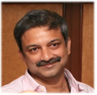
Steering committee member of the World's largest not-for-profit organization for urban
planners, architects and urban consultants - Council on Tall Buildings and Urban Habitat
(CTBUH) - based in Illinois.
a) Worked with various NGOs like
b) Contributed to some of the finest laws / movements in the country
c) Have addressed thousands of meetings to achieve the above objectives, ranging from
pesentations to governments, associations, street and corner meetings and addressing
various public meetings of up to 15,000 people.
d) Addressed International seminars in
a) Shanghai,
b) Hong Kong,
c) Chicago, New York
d) Dubai
e) Have worked closely with some of the world's best individuals and professional organizations
"REMAKING OF MUMBAI FEDERATION" (RoMF):

Mumbai is a mega city of 16 million people and the commercial
capital of India, the 4th largest economy in the world. A vibrantly
democratic India is on the path of tremendous growth and
modernization. Mumbai is an old city surrounded on 3 sides with sea
and a beautiful coastline. While early Mumbai was developed on the
southern part, unprecedented growth in the economy of Mumbai has
created unprecedent expansion of land use on the northern side.

In consonance with the guidelines and suggestions of various
government policies, judicial comments and expert opinion, it is
proposed to remake Mumbai, into a world class city in partnership
with the government using principles of modern technology, planning
and engineering by creation of "Remaking of Mumbai Federation".

Remaking of Mumbai Federation is seeking to collaborate and work
with some of the world's best Developers, Planners, Consultants,
Vendors and Engineers in this historical endeavor to recreate an
existing mega city using the best practices across the globe.

II: OPERATIONS MANAGEMENT - A KEY TO PROJECT MANAGEMENT SUCCESS BY MR. RAVINDRA TULSIYAN
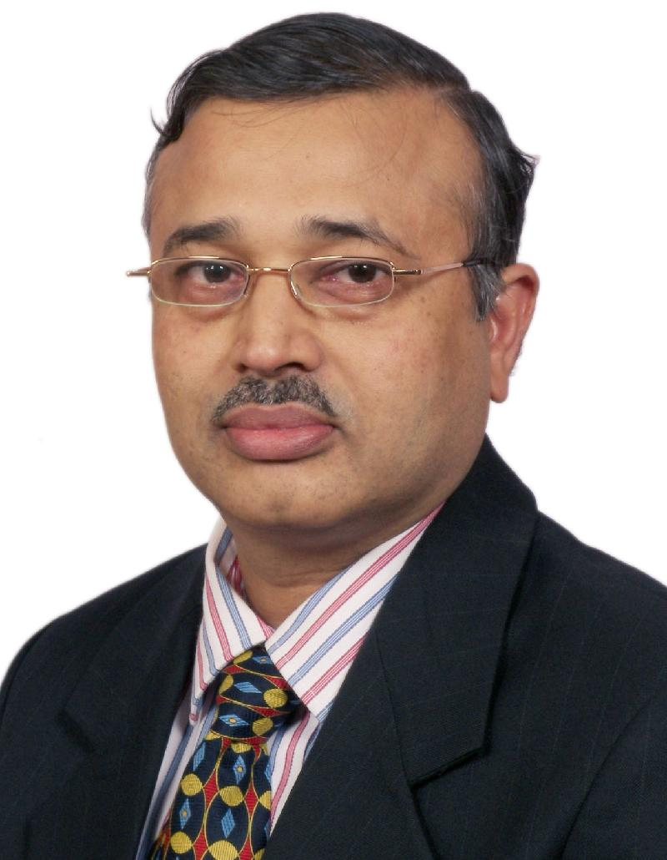
&nbs p; Ravindra Tulsyan, popularly knows as Ravi, is a highly effective change leader and
ERP/SCM/business process guru. In his career starting 1982, he has had very wide and deep
insight of business problems of more than 150 companies, in India and abroad, in all kinds of
manufacturing, distribution and service businesses. He is the pioneer of ERP and business
process movement in India.
Ravi did his B.Sc.Engg.(Hons.)(Mech.) from REC (Now NIT) Rourkela. He completed his M.Tech.
(Mech.) from IIT Kanpur and Diploma in Business Finance (DBF) from ICFAI Hyderabad. He is
Certified Fellow in Production & Inventory Management (CFPIM), Certified in Integrated
Resource Management (CIRM), and Certified Supply Chain Professional (CSCP), by APICS, USA.
Prior to starting his business, he worked for Tata Unisys Ltd. (now Tata Consultancy Services Ltd.) for more than six years. He started his own ERP consulting practice in 1989 in the name of Saksham Consultants. Later he formed another company that was SAP channel partner. Now, he is the Chairman and Chief Mentor of KnoWerX Education (India) Pvt. Ltd, an international associate of APICS The Association for Operations Management, USA and the international licensee of American Society of Transportation and Logistics, USA. He is one of the founders and played the lead role in forming the Business Process Council.
He has worn many hats; has been a consultant, implementer, visiting faculty, speaker and writer at many occasions. Many organizations in India as well as abroad had the opportunity to be guided by him and his team to improve their business processes. His book titled "How to Eat the Elephant?" is one of the most acclaimed books on the subject of enterprise systems implementation. He remains a well known personality in this field that organizations and individuals love to work with.
Operations Management - A key to Project Management Success
This session discusses the newly released framework of Operations Management Body of Knowledge (OMBOK) and how it helps to increase the chances of Project Management success. The integration and dependencies between project management and operations management are explored.
Venue:
Juhu Vile Parle Gymkhana Club, North South Road No. 13, Juhu, Mumbai - 400049, Phone: 2620-6016/5937/5973

(Directions:Landmark:Opposite Juhu Bus Depot (Bus Routes 203, 253, 256...)
Nearest Railway Stations Vile Parle (W) and Andheri (W) From Vile Parle (W), the side of the NM Management College move towards JUHU beach. Before turning left for Juhu beach/ J W Marriot, turn right onto NS Road No.13 and reach the venue)

Thanks & Regards,

Sumantra Sarkar
Vice President - PMPClub PMI MC
pmpclub@pmimumbaichapter.org Mob: 9819732489

Forward email

