Online Event Registration Form of PMI Mumbai Chapter

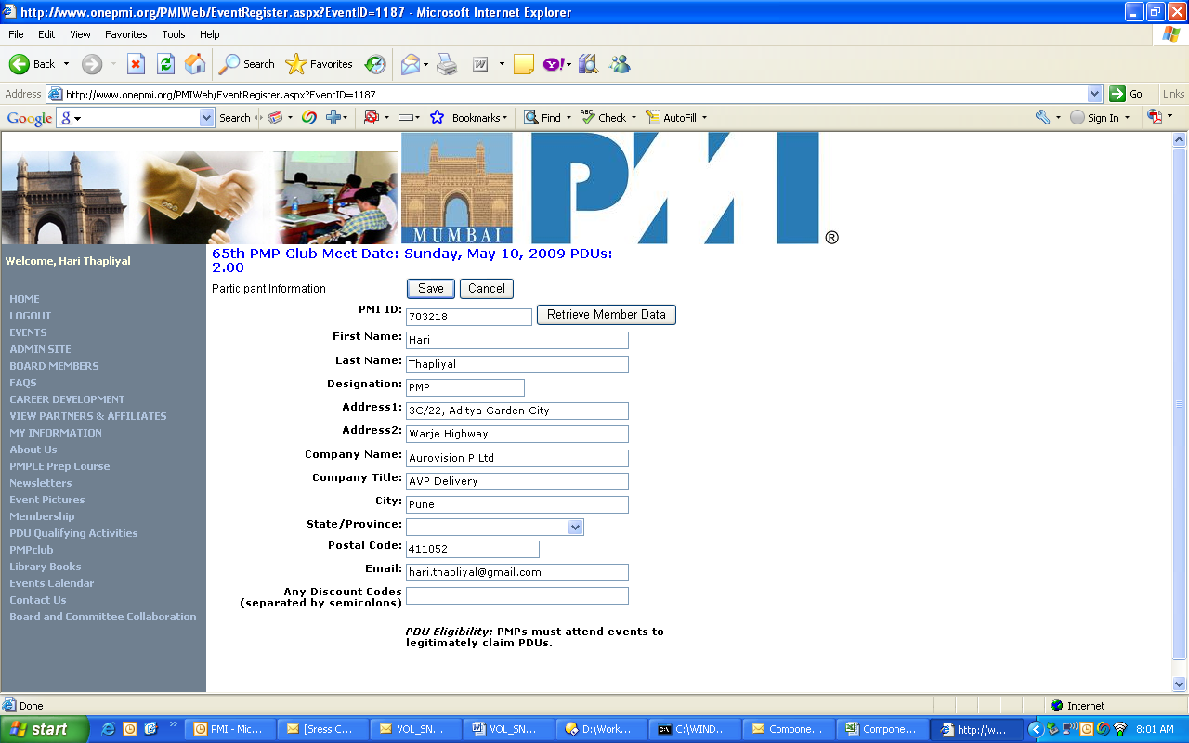

Document Control Page
Document ID |  |  | PMP_FRM2
Document Version |  |  | Version 1.0 Final
Document Status |  |  | Final
Document Description |  |  | PMPClub Event Registration Form
Document File Name |  |  | PMP_FRM2_PMPClub_Event_Registration_Form.doc
Created By |  |  | Hari P Thapliyal
Created On |  |  | 15-Mar-2009
Revision History of this Document
Version Number | Revision Date | Revision Author |  | Change Description | Approved by Name
1.0 | 15-Mar-2009 |  |  | Initial Draft (Screen snapshot taken from onepmi.org) | jTS, President

