# PRINCE2 Manual Important Pages

* 17 A summary of the themes within PRINCE2 (useful for those questions on themes)
* 23 Useful diagram on the business case development path
* 33 Useful diagram of the organization structure recommended by PRINCE2
* 49 Quality audit train, this diagram has been used in some practitioner questions
* 55 This is one of only two ‘grey boxes' that are included in the syllabus (the other being product based planning)
* 63 Diagram showing the planning procedure
* 86 List of risk threat and opportunity responses
* 95 Change management procedure
* 102 The six tolerances areas by level
* 115 If you have a magnifying glass this diagram could be useful
* 216 The factors that lead to tailoring the method
* 219 This diagram shows a project in the context of programme
* 222 Tale with examples of different scales of projects
* 235 In appendix A the product descriptions in alphabetical order, and should be referenced as needed
* 269 In appendix C the roles and responsibilities are in A-Z order. Useful when tackling the organization questions

# Project Timeline

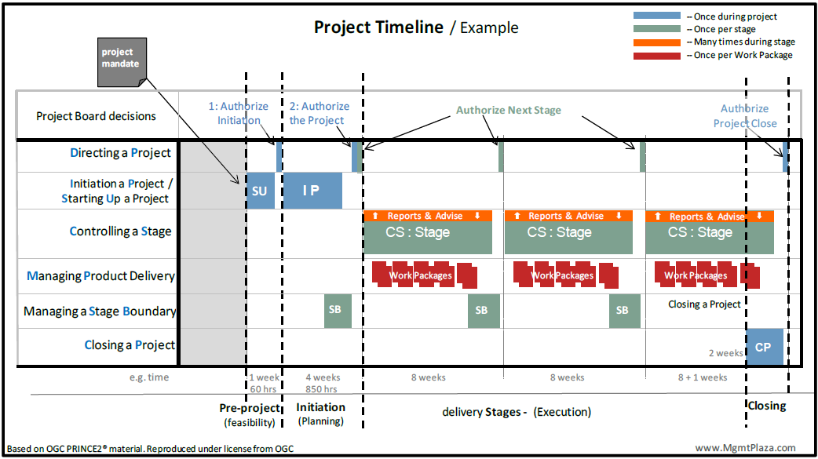

# PRINCE2 Management Product

|  |  |  |  |  |  |
| --- | --- | --- | --- | --- | --- |
| **Product Name** | **Type** | **Theme** | **Product Name** | **Type** | **Theme** |
| Benefit Review Plan | BL | BC | Lesson Log | REC |  |
| Business Case | BL | BC | Lesson Report | REP |  |
| Checkpoint Report | REP | PRO | Plan (Project, Stage, Team, Exception) | BL | PLN |
| Communication Management Strategy | BL | PRO | Product Description | BL | QLT |
| Configuration Item Record | REC | CHG | Product Status Account | REP | CNG |
| Configuration Management Strategy | BL | CHG | Project Brief | BL |  |
| Daily Log | REC |  | Project Initiation Documentation | BL |  |
| End Project Report | REP | PRO | Project Product Description | BL | QLT |
| End Stage Report | REP | PRO | Quality Management Strategy | BL | QLT |
| Exception Report | REP | PRO | Quality Register | REC | QLT |
| Highlight Report | REP | PRO | Risk Management Strategy | BL | RSK |
| Issue Register | REC | CHG | Risk Register | REC | RSK |
| Issue Report | REP |  | Work Package | BL |  |

# Key PRINCE2 Products

1. Project Mandate
2. PPD (Project Product Description) = Dev Skills Required + Acceptance Criteria + **Project Level Quality Tolerances** + Acceptance Method + Acceptance Responsibilities
3. PB = Project Definition + OBC + PPD + Project Approach + PM Team Structure + Role Description
4. BC = Executive Summary + Reasons + Business Options + Expected Benefits + Expected Dis-benefits +timescale+ Costs + Investment Appraisal + Major Risks
5. PD (Product Description) = Composition + Derivation + Dev Skills Required + Quality Responsibilities (P/R/A) + Quality criteria + **Quality tolerance** + Quality methods + Quality skills required
6. Plan = Description + Prerequisites + External Dependencies + Lessons Incorporated + Monitoring and Control + Budget+ **Tolerances** (T/C/S for Level of Plan. May stage/team related Risk) + Product Description + Schedule
7. PID = Project Definition + BC + Project Approach + PM Team Structure + Role Description + PP + Project Controls + 4 Strategies + Tailoring of PRINCE2
8. Work Package= Techniques, process & procedures + Development Interfaces + Ops/Maintenance Interfaces + Configuration Mgmt Req + Joint Agreements (efforts, cost, date, key milestones) + **Tolerance (T/C may be S/R)** + Constraints+ Reporting Arrangements + Problem handling and escalation + approval methods + extracts from stage plan and product description
9. PPD -> PBS -> Product Description -> Product Flow Diagram

# Issue and Change Control Procedure

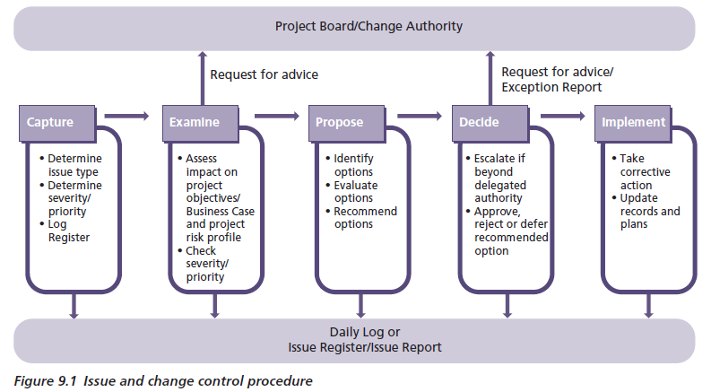

# Request for Change Possible Decisions

1. Approve the Change
2. Reject the Change
3. Defer decision
4. Request more info
5. Ask for an Exception Plan

# The Risk Management Procedure

1. Identify
2. Assess
3. Plan
4. Implement
5. Communicate

# Threat and opportunity responses

|  |  |
| --- | --- |
| **Threat responses** | **Opportunity responses** |
| Avoid | Exploit |
| Reduce (probability and/or impact) | Enhance |
| Fallback (reduces impact only) |
| Transfer (reduces impact only, and often only the financial impact) |
| Accept | Reject |
| Share | Share |