**SharePoint2010:**

SharePoint 2010 is the business collaboration platform for the Enterprise and the web that enables you to contact and empower people through an integrated set of rich features. SharePoint 2010 helps you cut costs with a unified infrastructure while allowing you to rapidly respond to business needs.

Microsoft announced about the SharePoint 2010 technical preview.

**SharePoint 2010 Builds on Existing Features of SharePoint 2007**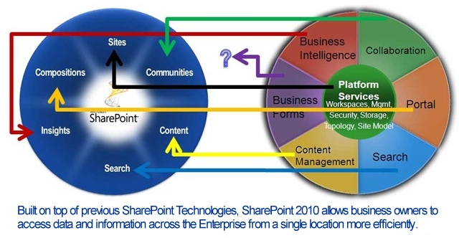

# Features of the new SharePoint 2010:

* **New User Interface including the new Ribbon:**  A streamlined new user interface including the Ribbon is an intuitive and contextual web user interface that makes users more effective. Reduces training, provides better performance and lowers cost.
* **Web Edit:**  Web Edit allows users to easily customize a site, making it possible to respond more quickly than ever to changes in your dynamic business environment.
* **Silverlight Web Part**: The Silverlight Web Part allows you to fully integrate Silverlight applications within your SharePoint site for a more interactive user experience.
* **Rich Theming**: Combined with Web Edit, rich theming allows you to skin your SharePoint site using your favorite office client themes. Change the colors and fonts to customize just as you like it.
* **Multiple Browser Support**: SharePoint 2010 will now support not only MS Internet Explorer, but now Firefox and Safari will also be fully supported.
* Visio Services: Visio will now be fully supported. You can link diagrams in real time, with high-fidelity in a consistent matter so that everyone can stay up to dat. Even those who do not have Visio.
* **New SharePoint Designer:** SharePoint Designer comes with a new User Interface with enhanced modeling capabilities and improved workflows.
* **Business Connectivity Services (The Business Data Catalog):** Business Connectivity Services (BCS) allows you to connect to Line-of-business applications, web services and databases in a user friendly way enabling users to interact and update it easily in both web and office clients.
* **SharePoint Workspace:** Formally named Groove, SharePoint Workspace is a rich client for SharePoint that lets you take your SharePoint lists and libraries off-line, including the ability to update content and sync it back when you re-connect.
* Rich Media Support: Silverlight and PowerPoint presentation capabilities are easily integrated with the new SharePoint 2010. Your information and presentations will come to life in new and dynamic ways with SharePoint 2010.

SharePoint 2010 is packed with exciting new features. Content authors, administrators and developers can all expect an improved experience.

**Content Authoring Improvements**

* Improved WYSIWYG Editor (Web Edit with Live Preview)
* Improved Theming
* Silverlight Web Part
* Ribbon Toolbar

**Administration Improvements**

* Streamlined Central Administration
* Best Practices Analyzer: analyzes farm health and can automatically fix common configuration errors out-of-the-box. Extensible and rules-based.
* Unified Logging Database
* Resource throttling for large lists and libraries

**Development Improvements**

* Visual Studio 2010 Tools including a Package Designer and Web Part Editor
* LINQ for SharePoint
* Developer Dashboard: Page-level debugging/trace output
* Business Connectivity Services (BCS) replaces Business Data Catalog (BDC) with SharePoint Designer 2010 and Visual Studio 2010 will provide BCS-specific tooling.
* Client Object Model (OM) is a new SharePoint API that runs on the client and can be called from JavaScript, .NET, or  Silverlight

**Compare SharePoint Server 2010 and SharePoint Server 2007**

SharePoint Server 2010 provides various advantages over its earlier version SharePoint Server 2007, but hardware requirements have been increased. Here we are trying to show the basic difference between Stand alone installation of both MOSS2010 vs. MOSS2007

|  |  |  |
| --- | --- | --- |
| **Component for Standalone Installation** | SharePoint 2010 Requirement | SharePoint 2007 Requirement |
| **Operating System** | 64-bit edition of Windows Server 2008 Standard with SP2 | Windows Server 2003 with SP1 or later Windows Server 2003, Standard Edition Windows Server 2003, Enterprise Edition Windows Server 2003, Datacenter Edition *Windows Server 2003, Web Edition  *if you are using Windows Server 2003, Web Edition in a single server environment, you can only perform an Advanced, front-end Web server installation. This is because the full SQL Server editions cannot be installed on Windows Server 2003 |
| **Processor** | 64-bit, dual processor, 3 GHz | Support both x32-bit–based and x64-bit–based systems  2.5 gigahertz (GHz) Recommended: Dual processors that are each 3 GHz or faster |
| **RAM** | 4 GB for stand-alone or evaluation installation 8 GB for single server and multiple server farm installation for production use | 1 gigabyte (GB) Recommended: 2 GB |
| **Disk** | 80 GB | NTFS , 3GB Free Space |
| Database | SQL Server 2008 Express with SP1 SQL Server 2008 Native Client Microsoft SQL Server 2008 Analysis Services ADOMD.NET ADO.NET Data Services v1.5 CTP2 | SQL Server 2000 Service Pack 4 SQL Server 2005 Express Edition and higher |
| .Net Framework | Microsoft .NET Framework version 3.5 SP1 | Microsoft .NET Framework version 3.5 SP1 |
| Other prerequisites | Web Server (IIS) role Application Server role Microsoft "Geneva" Framework Microsoft Sync Framework Runtime v1.0 (x64) Microsoft Filter Pack 2.0 Microsoft Chart Controls for the Microsoft .NET Framework 3.5 Windows Power Shell 2.0 CTP3  Microsoft Chart Controls for the Microsoft .NET Framework 3.5 Windows Power Shell 2.0 CTP3 | Internet Information Services (IIS) 6.0, including: Common files  WWW Simple Mail Transfer Protocol (SMTP) Internet Information Services (IIS) 7.0 |

**Limitations:**

SharePoint 2010 has hardware and other limitations:

1. SharePoint 2010 will only be available in a 64-bit version. This change is not limited to servers. Developers running on 32-bit hardware will need new machines.
2. SharePoint 2010 will require a 64-bit version of SQL Server 2005 or 2008 (2000 is no longer supported).
3. Not all applications written for SharePoint 2007 will work in 2010. Certain APIs will be no longer be available. Others will be deprecated.
4. The basic flow for many tasks as changed. That coupled with the laundry list of productivity-enhancing features means that any 2010 deployment should be accompanied by training for users, administrators, and developers.