

SharePoint Collaboration Service Governance Plan
Author:
Joel Oleson
Sr. Product Manager, Evangelist
Quest Software
Contributors
John Ross & Jennifer Mason
SharePoint911
Paul Culmsee
Seven Sigma
Date published:
March 2009
Summary:
The following sample governance plan is designed to help you outline the administration, maintenance, and support of an Office SharePoint® Server 2007 deployment in an enterprise. The fictitious company on which the plan is based supports collaboration and an Intranet portal.
The information contained in this document represents the current view of Microsoft Corporation on the issues discussed as of the date of publication. Because Microsoft must respond to changing market conditions, it should not be interpreted to be a commitment on the part of Microsoft, and Microsoft cannot guarantee the accuracy of any information presented after the date of publication.
This White Paper is for informational purposes only. MICROSOFT MAKES NO WARRANTIES, EXPRESS, IMPLIED OR STATUTORY, AS TO THE INFORMATION IN THIS DOCUMENT.
Complying with all applicable copyright laws is the responsibility of the user. Without limiting the rights under copyright, no part of this document may be reproduced, stored in or introduced into a retrieval system, or transmitted in any form or by any means (electronic, mechanical, photocopying, recording, or otherwise), or for any purpose, without the express written permission of Microsoft Corporation.
Microsoft may have patents, patent applications, trademarks, copyrights, or other intellectual property rights covering subject matter in this document. Except as expressly provided in any written license agreement from Microsoft, the furnishing of this document does not give you any license to these patents, trademarks, copyrights, or other intellectual property.
Unless otherwise noted, the companies, organizations, products, domain names, e-mail addresses, logos, people, places, and events depicted in examples herein are fictitious. No association with any real company, organization, product, domain name, e-mail address, logo, person, place, or event is intended or should be inferred.
© 2009 Microsoft Corporation. All rights reserved.
Microsoft, SQL Server, Office SharePoint Server, Windows SharePoint Services, and Active Directory, are trademarks of the Microsoft group of companies.
All other trademarks are property of their respective owners.


SharePoint Service Definition

Prepared on

Feb 21, 2009

Created by

Joel Oleson

Sr. Product Manager, Evangelist
Quest Software

Contributors
John Ross & Jennifer Mason
SharePoint911
Paul Culmsee
Seven Sigma

Table of Contents
SharePoint Collaboration Service Governance Plan 1
1 Executive Overview 1
1.1 What This Document Provides 1
1.2 SharePoint Collaboration Vision and Mission 1
1.3 Service Delivery Goals 1
2 Service Delivery Requirements 2
1.1 Technical Requirements 2
1.2 Business Requirements 3
2 Collaboration Service Definition 3
2.1 Objectives 3
2.2 Audience 4
2.3 Business Scope 4
2.4 Operational Risks / Concerns 4
2.5 Collaboration Service Offering 5
3 SharePoint Deployment Team Roles 6
3.1 SharePoint Service Team 6
3.1.1 Service Owner 6
3.1.2 SharePoint Business Champions 6
3.1.3 SharePoint Developers 6
3.1.4 SharePoint Operations (SharePoint Administrators) 7
3.1.5 Network Infrastructure 7
3.2 SharePoint Operational Tiered Roles 7
3.2.1 SharePoint Tier 1 Support Desk 7
3.2.2 SharePoint Tier 2 Operations 8
3.2.3 SharePoint Tier 3 Engineering 9
3.3 Customer Interaction and Feedback 9
4 SharePoint Physical Topologies 10
4.1 Recommended Global Deployment Approach 10
4.2 Management and Delegation 11
4.3 Multilingual Considerations 12
5 Development and Configuration Application Policies 12
5.1 Customization Policy 12
5.2 Browser Standards and Permissions 13
5.3 Site Provisioning and Templates 13
5.4 Site Management Storage and Life Cycle Policies 13
5.5 Becoming a Site Collection Administrator 13
6 Project and Operational Management 13
6.1 Communication Plan 13
7 SharePoint Business Review Meetings 13
7.1 Service, Operations, and Change Advisory Meetings 13
8 Education and Training Plan 13
8.1 Administrator, Developer and End User Training 13
8.2 Key Deployment Resources 13
9 Stakeholder Signoff and Commitment 13
10 Appendix Key Terms and Definitions 13
10.1 IT Governance Definitions 13
10.2 Understanding the Containment Hierarchy 13
10.3 Understanding SharePoint Service Provisioning 13
10.4 Understanding More SharePoint Key Service Terms 13

- Executive Overview
  - What This Document Provides

This SharePoint Governance Plan is a sample based on Fabrikam’s Collaboration service. It is a guideline outlining the administration, maintenance, and support of Fabrikam’s planned SharePoint deployment. It identifies lines of ownership for our business and technical teams and identifies who is responsible for which areas of the system. The plan also establishes rules for appropriate use of the SharePoint environments.

This governance plan ensures that our system is managed and used in accordance with its designed intent to prevent scope creep and chaos. Managing this enterprise-wide system involves both a strategic, business-minded board to craft rules and procedures for the use of the system and also a tactical, technically-competent team to manage the routine operational tasks that keep the system running. Users of the system will be empowered by a support and developer community sponsored by the business leaders.

Governance Plan Goals
- Establish the service definition and governing IT policies by which the SharePoint service will be run based on the requirements outlined.
- Create the people infrastructure to govern and support the SharePoint environments based on the first phase of this collaboration service offering based on SharePoint Server.
- Communicate the initial business and initial high-level IT requirements as they relate to the service definition
  - SharePoint Collaboration Vision and Mission
Vision
Reduce IT overhead through standardized sets of key services (Identity (AD), Mail (Exchange), Desktop services and Collaboration) to consolidate legacy platforms, and support corporate-wide cost reduction initiatives to reduce travel.
Mission
Provide a standardized and scalable Collaboration Service to address the business and productivity needs of corporate information workers, plant workers, and service consultants globally at Fabrikam.
  - Service Delivery Goals
- Provide a Collaboration Service that enables employees to share information.
- Reduce security risk by using a standardized IT-hosted collaboration platform.
- Provide consistent corporate-branded collaboration “team” sites for file sharing, project management, business management, and document management scenarios.
- Change corporate culture to keep “Master” documents on corporate assets (Collaboration servers). Corporate assets should live on servers that run SharePoint Server, for easier backup, search, auditing, and lifecycle management.
- Encourage Business Practices around Green Computing – be conscientious about travel and use SharePoint Server and real-time computing technologies where possible to reduce carbon emissions from travel and paper use. (This goal has more to do with the way the system influences corporate culture and adoption.)
- Service Delivery Requirements
  - Technical Requirements
- High Availability - Needs to be fault tolerant on Web with existing load-balancing infrastructure, search (query), & SQL Server® clustered.
- Disaster Recovery – Disaster recovery environment setup in Spokane with requirements to be determined later (SQL Server replication or ? TBD)
- Uptime target 99.9% or better.
- Recovery time objective 4 hours or less for non catastrophic outages and 7 days for catastrophic outages. (Note the dependency on network infrastructure, the Active Directory® directory service, and SMTP provided by the Exchange/Active Directory teams in the recovery data center.)
- Recovery point objective is 24 hours or less.
- Support calls to the 24/7 support desk should receive attention within a maximum of 15 minute hold time without prior notification of high call volume, and resolution should be a maximum of 3 days for 90% of calls. Resolution is considered resolution by the client with the exception of no response. This service is considered business critical. More detail provided by the support desk service offering.
- The hardware needs to scale and support company growth. The initial deployment should support at least 300GB of data with the ability to grow to 1TB over the first year. A SAN for shared disk for the SQL Server cluster is planned. The initial deployment should support 30,000 users over the first year, and 120,000 anticipated maximum monthly users globally by the third year.
- Auditing to capture site delete events is to be enforced. More detail in business requirement.
- Validate performance benchmark testing prior to rollout to establish baseline page and document performance levels (To be determined estimated at 7 seconds)
- Security review required for all changes to the software and service installed, security penetration testing scheduled every 6 months and once a quarter, and will be performed during the maintenance window. The operations team will be notified by the security team the week prior, but no settings changes should take place prior to the test.
- A maintenance window for planned downtime on Fridays at 18:00 Pacific Time for 2 hours will be provided and not count against availability SLAs. Longer planned maintenance downtime windows will require communication.
  - Business Requirements
- Search requirements – search will be included across all content in SharePoint Server and a single page provided for search across all sites.
- Login and authentication – users should be able to use their existing NT Active Directory accounts. No additional accounts should be used. If at a later date an extranet deployment is added this will be revisited.
- Expiration – content expiration will be limited to site collection expiration policies enforced by the SharePoint Operations team. No site will be deleted permanently without first notifying the owner, and then after some agreed-upon time the site should be backed up for quick retrieval prior to anything being deleted. These “archived” sites should be retained for a period of 1 year after being removed from the production system and restored upon request of either the site collection owner(s) or by approval from the general manager or higher for the business unit to which the site belongs. Note: The CodePlex solution at http://go.microsoft.com/fwlink/?LinkID=114564.
- Editing/Design/SharePoint Designer Usage Policies – Common look and feel across all sites with editing of workflows.
- Auditing – The default auditing settings will be turned on consistently across all sites for the purpose of tracking deletions and auto expiration policies that might be turned on at the site collection level. (Note: The Operations team is evaluating the CodePlex SharePoint Cross-site Configurator (http://go.microsoft.com/fwlink/?LinkId=146245) tool.
- Site Templates – For the first phase the business units need the Team site, the Intranet Portal, Internet Portal, Document and various Meeting Workspaces, and Wiki. No other templates are required at release.
- Collaboration Service Definition
  - Objectives
The primary objective of this plan is to establish a governing body for the usage and management of the SharePoint environments. Other objectives are:
- Identify appropriate business owners willing to provide strategic insight and direction for the site, and able to drive strategic initiatives into their respective organizations.
- Identify appropriate infrastructure (IT) resources to provide operational support for the system.
- Create an effective support system with proper channels of escalation for end users of the SharePoint environments.
- Establish initial governing usage and maintenance policies and procedures for the SharePoint environments.
  - Audience
This document is intended to provide the initial service definition and to be a living document. It can continue to provide direction and be consumed by the business and IT in addressing questions of the vision, mission and service from end users consuming or contributing to the collaboration environment to the site owners and those which would want to use the service in the future.
  - Business Scope
This Governance Plan includes the definition for the collaboration service environments including Dev, Q/A, and Production.
- This scope defines a service with a business critical environment. (1 year max retention.)
- IP retention should be restricted to only allow information which can be shared broadly and does not require retention policies of longer than 1 year. The default retention policies ran by this service would keep tapes off site for no longer than 1 year. This also applies to the destruction of data on tapes. If information needs to be destroyed or has that potential it should not be here.
- Legal holds, record retention, strict document management systems, and so on should not leverage the service at this time based on the policies defined in this document.
- Maximum quota of any one resource by any department, a technical requirement is established at 100GB.
  - Operational Risks / Concerns
The following are risks to an effective governance plan:
- Inadequate support from the business leaders to affect proper governance.
- Administrators or users refusing to abide by the given policies in this plan.
- Scope of the service – As time goes on demands for expanding the service will require that we revisit the scope of this environment to extend beyond collaboration.
- Insufficient resources including budget.
  - Collaboration Service Offering

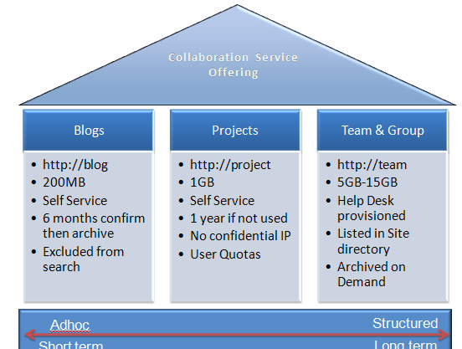

Taxonomic Section | Characteristics | Owners
Group and Team Sites | - Permanent and Temporary  - Sharing information (push / pull)  - Collaboration  - Ad hoc, lax control | - Business Group and Team Managers
Project Team Sites | - Short lived, timed expiration  - Collaboration  - Ad hoc, lax control | - Business Unit General Managers
Blog and My Sites | - Permanent  - Personal info  - Pull information  - Ad hoc, lax control | - Employees

- SharePoint Deployment Team Roles
Figure to show the overlapping roles of the SharePoint Virtual Team

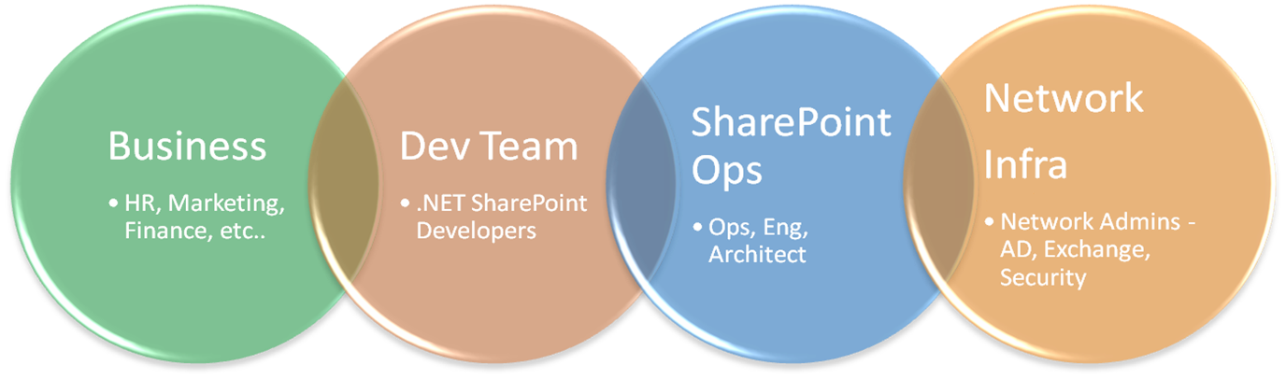

  - SharePoint Service Team
    - Service Owner
The Service Owner will provide strategic insight and direction for site hosting, and be able to drive strategic initiatives into his or her respective organizations. Resources represent a good balance between business and IT, and also centralized control versus decentralized empowerment. This team is a small, dynamic team reconstructed on a quarterly basis with new volunteers to maintain a fresh perspective on the business and exploit the collective wisdom of the company.
    - SharePoint Business Champions
Business savvy users recognized for the business skills which will help drive balance to control versus decentralized empowerment. Volunteers recognized for their skills as user champions help maintain a fresh perspective on the business and exploit the collective wisdom of the company.
    - SharePoint Developers
SharePoint Developers that are talented technically with Microsoft .NET skills, and are willing and able to customize, personalize, and use SharePoint Server in a manner that fulfills the business opportunities as identified by the strategy team. This team is a loosely-knit community of developers with varying degrees of proficiency in software development. Members can range from highly skilled programmers to technically savvy end users in charge of creating and managing workflows. Skilled developers will handle large change requests, new features, and program management while ensuring adherence to standards. The Fabricam collaboration service deployment is not to be considered an application platform, but instead an “out of the box” solution with limited third-party and custom development in addressing key business requirements in the initial rollout as it pertains to providing higher service levels.
    - SharePoint Operations (SharePoint Administrators)
SharePoint Ops team provides operational support for the system as they help to ensure the enforcement of the governance plan and manage the more routine maintenance of the system by performing nightly backups, usage monitoring and analysis, scheduled task validation, and keeping the system current with security releases and system upgrades.
    - Network Infrastructure
The Infrastructure team provides standardized services including backup, network switches, Active Directory services, firewalls, and SMTP service.
  - SharePoint Operational Tiered Roles
At an appropriate time, the Fabrikam Corporate Help Desk will assume a role in the support of end users. End users would first contact their resident SharePoint Products and Technologies expert. Second tier escalation will be to operations. Issues requiring further escalation will be escalated to Tier 3 Engineering. Final escalation would be to the appropriate software vendor. More detail below.
    - SharePoint Tier 1 Support Desk
Local SharePoint Products and Technologies experts, business owners, and the Corporate Help Desk are the first line of contact for all users with questions and problems concerning the SharePoint environments. Support staff helps users validate issues, understand features and functionality, resolve known issues and escalate issues that require additional expertise or back-end administrative access to the SharePoint Products and Technologies application or hardware. Help Desk technicians have SharePoint Products and Technologies experience and receive advanced training before they can assist end users.
Tasks include increasing site collection quotas, and change ownership where necessary. They will be given read access across the environment through Web application policies. (Escalation managers will be given full control to the content web applications.) No access at all to central administration for Tier 1. Their goal would be to focus on user issues, not changing settings in the Web applications, antivirus, blocked file types, and so on. These should be left to the Server Administrators Tier 2, ops team. The help desk should understand the site settings interface and list settings really well. These areas are where users can get stuck and will need help. Having access to these interfaces as support becomes more experienced will quickly result in faster resolution to support calls.
- Takes all requests and escalations referred from the forums.
- Creates and manages the FAQ/end user knowledge base.
- Maintains and supports end user training materials.
- Is aware and often involved in any planned downtime activities.
- Meets with the Tier 2 team to ask questions and share knowledge.
- Facilitates site creation.
- Resolves site lockout.
- Access and permissions related troubleshooting.
- Account management and password resets.
SLA Key Metrics
- Average Time To Resolution
- # of Tickets open
- # of Tickets closed
- % of Tickets closed within SLA (72 hrs service level agreement for example)
- # of Tickets closed beyond SLA
- % of Tickets closed - User Response Dissatisfied
- % of Tickets closed - Satisfied
- % of Tickets closed - Highly Satisfied
- # and % of Tickets escalated
    - SharePoint Tier 2 Operations
SharePoint Server Admins and Operations Team - This team has exclusive SharePoint Server access to production (not including Datacenter resources and backup ops). The central admin and SSP Admin UI is their console. This team resolves any issues which require access to the farm, Terminal Server or otherwise access. While the hardware and network are provided by other infrastructure teams, this team ultimately owns the environment. They are responsible for outages and isolating systemic issues. They take client escalations which relate to server issues including, but not limited to performance, site or service outages, restores, and server errors.
Some operations tasks may be allocated to a Tier 2 Operations SQL team:
- Installation
- Upgrade
- Maintenance: hotfixes, service packs
- Backup/restore – using Recovery Manager to recover items, but another Tier 2 Operations Backup team does the Server backups (SQL Server team does the SQL Server backups)
- Disaster recovery solutions - may be another farm or virtual solution
- Optional - Cluster and Load Balancing Support
- Security and Authorization (DC support/Firewalls)
- SQL Server Support and Maintenance (This ultimately may be outsourced to SQL team)
- Database Consistency and Maintenance
  - Database Backup
  - Database Index Maintenance
  - Defrag
  - Disk Growth management
  - Disk IO monitoring
- Disk Management
- Virtualization Support (may ultimately may be outsourced to another team)
- Dev environment support
- Test environment support
- Staging or Pre-Production
- Deployment of solutions and features (Requires a Windows® SharePoint® Services® solutions file with a file type of .WSP)
    - SharePoint Tier 3 Engineering
Tier 3 SharePoint Architect/Engineering Team with extensive SharePoint Products and Technologies experience, including those involved in the design and architecture of the system, provide tier 3 support. Tier 3 support is expected to comprise approximately 1 percent of systemic support calls.
Tasks
- Planning for high availability
- Upgrade validation and steps
- Storage management
- Performance management over time
- Risk management
- Oversight on change management
- ITIL and MOF implementation (Change Management processes) with the PMO (Project Management Office) team
- Database management plans and optimization techniques
- Establishes Operations processes and best practices
- Manages Cluster solutions
- Virtualization and imaging solutions and testing (may be outsourced)
- Reviewing usage reports and making recommendations for scale up / scale out
- Firewall and security management reviews
- Optimization plans and techniques
- Meeting with the dev teams to ensure best practices
- Investigating list scale, database scale, and site and site collection scale issues, and providing guidance and best practices
  - Customer Interaction and Feedback
A Site Collection “champions” advisory group will be established and comprised of the business site owners, business leads, for all the divisions as a special SharePoint community forum. The advisory group will be modeled after a typical product focused advisory group and is expected to grow to around 30 members. The purpose of the group will be to provide input to the planned feature enhancements/portal roadmap, share feedback around adoption, and prioritize support requests.
- SharePoint Physical Topologies
The development and test environments consist of virtual environments while the production and preproduction staging environment mimic each other to more quickly identify and reproduce issues. Service packs for example should always work their way out from the dev to the test and so on to eliminate issues. The pre-production staging environment should stay within the same build within a maximum of a couple of days to keep consistency.
The disaster recovery environment exists for data center outages and will require database mirroring from the primary data center.
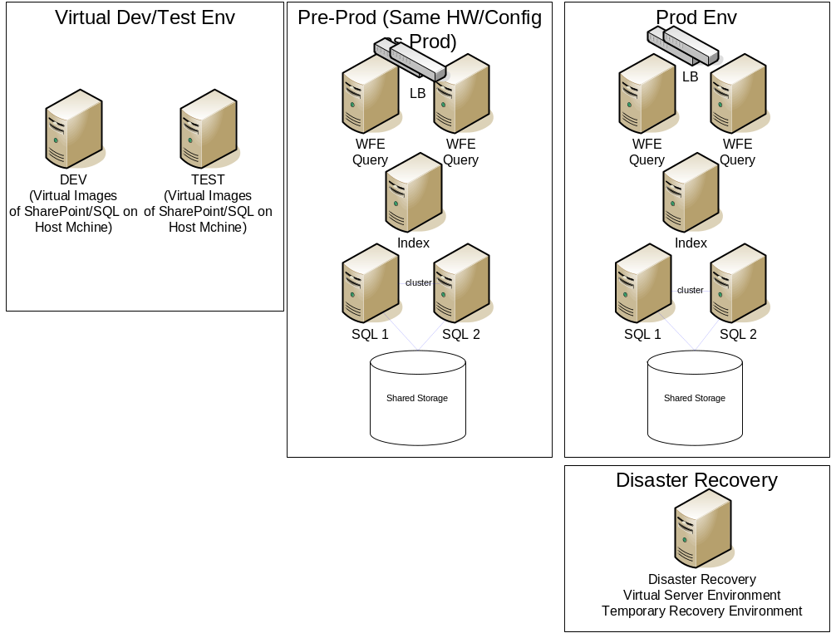
This equipment is subject to this governance plan except where existing IT governance policy dictates otherwise. In cases of discrepancy, the existing IT governance policy will prevail.
  - Recommended Global Deployment Approach
Centralized or Regional deployment approach is to be determined based on performance testing by the engineering team. Current approach is detailed below, subject to change.
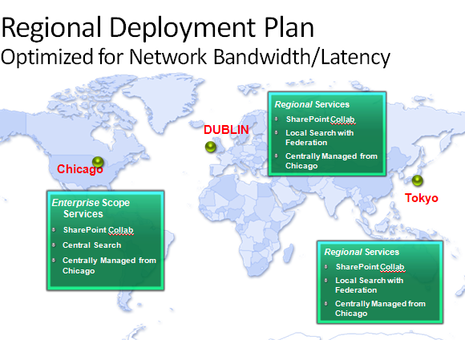
Americas
Chicago datacenter will provide SharePoint hosting of team sites, blogs, wikis, and project sites. Standardized Services provided for North and South America. (Examples: Corp forest, North American affiliates, Peruvian and Brazilian Plants)
Europe
Dublin datacenter will provide SharePoint hosting of team sites, blogs, wikis, and project sites. Standardized Services provided for Europe, Middle East, and Africa. (Examples: German and UK Offices, Spain Sales offices, and Middle East development offices)
Asia
Tokyo datacenter will provide SharePoint hosting of team sites, blogs, wikis, and project sites. Standardized Services provided for Asia, Pacific, Oceana and Australia. (Examples: Indian development centers, Chinese production, and Australian Sales offices.)
WAN acceleration devices will be provided in all Development centers. Small offices, consultants, and small sales offices should use Internet access to the secured internet facing site over SSL.
  - Management and Delegation

The SharePoint infrastructure environments will be managed via a top-down approach out of three geographically dispersed regions: North America, Europe, and Asia-Pacific. Environments to manage will be both IT infrastructure and operations. Regions are ultimately governed by the virtual team. Delegation of management happens at the site collection level to support a system of scale.

Existing Support Services which provide 24/7 will be trained and leveraged for global coverage with rollup at the tier 2 operations support team which is 9am-5pm and on call for outages.
  - Multilingual Considerations

Regional Deployment language considerations include:

In Scope: Language Packs of up to 10 additional languages per location with English provided as a default. Language packs to be provided will be determined by Regional Directors and Business affiliates.

Out of scope: Variations – from a supportability perspective, operations will support the language packs of one language per site collection.
- Development and Configuration Application Policies
  - Customization Policy
Service Definition as provided by the SharePoint Stakeholder Team
- Customization Policy – As is outlined in the section on SharePoint Designer, limited scope will be provided for designing a master page. Web Parts used by the business including those added by various site collection administrators should leverage default Web Parts. The content query Web Parts, dataview Web Parts, amongst others can be designed and created with special agreements with the development team. No Web Parts or solutions that require custom coding will be considered for any one site collection. If there is a Web Part which would benefit the service, the stakeholders will evaluate the business requirement and tradeoffs and determine if it would benefit the service without impacting the scale and risk to the service. Any deployment of a solution or assembly based Web Part would require a full review and full dev, test, production rollout sequence as well as maintenance paid for by that business.
- Support for customizations – Help desk will provide basic troubleshooting, but will not provide support for customizations to Web Parts or complex workflows. Issues determined as server side issues will be escalated to the operations team.
- Support and contact – All support issues should first seek help in the support and FAQ forums, and escalated to support when determined by the forum moderators.
- Third party solutions – No third-party software should be installed without the prior approval of the stakeholders and vetted through the change management processes.
- Design and Web Part Development requests that are approved should go to dev team, and server side development requires a .WSP for any and all assemblies and dependencies, exceptions will require engineering approval.
- A special service site with discussions, FAQs, and forums will be provided to address the most common issues and encourage community based support and available training.
  - Browser Standards and Permissions
- Browser standards – Internal Intranet and desktop standards are required for the SharePoint Collaboration service. (Currently Internet Explorer 7)
- Default permissions levels will be used to manage site collections. Inheritance is strongly encouraged for ease of management. When special permissions are required a second site or separate list should be created. Granular security on the item level should be avoided for support reasons. Rights should be managed with least privileged access in mind while sites designed with publishing broadly should leverage “authenticated users” to avoid adding large numbers of users difficult to maintain.
- Anonymous access on intranet collaboration is not allowed.
  - Site Provisioning and Templates
Policies
Site Collection Provisioning
Sites should target a specific audience
Employees will be able to create their own My Site
- Default Templates: Team, Blog, Wiki, including others to be determined
Sites will be created with templates appropriate for their business purpose.
Sites are based on templates that are centrally designed.
The assigned business site administrator is responsible for assigning further access to new sites.
Sites will adhere to the following standards:
- Site owner must be displayed in the top-right corner of each site.
- Fabrikam template with standardized masterpage to be used for all top level sites.
- Sub-sites list for immediate (single level) child sub-sites to be displayed under site owner.
Sites requests will list the following as required information:

Purpose
- What is the intention of the site to be created?
- Will it be a Departmental, Project, or Community site?

Value
- How will this site benefit Employees or the business?

Audience
- Who will need access to the site and use the site?

Site Owner
- Who is the person ultimately responsible for the site? This is the Primary Contact.

Site Administrator
- Who will administer and maintain the site? This is the Secondary Contact.

Features
- What are the features needed on the site?
- Document Storage, Newsletter, Calendar, Team Collaboration, and so on.
Site URLs will be short and concise in addressing both the needs of the team while keeping the number of characters under 8 characters per site including not using spaces in the URL.
  - Site Management Storage and Life Cycle Policies
Site Management
Site auto expiration: To ensure stale sites are removed and data storage is reclaimed, site collections untouched for 90 days will be sent notification for archive for automatic deletion. Site Collection owners will be notified if their site is slated for deletion and provided with a mechanism to remove it from the automatic deletion list.
Ignoring the mails will archive the site and result in it being backed up after 90 and then deleted after another 90 days.
User Access
All SharePoint Administrators must review the training materials and complete a skills assessment prior to becoming an Administrator.
Development
There are business-assigned developers. For any development work, contact your business developer.
Custom development needs to be first scoped by the developer and then approved by Portal Administrators. This includes any development under Windows Workflow Foundation.
No Web development tools other than those provided by SharePoint Server for development of the SharePoint user interface (no SharePoint Designer, also known as FrontPage, no Visual Studio, no Cold Fusion, and so on). These tools are permissible only for the development of custom Web applications outside of SharePoint deployments. These applications are considered external to SharePoint deployments.
Fabrikam Employees must develop Web sites in compliance with Intranet design standards and laws concerning copyrights, proprietary names and trademarks.
Storage Quotas
By default SharePoint Server imposes a 50MB limit on the size of a single document that can be uploaded into a document library.
- 1 GB of storage is allotted for each user’s My Site.
- 15 GB of storage is allotted for all Collaboration MAX Sites for shared databases.
- 5 GB is default quota (to reduce support calls there are 3 levels... 5, 10, 15. At 15GB if business justification is provided the site collection is put in its own database with MAX capacity of 100GB NO exceptions. (Configured on the database limits as well as in SharePoint Server.)
- Team Site administrators receive alerts when storage is at 90% of quota.
- SharePoint administrators can override storage quota for Site Collections if necessary.
Document Settings
Documents used only by a particular location, or with minimal sharing, should be stored at that site, typically on that site’s WSS server.
Documents shared across multiple divisions should be stored on the Portal
Allowed file types: Default
Prohibited file types: Default MINUS: .URL, .LNK PLUS: default mp3
Information retention: max 1 year tape retention (1 tape per month for offsite storage in Iron Mountain or equivalent)

Information Policy: Business Critical Only (Data retention of 1 year max)
- No HIGHLY Sensitive data or data requiring legal holds
- No Finance Data
- No HR Policy data
Procedures
Service Site
- Training
- Fill out the requested information on this site
How to Obtain Support
- Contact the site owner listed on the site.
- Contact your local System Administrator unless a SharePoint Support Representative has been designated for your location. In that case, contact your local SharePoint Support Representative.
- Contact a member of your business unit’s volunteer Support Team. Members are listed on the SharePoint Governance site.
- Contact the Portal Administrator for your region (North America, Europe, and Asia-Pacific). Portal Administrators are listed on the SharePoint Governance site.
- Contact the Help Desk.
Requesting a New Site (Site provisioning)
  - Business owner fills out requirements on site request form.
    - Assign Site Owner and Site Administrator (self or direct report). May be same person.
    - Secondary owner
    - Storage requirement justification
  - Email is generated and sent to Business Owner that site is available.
  - Becoming a Site Collection Administrator

All SharePoint Site Collection Administrators must review the training materials and complete a skills assessment prior to becoming an Administrator.

Steps to becoming a SharePoint Administrator of your own site:
- View the SharePoint Site Collection Admin Training Guide from the Service site.
- Steps will be included to provision a new “sandbox” site that you can learn with.
- Read the entire Training Guide.
- Use your training site to complete the Skills assessment section at the end of the guide.
- Notify the support desk to take the evaluation test, which will provide the rights.
- Project and Operational Management
  - Communication Plan

Communication to the business regarding this Governance Plan will be in the form of Web content on a site off the home page of the corporate portal site. There will be sections on the page for the following:
- Hierarchy of Governance (Summary)
- Team roles and responsibilities
- Strategy Team
- Tactical Operations Team
- Tactical Support Team
- Tactical Development Team
- Individual roles and responsibilities
- IT roles
- SharePoint roles
- Business roles
- Current membership of above teams
- How to get involved and become a member of above teams
- Hardware equipment hosting the SharePoint environments (IT access only)
- How to obtain support, by location
- SharePoint Business Review Meetings
  - Service, Operations, and Change Advisory Meetings
While individual teams should meet on a more frequent basis, the following meetings should be set up and recur to address the various matters which occur for the service.
Change Control Board – Weekly Standing meeting to review service change requests held when there are any pending change requests.
Operational Review – Performance and metrics review against service level agreements. Held monthly and ran by the operations manager with representation from project management. All tiers of the operations teams from Tier 1 support, Ops, and Engineering should be represented.
Service Review – Business requirements are reviewed to evaluate adoption and to ensure the various service goals are being met. In the beginning these service reviews may be monthly and move out to quarterly based on the needs of the stakeholders.

Communication to the governance teams regarding this Governance Plan or any governance activities or issues will be in the following forms:
- Quarterly Review through scheduled meetings and impromptu conference calls.
- Impromptu communications via e-mail.
- Education and Training Plan
  - Administrator, Developer and End User Training

For any new system, a solid training plan is required if users are going to adopt the new system and use it effectively in their daily activities. Training Requirements are listed below.
Training
All users of the system will receive multiple options for training including computer-based training, step-by-step walkthroughs, and one-day corporate learning classroom instruction.
Business Owners need education of the product including capabilities.
Site Owners need advanced training, including office integration and Security Policies.
End Users need usage overview training.
Help Desk personnel require intense training and troubleshooting analysis. Tier two or tier three support should be considered for official, externally-provided training.
Training approach should begin by covering elementary tasks and progress to more difficult tasks, culminating in administrator level tasks and administrator “certification”.
Training tools may include:
- “How to” documentation (such as what exists today)
- Instructor-led training hosted by the Portal Administrator or other competent individuals
- Online labs hosted on a sandbox environment
Training will initially consist of online reference materials for both typical end users (addressing “How To” information) and system administrators (addressing more technical issues such as WSS deployment “best practices”).
All core SharePoint Developers and core SharePoint Admins will attend a one week SharePoint Server course. (SharePoint MVP instructors strongly encouraged.) Those attending training must take the certification exams within 3 months following the course.
Refer to the Fabrikam SharePoint Training Plan for an overview of this training.
  - Key Deployment Resources

Sample Project Plan

Deployment Project Plan Sample (Project 2003 format, Project 2007 format)

Governance Template

http://go.microsoft.com/fwlink/?LinkId=92333

Governance Checklist

http://go.microsoft.com/fwlink/?LinkId=108286

Governance CodePlex applications

http://go.microsoft.com/fwlink/?LinkID=114564

SharePoint Learning Kit

http://go.microsoft.com/fwlink/?LinkID=146149
- Stakeholder Signoff and Commitment
Signoff
Chief Information Officer | Date
Signoff
Collaboration Service Manager | Date
Signoff
Operations Manager | Date
Signoff
Customer Support Director | Date
- Appendix Key Terms and Definitions
  - IT Governance Definitions
Governance Plan – a dynamic service definition setup to mitigate business and IT conflict and provided by established resources and stakeholders, consistent processes, and IT policies.
Service – The Standardized IT Offering
Service Definition – Description of the deployment to be delivered in a consistent and standardized way. It describes the offering by which the business can consume the delivery. The definition can change over time through a change management process as determined by the change advisory board.
Change Management – As business and IT requirements change a process will be established to review these changes to implement them both for the service definition and the physical deployment. Rolling out service packs and hotfixes are an example of the physical deployment change. Changing the storage size for quota is an example of a change to the service definition.
Information – documents, calendars, tasks, and string of characters
Stakeholder – While there may be a virtual team designed around the delivery of the service, the stakeholders are those in the business and in IT that have a vested ownership in the success of the service. The key stakeholder may be the HR or Communications Director or the CIO. Stakeholders from IT may be the Service Owner (Collaboration or Web Infrastructure or IT Ops Manager), the Lead SharePoint Architect.
Policies – rules and guidelines enforced to provide consistency and standardization to both business and IT services
Virtual team – The service delivery team and stakeholders involved in the virtual team are made up of representatives to build a team which provides the service and meets to help move it forward and assist in both the delivery and definition.
  - Understanding the Containment Hierarchy
The SharePoint hierarchy is a key piece of all SharePoint information architecture plans. The hierarchy affects performance, extensibility, and information storage.
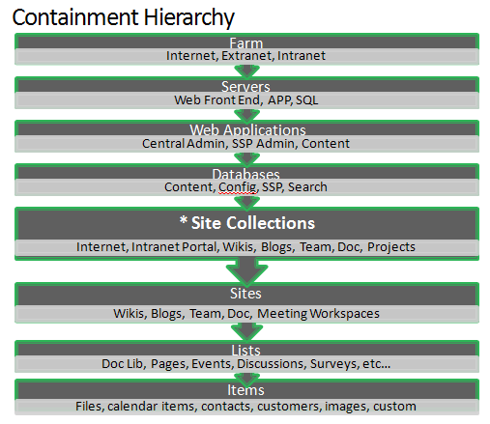
  - Understanding SharePoint Service Provisioning
Farm – collection of servers that act together to provide a set of Web applications. The farm is most easily defined by the configuration database which defines the server member and roles of the farm as well as database servers used for storage.
Web application – In a SharePoint deployment contains IIS Web Sites previously known as IIS Virtual Servers that have been extended with SharePoint Server and have been set up to use the .NET assemblies to provide the SharePoint Application. There are content Web applications, and administration Web applications for both the central admin and the SSP admin. Web applications are known for their ability to isolate content in separate memory space with application pools which contain worker processes. In a collaboration service the Web application provides the container for the site collections in the farm.
Site Collection – A site collection is the most scalable unit in a SharePoint deployment and is a container for sites. The special properties of the site collection are the ability to have a quota, contain a global navigation, masterpage, and various galleries provided across the sites below it, and the ability to contain ownership. Considered the most scalable object in a deployment and the easiest to manage for its ability to be backed up and moved full fidelity across databases.
Site – a container of multiple lists which can inherit security, and leverage the galleries of the site collection above it. Primarily usage in a collaboration environment is for delegation of projects or to divide up content for easy navigation.
Portal – A special site template designed to host many sites below it. Common properties include special page galleries for Internet, or site directory on an Intranet portal. Another term might be hub based on navigation and a common place to go where you don’t know where to look for something. It’s the top of the breadcrumb navigation.
  - Understanding More SharePoint Key Service Terms
Quota – The SharePoint Server feature of Quota allows for a notification level and a maximum level. The notification advises the owners that the site is nearing the maximum quota and the site should be “cleaned up.” When the maximum quota is reached, the state of the site is read only and no further content can be added. When one quota is referred to, it is always the maximum quota.
Site Administrator – The manager of the permissions, providing delegation of rights and permissions levels
Site Owner – Specified during creation the primary and secondary owners provide the determination of the site. They receive both quota notification and expiration notifications for the site collection. It is common that site administrators and owners are the same individuals.
Microsoft Office SharePoint Designer / SharePoint Designer – Tool used to create master pages, create and manage workflows, and Web Part designer. A powerful tool for managing sites and its usage should be monitored.
WSS – Windows SharePoint Services provides the foundation of the collaboration platform with permissions levels and common templates.
MOSS – Office SharePoint Server provides application functionality on top of the base platform including auditing, expiration, common workflow templates, better master page galleries, and intranet and internet templates for quick deployment scenarios.
Master page – Controls the consistency and look and feel of a site or site collection.
Gallery – A special list or library containing Web Parts, master pages, and layouts.
Web Part – A snippet of code used for displaying lists, libraries, images, navigation or functional UI. Also used synonymously with widget, gadget, JQuery plugin.
List – A collection of items with rows and columns similar to a table. A list can contain documents, images, a user contact, a row of text, as well as business data.
Content type - Controls the aspect of what data can be added to a list and how that data is handled, but this document won’t provide the depth of the abilities of content types as this is primarily a collaboration environment with flexible content types to be delegated and managed by the site owner.

