HAD.PM 2
AstroWix Final 3
oliverlehmann.com 4
Preparepm.com-PMP 6
Oliver-175 Questions 8
edwel.com 11
PMBank 13
PMStudy 19

HAD.PM
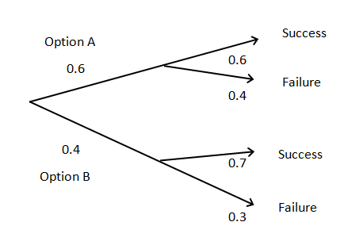
12. What is the probability that option B will be selected and will be successful?
A. 70%
B. 40%
C. 28%
D. 38%

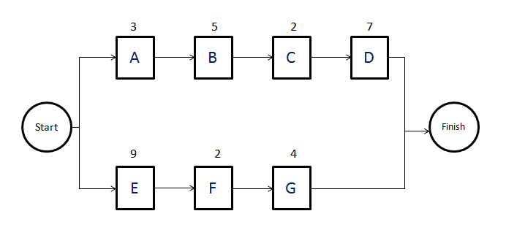
15. In the above diagram, which is the relationship between tasks B and C?
A. SS
B. SF
C. FF
D. FS

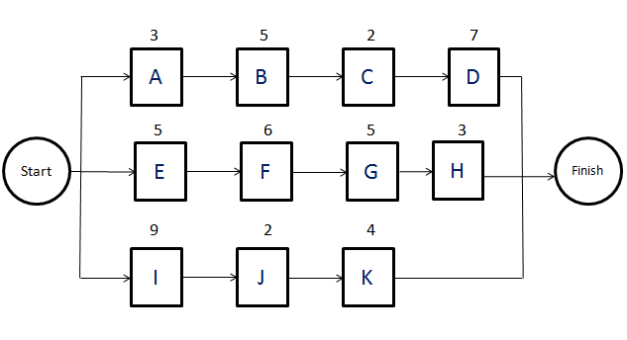
15. Which is the critical path?
A. IFGD
B. ABCD
C. EFGH
D. IJK

AstroWix Final
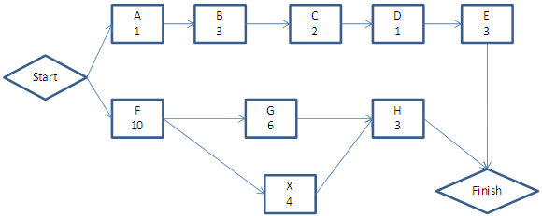
56 | You are a project manager of a project development project & the CCB approves to insert a new activity X with an estimated duration of days to the project as shown in the network. The free float & the total float of the activity X respectively are | B
A | 6.4
B | 2,2
C | 0,2
D | 2,0

oliverlehmann.com
Question 18
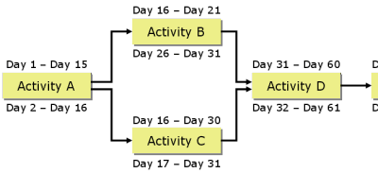
18. | In the following network logic diagram start dates are defined as early morning, finish dates are evening. If tasks are scheduled to begin at early start date, what is true?
A | Activity B has a free float of 10 d.
B | Activity B has a total float of 10 d.
C | Activity A has a free float of 10 d.
D | Activity A has a total float of 10 d.

Question 27
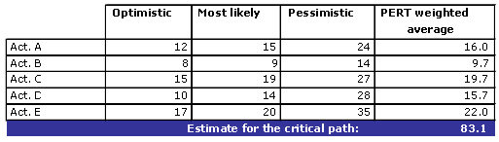
27. | A project manager made 3-point estimates on a critical path and found the following results: Assuming ±3 Sigma precision level for each estimate, what is the standard deviation of the allover path?
A | App. 4.2 days
B | App. 5.2 days
C | App. 6.2 days

Question 31
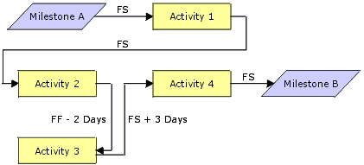
31. | Activity 1 has a duration of 20 days, Activity 2 of 10 days, Activity 3 of 5 days and Activity 4 of 6 days. What is the minimum total duration between the Milestones A and B?
A | 36 days
B | 37 days
C | 39 days
D | 42 days

Question 44
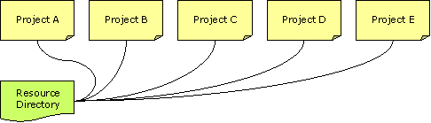
44. | In a software company a large number of simultaneously performed projects utilize the same groups of human and other resources. What is the term commonly used for this situation?
A | Concurrent engineering
B | Resource over-allocation
C | Resource pooling
D | Program management

Question 66
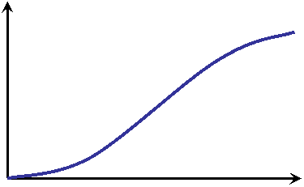
66. | What is the S-curve in project management?
A | A graph that is generated if a normal curve is integrated.
B | A graph that is to be integrated to generate a normal curve.
C | A metaphoric description of the short term uncertainties that are present in every project.
D | The graph that describes the typical growth of earned value during the course of the project.

Question 75
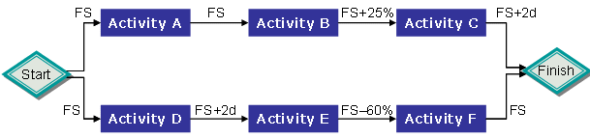
75. | You just created the following network logic diagram to describe the planned flow of activities for your project which will start tomorrow: Which potential inconsistency in the diagram should you solve right now?
A | Activity E is a logical dangle in relation to the sink before the finish milestone.
B | Activity F is a logical dangle in relation to the burst point after the start milestone.
C | You cannot calculate a critical path when lags and/or leads are calculated in percent.
D | Activities E to F need another task drawn as a hammock to calculate Level Of Effort.

Answers

18 | B
27 | C
31 | C
44 | D
66 | D
75 | A

Preparepm.com-PMP
- A Project Manager is using AOA to perform critical path analysis. The network diagram is represented as shown using below. Which of the following represents the path
Activity | Duration | Dependent on
A | 3 | none
C | 3 | none
B | 2 | A
D | 5 | C
E | 2 | none
F | 4 | E
G | 3 | D,F
H | 1 | D,F
I | 2 | B,G
R | 0 | H,I
  - ABIR
  - CDHR
  - CDGIR
  - EFGIR
Ans: 15 | c. | CDGIR represents the critical path. It is the longest path through the network with the duration of 13.

- For the sequence diagram in question 15, what is the float of activity B
  - 2
  - 3
  - 5
  - 6
Ans: 16 | d. | The path ABIR has duration of seven. Hence B can be delayed by six days before the next event can begin.

- For the sequence diagram in question 15, what is the float of activity H
  - 2
  - 3
  - 4
  - 6
Ans: 17 | c. | The path CDHR has duration of nine days. Hence H can be delayed by four days before the next event can begin.

- You are in the process of Source Selection for a contract for your project. You are planning to use weighing process for source selection. There are four vendors being considered. There are two deciding factors price (weightage 40), quality (weightage 60). The scores of four vendors that your team has computed are displayed in the table below. Which vendor will among these four should be chosen?
Vendor scores
 | Vendor 1 | Vendor 2 | Vendor 3 | Vendor 4
Price | 8 | 10 | 12 | 11
Quality | 12 | 10 | 8 | 11
  - Vendor 1
  - Vendor 2
  - Vendor 3
  - Vendor 4

Ans: 57 | d. | We need to compute the following for all the vendors - (0.4*Price + 0.6*Quality). The scores come out to be vendor 1 - 10.4, vendor 2 - 10, vendor 3 - 9.6, and vendor 4's 11. Since vendor 4 has the highest score, it should get selected.

Oliver-175 Questions
Ques- 59 | You recently assigned staff members to activities, estimated work and scheduled your project. You then created the following resource histogram for your staff: What does this diagram tell you? 59
A | The project can probably not be finished as scheduled.
B | You may be able to finish the project early by reassigning work.
C | You should avoid network logic diagramming for scheduling.
D | You may run into problems with dual reporting relationships.

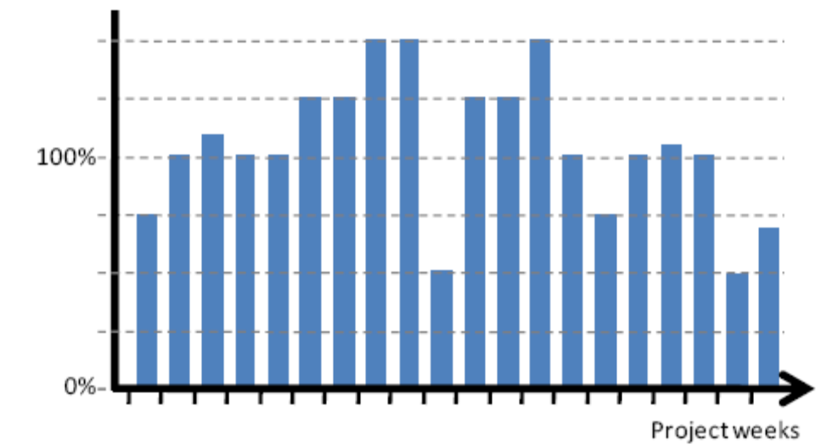

Ques-73 | During project planning, you are presented with the following diagram that depicts a cumulative likelihood distribution for the duration of a project: What kind of conclusion can you draw from the information depicted in it? 73
A | The likeliness that the project will finish exactly at the date marked with ―Deadline‖ is 80%.
B | The likeliness that the project team will exceed the date marked with ―Deadline‖ is at 80%.
C | If the project team will meet the deadline, project costs will be 80% of the budgeted costs.
D | The likeliness that the project team will meet the deadline or will finish earlier is at 80%.

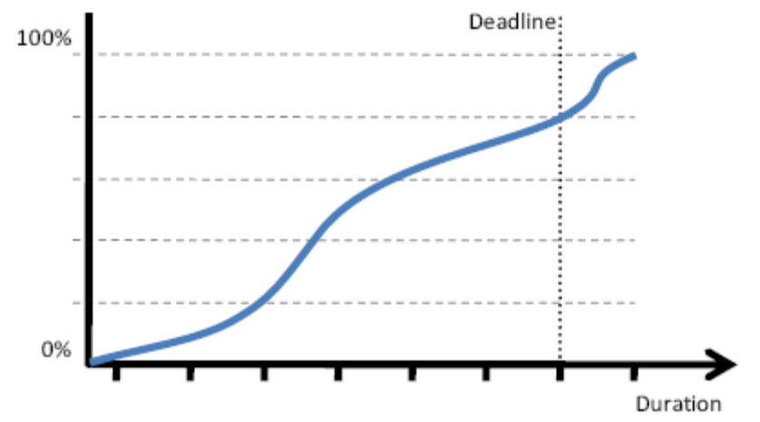

Ques: 96 | What is the purpose of the following diagram?
A | Describing the influence of extreme weather conditions on progress and on the achievement of project objectives.
B | Comparing the relative importance of variables that have a high degree of uncertainty with those that are more stable.
C | Evaluating team performance and identifying team members with low productivity and work effectiveness.
D | Evaluating the degree to which project work and deliverables conform to the expectations of key stakeholders.

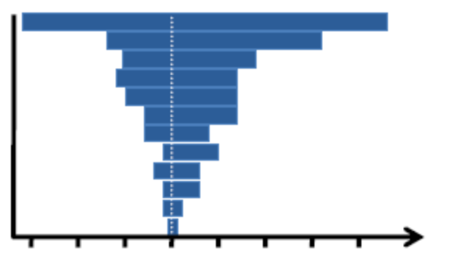

Ques-164 | Which technique has been applied to develop the following diagram?
A | Decision tree
B | P/I matrix
C | Strategic scoring
D | Risk breakdown structure

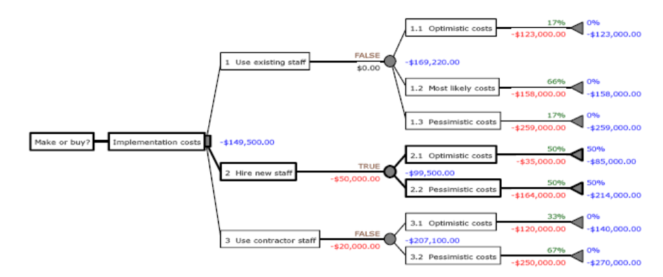

Ques-173 | What is wrong in this diagram?
A | The data date must be accurately between weeks.
B | AC cannot be higher than PV when EV is lower.
C | EV cannot be assessed beyond the data date.
D | PV cannot be assessed beyond the data date.

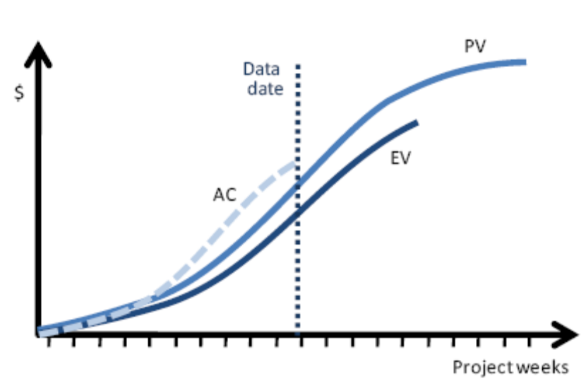
Answers
59 | 1 | PMBOK® Guide® 4th Edition, page 224. | Planning
63 | 3 | PMBOK® Guide® 4th Edition, pages 181-187. | Monitoring and controlling
73 | 4 | PMBOK® Guide® 4th Edition, page 301. | Planning
96 | B | PMBOK® Guide® 4th Edition, page 298 (―Sensitivity analysis‖, last sentence explaining the purpose of a tornado diagram) | Planning
164 | A |  | Planning
173 | 3 |  | Monitoring and controlling

edwel.com

24. Create the Network Diagram using the enclosed grid. All times in weeks. What is the critical path of the network described above? Text:
a. A-B-D-F-end
b. A-C-D-F-end
c. A-C-E-F-end
d. A-C-E-G-end
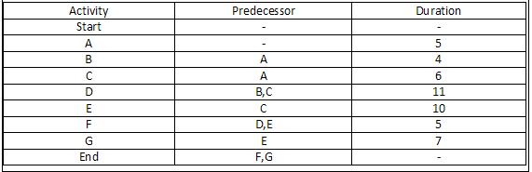

Answer:  d | A-C-E-G yields a critical path of 28

56. Create the Network Diagram using the enclosed grid. All times in weeks. The customer has demanded that you reduce the schedule by three weeks. What does this mean in terms of the Project schedule? Text:
a. You have decided that fast tracking is the best option to pull in the schedule by three weeks
b. You have decided that crashing the schedule is the best option to pull in the schedule by three weeks
c. Your project has negative float
d. You cannot deliver the project three weeks earlier without impacting project quality

Answer  c | Notice the question doesn't ask you what you will do about it – it simply asks you ‘what does this mean’? What it means is that your project now has a negative float of three weeks

79. Create the Network Diagram using the enclosed grid. All times in weeks. The customer has asked that you reduce activity D by 2 weeks. What impact does this have on the schedule? Text:
a. None. It is not on the critical path
b. It will reduce the schedule by two weeks
c. It will only work if you also reduce activity B by two weeks
d. It will only work if you also reduce activity F by two weeks

Answer: a | None. Activity ‘D’ is not on the critical path - shortening it will make no difference.

PMBank

 | The following should be used for questions 15 through 17.
 | A project manager is assigned to a project early in the project lifecycle. One of the things that must be done is to do a justification for the project. Since very little information is known about the project, the estimates are considered to be rough estimates. The following table is the project manager’s estimate of the cash flow that will take place over the next five years.
 | End of Year Cash Flow In Cash Flow Out
 | 1 0 500,000
 | 2 300,000 90,000
 | 3 400,000 100,000
 | 4 100,000 175,000
 | 5 50,000 35,000
15 | 15. What is the payback period for this project? | C | Three years
a | a. One year
b | b. Two years
c | c. Three years
d | d. Four years
16 | 16. What is the net cash flow at the end of five years? | B | ($50,000)
a | a. $50,000
b | b. - $50,000
c | c. $850,000
d | d. $100,000
17 | 17. If the net present value for each of the cash flows were calculated at a 10% interest rate, the net present value cash flow at the end of five years would be: | B | Less than the total cash flow without the net present value applied
a | a. Greater than the total cash flow without the net present value applied
b | b. Less than the total cash flow without the net present value applied
c | c. The same as the total cash flow without the net present value applied
d | d. Unable to be calculated with the information supplied

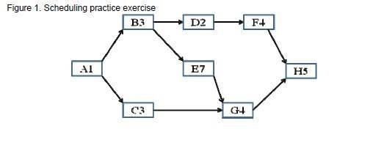
 | The following information and questions 42 through 51 refer to Figure 1
 | The project is a rush job, and the contractor has agreed to schedule the work on a single shift basis but will work seven days per week until the job is done. The project is to begin on May 1.
42 | What day in May will activity D have for its early finish date? | B | 6-May
a | May 13
b | May 6
c | May 7
d | May 5
43 | What is the free float for activity F? | B | 7
a | 6
b | 7
c | 0
d | 8
44 | What is the free float for activity D? | D | 0
a | 6
b | 7
c | 8
d | 0
45 | What is the critical path of the project? | A | A B E G H
a | A B E G H
b | A B D F H
c | A C G H
d | A B E D F H
46 | What is the late start for activity F? | C | 12-May
a | May 10
b | May 11
c | May 12
d | May 14
47 | How long is the project in days? | B | Twenty
a | Nineteen
b | Twenty
c | Twenty-one
d | Eighteen
48 | What is the early start for activity F? | C | 5-May
a | May 7
b | May 6
c | May 5
d | May 4
49 | If there is a delay in activity F of six days, what is the effect on the project completion date? | B | No change to project completion date
a | Increases one day
b | No change to project completion date
c | Increases two days
d | Increases three days
50 | What is the early finish date for activity A? | A | 1-May
a | May 1
b | May 2
c | May 3
d | May 4
51 | The above diagram is called: | C | Precedence diagram
a | Activity on arrow network diagram
b | Network diagram
c | Precedence diagram
d | Gantt chart

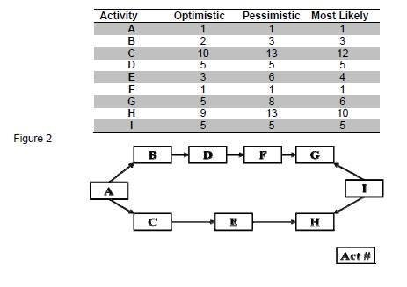
 | Questions 53 through 56 refer to the diagram in Figure 2 and the table that follows.
 | In a project to install concrete sewer lines there is a lot of uncertainty as to how long the durations should be for the tasks involved. The project manager has determined that the team will use the PERT technique to evaluate the project’s completion date. The diagram shows nine activities and the table shows the optimistic, pessimistic, and most likely estimates that the team has already made.
53 | What is the expected value of the number of days to complete the project? | C | 32.3
a | 47.3
b | 22.0
c | 32.3
d | 48
54 | It is desirable to make an estimate that has a greater than 95% chance of being correct. Which of the following ranges of time for the impletion of the project best describes this probability of being correct? | B | 34.28 to 30.39
a | 33.31 to 31.36
b | 34.28 to 30.39
c | 14.39 to 33.48
d | 35.25 to 29.42
55 | What is the expected value of the duration for activity B? | B | 2.8
a | 5.6
b | 2.8
c | 3.0
d | 2.6
56 | What is the standard deviation for the duration of activity B? | C | 0.166
a | 1.000
b | .133
c | .166
d | 1.413

81 | 81. Using the formula: Present value = S/(1+i)n where i is the interest rate in percentage, n isthe number of periods, and S is the starting amount, the following table is produced: | A | $3,122.60
 | Periods 10% 12% 14%
 | 1 0.909 0.893 0.877
 | 2 0.826 0.797 0.769
 | 3 0.751 0.712 0.675
 | 4 0.683 0.636 0.592
 | 5 0.621 0.597 0.519
 | Based on the table, what is the value of an annual income flow of $1,300 each year overthe next three years at 12%?
a | a. $3122.60
b | b. $3900.00
c | c. $3497.00
d | d. 36%

 | The following table and description refer to questions 83 through 89.
 | A project manager is using the earned value reporting method to manage his project. Thefollowing table shows the data collected to date. The plan is for the project to be complete aftereight weeks. The earned value report shows data collected for the first four weeks of the project.
 | The figure shown in the table are cumulative.
 | Week PV AC EV
 | 1 1,000 1,000 1,000
 | 2 3,000 2,000 2,500
 | 3 5,000 5,000 6,000
 | 4 7,000 9,000 7,000
 | 5 13,000
 | 6 17,000
 | 7 19,000
 | 8 20,000
83 | 83. What is the cost performance index for week 4? | B | 0.777
a | 1.000
b | 0.777
c | 1.286
d | 1.250
84 | 84. What is the schedule performance index for week 3? | A | 1.2
a | 1.200
b | 0.833
c | 1.000
d | 1.500
85 | 85. What is the BAC for the project during week 4? | D | 20,000
a | 7,000
b | 9,000
c | 5,000
d | 20,000
86 | 86. During week 5 it is found that some of the work that was reported complete in week 2was considered unacceptable. It will require $500 to fix the problem and make this workacceptable. The work is scheduled to be done in week 6. No other work is reported to becomplete during week 5. What is the EV for week 5? | B | 6,500
a | 7,000
b | 6,500
c | 9,000
d | 5,000
87 | 87. What is the cost variance for week 4? | B | -2,000
a | 0
b | -2,000
c | 2,000
d | 7,000
88 | 88. What is the schedule variance in week 2? | C | -500
a | 500
b | 1,000
c | -500
d | -1,000
89 | 89. What is the EAC at week 4? | C | 25,740
a | 20,000
b | 15,555
c | 25,740
d | 17,717

165 | A risk has four possible outcomes. Given the following information, what is the expected value of this risk? | D | ($7,000)
 | Probability Result of Risk
 | 0.4 -10,000
 | 0.3 -7,500
 | 0.2 -5,000
 | 0.1 +2,500
a | -$20,000
b | -$14,500
c | $7,000
d | -$7,000

204 | Refer to the table. What is the critical path? | D
A | Start A B C I Finish
B | Start A B H I Finish
C | Start D E H I Finish
D | Start F G I Finish
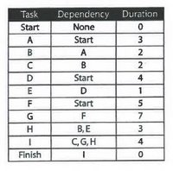

PMStudy

Question No :16
Selected Choice :

Top of Form
Please refer to the diagram given below (all units are in days):
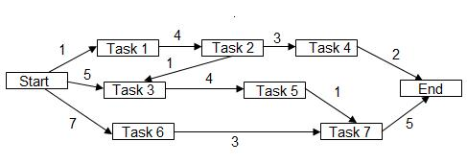
What is the project float if management wants to complete this project within 13 days?
 | 1  | 0 days
 | 2 | - 3 days
 | 3 | 2 days
 | 4 | Cannot be determined, because information given in the question is incomplete

 |  |  |  |  |  | 

 |  |  |  | 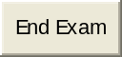

Ans:
Correct Choice : 2

Justification :

The possible paths are as follows:

Start -> Task1 -> Task2 -> Task4-> End: 10
Start -> Task3 -> Task5 -> Task7-> End: 15
Start -> Task6 -> Task7 -> End: 15
Start -> Task1 -> Task2 -> Task3 -> Task5 -> Task7 -> End: 16

The critical path is 16.

If the project has to be completed within 13 days, the project float is - 3 days (i.e., 13 - 16)

Please note: A project may have a negative project float. To deal with such conditions, if the project has to be completed on time, the project manager will have to either fast-track or crash the project schedule.

Question No :93
Selected Choice :

Top of Form
Please refer to the table given below:
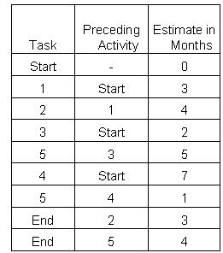
What is the slack of task 5?
 | 1 | 0
 | 2 | 1
 | 3 | 2
 | 4 | -1

Question No :129
Selected Choice :

Top of Form
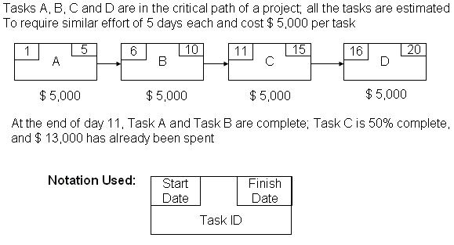
What is the status of the project?
 | 1 | Behind schedule, under budget
 | 2 | Ahead of schedule, under budget
 | 3 | Ahead of schedule, over budget
 | 4 | Behind schedule, over budget

Question No :197
Selected Choice :

Top of Form
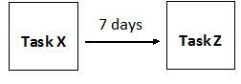
Please refer to the diagram above. Which of the following situations can this diagram represent?
 | 1 | Task X (actual work of writing) and Task Z (thinking about what to write) should be done in parallel.
 | 2 | Task Z (unit testing the code) should begin 7 days after finishing Task X (writing the code).
 | 3 | Task X and Task Z together have 7 days of slack.
 | 4 | Task Z (plastering the floor) should begin 7 days after beginning Task X (pouring concrete).

Ans: 4
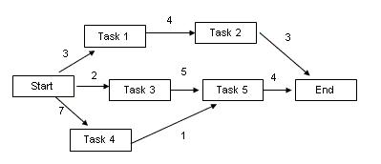
The lengths of different paths are:
Start -> 1 -> 2 -> End: 10
Start -> 3 -> 5 -> End: 11
Start -> 4 -> 5 -> End: 12
Since the longest path is Start -> 4 -> 5 -> End; this is the critical path.
Task 5 lies on the critical path; hence the slack for task 5 is "0".

Ans:
8 | A | 5 | Details | Parametric estimating uses a statistical relationship between historical data and other variables.
76 | D | 2 | Details | Change control meetings is a technique used in Perform Integrated Change Control process.  The activities performed during the Direct and Manage Project Execution process include but are not limited to manage sellers and suppliers, create project deliverables, implement the planned methods and standards, etc.
93 | A | 4 | Details
95 | C | 11 | Details | Option 3: Since the government is an external agency, and this is a "recently awarded" project as mentioned in the question, hence inputs(e.g. contract) from the government will help the project manager in creation of the project charter for the performing organization.  Option 1: Scope Baseline includes the Scope Statement, WBS and WBS Dictionary. So, this will be created later on after the project charter is finalized.  Option 2: Business Need/Business case for the project should be already established because the government has contracted out the work to your company.  Option 4: Project management plan is a planning document which will be created after the project charter is finalized.
129 | C | 5 | Details | Earned value (EV)  = The sum of the approved cost estimates for activities completed during a given period  = Estimated cost of work that is completed after day 11  = $ 5,000 + $ 5,000 + $5,000*.50 = $ 12,500 (because Task A, Task B are complete, Task C is 50% complete)  Present value(PV)  = Present work to be completed after day 11  = $ 5,000 + $ 5,000 + $ 5,000 * (1/5) (because at end of day 11, according to our plan, Task A, Task B should be complete; Task C only one day out of 5 days should be complete, i.e., 20% complete ($ 1,000 of work should be done)  = $ 11,000.  Actual cost (AC)  = Actual Cost of work completed  = $ 13,000.  Schedule variance (SV)  = EV - PV = $ 12,500 - $ 11,000 = $ 1,500  Since SV is positive, we are ahead of schedule.  Cost variance (CV)  = EV - AC = $ 12,500 - $ 13,000 = - $ 500  Since CV is negative, we are over budget.
197 | B | 4 | Details | This is used to depict a finish-to-start relationship where 7 days (positive value) means that there is a lag or waiting period. Only option 2 talks about a lag where, after completing Task X, we wait for 7 days before starting work on Task Z.  Please note:  Option 1 shows parallel relationship between the activities and not a lag  Option 3 shows slack and does not describe lag  Option 4 shows start-to-start relationship with a lag

