**Nomination Form for Region Best Practices Taskforce (RBPT) 2013**

(To be returned by March 10, 2013 in soft format to [tejas.sura@mentor.pmi.org](mailto:tejas.sura@mentor.pmi.org) with a copy to [reseena.abdullah@pmi.org](mailto:reseena.abdullah@pmi.org)**)**

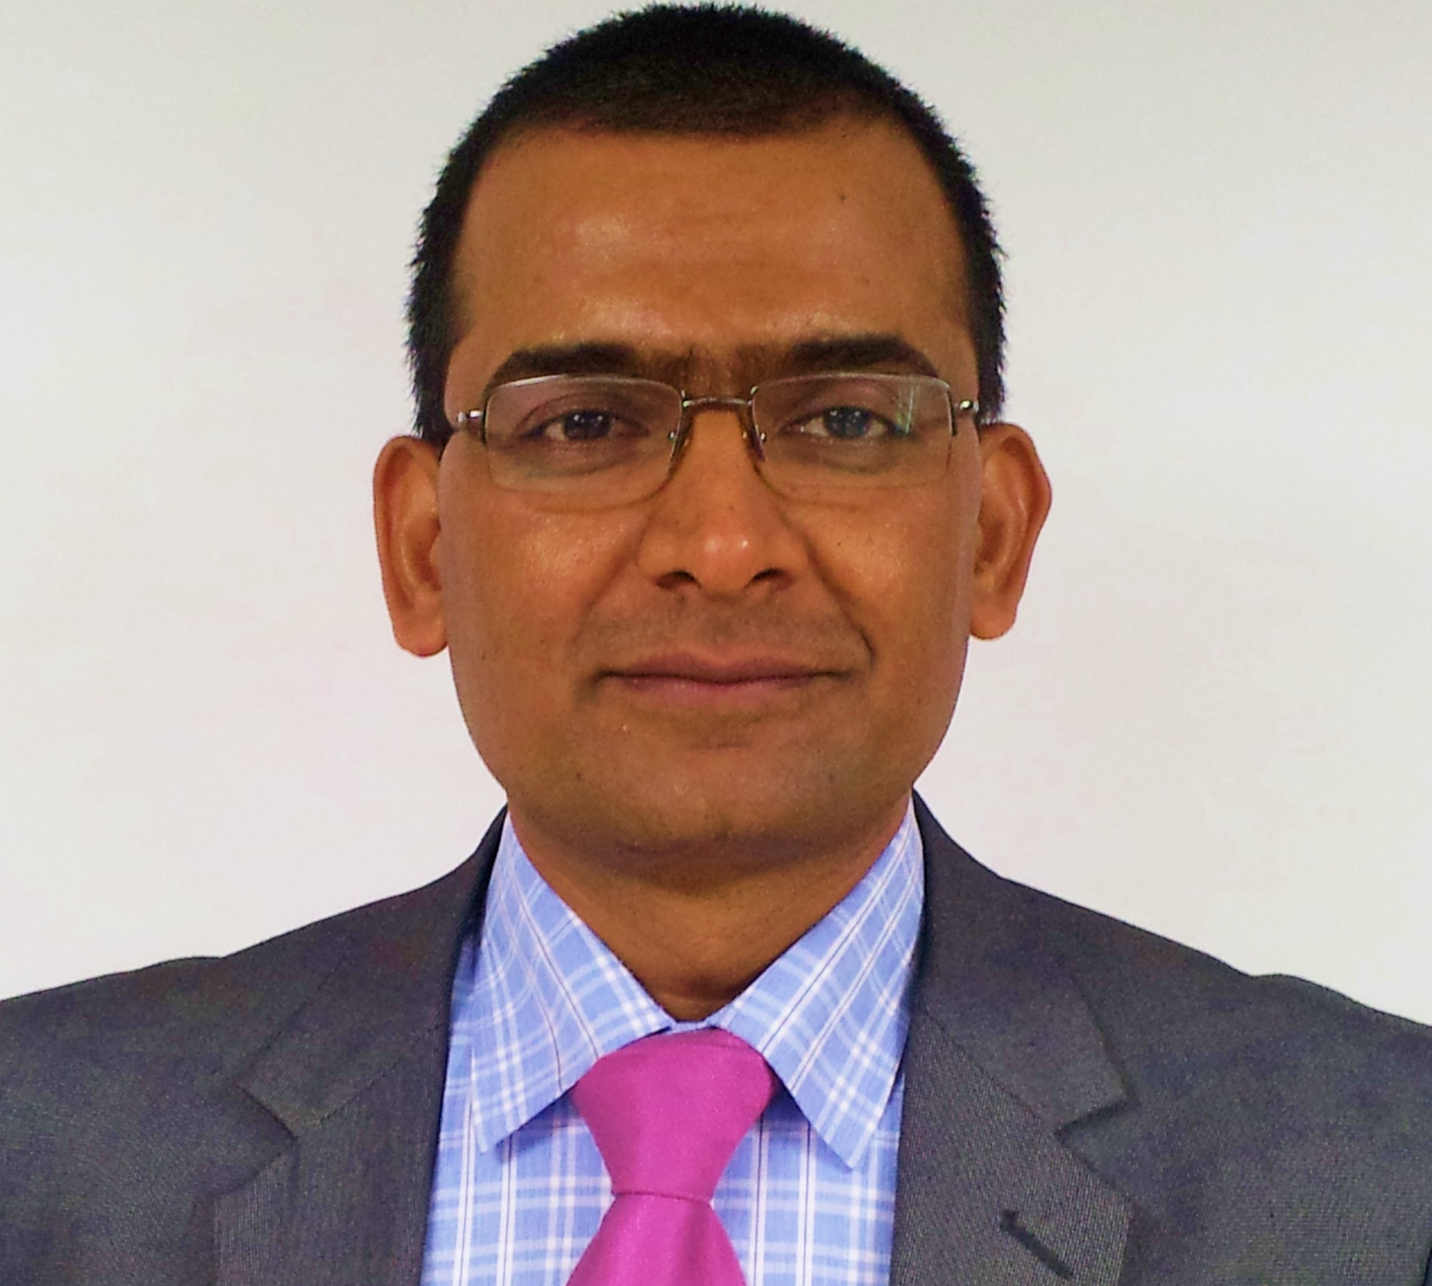

|  |  |  |  |  |  |  |
| --- | --- | --- | --- | --- | --- | --- |
| NAME OF REGION 11 CHAPTER NOMINATING | **PMI Mumbai Chapter** | | | | | |
| FULL LEGAL NAME OF NOMINEE: | **Hari Prasad Thapliyal** | | | | | |
| NOMINEE DETAILS:  PMI Membership No.:  Chapter Membership since when:  Valid Till:  (Should be a Past Board Member in good standing of Region 11 Chapter for at least one complete term as on March 10, 2013.) | **703218**  **2007** | | | | | |
| Name any Certifications from PMI  Certification No.:  Completed On:  Valid Until: | **PgMP** | **PMP**  #318050  6-Feb-06  6-Feb-16 | **CAPM** | **PMI SP** | **PMI RMP** | **PMI ACP**  #1563385  Dec-12  Dec-15 |
| Current Designation & Organization: | **Vedavit Project Solutions**  **PMO Evangelist & PM Trainer** | | | | | |
| Address for postal or courier Correspondence: | **C-1105, Purva Venezia, Yelhanka New Town, Bangalore- 560064** | | | | | |
| Telephone Numbers and Mobile numbers for correspondence: | **+91-9535999336** | | | | | |
| Preferred E-mail ID for Correspondence: | [**Hari.prasad@vedavit-ps.com**](mailto:Hari.prasad@vedavit-ps.com) | | | | | |
| Gender | **Male / Female- Male** | | | | | |
| Number of years of Project Management experience (provide details) | **15 Years.**   * Independent Project Management Trainer, Mentor, Coach, PMO Consultant & Evangelist empaneled with various REPs., Dec-2009 to Till Now * Aurovision Pvt Ltd (ISO 9001:2000), Mumbai, May 2006 to Jul 2009, AVP Delivery * Pyramid IT Consulting, Noida, India (CMMI4), May 2005 to May 2006, Project Manager * Cache Computer Systems, New Delhi, Apr 2002 to Apr 2005, Project Manager * AMSYS Infotech, Noida, India (ISO9001, CMM), Feb 2001 to Oct 2001, Project Manager/Lead * Hi-Fi Tradecom (P) Ltd., Calcutta, India, Feb 1999 to Feb 2001,Project Manager | | | | | |
| Industry Vertical | **BFSI, Cargo, NGO, Education** | | | | | |
| Positions held in Region 11 Chapter with period | VP Volunteer Development 2009-2010 (Mumbai)  VP Volunteer Development 2010-2011 (Chennai) | | | | | |
| Any other relevant details or interest areas: | Any work related to content development, communication, connecting to people, evangelizing project management. | | | | | |
| Brief Profile: (Not exceeding 250 words.) | MCA, MBA (Operations), PGDFM, PMP, MCITP, PMI-ACP, Prince2 Practitioner, CSM with 2 decades of experience in IT Delivery, Training, Consulting, Agile/Scrum. 14+ years in senior IT delivery positions, 4 years as Project Management Trainer/Coach/Mentor.  Trainer for PMP®, CAPM®, Microsoft Project® 2007 & 2010, PMI-ACP®, Enterprise Microsoft Project Server® 2007 & 2010, AgileEVM, Earn Value Management, Function Point Estimation (FPA), Project Risk Management, Project Schedule Management | | | | | |
| **SIGNATURE OF PRESIDENT OF REGION 11 CHAPTER CONFIRMING NOMINATION OF ABOVE CANDIDATE** | **SIGNATURE OF NOMINEE**  Please sign below to indicate “I Read, Understood and AGREE to be included in RBPT.  Hari Prasad Thapliyal | | | | | |