
Guide to MS Project Schedule Updating

INSERT THE AIRLINE LOGO HERE AND DELETE THIS TEXT BOX


REFERENCE

March 2012

© 2026, Sabre Inc. All rights reserved.
This documentation is the confidential and proprietary intellectual property of Sabre Inc. Any unauthorized use, reproduction, preparation of derivative works, performance, or display of this document, or software represented by this document, without the express written permission of Sabre Inc. is strictly prohibited.
Sabre and the Sabre logo design are trademarks and/or service marks of an affiliate of Sabre Inc. All other trademarks, service marks, and trade names are owned by their respective companies.

Table of Contents
- General Information 4
Purpose 4
- MS Project fields used for tracking 5
Duration (Number 1) 5
Expected Hours (Number 3) 5
Deviation Switch (Number 4) 5
% Deviation (Number 6) 6
Expected % Complete (Text 1) 6
Project Status (Text 11) 7
Overdue Flag (Text 12) 7
Red Report Fields 8
Reporting / Statistical Data 8
- Creating the Program Schedule 10
Importing the Project Schedules 10
Creating Inter-Project Dependencies 10
- Schedule Updating and Reporting 13
Timeline 13
Creating the Red Report 13
Creating the Critical Path Report 15
Creating the Program Statistics 15
Pivot Table 1: Work Stream/ Project Status 15
Pivot Table 2: Work Stream/ Project Status on Critical Path 16
Statistics 16

Purpose

General Information
1
This document is intended for use by Sabre Program and Project Managers (PMs). It is intended as a guide to assist the PMs in updating their Microsoft Project (MS Project) Schedules. Using the guidelines will:
- Ensure consistency across the Program
- Facilitate Program level tracking and reporting.

The following custom fields are required to be used in all MS Project schedules which are created for the purpose of tracking Sabre Programs. The fields are described below in this section. If a baseline has not been created, but a report is needed, remove the term “Baseline” in the formulas.

MS Project fields used for tracking
2

Duration (Number 1)
Shows duration in hours. Assumes that there will be a standard 8 hours of work done on the task with only 1 resource and that work is spread evenly over the task. Used for calculation purposes only. Use ‘Sum’ for summary tasks.

IIf([Baseline Duration]=0,1,[Baseline Duration]*8)

Expected Hours (Number 3)
Contains the value 0 if the start date is in the future, the value 1 if task is a milestone OR the finish date is in the past and the number of hours we should have completed by the status date for all other tasks. Use ‘Sum’ for summary tasks.

IIf([Baseline Start]>[Status Date],0,
IIf([Baseline Start]=[Baseline Finish] Or [Finish]<[Status Date],1,
ProjDateDiff([Baseline Start],[Status Date],"Standard") / ProjDateDiff([Baseline Start],[Baseline Finish],"Standard")))* [Number1]

Deviation Switch (Number 4)
Assigns the value of 1 if the % deviation is greater than or equal to 10 (RED), assigns the value of 0 if the % deviation is greater than or equal to 5 but less than 10 (YELLOW) and assigns the value of -1 if the % deviation is less than 5. Use Formula for summary tasks.

IIf([Number6]>=10,1, IIf([Number6]>=5,0,-1))

% Deviation (Number 6)
% Delay i.e. Expected % Complete – actual % Complete. Use 100% for Expected % Complete if the expected completion date on a task is in the past. Use Formula for summary tasks.

IIf([Baseline Duration]>0 And [Baseline Finish]<[Status Date],100-[% Complete],int([Number3]/[Number1]*100)-[% Complete])

Expected % Complete (Text 1)
Displays the expected % complete.

IIf([Baseline Duration]>0 And [Baseline Finish]<[Status Date],"100%",int([Number3]/[Number1]*100) & "%")

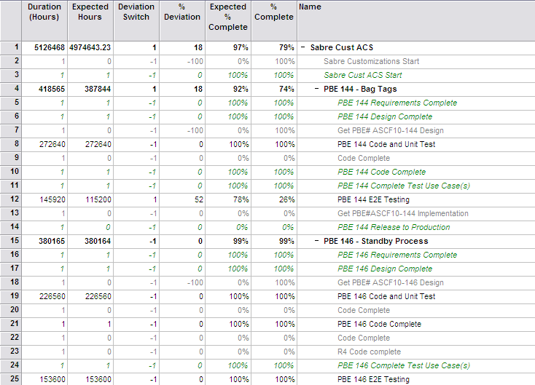

Project Status (Text 11)
Displays the project status indicators.

Switch(
[% Complete]=100,"Complete",
([Baseline Start]=ProjDateValue("NA")) Or ([Baseline Finish]=ProjDateValue("NA")),"No BL",
[Number4]=-1,"Green",
([Number4]=0),"Yellow",
[Number4]=1,"Red")

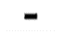
Complete
No Baseline
Green: On time or starts in future
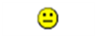
Yellow: Delay 5% up to 10% (based on task duration)
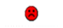
Red: 10% or greater delay (based on task duration)

Overdue Flag (Text 12)
Overdue Indicator

IIf([% Complete]<100 And [Baseline Finish]<=[Status Date],"Overdue","")

Overdue

Red Report Fields
The following fields are populated by the PM or the PMO when a task has a Red or Overdue status.
Project Manager (Text 16): The Project Manager responsible for a particular task. It allows the PM to filter the Red Report to look for their tasks.
Red/Overdue Reason (Text 13): The reason the task is late – an explanation to everyone on the program. An example could be that the date has changed and a CR is in process to move the date. Another reason could be lack of resources.
Action Planned/Required (Text 14): What action will be taken or is needed by others to move this task forward and get the project back on track. Examples of this could be a CR is in process to move the date or we are acquiring additional resources to accommodate the work.
Red Action Due Date (Text 17): Date by when the action planned/required is to be implemented.
Red Action Risk if not complete (Text 18): What is the risk to the project if the action is not accomplished on or before the due date?
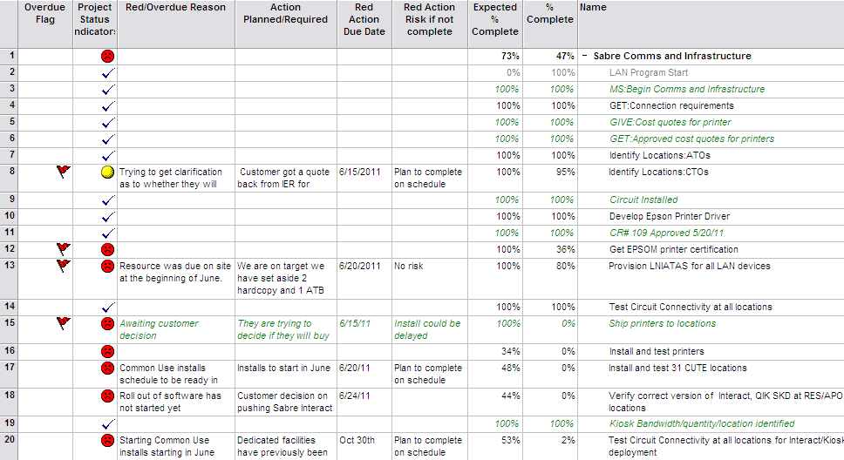

Reporting / Statistical Data
Work Stream (Text 15): Contains the Work Stream the task is in. Sabre projects should be prefaced with “Sabre – “ and Customer projects should be prefaced with the customer identifier, i.e. “AR – “ Note: when Sabre and Customer tasks are in the same file, ensure customer tasks are prefaced with the Customer code.
Sub Program Name (Text 7): Contains the Sub-Program name.
Life Cycle (Text 19): Contains the Life Cycle the task is in.

Importing the Project Schedules

Creating the Program Schedule
3
All schedules in a program need to be incorporated into an overall program schedule. The program schedule will include all the work streams within Sabre and the customer organizations. This will allow for a comprehensive view of the timeline at a program level.
- Move all the schedules to be included in the program schedule into the folder you are going to be updating from each time.
- In the Program Schedule, insert all the sub-schedules in the order you want to show them in the Program schedule. To insert a schedule, select Insert->Project – and select the location and name of the project you are inserting.
- Continue repeating the above step until you have inserted all the projects.

Creating Inter-Project Dependencies
To create a meaningful critical path, the dependencies between the various projects in the program must be identified. Setting up an inter-project dependency is similar to the way a dependency within a single project is created, but the full file path to the other file is captured. In the example below, the Cutover Readiness task “Sabre Data Migration Complete” is dependent on the completion of the Data Migration work stream.
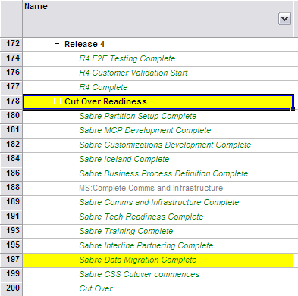

- In the Data Migration schedule, find the line number of the predecessor milestone.
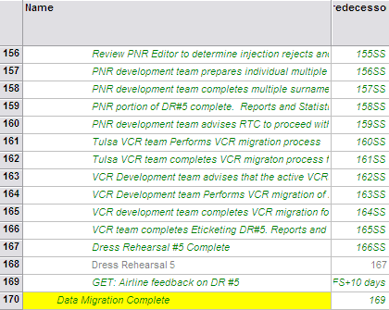

- Double click on the Cutover Readiness task “Sabre Data Migration Complete” and go to the ‘Predecessors’ tab. In the “ID” field, type in the path, schedule name, and the task/milestone ID of the predecessor.
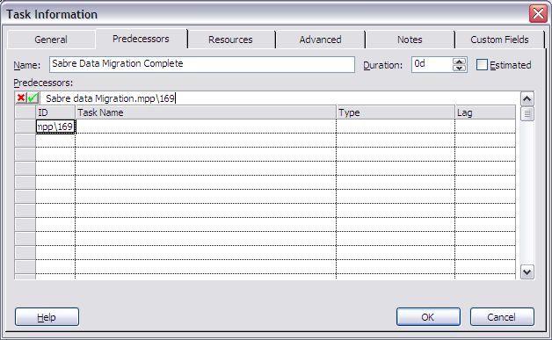

- You will see the following screen:

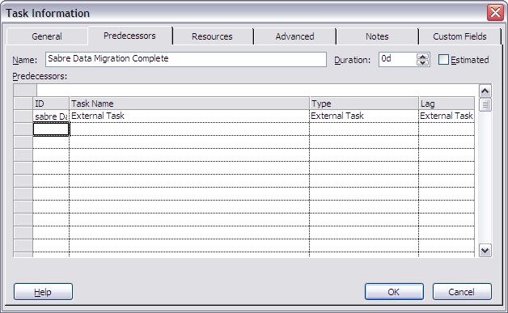
- Hit OK and the dependency will be updated. Double click again and you will be able to see the predecessor as follows:
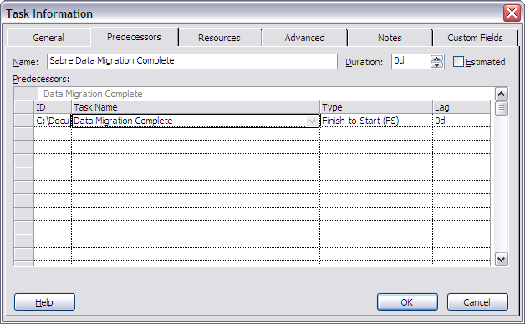
- You can also see all external dependencies in any schedule by going to the menu and selecting Tools->Links Between Projects.

Timeline

Schedule Updating and Reporting
4
The schedules are updated weekly or bi-weekly depending on the choice of the project/program. The following is an example of a schedule update timeline which will vary for each program depending on the size and reporting period:
- Friday Noon: All schedules updated by owners.
  - Add percent complete to all applicable tasks/milestones
  - Update overdue task information (Overdue Reason, Action Planned, Action Due Date, Action Risk if not complete)
- Friday PM:
  - PMO: Check out the schedules from SharePoint and copy/paste them from the “SharePoint Drafts” folder into the folder with the program schedule on your hard drive. QC project schedules for completeness. Follow up as necessary and make any updates.
- Monday PM:
  - PMO: Create Core Team deck statistics and update deck.
  - PMO: Copy project plans from “working” folder to “SharePoint Drafts” folder.
  - PMO: Update the Status Date (Project->Project Information) with the next status date – in this case, the following or second Friday from today.
  - Check plans back in to SharePoint.
  - Zip current week’s .mpp files, Red Report, and Integrated Program Plan. Load copy to SharePoint.
- Tuesday: Leadership review Red milestones/projects explanations. This step may be at the weekly / bi-weekly status meeting instead of a unique meeting. This will depend on the size and complexity of the Program.

Creating the Red Report
The Red Report is created by doing an export from the Program schedule to an Excel file.
NOTE: (These two steps only need to be completed on your first Red Report.)
- Copy the Airline Project Status map into your MPP Global. (Tools / Organizer / Maps tab / click on the “Airline Project Status” map, and click Copy. Close the Organizer dialogue box.)
- Validate the following security setting in Excel. Tools / Options / Security tab / In last group of settings…..Legacy Formats, Select the bottom option to “ALLOW loading files with legacy or non default file options.” / Cick OK. If not selected, you will get the following error message when saving from mpp to Excel, “You are trying to save a file saved in an older file format. Your settings do not allow you to save the file in older file formats. To change your setting, navigate to the “Security” tab in the Options dialog box”.
- Expand all the tasks in the schedule so that all individual tasks are showing (i.e. no ‘+’ signs in the entire schedule).
- Edit Text 11 in all non-US .mpp plans to show “N/A” in the formula for Project Status (Text 11).
- Select File->Save As. Change the file type to Microsoft Excel Workbook (*.xls), choose folder, edit file name. Click Save. This will be your source file.
- The Project Export Wizard will begin. Click Next.
- Choose ‘Selected Data’ and click Next.
- Choose ‘Use Existing Map’ and click Next.
- Choose ‘Airline Project Status’ from the list that pops up. Click Next.
- The following boxes are checked on the next page: ‘Tasks’ and ‘Export Includes Headers’. Click Next.
- On the Task Mapping page you should not have to change anything but here is where you can change the fields you want to export to the Excel file if necessary. If you change anything and want it saved to the map, click Next, otherwise click Finish.
- Open the Excel file you just created (source file). It will be in the same folder as your Program schedule and have the same name, unless you changed the folder and/or name in the step above.
- Validate there are not any Expected % Complete greater than 100%. If so, change to 100%.
- Format date columns (H:M) as 01-May-11. Save file.
- Open current Statistics file (or SAMPLE Program Schedule Stats file if this is your first red report). Clear contents on tabs: Task_Table1, Overdue Red Report, and Critical Path.
- Copy the contents of the source file to the Statistics spreadsheet (tab Task_Table1).
- To create the Red Report you will filter on the following fields in the Task_Table1 tab:
  - Summary ‘No’
  - External ‘No’
  - Project Status ‘Red’
This will give you all the Red tasks and milestones.
- Copy the filtered data to the Overdue Red Report tab.
- Go back to the Task_Table1 tab and filter the following fields:
  - Summary ‘No’
  - External ‘No’
  - Overdue Flag ‘Overdue’
  - Project Status everything except ‘Red’
This will give you the Green and Yellow tasks/milestones which are Overdue.
- Copy this additional data to the first blank row in the Overdue Red Report tab. Select all and sort on ‘Start Date’.
- Delete columns R through V.

Creating the Critical Path Report
The Critical Path Report is created using the same exported data as the Red Report with different filters.
- Go to the tab containing all the exported data. Filter the following:
  - Summary ‘No’
  - External ‘No’
  - Critical ‘Yes’
  - Deselect any other filters (i.e. Overdue & Project Status).
- Copy the filtered data to the Critical Path tab.
- Select all and sort by Start Date and then Project.
- Delete columns N through V.

Creating the Program Statistics
The Program Statistics are created from the raw data using Pivot tables.

Pivot Table 1: Work Stream/ Project Status
In the Pivot Table Field List use the following values:
Data Source:
- ProgramScheduleData range in Task_Table1 tab. Note: if table is already created, just update the area reference for area named “ProgramScheduleData” (via Formulas / Name Manager).
Report Filter:
- Summary value ‘No’.
- External Task value ‘No’.
Row Label:
- Workstream. Filter out blanks or old Workstreams that are no longer valid.
Column Label:
- Project Status.
Values:
- Count of Project Status.

Pivot Table 2: Work Stream/ Project Status on Critical Path
In the Pivot Table Field List use the following values:
Data Source:
- ProgramScheduleData range in Task_Table1 tab.
Report Filter:
- Summary value ‘No’.
- External Task value ‘No’.
- Critical value ‘Yes’.
Row Label:
- Workstream. Filter out blanks or old Workstreams that are no longer valid.
Column Label:
- Project Status. Filter out blanks and No Baseline.
Values:
- Count of Project Status.

Statistics
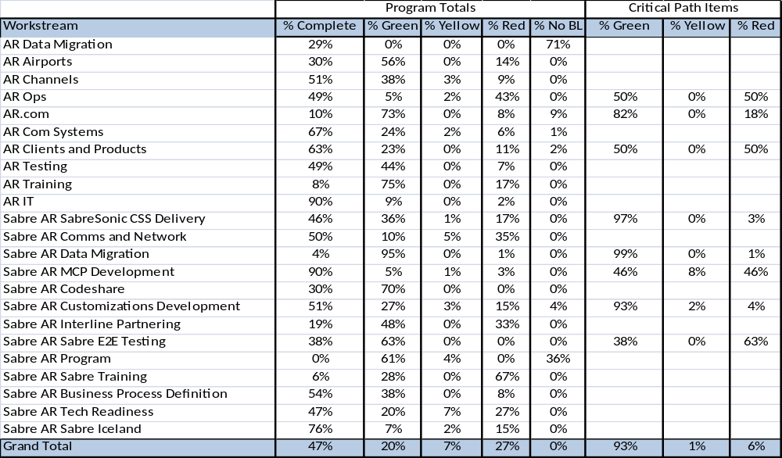
Create a regular table using the values from both of the above pivot tables. The table will have Workstreams as the rows names with the % of the total for each project status in the first series of columns, and on the critical path in the second series of columns. Add a comment next to each of the Sabre work streams to explain the red items – especially red items on the critical path.

Notes:
- Pivot tables and regular table are only built initially. Once built, all you have to do for weekly/biweekly updates is:
  - Create the Red Report
  - Create the Critical Path Report
  - Update the “ProgramScheduleData” range and refresh the pivots.
  - Validate formulas in the regular table at top, particularly the critical path formulas.
  - Update any comments for Sabre work streams.

