Microsoft Office Project- Post Training Questions

- Which one the following is not a constraint in project
- Scope
- Cost
- Schedule
- Requirements

- Which view you will use to know resource over-allocation
- Gantt Chart View
- Resource Sheet View
- Resource Graph
- Task Usage View

- What is highest priority possible for any task in Micro Office Project
- 100
- 500
- 1000
- 10000

- Rates for any resource can be entered in any of the following term per hours, per day, per week, per month. Is this statement Ture

- Yes
- No

- Slack or float is
- Amount of time by which project has been already delayed by status reporting date
- Amount of time by which you can delay a project without delay early start of next task.
- Amount of time by which you should finish project
- Amount of time by which you can delay a project without delaying project end date.

- Using global.mpt file you cannot customize following components of Microsoft Office Project
- View
- Reports
- Tables
- Menu

- Which of the following is not part of Earned Value Management (EVM)
- Planned Valued
- Actual Cost
- Budget at completion
- % Complete

- You are building a project schedule in Microsoft Office Project. The Schedule includes 2 tasks. Task B is dependent on the finish date of task A. Each Task has a duration of 5 days. You need to ensure that task B starts 2 days after Task A starts. Which type of dependency should you create?

- Start-to-start, with a lag of 2 days
- Start-to-finish with a lag of 2 days
- Finish-to-start with a lag of 2 days
- Finish-to-finish with a lag of 2 days

- Program Evaluation and review technique (PERT) method uses a weighted average duration estimate to calculate activity durations. It is also called three-point estimate. Formula is

- (Pessimistic + Optimistic + 4*Most Likely) / 6
- (Pessimistic + Optimistic) / 4
- (Pessimistic + Optimistic + Most likely) / 6
- (Pessimistic + Optimistic + 4*Most Likely) / 3

- You are managing a project in Microsoft Office Project. You will be managing similar projects in the future and plan to reuse information from the current project. You need to save the tasks, durations, views, and formatting the current project for reuse. What should you do?

- Save the project as a template
- Create a baseline of the project schedule.
- Copy the projects rows from the Gantt chart view into another project file
- Use the organizer to transfer the information you want to save from your project into the Global.mpt file

- What information you should remove from the project when you are saving it as template.
- Summary Task Name
- Work
- Dependency
- Resource Name

- You are creating a project schedule in Microsoft Office Project. Task A and B each have a estimated duration of 10 days. You expect the actual duration of one or both tasks to change when work begins. You want task B to start when task A is 60 percent complete. You need to model these tasks in the project schedule by creating a dependency from Task A to Task B. Which type of dependency should you create?

- Start-to-start with a lag of 6 days
- Finish-to-start with a lag of 60%
- Start-to-start with a lag of 60%
- Finish-to-start with a lag of 4 days

- In Microsoft Office Project, you create a new task in a project plan and assign a resource to the task. The default task duration is 1 day and the default amount of work is 7 hours. You need to change the calendar options to set the default amount of work to 8 hours. What should you do?

- Set the hours per day to 8
- Set the hours per week to 40
- Set the days per month to 20
- Set the default start time to 8:00 AM and default end time to 4:00 PM

- You are managing a project in Microsoft Office Project. The calendar for one of the resource has been edited to block out his vacation days. You learn that the resource can be utilized only on certain days. You want to ensure that resource should not be assigned any task on vacation days. What should you do?

- Assign the updated resource calendar to the task.
- Create a vacation exception on the project calendar.
- Change the resource calendar to match the task calendar.
- Modify the resource calendar so that it will override the task calendar

- You have two project plans in Microsoft Office Project that are part of one large initiative. You need to display a single critical path across both projects in Gantt chart view and show to your management. What should you do?

- Open both project plans and then display them side by side
- Copy and paste of Gantt of each project plan into Excel and show to your management.
- Create a visual report of each project plan and then merge the data in Microsoft Office Excel to show to your management
- Create a third plan as Master Plan. Insert both project plans into this project plan. Expand the inserted projects and all their tasks and show to your management.

- You are working in Microsoft Office Project on an activity plan in which task A and Task B are not linked. However, Task B cannot start until Task A is complete. You need to link the two tasks so that Task B starts when Task A is complete. What should you do?

- Set the start date for Task B equal to the finish date for Task A
- Set the start date for Task B to a date after the finish date for Task A.
- Set Task B as the predecessor for Task A
- Set Task A as the predecessor for Task B

- Your organization uses Microsoft Office Project Server 2010. A number of task enterprise custom fields have been defined. You need to ensure that all project managers use a custom view that includes these fields when they develop their project plans. What should you do?

- In a blank project add the custom fields to a custom view and then save the project as an enterprise template.
- Use the organizer to add the custom fields to their projects.
- Add the custom fields to your project workspace site template.
- Add the task custom fields to a custom view in the Enterprise Global Template

- Which of the following is new feature of Microsoft Project Professional 2010.

- Task driver and Team planner
- Timeline and Task driver
- Team Planner and Timeline
- All of the above

- How many baselines are available at the project level?

- One
- Eleven
- Ten
- Five

- You have a project plan which was created using Microsoft Office Project. You need to create a presentation of project status which will allow you to dynamically change the timescale and fields which are displayed. What should you do?

- Create a visual report
- Create a custom basic report
- Paste a picture of the Gantt chart into a visual presentation
- Filter the project plan to display only critical tasks and then paste a copy of the table into a visual presentation

- You are managing a project schedule in Microsoft Office Project. Your organization’s accounting system utilizes cost accounts to track expenses against spendings. What should you do?

- Set up interim plans
- Map accounts of accounting department with Control Account in project schedule
- Enter cost resources
- Enter budget resources

- You are managing a project schedule in Microsoft Office Project. While planning you want to ensure that allocation of resources should not be more than the budget given by senior management. What should you do?

- Set up interim plans
- Enter cost resources
- Enter budget resources and compare plan resources against budget resources
- Copy cost data from the task usage table into the accounting system

- You are managing a project using Microsoft Office Project. As part of tracking you need to compare the original project schedule to the current project schedule in the default tracking Gantt view. What is not required for this work?

- Interim plan
- Baseline
- Task status of tasks
- Actual spending on tasks

- You are creating a schedule in Microsoft Office Project. For budgeting purposes, you allocate resources 6 months in advance of the project. At this time you do not know who will be assigned to your project. You need to forecast when the project will need resources with specific skills. What should you do?

- Assign generic work resources to tasks
- Assign generic budget work resources to tasks
- Assign budget work resources to tasks
- Assign work resources to tasks

- You are creating a new project schedule in Microsoft Office Project. You use an existing template as the starting point and then add tasks to the project. You need to retain the changes to the project template for future use. What should you do?

- Save the file as an .mpp file in the templates directory.
- Save the file as an .mpw file in the templates directory
- Save the file as an .mpt file, overwriting the existing file
- Save the file as an .xml file, overwriting the existing file

- You are planning a new project in Microsoft Office Project. The project will tentatively will start next month. Your project has 300 activities, you created a plan in such a way that when project start you just set a date and the date of all other project activities change automatically. What action you should you take?

- Set the start date in the project information dialog box
- Set the current date in the project information dialog box
- Create a milestone as the first task and then enter the projected start date in the start field
- Create a milestone as the first task and then enter the projected start date in the actual start field

- You are managing the schedule for a multi-level project in Microsoft Office Project. The project is complete. There are a number of project milestones embedded at all levels of the project hierarchy. Your organization reports the names and finish dates of project milestones in a Microsoft Office Excel Workbook. You need to export the project milestone data from the project schedule to an Excel workbook for the purposes of this report. What should you do?

- Save the project file as an Excel workbook by using the project excel template option
- Save the project file as an Excel workbook, using the existing top-level task mapping when prompted to do so
- Save the project file as an Excel workbook, creating a new task-based map that includes the name and finish fields and the milestone filter, when prompted to do so
- Filter the schedule to show only the milestones. Then save the project file as an Excel workbook, using the existing top-level task mapping when prompted to do so

- You created a new base calendar for a project that you are tracking in Microsoft Office Project. You need to make this calendar the default calendar for the project. What should you do?

- Create a copy of the standard calendar
- Click the set as default button in the calendar option
- Set the new base calendar as the project calendar in Project Information
- Set the new base calendar as the calendar in the change working time options.

- You are managing a project schedule in Microsoft Office Project. Two resources are changing from the day shift to the night shift for two weeks. You need to modify the project to reflect this temporary change. What should you do?

- Set the night shift calendar as the project calendar
- Apply the night shift calendar to each resource's calendar
- Add a night shift entry to the exceptions of the project calendar, with the appropriate dates and hours set for these 2 weeks
- Add a night shift entry to the exceptions of each resource's calendar, with the appropriate dates and hours set for these 2 weeks

- You are creating a project schedule in Microsoft office Project. You enter the Task name, start dates and estimated durations. Except for the first and last Tasks, all of the tasks have at least one predecessor and one successor. You learn that all of the Phase 1 tasks can be completed faster than originally estimated. When you shorten the durations of this tasks,the finish dates does not change. You need to adjust the schedule so that it estimates an accurate finish date. What should you do?

- Delete the shorten Tasks and then re-enter them.
- Insert the constraint date column,and type in the finish date.
- Check the constraint types of all tasks. It should be “As Soon As Possible”.
- Change the tasks to effort-driven,and then assign resources to the tasks to reduce the work associated with each task.

- You are displaying a project plan in Microsoft office project. You need to see both critical and non-critical tasks on the same screen and be able to distinguish them. What should you do?

- Apply a filter.
- Display the calender view.
- Display the task usage view.
- Use the Gantt chart wizard to display the critical path.

- You are managing a project schedule in Microsoft office project. The project activities occur at two locations. Project team members must travel between the locations by air and incur lodging expenses. The travel occurs on an irregular schedule,and expenses have varying cost, frequencies and durations. You need to provision this costs in the schedule as accurately as possible. Which cost type should you use?

- Budget resources.
- Cost resources.
- Per-use costs
- Rate-based costs.

- You have project plan which was created using Microsoft office project. You need to create presentation of project status which will allow you to dynamically change the timescale and fields which are displayed. What should you do?

- Create a visual report.
- Create custom basic report.
- Paste a picture of the Gantt chart into a visual presentation.
- Filter the project plan to display only critical tasks, and then paste a copy of the table into a visual presentation.

- You are tracking a project in Microsoft office project standard 2010.You monitor the project status by reviewing the following data: Actual start and finish dates, Schedule start and finish date, Cost, Work, Task Duration. You need to display all of this project information in one window. What should you do?

- Display the summary table.
- Display the project schedule in the default tracking Gantt view.
- Display the project statistics from properties of dialog box.
- Display the project statistics from the project information dialog box.

- What type of default duration created for a new activity in Microsoft Office Project?

- Set Duration
- Calculated Duration
- Estimated Duration
- Undefined Duration
- Which of the following is not out of the box calendar in Microsoft Office Project?

- 24 Hours
- Night Shift
- Standard
- Regular
- Which one of these is not calendar in Microsoft Office Project?

- Resource Calendar
- Project Calendar
- Task Calendar
- Assignment Calendar
- How many types of constraints supported in Microsoft Office Project?

- 8
- 6
- 4
- 10
- Which one of these is not constraint type?

- MSO, MFO,
- SNET, SNLT,
- FNLT, FNET,
- ASLP, ALEP
- Which of the following is not dependency type in Microsoft Office Project?

- First-to-Last
- Finish-to-finish
- Finish-to-Start
- Start-to-finish
- What is the purpose of Split of activity?

- To adjust resource availability for remaining work
- Break the long activity in smaller manageable
- To adjust cancelled activities
- To Adjust delayed activities
- What is Driving Resource in Microsoft Office Project?

- Activity Owner
- The resource whose assignment to a task determines the finish date of the task
- Project Leader
- Product Owner
- How many task types supported in Microsoft Office Project

- 2
- 3
- 4
- 5

- You are tracking a project in Microsoft Project 2010. The project follows the plan shown below:

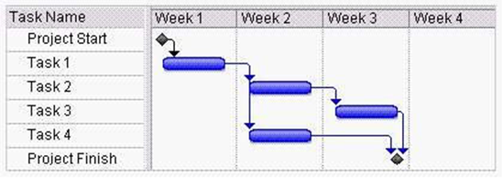

What is the latest finish (LF) date of Task 4?

- The end of week # 1
- The end of week # 2
- The end of week # 3
- The end of week # 4

- In Microsoft Project, you create the following project plan

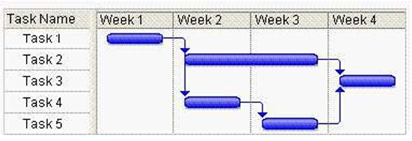
You need to identify the critical path. Which tasks are on the critical path?

- 1, 2 and 3
- 1, 2, 3 and 5
- 1, 3, 4 and 5
- 1, 2, 3, 4 and 5

- You are editing a schedule in Microsoft Office Project, scheduling from the start of the project. You noticed that Task X is starting later than you expected. Task W is 100 percent complete

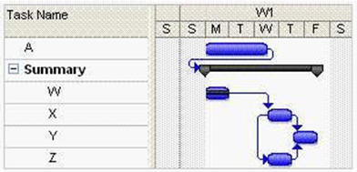
You need Task X to start on Tuesday. Which dependency should you delete?

- The dependency between Task A and the summary task
- The dependency between Task W and Task X
- The dependency between Task X and Task Y
- The dependency between Task Z and Task X

- You are managing a project in Microsoft office project. The project follows the plan shown below.

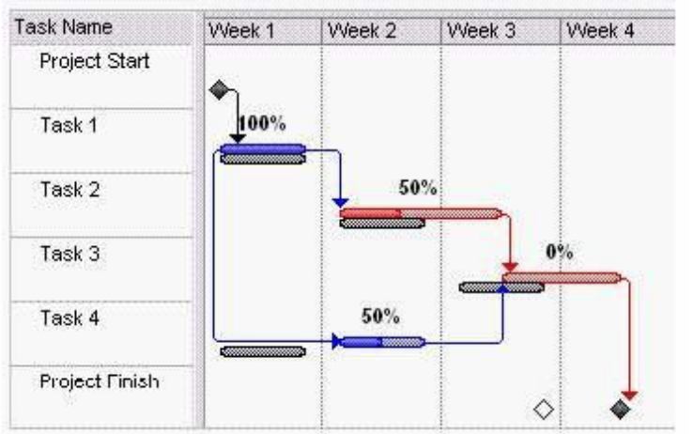
Task 1 is 100 percent complete. Task 2 and 4 are each 50 percent complete. The forecast duration of Task 2 if half a week more than its baseline duration. Task 3 cannot start until Task 2 is complete. Task 4 is 1 week late. You need to modify the schedule to meet the original finish date. What should yo do?

- Clear the existing baseline,and then set a new baseline.
- Assign extra resources to Task 4 to eliminate the 1-week delay.
- Assign extra resources to Task 2 to eliminate the forecast increase in the duration.
- Delete the link between Task 2 and 3.Then change the Task 1 to a predecessor of Task 3,so that Task 3 can start ahead of time.

Answer the following question based on the network diagram
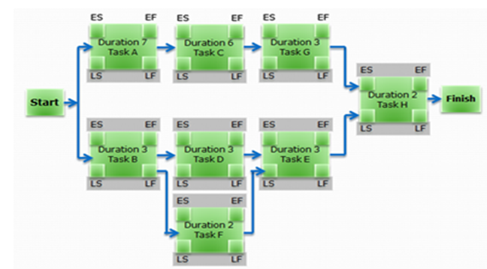

- Which of the above activities are critical?

- B, D, E, H
- A, C, G, H
- B, F, E, H
- Cannot be determined

- What is the slack period available for Task F?
- 0 Days
- 4 Days
- 2 Days
- 8 Days

- What is the project duration
- 10 Days
- 11 Days
- 18 Days
- Cannot be determined

