Document ID | Document Name | Version | Date
SG_ENG_COM05 | Product Integration and Testing | V 1.0 | 08-Aug-06

Revision History
Sr. No. | Version No. | Author | Date of Release | Description of Release/Change | Approved By
1. | 1.0 | Hari P Thapliyal | 08-Aug-06 | Initial release
2.
3.
4.
5.

This is a controlled document. Unauthorized access, copying, and replication are prohibited. This document must not be copied in whole or in parts by any means without the written authorization of the Software Delivery Head, Aurovision, Mumbai , India.

© Copyright 2006, Aurovision P. Ltd. All rights reserved.
Table of Contents

1. Document Overview 3
1.1 Purpose 3
1.2 Scope 3
1.3 Reference Documents 3
1.4 Definitions & Acronyms 3
2. Overview 4
2.1 Project Organization 4
2.2 Testing Activities 4
2.3 Testing Documentation 4
3. General Concepts of Testing 5
3.1 Testing Objectives 5
3.2 Testing Strategy 5
3.3 Levels of Testing 5
3.4 General Testing Principles 6
4. Levels of Testing 7
4.1 Unit Testing 7
4.1.1 Scope of Testing 7
4.1.2 Activities, Documentation and Parties Involved 7
4.1.3 Practical Guidelines 7
4.2 Integration Testing 7
4.2.1 Scope of Testing 7
4.2.2 Practical Guidelines 8
4.3 Function Testing 8
4.3.1 Scope of Testing 8
4.3.2 Activities, Documentation and Parties Involved 8
4.3.3 Practical Guidelines 8
4.4 System Testing 9
4.4.1 Scope of Testing 9
4.4.2 Activities, Documentation and Parties Involved 9
4.4.3 Practical Guidelines 9
4.5 Acceptance Testing 10
4.5.1 Scope of Testing 10
4.5.2 Activities, Documentation and Parties Involved 10
4.5.3 Practical Guidelines 10
5. Test Planning and Control 12
5.1 Test Planning 12
5.2 Test Group 12
6. Product Integration 13
6.1 Integration Process Model 13
6.2 Integration Strategy 14
6.3 Integration Type 15
6.3.1 Big Bang Integration 15
6.3.2 Top Down Integration 16
6.3.3 Bottom Up Integration 16
6.3.4 Sandwich Integration 17
6.3.5 Integration Approach 18
7. Appendix A – Item List for Unit Testing 22
8. Appendix B – Item List for Integration Testing 23
9. Appendix C – Item List for Function Testing 24
10. Appendix D – Item List for System Testing 25
11. Appendix E – Item List for Acceptance Testing 26

Document Overview

Purpose
The purpose of this document is to provide a set of application software testing guidelines, to ensure that application systems are properly tested, so that final deliverable of work product is defect free.

This document also provides a set of guidelines to conduct product integration.

Scope
This document, as the name suggests, is to provide a set of guidelines to be referenced by the project teams for planning and carrying out product integration and testing activities for the software. It is important that users of this document should not treat these guidelines as mandatory standards, but as a reference model; and should tailor the guidelines according to an individual project’s requirements.

Reference Documents
A Structured Approach to Systems Testing by William E. Perry

Definitions & Acronyms
- UT – Unit Testing
- ST/IT – System Testing / Integration Testing
- UAT – User Acceptance Testing
- PSM – Project Software Manager
- QR - Quality Representative
- SCM - Software Configuration Manager

Overview
This document, in essence, suggests a reference model for the planning and carrying out of software testing, and product integration in Aurovision. The following serves as an overview of the model:

Project Organization
Where resource constraints permitted, an independent test group is set up to carry out the testing activities. The emphasis here is on the independent role of the test group, which does not necessarily mean dedicated resources.

Testing Activities
The testing activities should be identified to test out a software system from the following 5 different perspectives (the emphasis here is on different perspectives, which does not necessarily mean different testing phases):
- To validate individual program modules against program specifications (Unit Testing)
- To validate program linkages against design specifications (Integration Testing)
- To validate integrated software against functional specifications (Function Testing)
- To validate the integrated software against specifications on operating environment (System Testing)
- To validate the integrated software against end-user needs (Acceptance Testing).

Testing Documentation
Testing activities would be documented through the use of:
- Test plans
- Test case and report (results)
- Defect report
- Status report

General Concepts of Testing

Testing Objectives
Testing is the process of executing program(s) with the intent of finding errors, rather than (a misconception) of showing the correct functioning of the program(s). The distinction may sound like a matter of semantics, but it has been observed to have profound effect on testing success. The difference actually lies on the different psychological effect caused by the different objectives: If our goal is to demonstrate that a program has no errors, then we will tend to select tests that have a low probability of causing the program to fail. On the other hand, if our goal is to demonstrate that a program has errors; our test data will have a higher probability of finding errors.
Specifically, testing should bear the following objectives:
- To reveal design errors
- To reveal logic errors
- To reveal performance bottlenecks
- To reveal security loopholes
- To reveal operational deficiencies
All these objectives and the corresponding actions contribute to increased quality and reliability of the application software.

Testing Strategy
There are two strategies for testing software, namely White-Box Testing and Black-Box Testing. White-Box Testing is also known as Code Testing. It focuses on the independent logical internals of the software to assure that all code statements and logical paths have been tested.
Black-Box Testing is also known as Specification Testing. It focuses on the functional externals to assure that defined input will produce actual results that agreed with required results documented in the specifications.
Both strategies should be used, according to the levels of testing.

Levels of Testing
There are 5 levels of testing, each of which carry a specific functional purpose and are to be carried out in chronological order.

Testing Level | Testing Strategy Applied
Unit Testing  - Testing of the program modules in isolation with the objective to find discrepancy between the programs and the program specifications. | White box testing
Integration Testing  - Testing of the linkages between tested program modules with the objective to find discrepancy between the programs and system specifications. | White box testing
Function Testing  - Testing of the integrated software on a function-by-function basis with the objective to find discrepancy between the programs and the function specifications. | Black box testing
Systems Testing  - Testing of the integrated software with the objective to find discrepancy between the programs and the original objectives with regard to the operating environment of the system (e.g. Recovery, Security, Performance, Storage, etc.). | Black box testing
Acceptance Testing  - Testing of the integrated software by the end users (or their proxy) with the objective to find discrepancy between the programs and the end user needs. | Black box testing

General Testing Principles
The following points should be noted when conducting testing:
- As far as possible, testing should be performed by a group of people (referred to in this document as Test Group) different from those performing design and coding of the same system.
- Test cases must be written for invalid and unexpected, as well as valid and expected input conditions. A good test case is one that has a high probability of detecting undiscovered errors. A successful test case is one that detects an undiscovered error.
- A necessary part of a test case is a definition of the expected outputs or results.
- Do not plan testing effort on assumption that no errors will be found.
- The probability of the existence of more errors in a section of a program is proportional to the number of errors already found in that section.
- Testing libraries should be set up allowing Regression test to be performed at the time of system maintenance and enhancement.
- The later in the development life cycle a fault is discovered, the higher is the cost of correction.
- Successful testing relies on complete and unambiguous specification.

Levels of Testing

Unit Testing

Scope of Testing
Unit testing (or Module Testing) is the process of testing the individual subprograms, subroutines, or procedures in a program. The goal here is to find discrepancy between the programs and the program specifications.

Activities, Documentation and Parties Involved
- Designers to include test guidelines (i.e. areas to be tested) in the design and program specifications.
- Programmers to define test cases during program development time.
- Programmers perform unit testing after coding is completed.
- Programmers to include the final results of unit testing in the test report.

Practical Guidelines
- Testing should first be done with correct data, then with flawed data.
- A program unit would only be considered as completed after the program documentation (with testing results) of the program unit has been submitted to the project leader/SA.
- If there are critical sections of the program, design the testing sequence such that these sections are tested as early as possible. A ‘critical section’ might be a complex module, a module with a new algorithm, or an I/O module.
- There are three types of the test that the Unit Testing should satisfy:
  - Functional Test - Execute the program unit with normal and abnormal input values for which the expected results are known.
  - Performance Test (Optional) - Determine the amount of execution time spent on various parts of the program unit, response time and device utilization by the program unit.
  - Stress Test (Optional) - Stress test is designed to test the program unit with abnormal situations. A great deal can be learned about the strengths and limitations of a program unit by executing it in a manner that demands resources in abnormal quantity, frequency, or volume.
- Please refer to Appendix A for a list of items to be tested at the time of unit testing.

Integration Testing

Scope of Testing
Integration testing is the process of testing the linkages between program modules as against the system specifications. The goal here is to find errors associated with interfacing. As a by-product of the testing process, the software modules would be integrated together.
It is worth noting that this level of testing is sometimes referred to as “Integration Testing”, which is understood to mean that the testing process would end up with the software modules in integration.
Activities, Documentation and Parties Involved
- Test group to prepare an integration test plan.
- Test group to prepare integration test cases before testing commences.
- Test group, with the aid of the designers/programmers, to set up the testing environment.
- Test group to perform integration testing; and upon fault found raise defect report to designers/programmers, who would fix up the liable errors.
- Test group to report progress of Integration Testing through periodic submission of the status report.

Practical Guidelines
- Both control and data interface between the programs must be tested.
- Both Top-down and Bottom-up approaches can be applied. Top-down integration is an incremental approach to the assembly of software structure. Modules are integrated by moving downward through the control hierarchy, beginning with the main control module (‘main program’). Modules subordinate (and ultimately subordinate) to the main control module are incorporated into the structure in either a depth-first or the breadth-first manner. Bottom-up integration, as its name implies, begins assembly and testing with modules at the lowest levels in the software structure. Because modules are integrated from the bottom up, processing required for modules subordinate to a given level is always available, and the need for stubs (i.e. dummy modules) is eliminated.
- As a result of the testing, integrated software should be produced.
- Please refer to Appendix B for a list of items to be tested at the time of Integration testing.

Function Testing

Scope of Testing
Function testing is the process of testing the integrated software on a function-by-function basis as against the function specifications. The goal here is to find discrepancy between the programs and the functional requirements.

Activities, Documentation and Parties Involved
- Test group to prepare function test plan, to be endorsed by the project committee via the test control sub-committee, before testing commences.
- Test group to prepare function test cases before testing commences.
- Test group, with the aid of the designers/programmers, to set up the testing environment.
- Test group (participated by user representatives) to perform function testing; and upon fault found raise defect reports to designers/programmers, who fix up the liable errors.
- Test group to report progress of function testing through periodic submission of the status report.

Practical Guidelines
- It is useful to involve some user representatives in this level of testing, in order to give them familiarity with the system prior to acceptance test and to highlight differences between users’ and developers’ interpretation of the specifications. However, degree of user involvement may differ from project to project, and even from department to department, all depending on the actual situation.
- User involvement, if applicable, could range from testing data preparation to staging out of the function testing.
- It is useful to keep track of which functions have exhibited the greatest number of errors; this information is valuable because it tells us that these functions probably still contain some hidden, undetected errors.
- Please refer to Appendix C for a list of items to be tested at the time of function testing.

System Testing

Scope of Testing
System testing is the process of testing the integrated software with regard to the operating environment of the system. (i.e. Recovery, Security, Performance, Storage, etc.)
It may be worthwhile to note that the term has been used with different environments. In its widest definition especially for the small-scale projects, it also covers the scope of integration testing and the function testing.
For small scale projects which combine the integration testing, function testing and system testing in one, it is crucial that the test specification should include distinct sets of test cases for each of these 3 levels of testing.

Activities, Documentation and Parties Involved
- Test group to prepare a system test plan, to be endorsed by the project committee via the test control sub-committee, before testing commences.
- Test group to prepare system test cases before testing commences.
- Test group, with the aid of the designers/programmers, to set up the testing environment.
- Test group (participated by the computer operators and user representatives) to perform system testing; and upon fault found raise defect reports to the designers/programmers, who would fix up the liable errors.
- Test group to report progress of the system testing through periodic submission of the status report.

Practical Guidelines
- Eight types of systems tests are discussed below. It is not claimed that all 8 types will be mandatory to every application system nor are they meant to be an exhaustive list. To avoid possible overlooking, all 8 types should be explored when designing test cases.
  - Volume Testing - Volume testing is to subject the system to heavy volumes of data, and the attempt of which is to show that the system cannot handle the volume of data specified in its objective. Since volume testing being obviously expensive, in terms of machine and resource time, one must not go overboard. However every system must be exposed to at least a few volume tests.
  - Stress Testing - Stress testing involves subjecting the program to heavy loads or stress. A heavy stress is a peak volume of data encountered over a short span of time. Although some stress test may experience ‘never will occur’ situations during its operational use, but this does not imply that these tests are not useful. If errors are detected by these ‘impossible’ conditions, the test is valuable, because it is likely that the same errors might also occur in realistic, less stressful situations.
  - Performance Testing - Many programs have specific performance or efficiency objectives, such as response times and throughput rates under certain workload and configuration conditions. Performance testing should attempt to show that the system does not satisfy its performance objectives.
  - Recovery Testing - If processing must continue during periods in which the application system is not operational, then those recovery processing procedures/ contingent actions should be tested during the system test. In addition, the users of the system should be involved in a complete recovery test so that not only the application system is tested but the procedures for performing the manual aspects of recovery are tested.
  - Security Testing - The adequacy of the security procedures should be tested by attempting to violate those procedures. For example, testing should attempt to access or modify data by an individual not authorized to access or modify that data.
  - Procedure Testing - Computer systems may not contain only computer processes but also involve procedures performed by people. Any prescribed human procedure, such as procedures to be followed by the system operator, database administrator, or terminal user, should be tested during the system test.
  - Regression Testing - Regression testing is the verification that what is being installed does not affect any already installed portion of the application or other applications interfaced by the new application.
  - Operational Testing - During the system test, testing should be conducted by the normal operations staff. It is only through having normal operation personnel conduct the test that the completeness of operator instructions and the ease with which the system can be operated can be properly evaluated. This testing is optional, and should be conducted only when the environment is available.
- It is understood that in real situations, due to possibly environmental reasons, some of the tests (e.g. Procedures test, etc.) may not be carried out in this stage and are to be delayed to later stages. There is no objection to such delay provided that the reasons are documented clearly in the test report and the test be carried out once the constraints removed.
- Please refer to Appendix D for a list of items to be tested at the time of systems testing.

Acceptance Testing

Scope of Testing
Acceptance testing is the process of comparing the application system to its initial requirements and the current needs of its end users. The goal here is to determine whether the software end product is acceptable or not to its user.

Activities, Documentation and Parties Involved
- User representatives to prepare an acceptance test plan, which is to be endorsed by the project committee via the test control sub-committee.
- User representatives to prepare acceptance test cases, which is to be endorsed by the project committee via the test control sub-committee.
- User representatives, with the aid of Aurovision project team, to set up the testing environment.
- User representatives to perform acceptance testing; and upon fault found raise problem report to the project manager, who will fix up the liable error.
- User representatives to report progress of the acceptance testing through periodic submission of status report.
- Aurovision project manager keeps the overall test report as documentation proof.

Practical Guidelines
- There are three approaches for acceptance testing, namely,
  - A planned comprehensive test using artificial data and simulated operational procedures, and usually accompanied with the Big Bang implementation approach but can also be used as a pre-requisite step of other approaches.
  - Parallel run using live data and would normally be used when comparison between the existing system and the new system is required. This approach requires duplicated resources to operate both systems.
  - Pilot run using live data and would normally be used when the user is not certain about the acceptance of the system by its end-users and/or the public. Users are responsible to select the approach(es) that is most applicable to its operating environment.
- Precautions for Aurovision Project Manager
  - Communicate clearly to the users of their commitments on the testing
  - Some users may be physically involved for the first time; therefore sufficient presentation, introduction, and training will be very important
  - Development team must be available to resolve problems if required
  - If possible, future maintenance team should be identified
  - Ensure all tasks are completed before handover to the maintenance team
- Precaution for users
  - Testing staff should be freed from their routine activities
  - Commitment is authorized
- Please refer to Appendix E for a list of items to be tested at the time of user acceptance testing.

Test Planning and Control

Test Planning
As general practices, integration testing, function testing, system testing and acceptance testing for the projects normally account to about 20% to 30% of the project implementation effort.
The objective of test planning is to prepare the blueprint used by the project personnel and users to ensure that the application system achieves the level of correctness and reliability desired by the user.
Test planning normally is accomplished by performing the following 7 activities in the sequence indicated:
- Identification and inclusion of the testing activities in the project plan;
- Setting up of the test group & the test control sub-committee; For each level, with the exception of unit testing,
- Preparation of a test plan, which should define the scope of the testing and include criteria for ending testing;
- Decide on what test method, strategies, tools and resources to be used;
- Preparation of test cases;
- Purchase or develop test tools prior to the time when they will be needed;
- Set up of the testing environment.

Test Group
By definition, testing is the process of executing a program with the intent of finding errors, since it is a “destructive” process; it is more effective and successful if performed by another party other than the original designers / programmers. As far as possible, testing should be performed by a group of people different from those performing design and coding of the same system, and those people called the Test Group.

Product Integration
The product integration process for the software products addresses the assembly of the software components into complete products. The integration of software components into working products is one of the major challenges in product development. Typically, the software product integration is done according to a defined plan, either in one stage or incrementally.
Integration activities begin at the design phase with the development of the integration plan (that is documented within the test plan). There are various integration approaches that can be followed depending on the type of project/situation at hand. The following paragraphs define the guidelines that can help a PSM in identifying the best integration approach for his/her project.
The input for the software integration process is a set of source code files. The files are delivered by the software developer after completing the unit/development testing.
As output, the integration process delivers a well-tested software product, which runs properly on a specific target hardware.
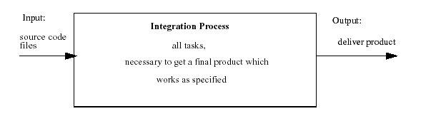

Integration Process Model
The integration process model has three main elements:
- Build Element: The input i.e. all the source code files which make up the software product have are transferred into the target software product (image) for the specific hardware. The source code is compiled, linked, converted (e.g. compressed) and combined (load set) as specified for the final product.
- Test Element: The software product is loaded/programmed to the target hardware. The system behavior defined by the software product is checked to ensure that all specifications are fulfilled i.e. whether the expected output is performed for a specific input and a proper state or a specified reaction is provided.
- Debug Element: If misbehavior is recognized, the misbehavior has to be analyzed and the reason has to be identified. The problem has to be fixed by the development team and the integration process is repeated again from the beginning.
The picture below illustrates the general integration process model. The relationship and the interworking between the three basic elements and the interfaces of the integration model the software development and the customer of the integration team any further test instance is shown.
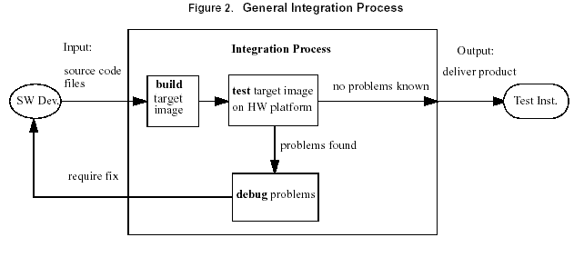

Integration Strategy
The software integration and testing on the target hardware could be done in several ways. The points to be considered before preparing the integration strategy are:
- Interactions between different software parts
- Availability of proper hardware for the test
- Availability of proper target hardware needed for integration
- Availability of test, debug and human resources
- Different delivery times of software parts
The proper strategy has to be selected in order to avoid:
- Improper testing of a feature due to a missing test interface or appropriate test equipment.
- Delay in integration start due to a missing software part, which is delivered later or is even planned to be later.
- New product is overloaded with too many changes, this could cause layered faults, which are hard to debug and identify (therefore minimize the number and size of software changes in the product for integration, this makes debugging easier and enables a better focus in case of problems).
- Lack of human resources for doing testing/debugging.
- Problems caused due to lack of knowledge for testing.
- Blocking of the whole integration process due to an external reason e.g. a bug which is not directly part of the feature or not in the focus of this test but blocks the whole integration and testing.
Each integration approach has its specific characteristics. Depending on the start-up conditions, the problem description and the required integration tasks, the most appropriate approach has to be selected. Very often a mixture of the different strategies is necessary to cover all areas.
The integration approaches refer to some key words the meanings of which are given below:
- Module: A module could be a driver or any other software part, which is a completed software identity.
- Block: Combination of some modules, which make up a higher software hierarchy.
- Feature: Is a combination of several modules, blocks etc., which handle and provide a feature.
- System: Is a combination of all software parts running on the system hardware and the target hardware itself?
- Bug Fix: Is a software change to repair a misbehavior in a module
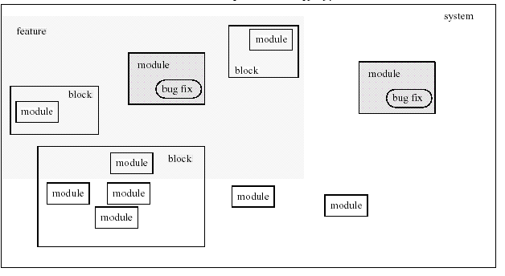

Integration Type

Big Bang Integration
- Non-incremental strategy
- Unit test each module in isolation.
- Integrate as a whole.
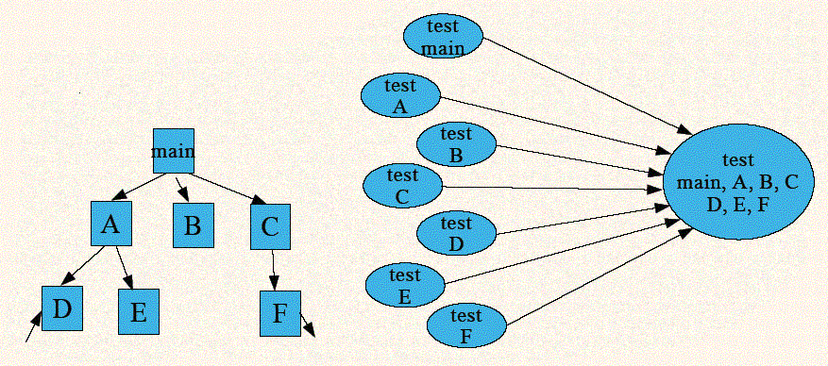
Advantages
- Convenient for small systems
Disadvantages
- Need driver and stubs for each module
- Do not allow parallel development
- Fault localization difficult
- Easy to miss interface faults

Top Down Integration
- Incremental strategy
- Test high-level modules, then
- Modules called until lowest level modules
- Possible to alter order such to test as early as possible
- Critical units
- Input/output units
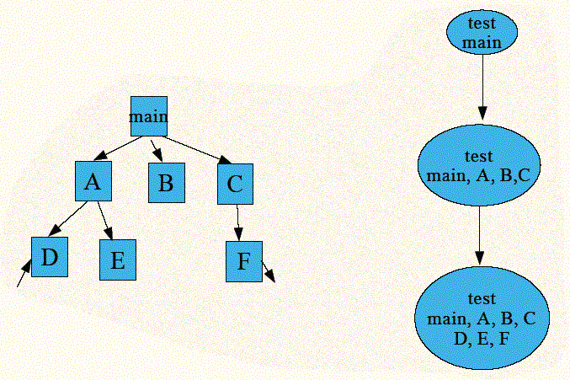
Advantages
- Fault localization easier
- Few or no drivers needed
- Possibility to obtain an early prototype
- Different order of testing/implementation possible
- Major design flaws found first in logic modules on top of the hierarchy
Disadvantages
- Need lot of stubs
- Potentially reusable modules (in bottom of the hierarchy) can be inadequately tested

Bottom Up Integration
- Incremental strategy
- Test low-level modules, then
- Modules calling them until highest level module
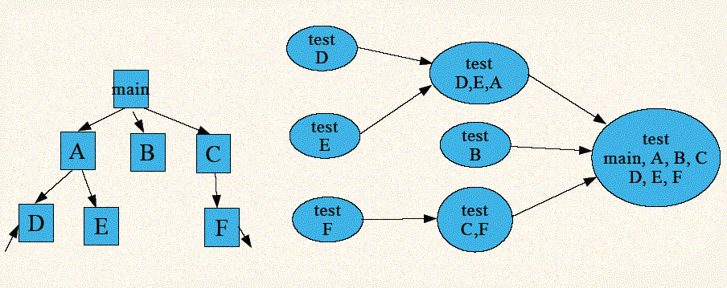
Advantages
- Fault localization easier (than big-bang)
- No need for stubs
- Logic modules tested thoroughly
- Testing can be in parallel with implementation
Disadvantages
- Need drivers
- High-level modules (that relate to the solution logic) tested in the last (and least)
- No concept of early skeletal system

Sandwich Integration
- Combines top-down and bottom-up approaches
- Distinguish 3 layers
- Logic (top) - tested top-down
- Middle
- Operational (bottom) – tested bottom-up
- Modules tested first in isolation before integration
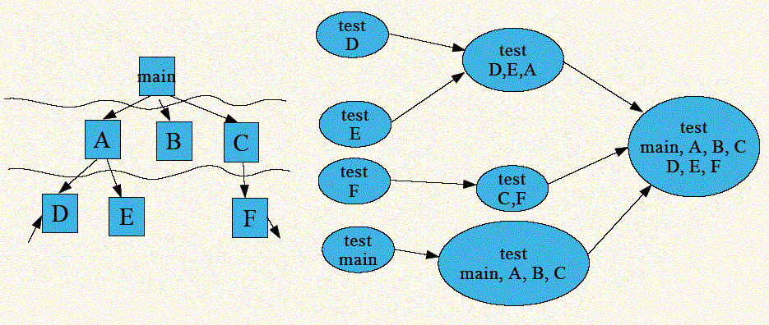

Integration Approach
Option 1: Module Approach
Selection Criteria:
The module approach integration strategy is suitable if a single software part can be tested in isolation from the hardware i.e. it does not need any resources of the target hardware or is performance or time sensitive. Another criterion is that it should be possible to provide a test environment for the so-called module or host tests with a limited effort.
Procedure Description:
Module integration is done apart from the target hardware. Instead on the target hardware the testing is performed in the host environment. The feature developer prepares a test specification, which contains the detailed tests and the expected results, a description of the test environment and how to set it up.
A special test environment with a test driver is necessary which would support all the in and out interfaces of the module. Tests will be defined; a kind of test script or a console shell for entering commands, and information etc. is expected. The expected results e.g. output like messages, changed data etc. have to be checked by the tester. A special executable image with the test module and the test driver has to be built. In case of file output, the files could be attached to the test description.

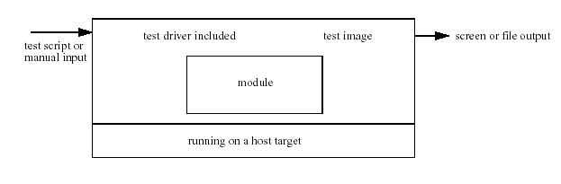
Advantage:
- Useful in case the initial integration of a new module has to be performed. Due to the direct test access, all interface parameters can be tested.
- The test is much faster and more direct than any test using target hardware. It is a real white-box test.
- Avoids an external blocking of tests by others, as no other handlers are involved.
- Pre-tested handler could be delivered to the system integration.
- Saves time as lots of tests can happen in parallel, while the development of other handlers still continues.
Disadvantage:
- This method cannot be used for hardware drivers, if timing or other resource dependent and sensitive handlers have to be tested.
- A special test environment has to be implemented which costs additional effort.
Option 2: Block or Layered Approach
Selection Criteria:
The block or layered approach is similar to module integration. After module integration and test is finished completely, some individually tested modules can be combined into a block and the interworking and relationship between the modules is tested as a whole. A host test of a block could be performed if some software parts (running on a common platform e.g.) could be tested isolated from the hardware. This could be done if there is no need for any specific hardware resources and the software parts are not considered as performance or time critical. Another criterion is that it should be possible to provide a test environment with a limited effort and which is realistic i.e. the results of the host tests are useful and could be compared with the results of the target test.
Procedure Description:
After a successfully executed module test, some modules, which are related to each other, will be combined and tested as a bigger module, a block, before some of these modules can be combined to an even bigger block and the procedure is repeated again.
It makes sense to combine blocks which build up a common feature e.g. and work together like in a chain e.g. the output of one module is the input of the other module. If the software is structured in layers, each layer could be seen as a block and the integration procedure is the subsequent combination of one layer after the other.
This is a proper method for the initial integration of new software.
The block integration is performed under the UNIX/Host environment. A special test environment with a test driver is necessary which supports all in and out interfaces of the block. The feature developer prepares a test specification, which contains the detailed tests and the expected results, a description of the test environment and how to set it up.
Tests for the block have to be defined; a kind of test script or a console shell for entering commands, and information etc. is necessary. The expected results e.g. outputs like messages, changed data etc. have to be checked. A special image with the test modules, which make up the block and the appropriate test driver, has to be built. In case of file output, the files could be attached to the test description.
If a proper test environment could be provided, this block or layered approach could also be performed on the target hardware directly.
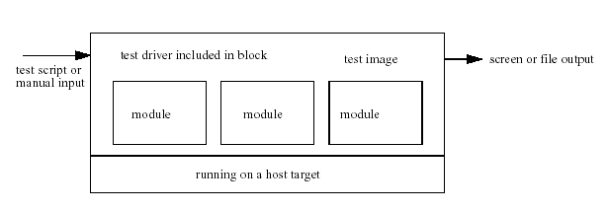
Advantage:
The advantages are similar to the module test.
Especially if the integration of a new feature has to be performed it is recommended to select a block integration strategy of some modules before the real target test is performed. This pre-test could save resources and time.

Disadvantage:
This method could not be used for hardware driver, if timing or other resource dependent and sensitive handlers have to be tested. A special test environment and a separate build environment are needed.
Option 3: New Feature Integration
Selection Criteria:
Selected if a new feature is introduced in stable platform software or a total new image has to be integrated the first time on the target hardware.
Procedure Description:
Introduction of a new feature means, new modules have to be created or existing have to be extended. Before the new feature integration on the target hardware is started, the new or changed modules should be pre-tested with host tests first, i.e. module integration and/or block integration should be executed before as far as it is possible.
Advantage:
- This feature test procedure involves both integrators and software developers to ensure that a real white box test on the target is performed.
- The core integrators take care for the test environment and check the system behavior, the developer will check the behavior of his module in the system, both the tasks happen in parallel thereby saving time.
- Due to the cooperation, the knowledge transfer between software development and integration team is ensured.
Disadvantage:
- Focuses on some changed parts in the system. The overall system stability is not covered by feature integration alone. Therefore additional regression tests and basic system tests have to be performed.
Option 4: Incremental Approach
Selection Criteria:
Some change requests have to be integrated and only small and very specific changes i.e. bug fixes were made in the product, which is considered as a stable platform. In such a case, the “incremental approach” strategy could be useful.
Procedure Description:
A maintenance loadset consists of a lot of bug fixes. Incremental approach means, the integration procedure of all these bug fixes is done in several subsequently steps.
In each step, a test loadset is built with a restricted set of introduced changes.
For each loadset, first specific tests will be performed in order to verify that the faulty behavior is fixed now by the introduced code changes. All change requests defined for a step have to be re-tested and successfully integrated before the next step is entered and new code changes are added. This procedure will be repeated for each step.
The time and resource intensive regression tests etc. will only be performed at the end of the incremental approach procedure or if regression testing makes sense in order to verify a specific bug fix.
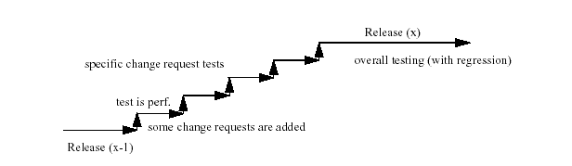
Advantage:
- Incremental Approach integration is a useful and fast method to verify that single bug fixes are solved.
- This approach can be especially used in the “Maintenance” phases i.e. when a maintenance loadset is planned and bugs are fixed which have caused only less code modifications.
- Using this integration strategy, the change requests could be integrated one after the other and verified immediately. However, the overall test and the regression test is performed only at the end, which saves some resources and effort.
Disadvantage:
- Useful only in the case the changes are small and integration is done on a stable platform. If new features or many complex changes have to be integrated, this method is not suitable.

Appendix A – Item List for Unit Testing
(This list is only to suggest areas for the definition of test cases and is for information purpose only; in no way is it meant to be an exhaustive list.)
Input
- Validation rules of data fields – do not match with the program/data specification.
- Valid data fields are rejected
- Data fields of invalid class, range and format are accepted.
- Invalid fields cause abnormal program end.
Output
- Output messages are shown with misspelling, or incorrect meaning, or not uniform.
- Output messages are shown while they are supposed not to be; or they are not shown while they are supposed to be.
- Reports/Screens do not conform to the specified layout with misspelled data labels/titles, mismatched data label and information content, and/or incorrect data sizes.
- Reports/Screens page numbering is out of sequence.
- Reports/Screens breaks do not happen or happen at the wrong places.
- Reports/Screens control totals do not tally with individual items.
- Screen video attributes are not set/reset as they should be.
File Access
- Data fields are not updated as input.
- “No-file” cases cause program abnormal end.
- “Empty-file” cases cause program abnormal end.
- Program data storage areas do not match with the file layout.
- The last input record (in a batch of transactions) is not updated.
- The last record in a file is not read while it should be.
- Deadlock occurs when the same record/file is accessed by more than 1 user.
Internal Logic
- Counters are not initialized, as they should be.
- Mathematical accuracy and rounding does not conform to the prescribed rules.
Control Procedures
- A wrong program is invoked and/or the wrong library/files are referenced.
- Program execution sequence does not follow.
- Run time parameters are not validated before use.
Program Documentation
- Documentation is not consistent with the program behavior.
Program Structure (through program walkthrough)
- Coding structure does not follow installation standards.
Performance
- The program runs longer than the specified response time.
Sample Test Cases
- Screen labels checks.
- Screen videos checks with test data set 1.
- Creation of record with valid data set 2.
- Rejection of record with invalid data set 3.
- Error handling upon empty file 1.
- Batch program run with test data set 4.

Appendix B – Item List for Integration Testing
(This list is only to suggest areas for the definition of test cases and is for information purpose only; in no way is it meant to be an exhaustive list.)
Global Data (e.g. Linkage Section)
- Global variables have different definition and/or attributes in the programs that referenced them.
Program Interfaces
- The called programs are not invoked while they are supposed to be.
- Any two interfaced programs have different number of parameters, and/or the attributes of these parameters are defined differently in the two programs.
- Passing parameters are modified by the called program while they are not supposed to be.
- Called programs behaved differently when the calling program calls twice with the same set of input data.
- File pointers held in the calling program are destroyed after another program is called.
Consistency among programs
- The same error is treated differently (e.g. with different messages, with different termination status etc.) in different programs.
Sample Test Cases
- Interface test between programs P1, P2 & P3.
- Global (memory) data file 1 test with data set 1.

Appendix C – Item List for Function Testing
(This list is only to suggest areas for the definition of test cases and is for information purpose only; in no way is it meant to be an exhaustive list.)
Comprehensiveness
- Agreed business function is not implemented by any transaction/report.
Correctness
- The developed transaction/report does not achieve the said business function.
Sample Test cases
- Creation of records under user normal environment.
- Enquiry of the same record from 2 terminals.
- Printing of records when the printer is in normal condition.
- Printing of records when the printer is off-line or paper out.
- Unsolicited message sent to console/supervisory terminal when a certain time limit is reached.

Appendix D – Item List for System Testing
(This list is only to suggest areas for the definition of test cases and is for information purpose only; in no way is it meant to be an exhaustive list.)
Volume Testing
- The system cannot handle a pre-defined number of transactions.
Stress Testing
- The system cannot handle a pre-defined number of transactions over a short span of time.
Performance Testing
- The response time is excessive over a pre-defined time limit under certain workloads.
Recovery Testing
- Database cannot be recovered in event of system failure.
- The system cannot be restarted after a system crash.
Security Testing
- The system can be accessed by an unauthorized person.
- The system does not log out automatically in event of a terminal failure.
Procedure Testing
- The system is inconsistent with manual operation procedures.
Regression Testing
- The sub-system / system being installed affect the normal operation of the other systems / sub-systems already installed.
Operation Testing
- The information inside the operation manual is not clear and concise with the application system.
- The operational manual does not cover all the operation procedures of the system.
Sample Test Cases
- System performance test with workload mix 1.
- Terminal power off when an update transaction is processed.
- Security breakthrough - pressing different key combinations onto the logon screen.
- Reload from backup tape.

Appendix E – Item List for Acceptance Testing
(This list is only to suggest areas for the definition of test cases and is for information purpose only; in no way is it meant to be an exhaustive list.)
Comprehensiveness
- Agreed business function is not implemented by any transaction/report.
Correctness
- The developed transaction/report does not achieve the said business function.
Sample Test Cases
(Similar to Function Testing)

